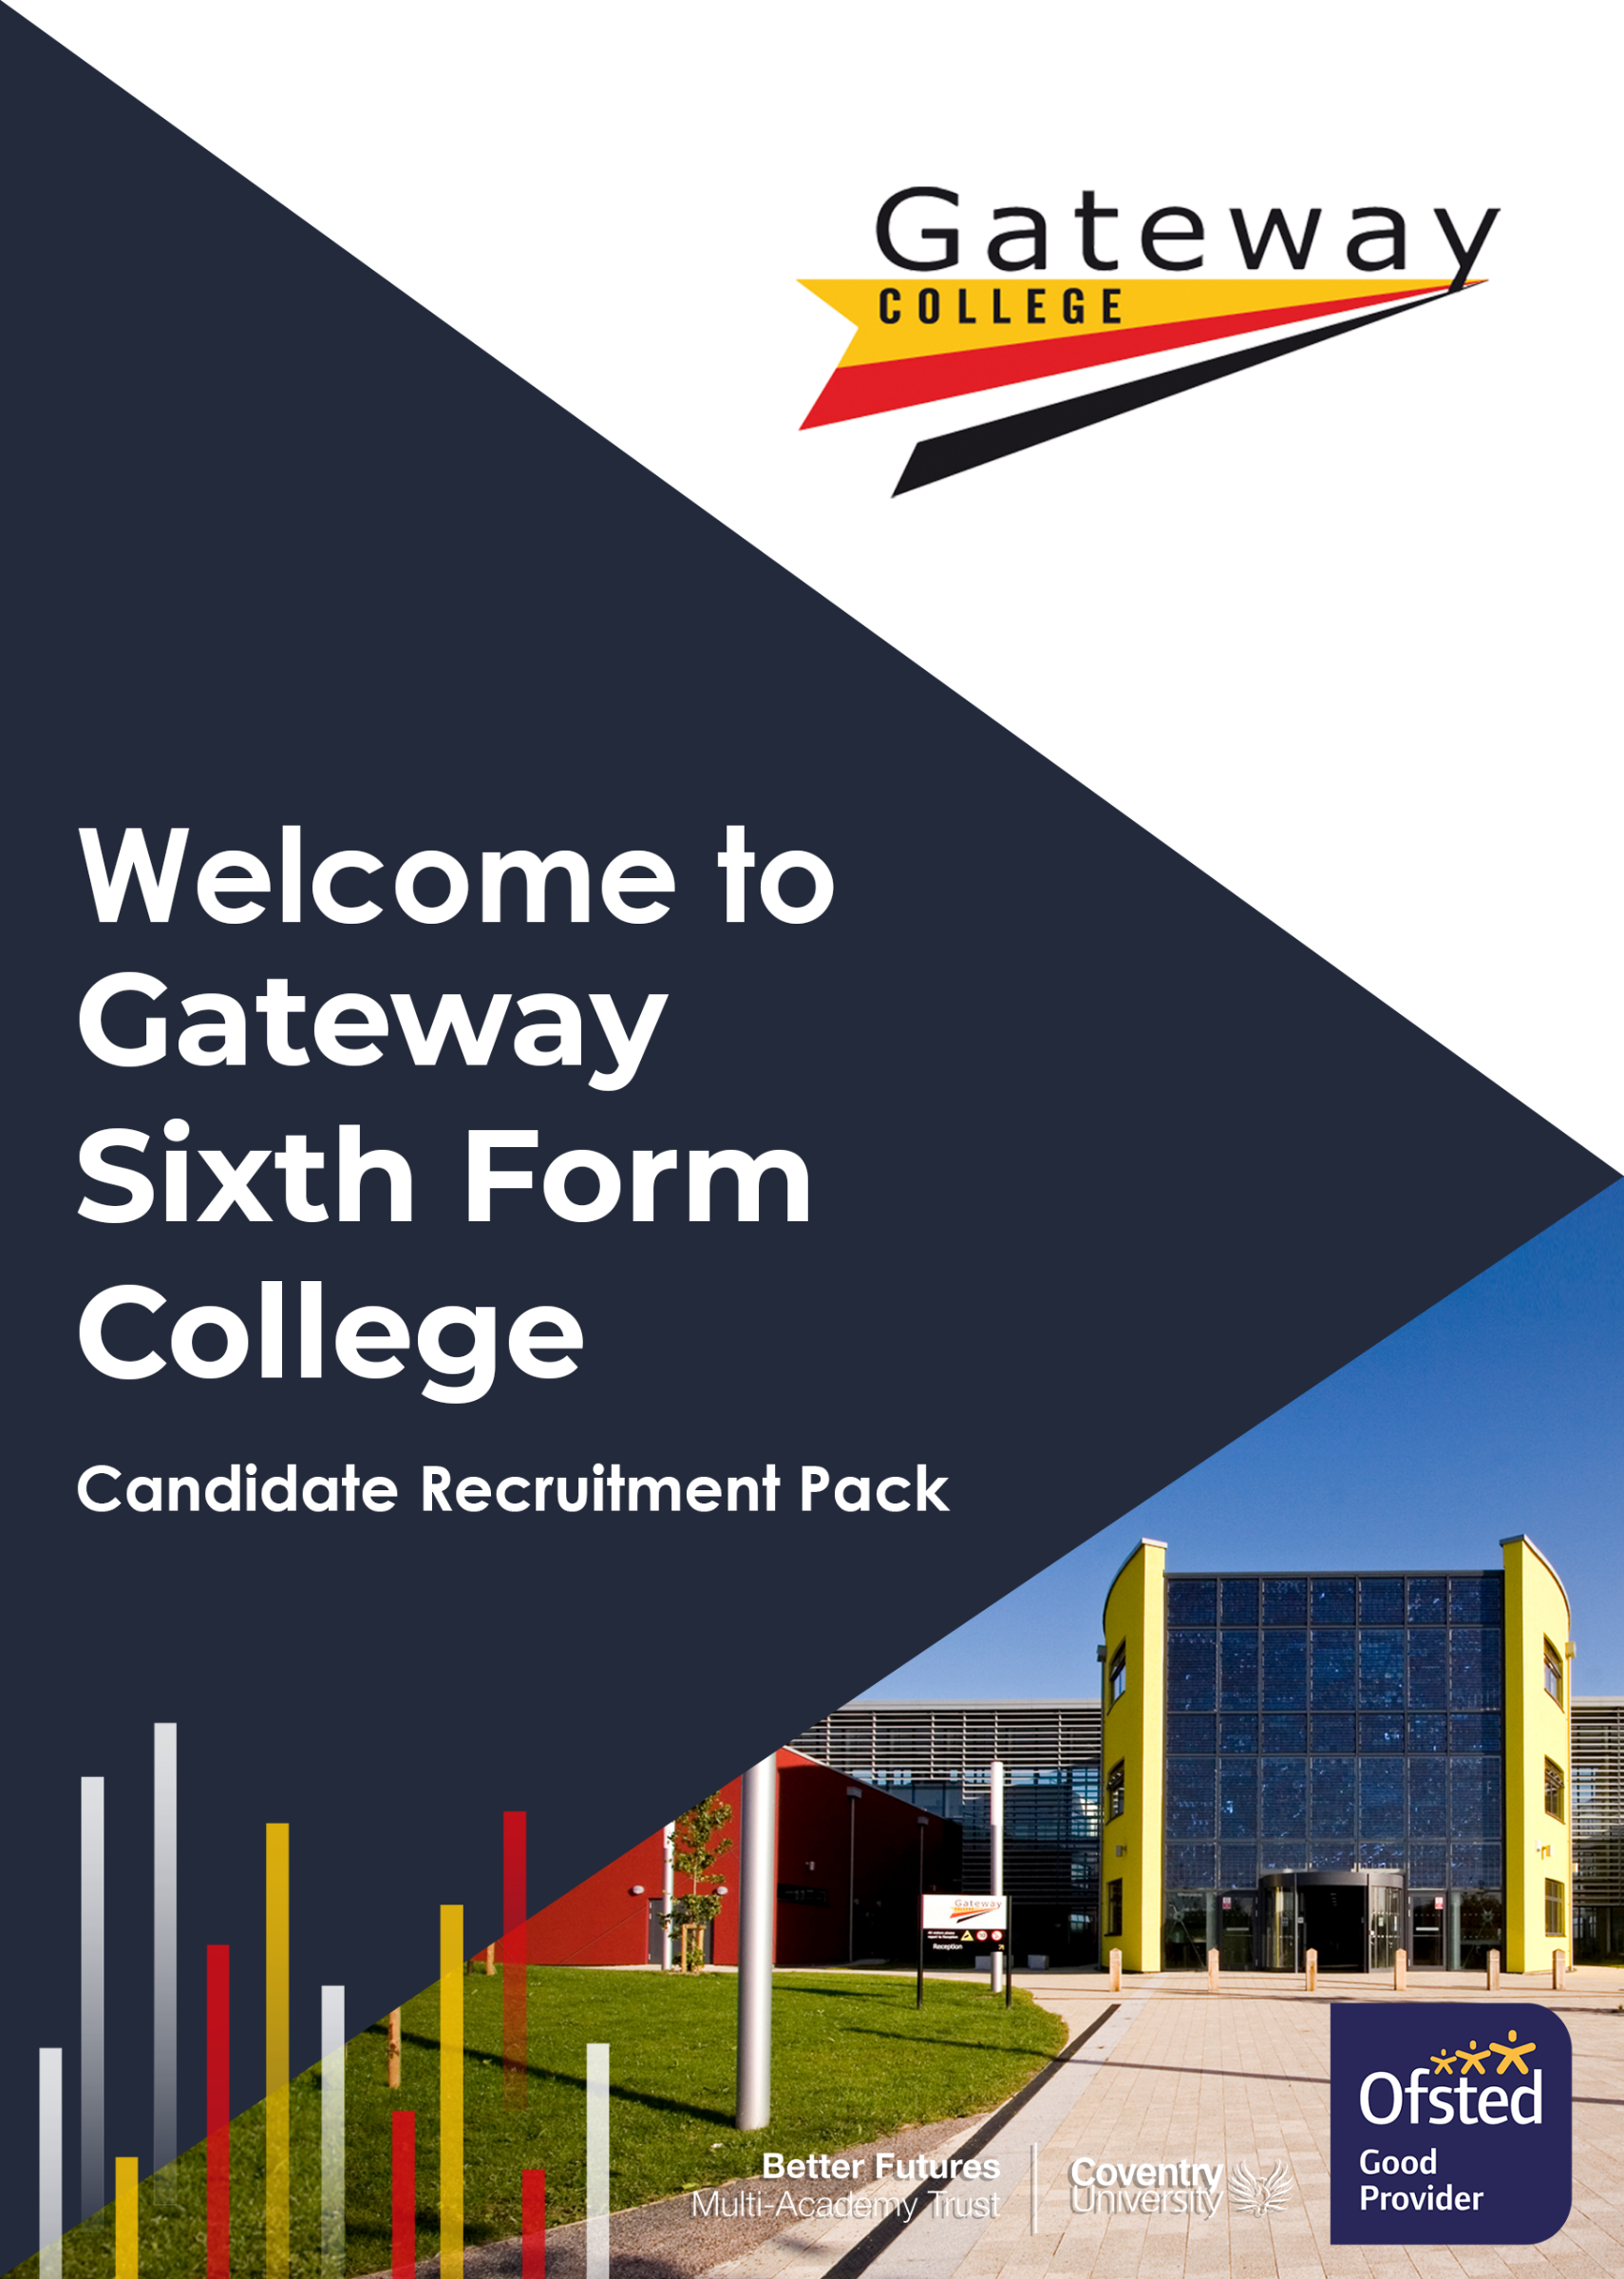

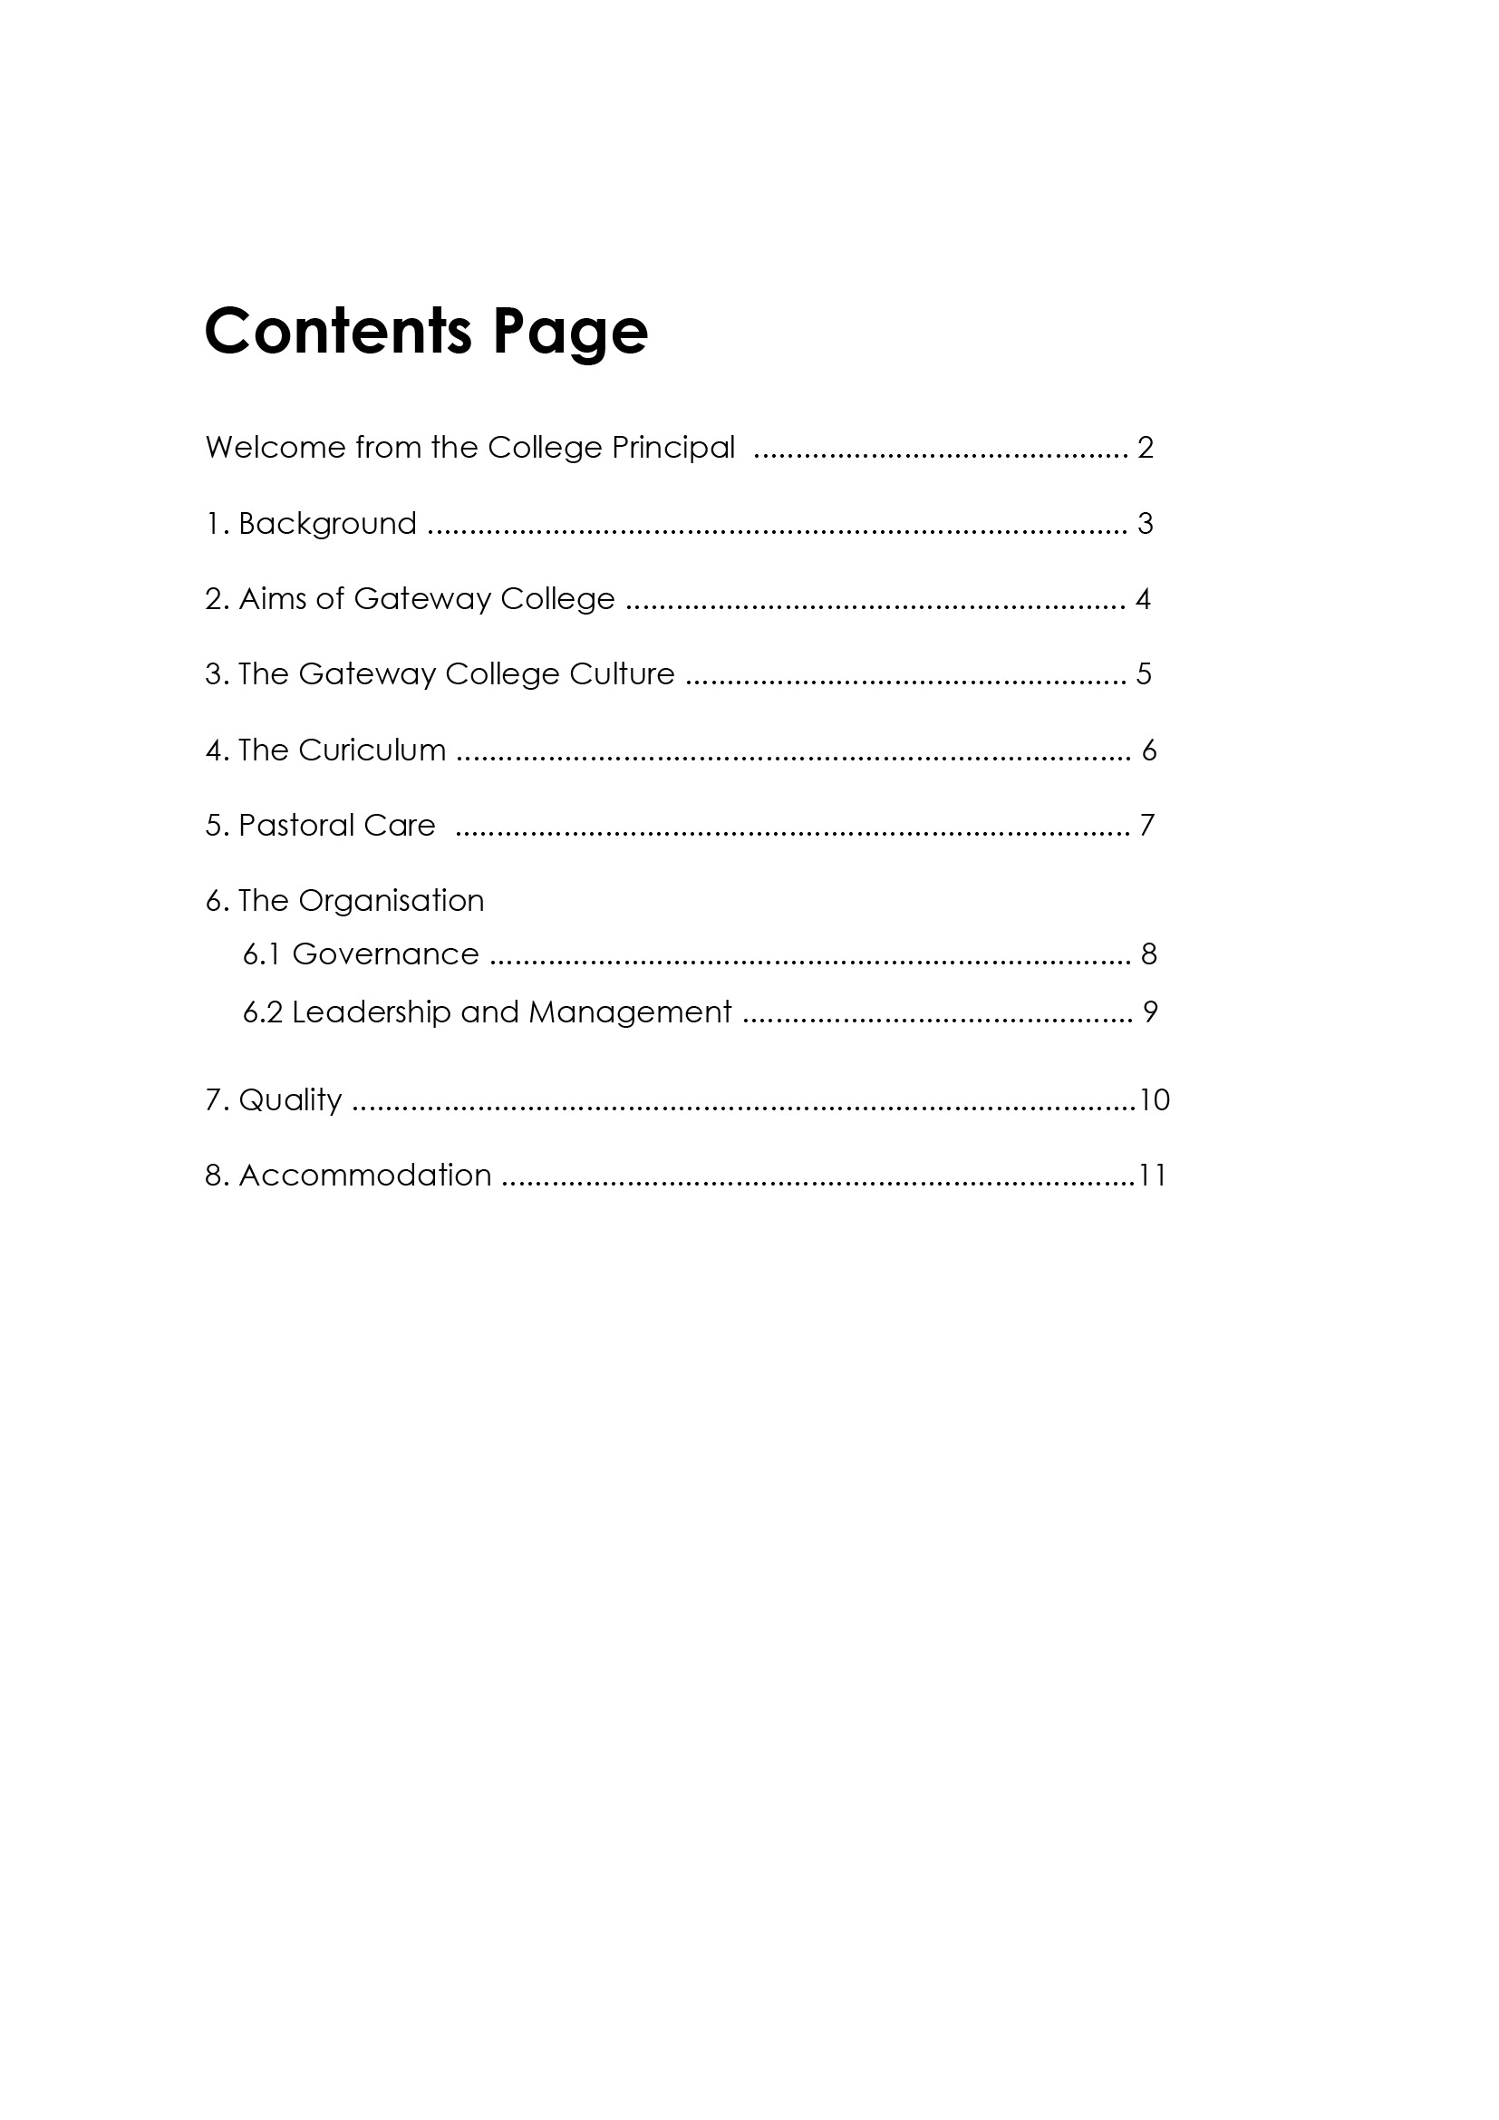

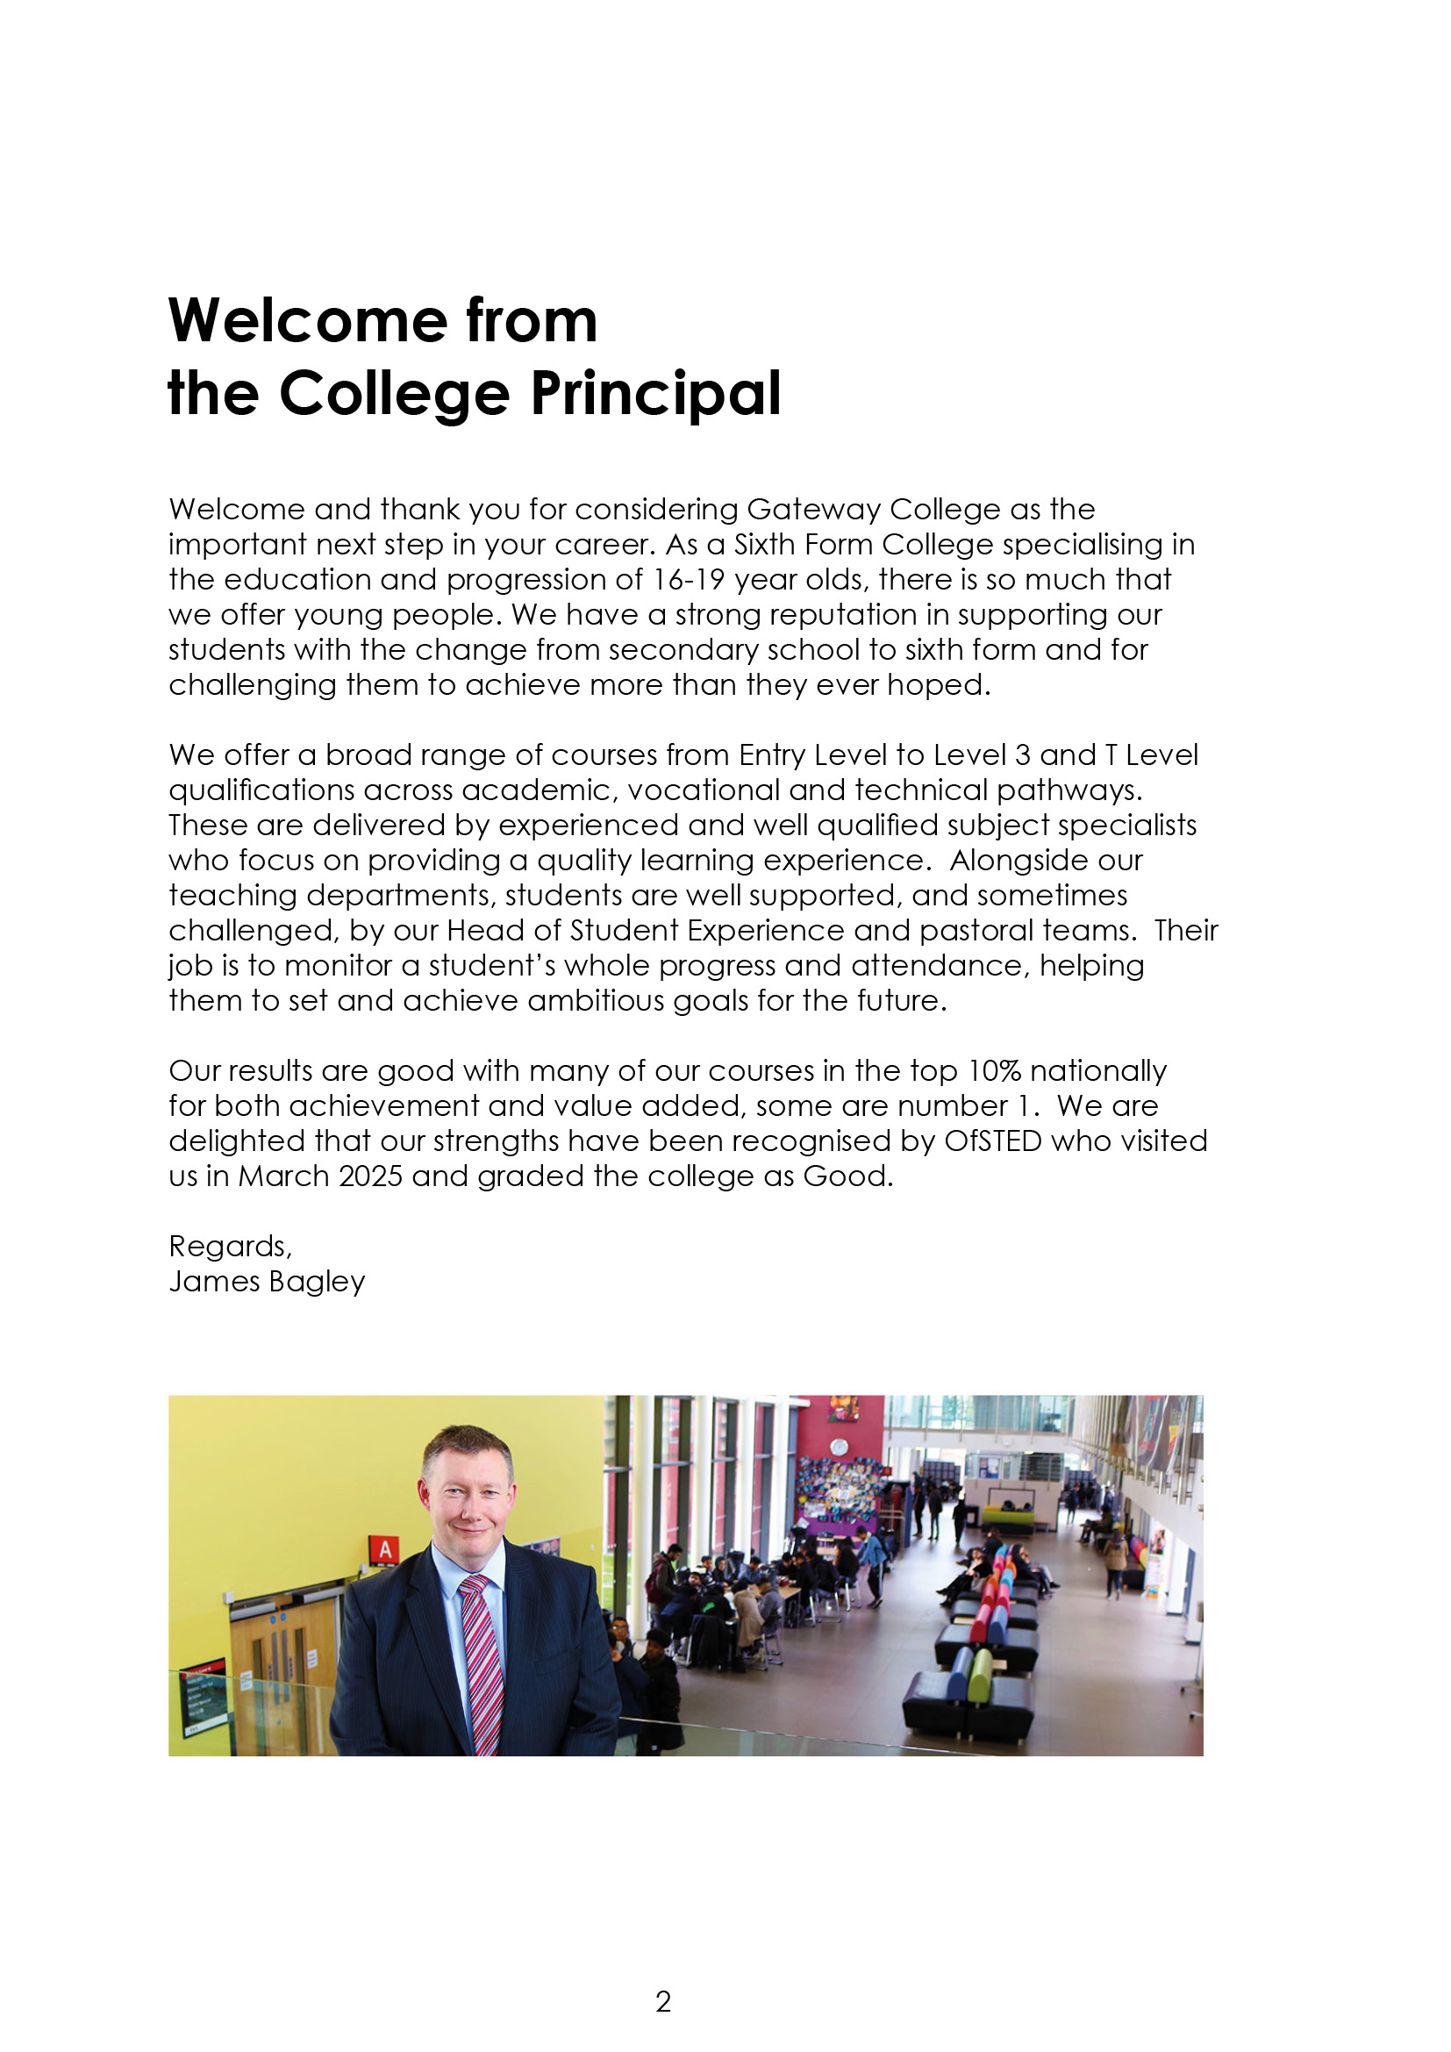

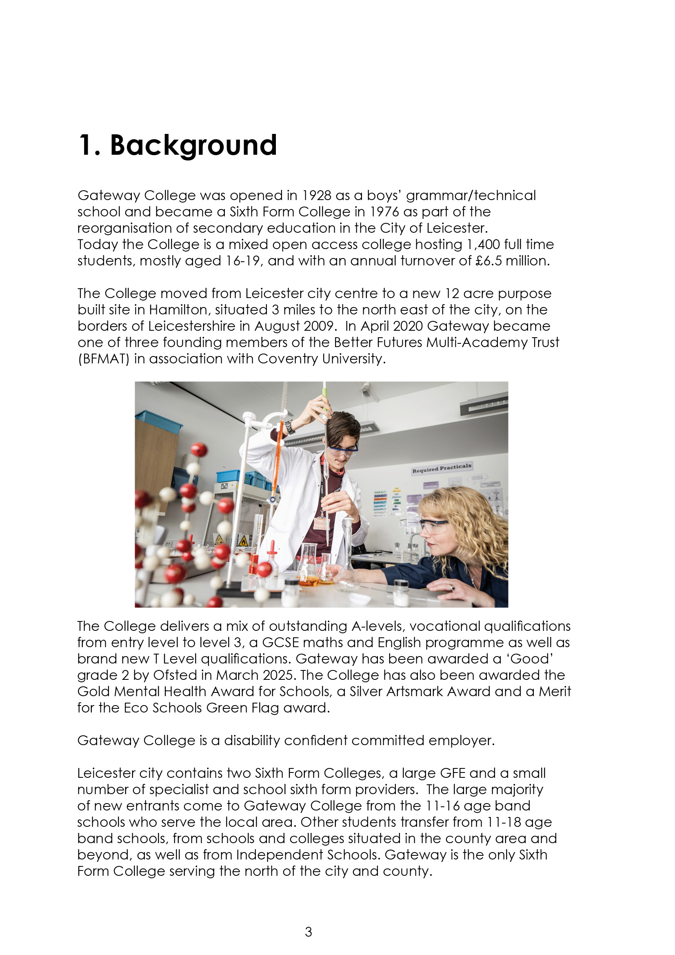

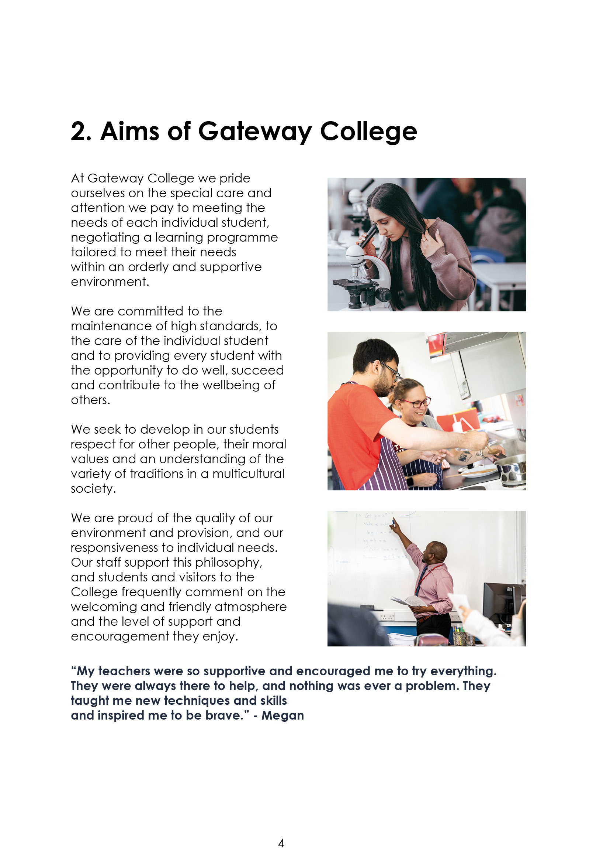

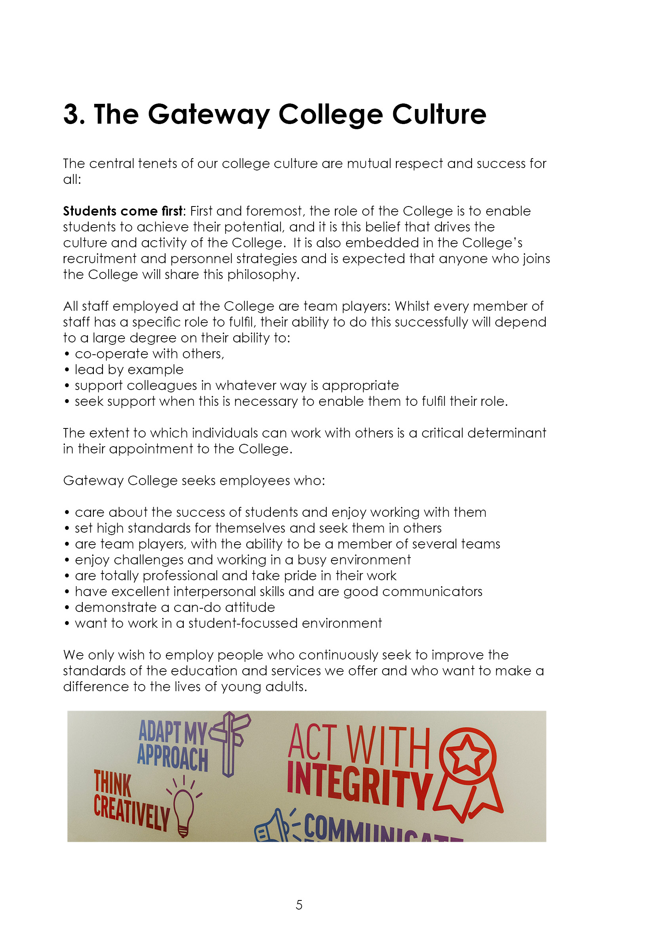

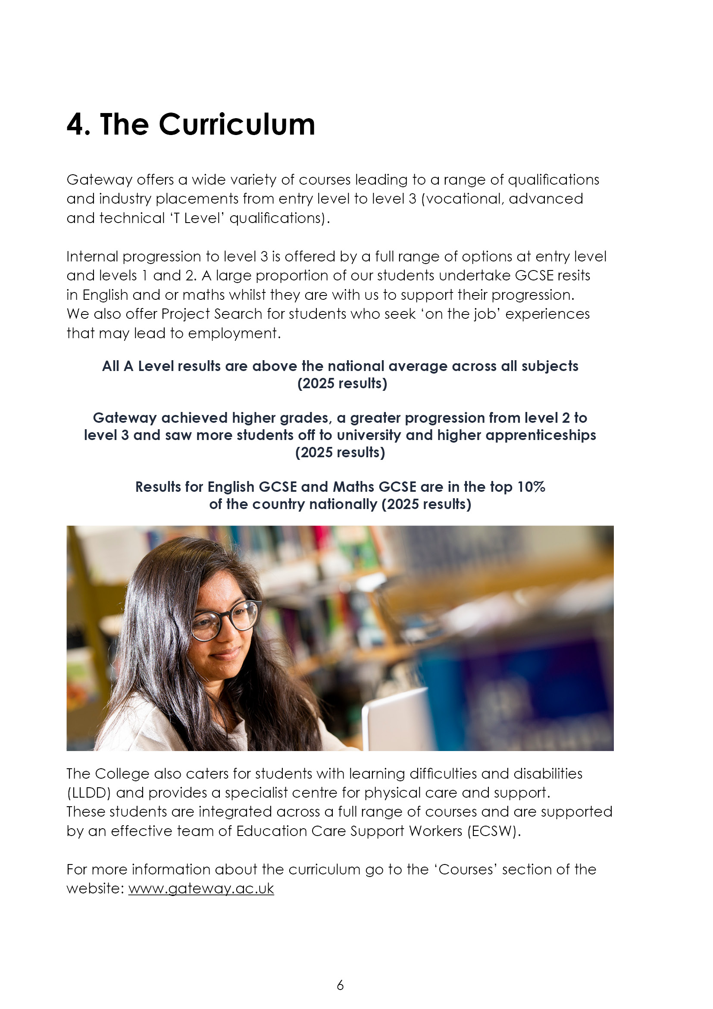

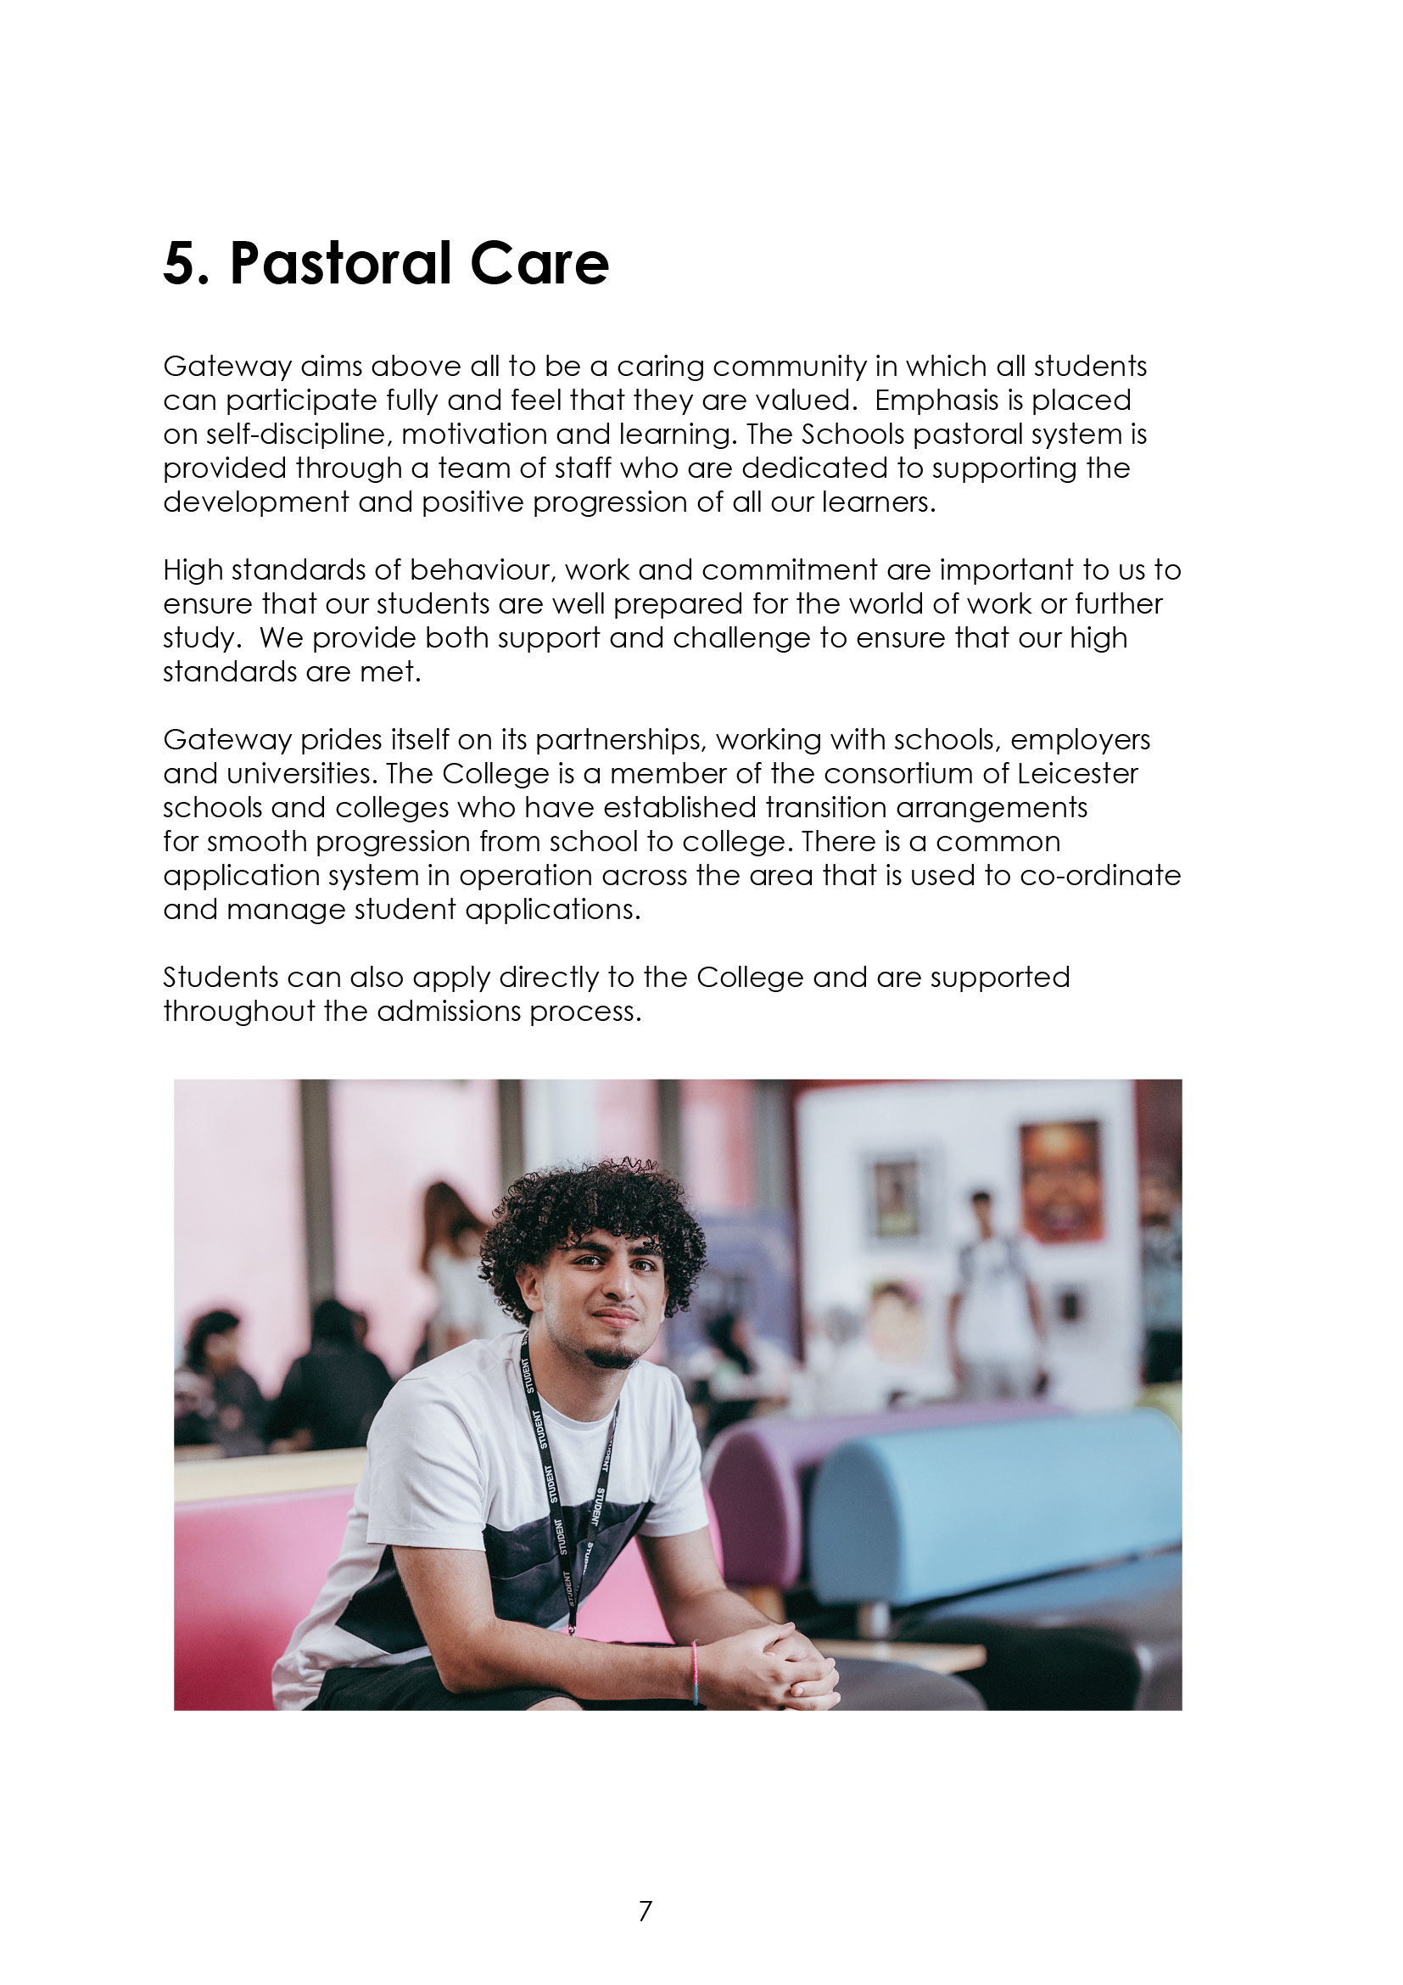

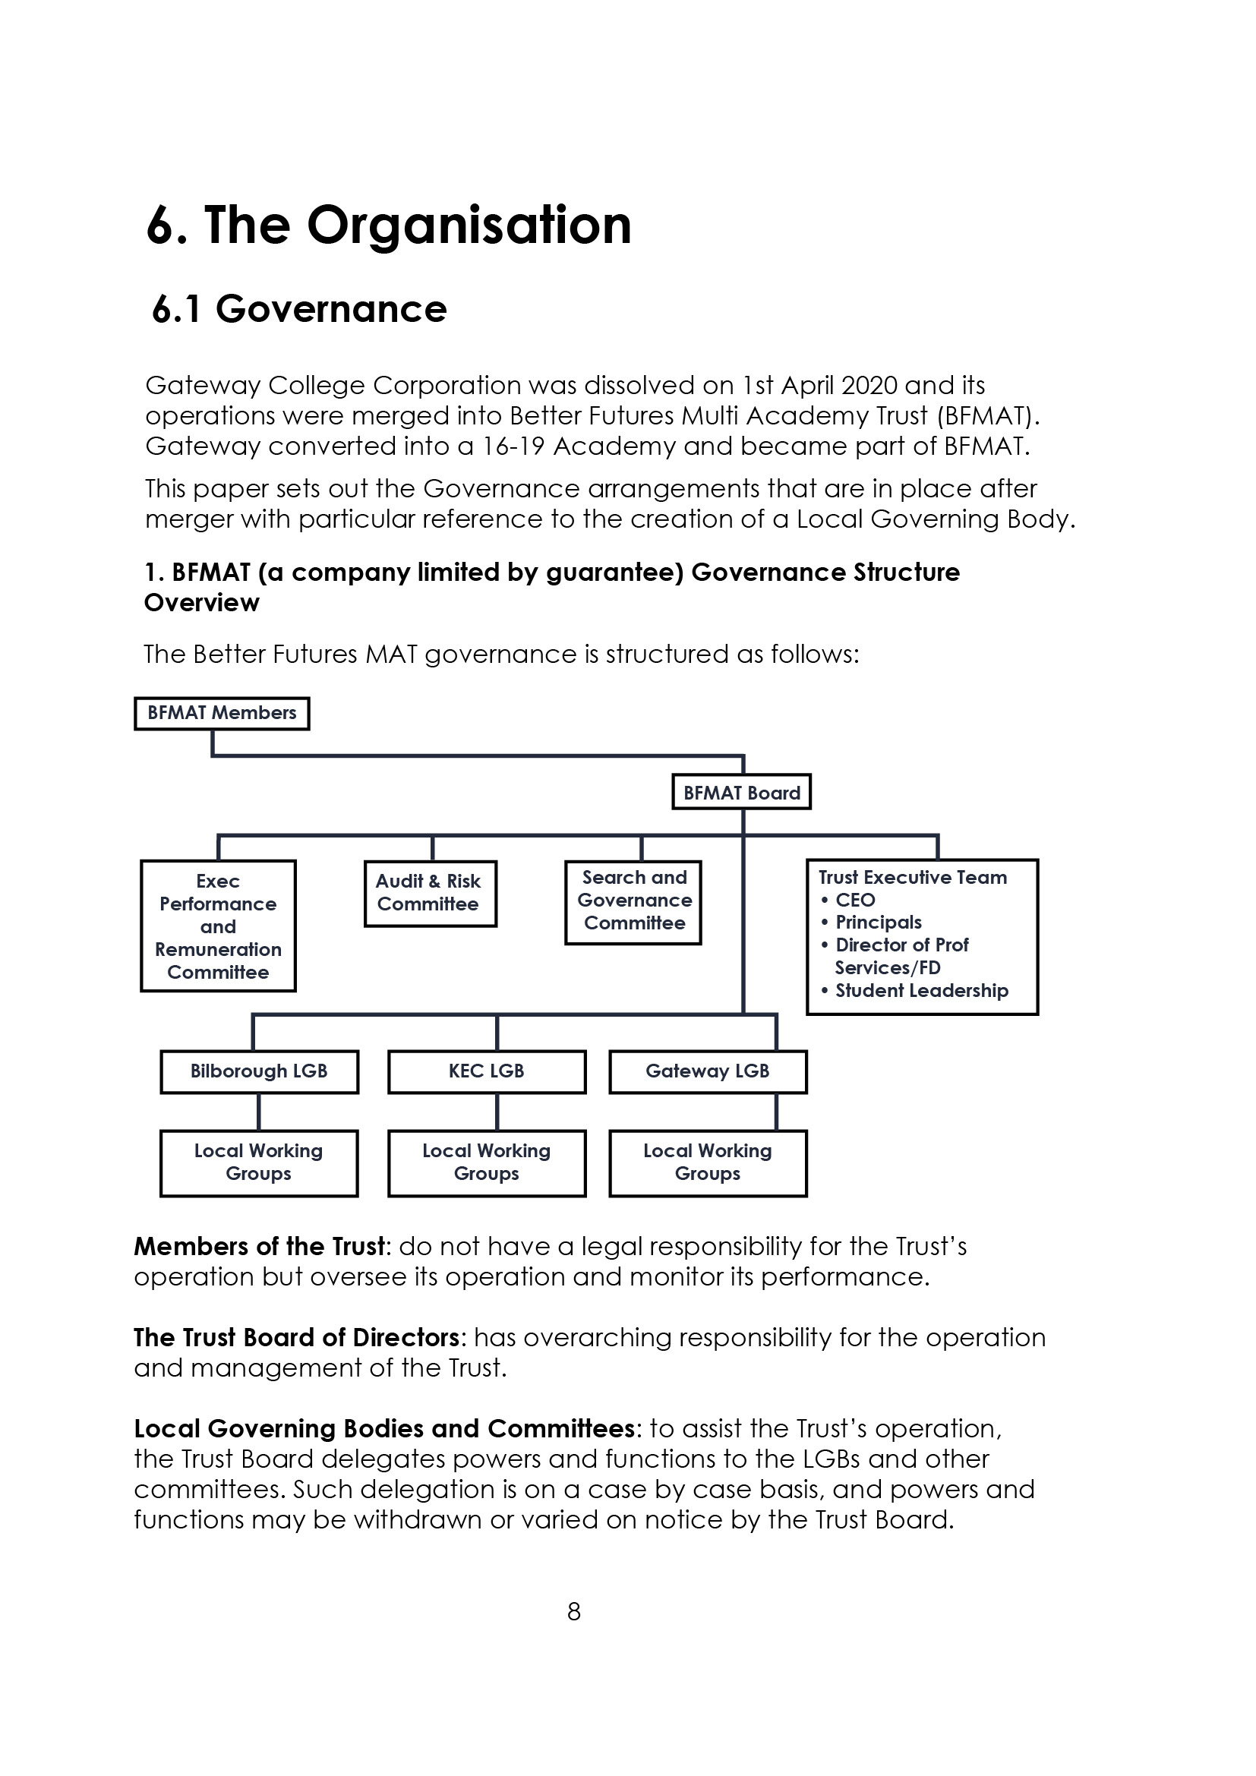

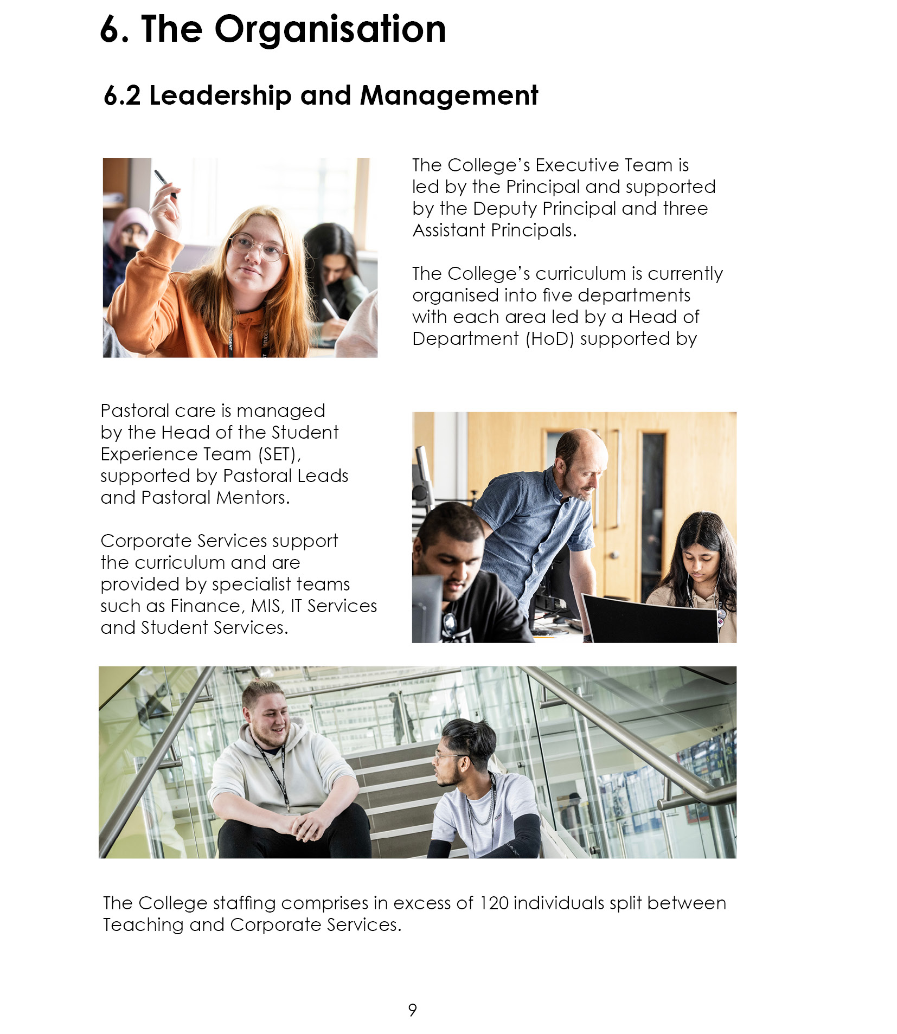

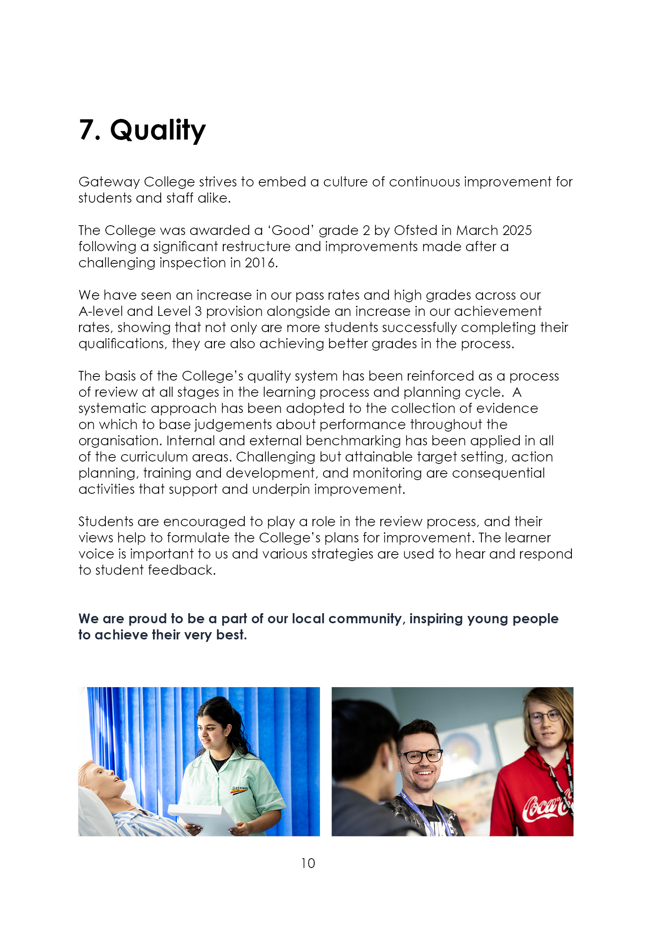

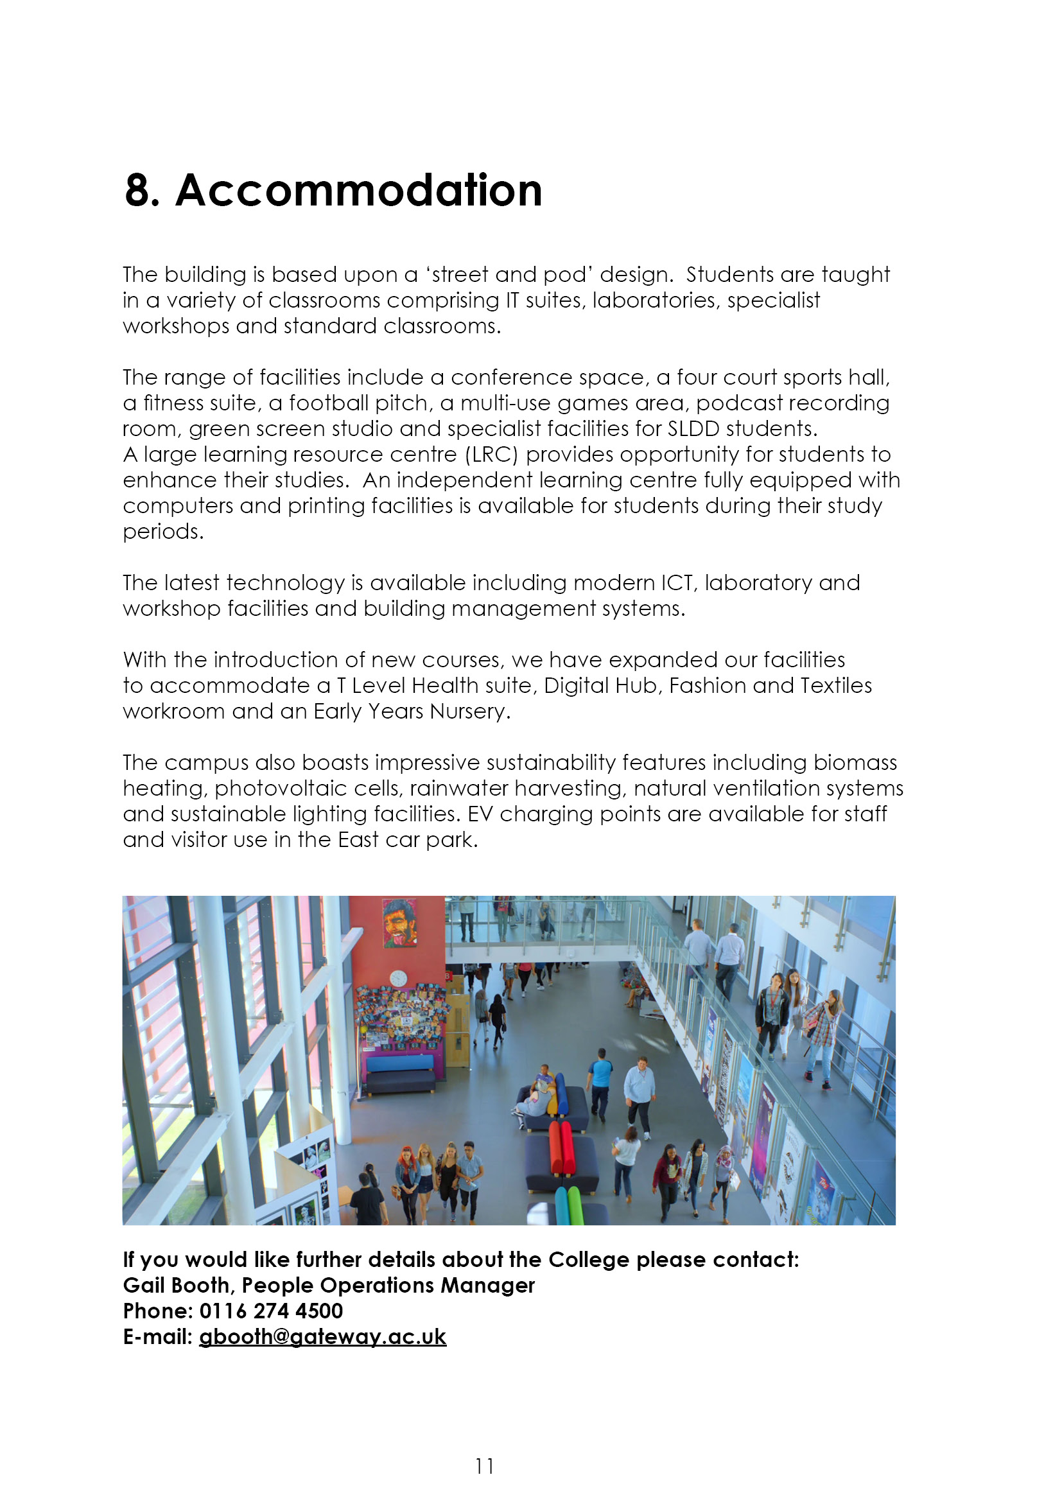

9. Job Advert
STUDENT COUNSELLOR VOLUNTEER (REF 26-07)
Gateway College is looking for a volunteer Student Counsellor with the opportunity to join a dynamic and committed Student Support team who consistently ensure that their students’ needs are fully met for them to achieve success and enjoy their courses.
This is an exciting opportunity to make a real difference to our students’ experience at Gateway College and to be part of a nurturing and motivated culture in which students from many different backgrounds grow together.
The student counselling service at Gateway College is offering supervised counselling placements.
As a trainee counsellor, you will preferably have previous experience of counselling:
- Attended/attending a theoretical and practical training course
- With some knowledge and ideally experience of counselling young people
- Or have considerable experience of working with young people in a different capacity
- Ideally you will be aware of the issues and challenges facing 16-19 year olds in a sixth form environment.
- You will be required to be available for one day per week between the hours of 9.00am and 3.00pm.
- You will be required to hold your own professional indemnity insurance.
- Supervision will be provided by the College.

At Gateway College we value our employees, and we recognise that they are vital to our continued success. We offer a forward-thinking, welcoming environment with supportive colleagues and access to continuous professional development.
We are a Sixth Form College with a diverse student community. We particularly welcome applications from ethnic minorities as they are currently under-represented within our teaching staff.
The College is committed to safeguarding and promoting the welfare of all students in our care and expects all staff and volunteers to share this commitment. All staff appointments are subject to pre-employment screening including DBS clearance. We are an equal opportunities employer.
Further details and an application pack can be found at Teaching and education jobs in LE5 1GA | Tes or by contacting peopleoperations@gateway.ac.uk
The closing date for receipt of applications is 3rd July 2026.
Interviews will be held W/C 6th July 2026

10. Job Description
Job Purpose
To provide counselling support to students to support them in achieving success at college.

The information given within the Job Description is intended to provide the postholder, and college managers, with an understanding and appreciation of the workload of this post and its role within Gateway College.

The Job Description outlines the main duties and responsibilities under broad headings. It is not intended to specify every job activity or item in detail.

All college employees are expected to work flexibly to ensure that the responsibilities of their post are fulfilled efficiently and effectively according to the needs of the college and its students.

Main Duties and Responsibilities
The Voluntary Counsellor has an important role within the Counselling Team. Considerable emphasis is involved in ensuring that all clients are dealt with in a friendly, courteous and efficient manner.

The specific responsibilities involved include:-

1. One-to-one counselling sessions with students.

- Work as part of a team with the College Counsellor in order to support the service and students effectively

- Attend meetings with the College Counsellor as and when necessary

- Maintenance of client files.

- Monitor own number of client hours accrued at Gateway College.

- Timely provide academic paperwork for placement provider’s comment and signature as necessary.

General Duties and Personal Responsibilities

1. All members of staff have a responsibility for promoting and safeguarding the welfare of children and young persons they are responsible for or come into contact with. The postholder will have unsupervised contact with students on a daily basis. The postholder will not be authorised to use physical intervention techniques unless specifically identified and authorised by the Principal under the Physical intervention Code of Practice. Such authorisation may be on a permanent or long-term basis relative to the nature of the person’s job, or short term for a specific event, e.g. a college trip. The people concerned will be explicitly informed of the authorisation, to ensure they are aware of and properly understand what the authorisation entails. Training or guidance from a senior member of the teaching staff may be arranged if appropriate.

- To act in accordance with provisions of the College Staff Code of Conduct.

- To abide by the College Data Protection Policy.

- To use information technology systems as required, in compliance with the College IT Policy.

- To carry out the responsibilities of the post with due regard to all or any of the College equality and diversity policies.

- To operate in accordance with Health and Safety Legislation, which specifies that all employees have a duty to work safely and not to put others at risk.

- a. To be responsible for own self-development on a continuous basis, including undertaking/participating in training as appropriate.

b. To be responsible for the professional review / appraisal, and training and development of staff under your line management.

- To comply with and follow all other college policies and procedures in force (available on the college intranet) and with the conditions of service stipulated within the contract of employment.

- To contribute to divisional, section wide and whole college activities and arrangements as appropriate and as directed by the line manager

- To undertake such other duties as the college management shall deem appropriate for the level of responsibility involved.

Terms and Conditions – as detailed in the contract of employment

Person Specification: Student Volunteer Counsellor

 |  | Assessed at:  Shortlisting (S) Interview (I)  Both (SI) | Weighting to show relative importance:  Low (1)  Medium (2)  High (3)

A. SKILLS AND ABILITIES
Essential: | Ability to understand, develop and maintain professional boundaries | SI | 3
Essential: | Ability to commit to a minimum of 1 year at Gateway College | SI | 3
Essential: | Able to abide by BACP/UKCP ethical working guidelines | SI | 3
Essential: | Professional and courteous manner | I | 3
Essential: | Ability to be flexible and well organised, | I | 3
Essential: | Excellent interpersonal communication skills | I | 3
Essential: | Enthusiastic and energetic | I | 3
Essential: | Team player and be able to work under own initiative | I | 3

B. EXPERIENCE AND KNOWLEDGE
Essential: | Undergoing own personal therapy | S | 3
Essential: | Awareness of issues facing 16–19-year-olds on A level courses | SI | 3
Essential: | Having an understanding/awareness of counselling theory/theories | SI | 3
Essential: | A commitment to ensuring the promotion of equality, diversity and inclusion | SI | 3
Desirable: | A knowledge of mental health issues | SI | 2
Desirable: | Some prior experience of one-to-one counselling sessions | S | 2
Desirable: | Knowledge of counselling young people | SI | 2

C. LEVEL OF QUALIFICATION
Essential: | Registration with either UKCP or BACP | S | 3
Essential: | Attended/attending a theoretical and practical training course | S | 3
NOTE - if the applicant is short listed any relevant issues arising from his/her references will be taken up at interview (if, at the time of the interview, references are not available, e.g. due to late receipt or not yet taken in accordance with the applicant’s request, any issues relating to references will be raised with the applicant at a later date as appropriate but prior to appointment).



