

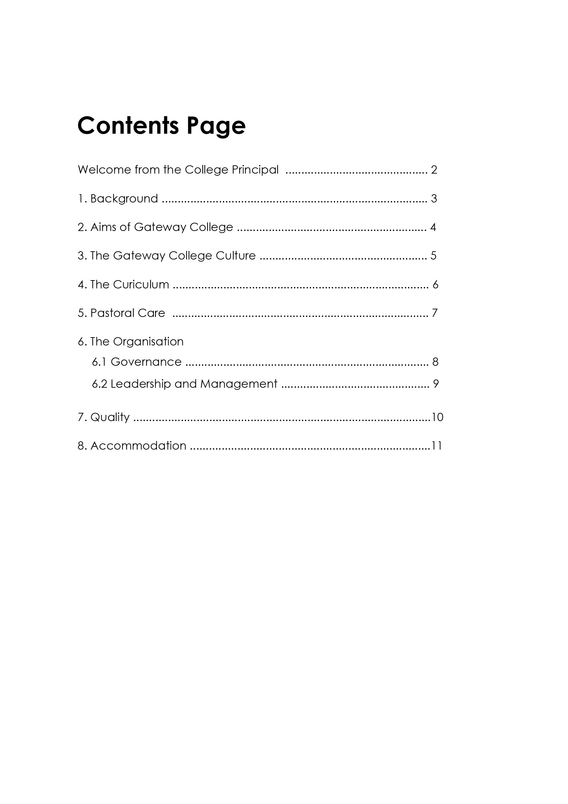

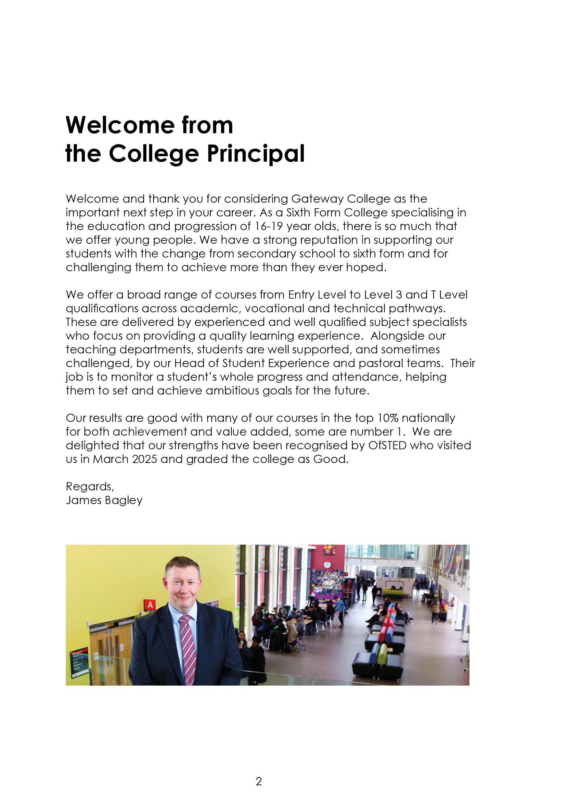

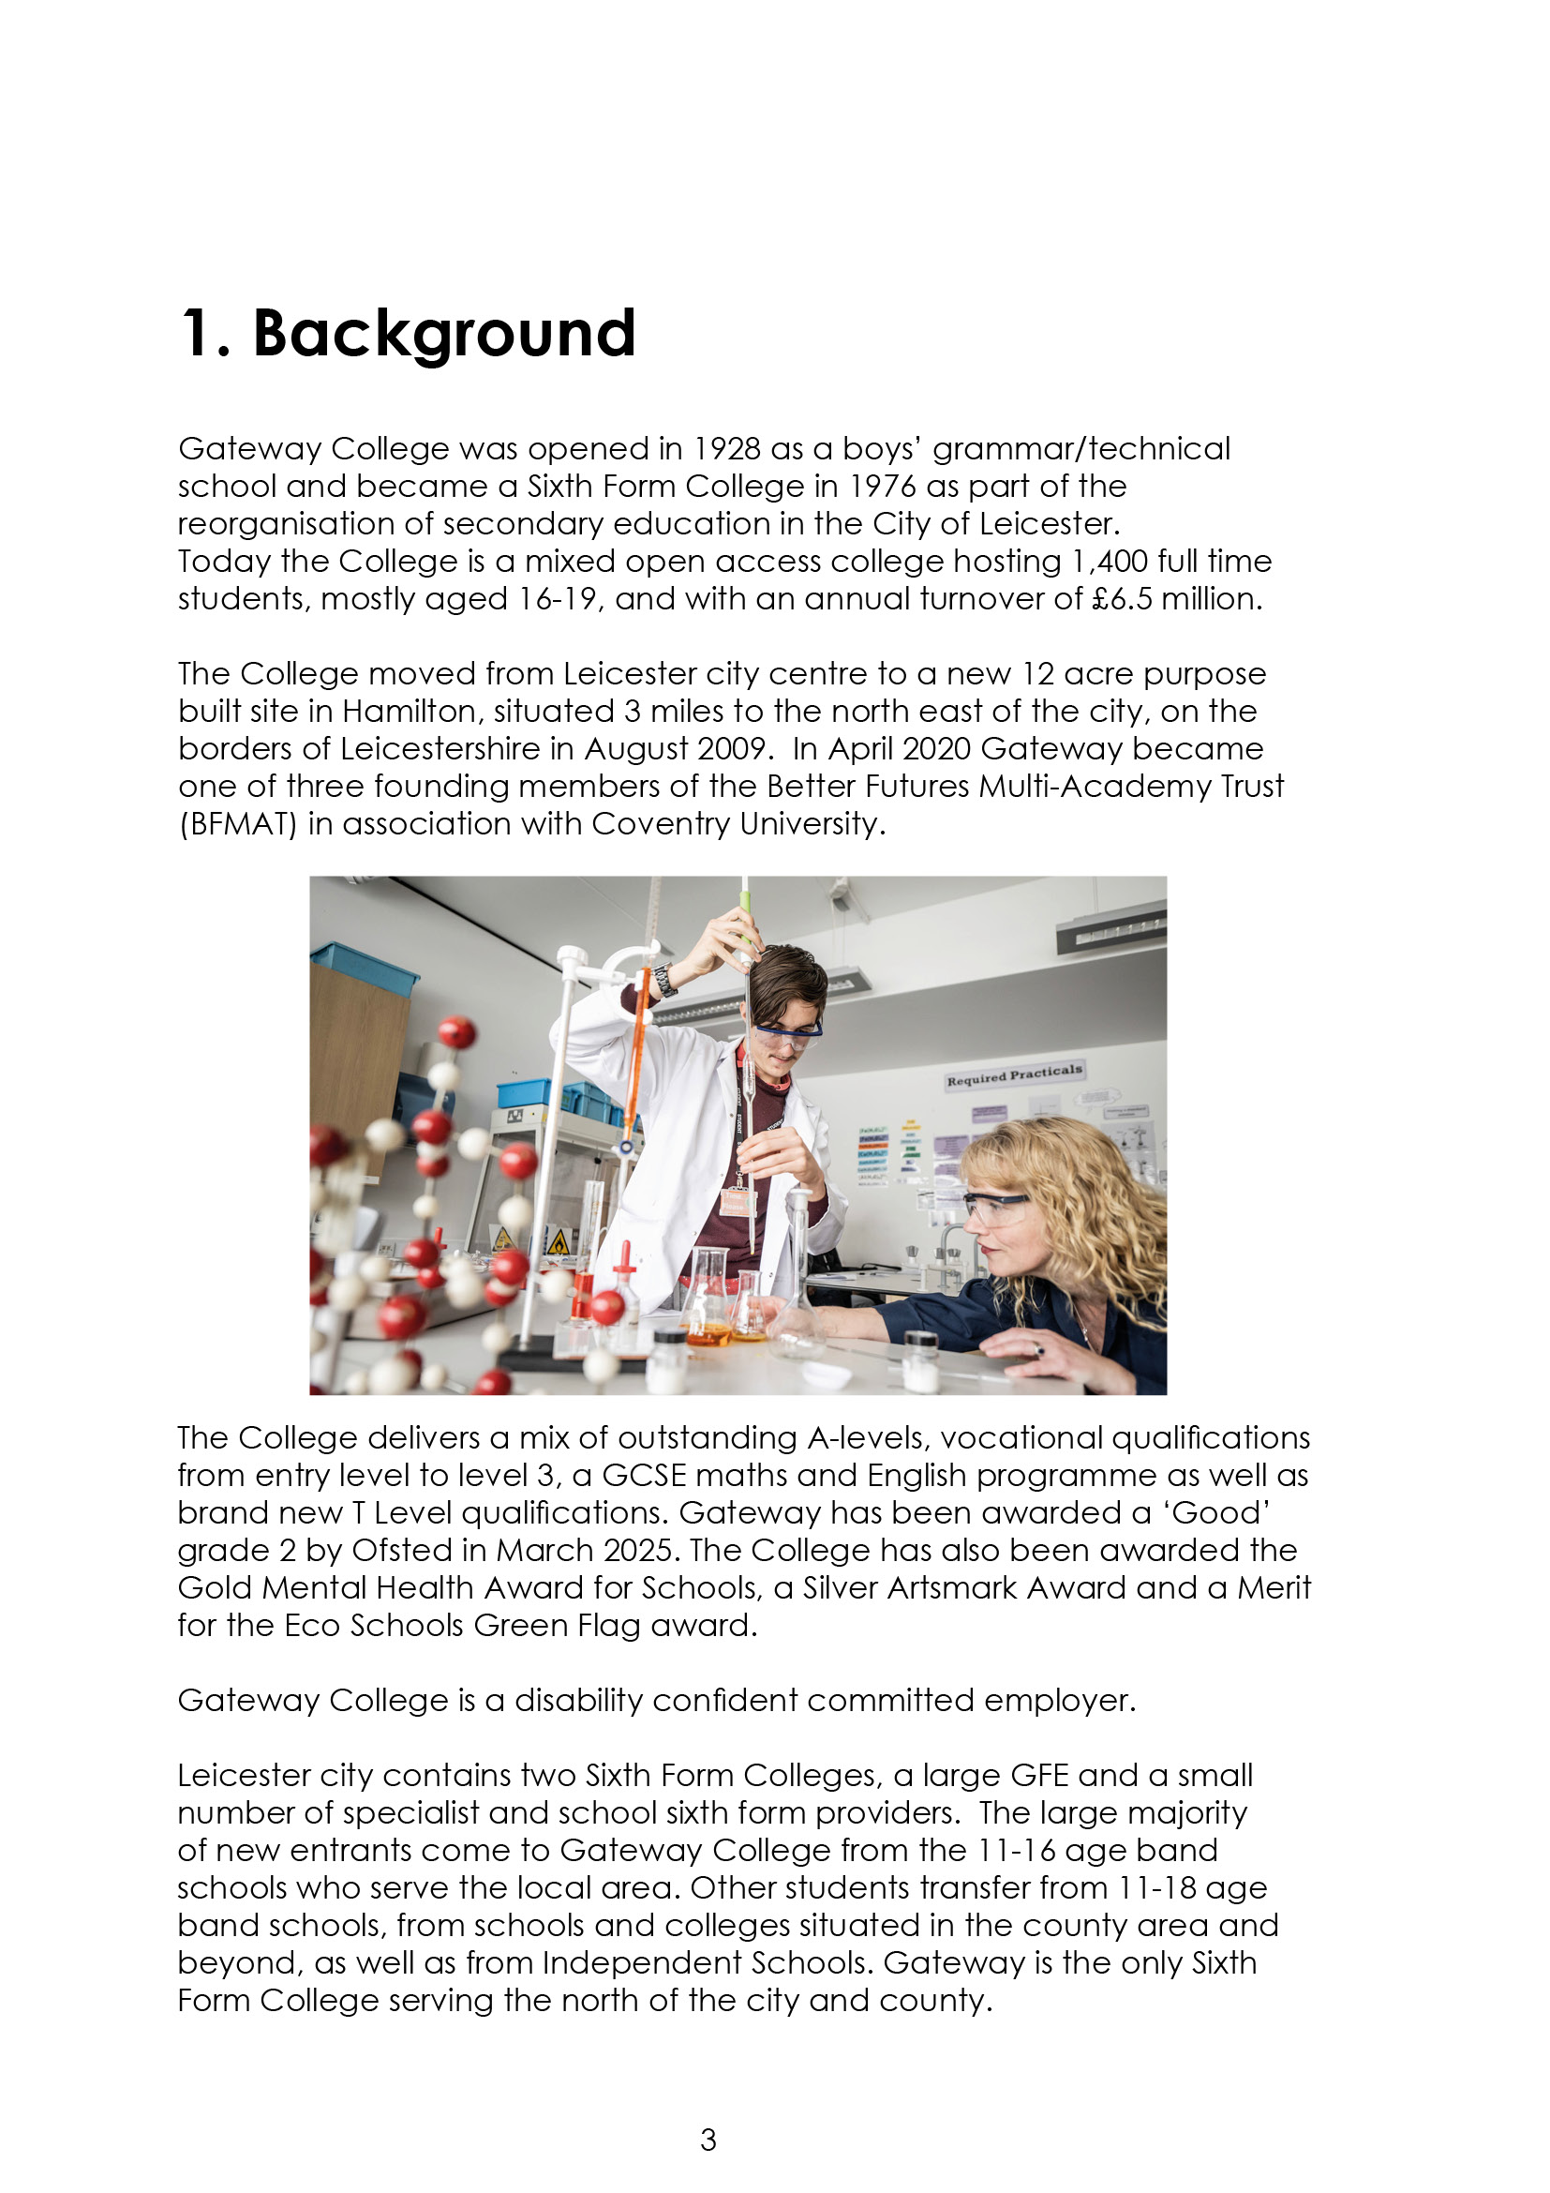

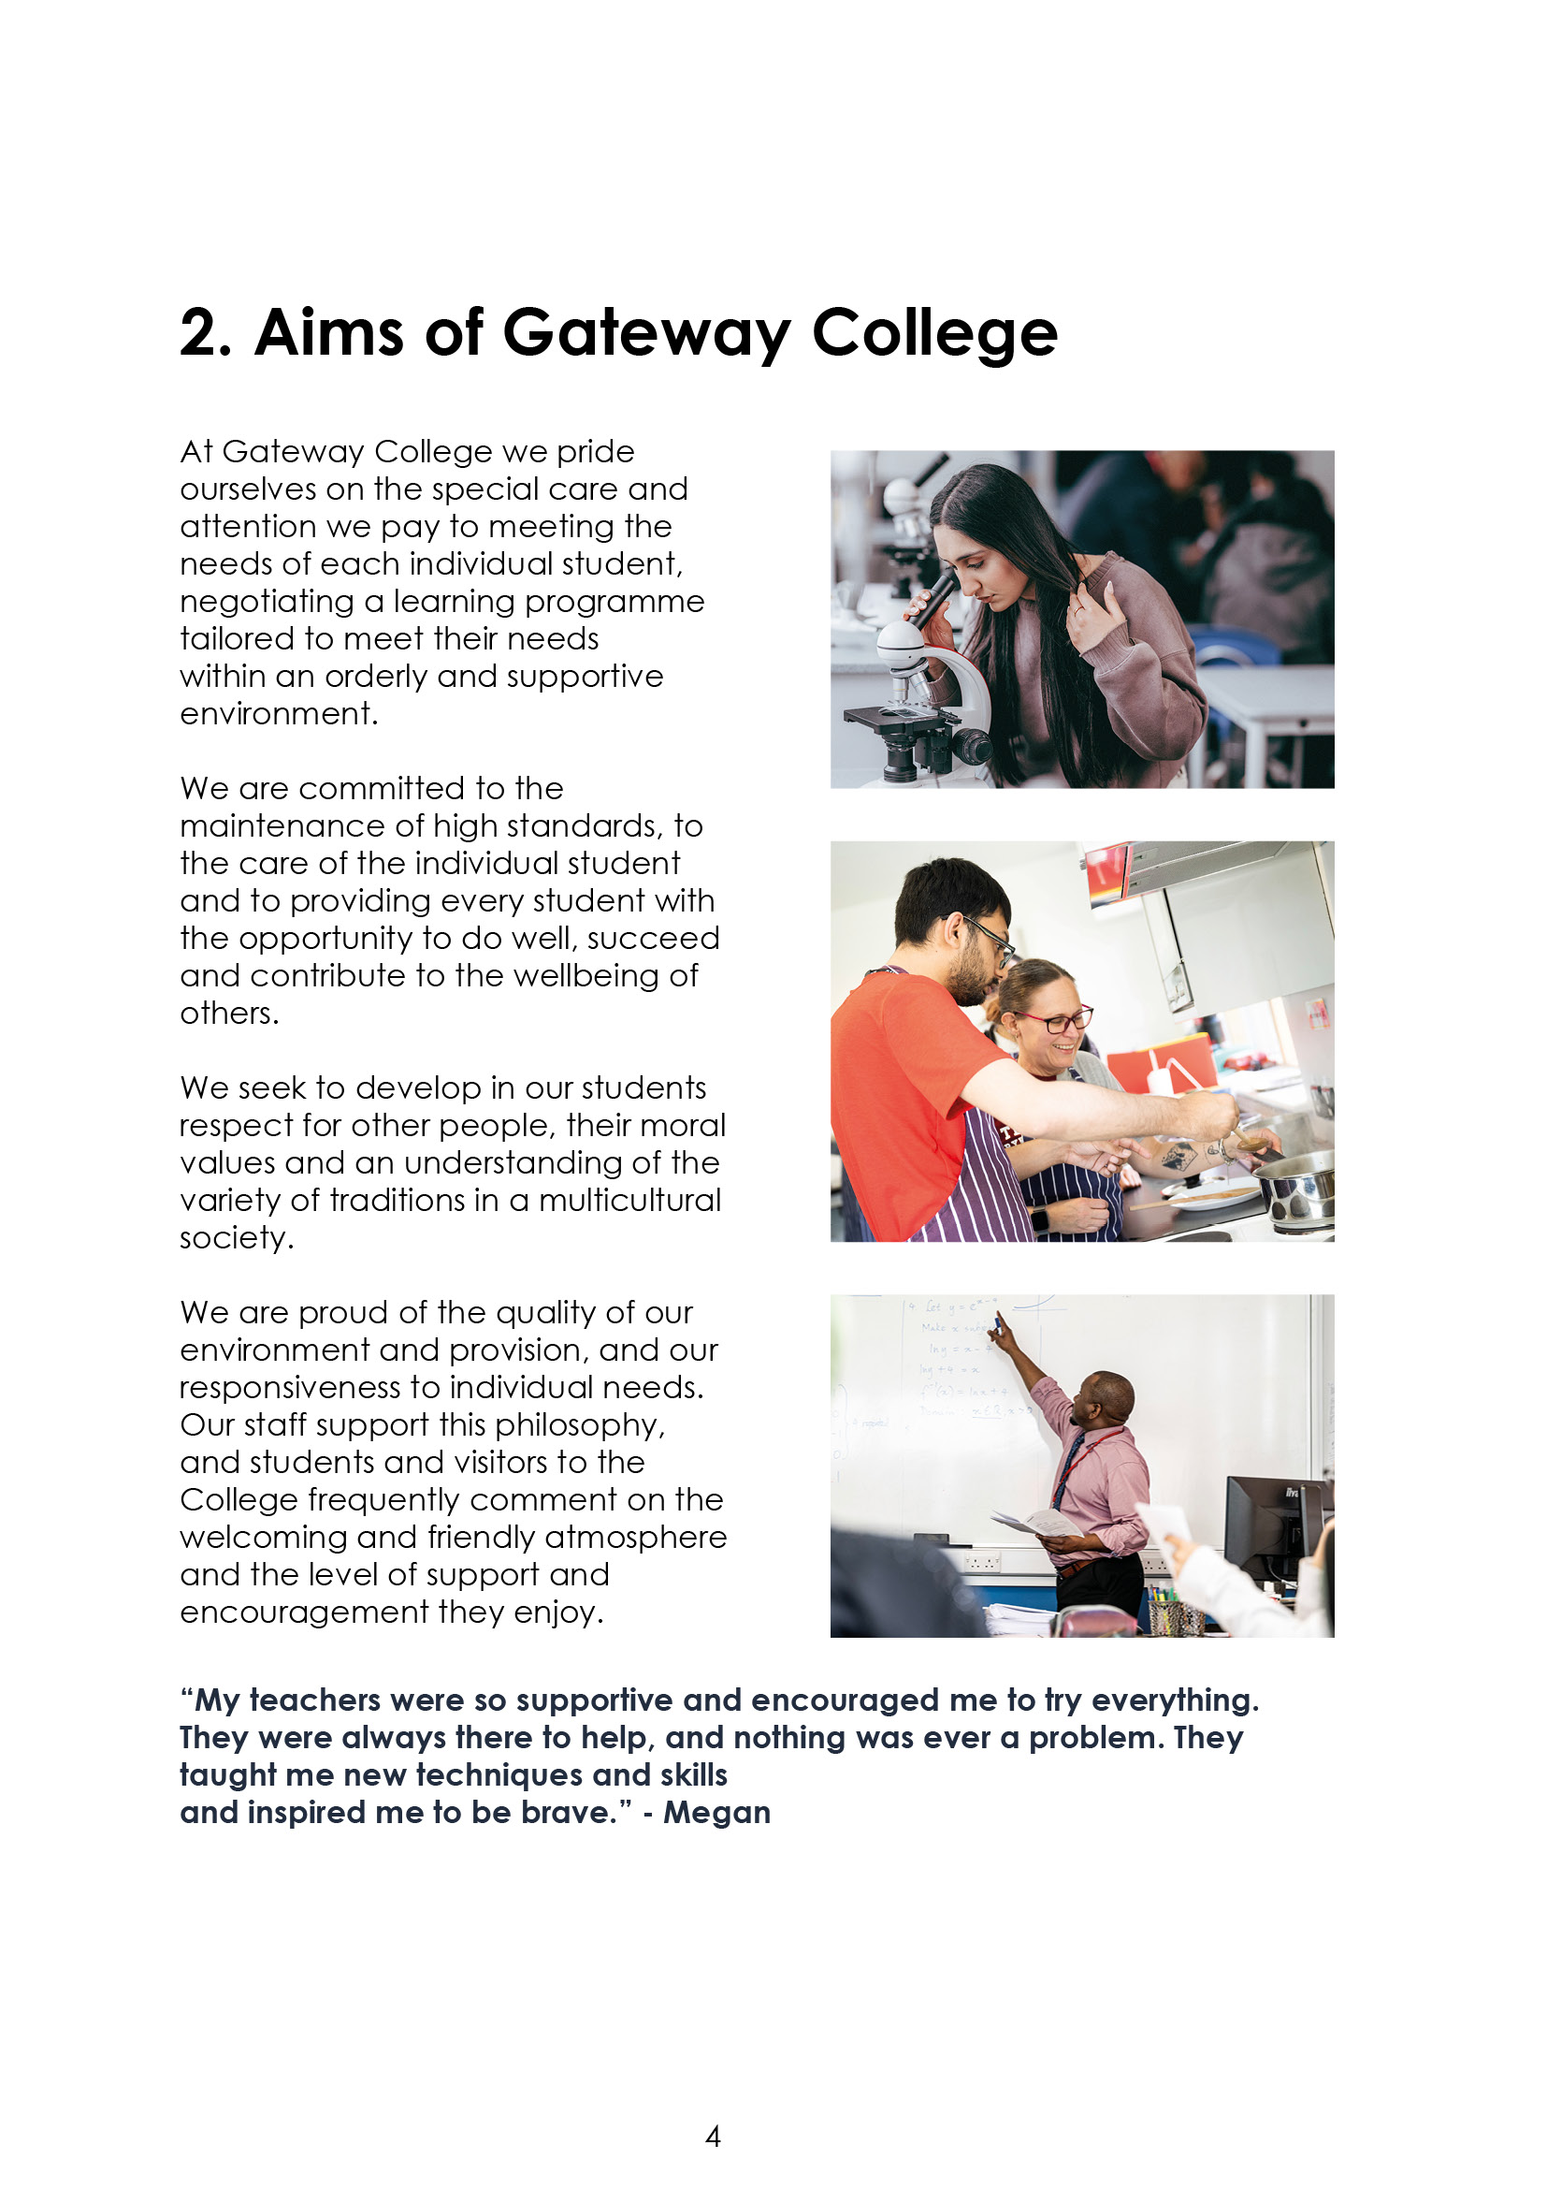

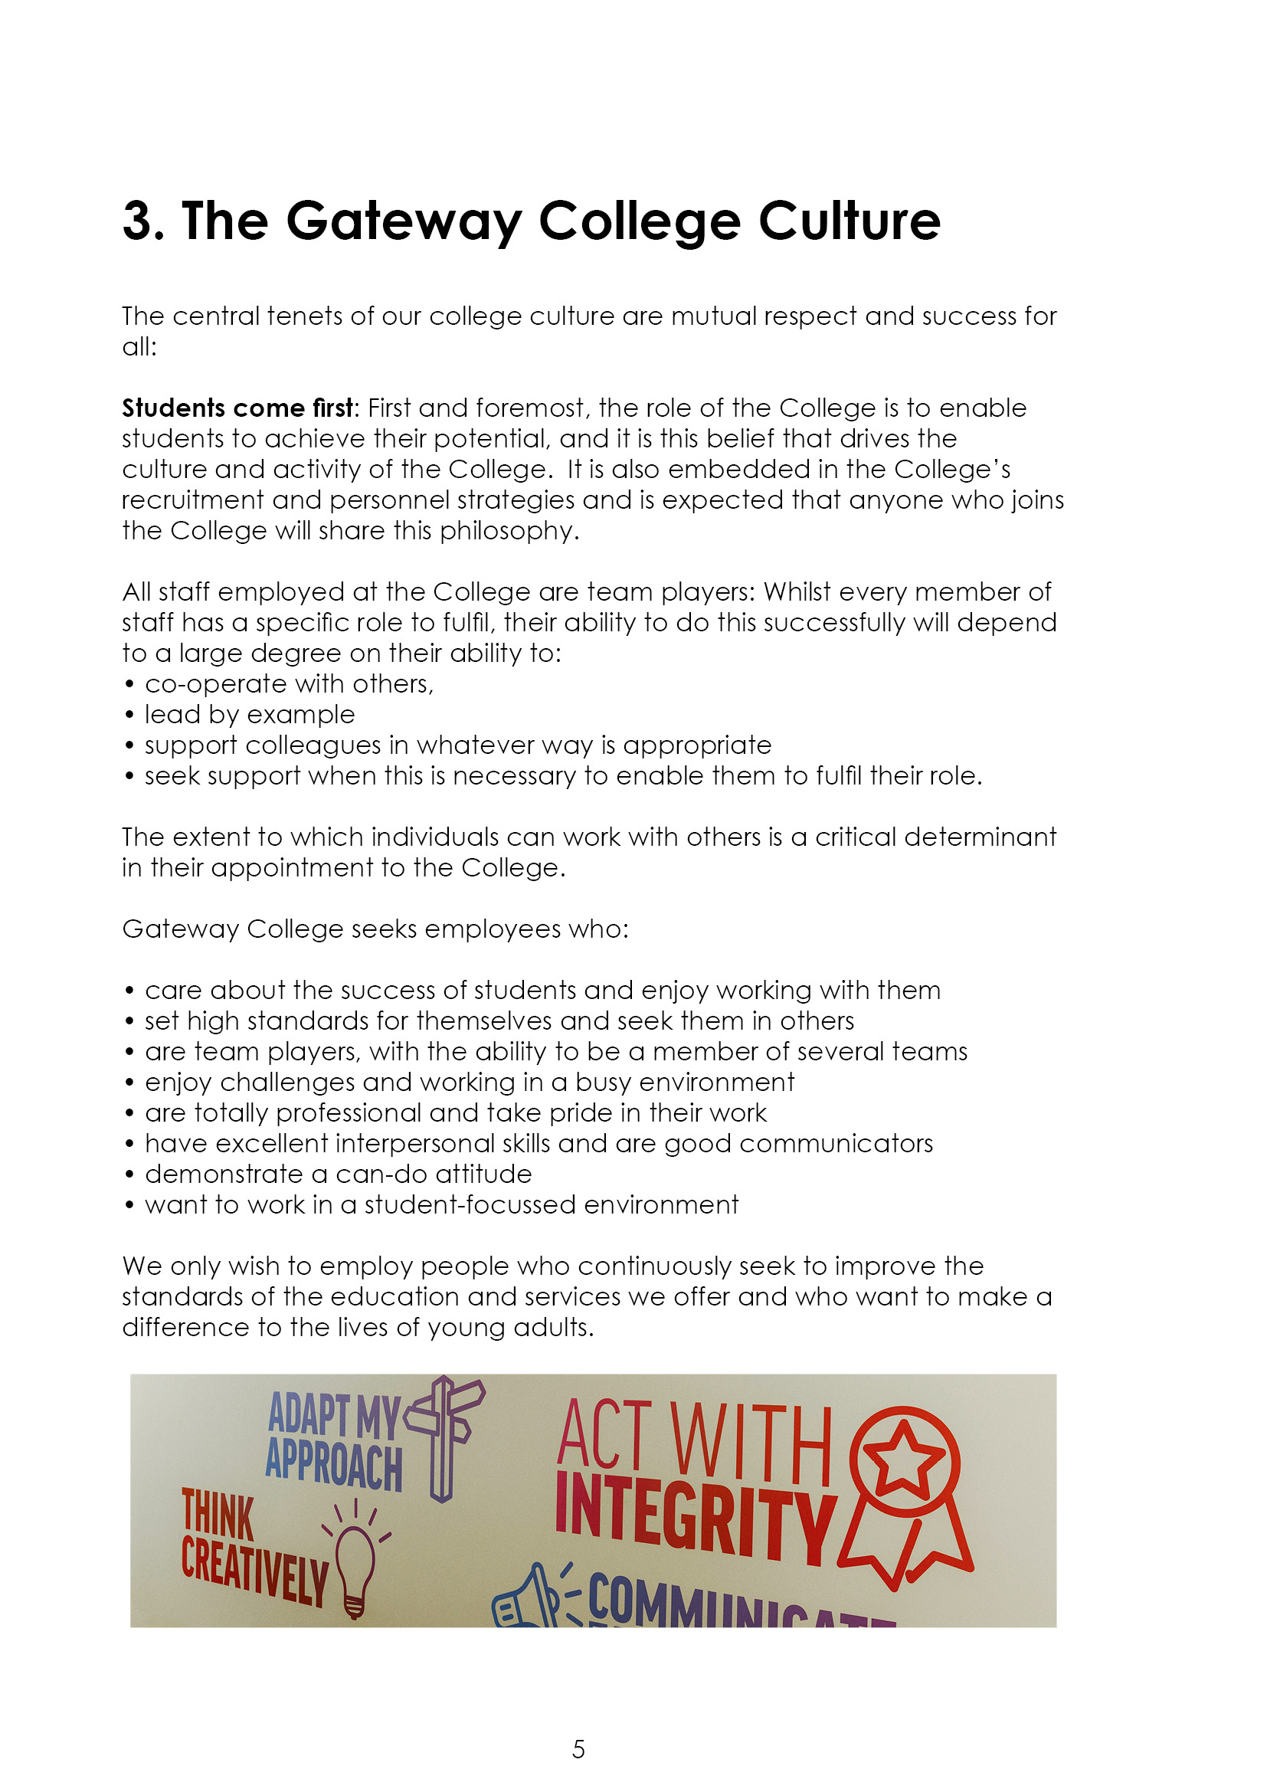

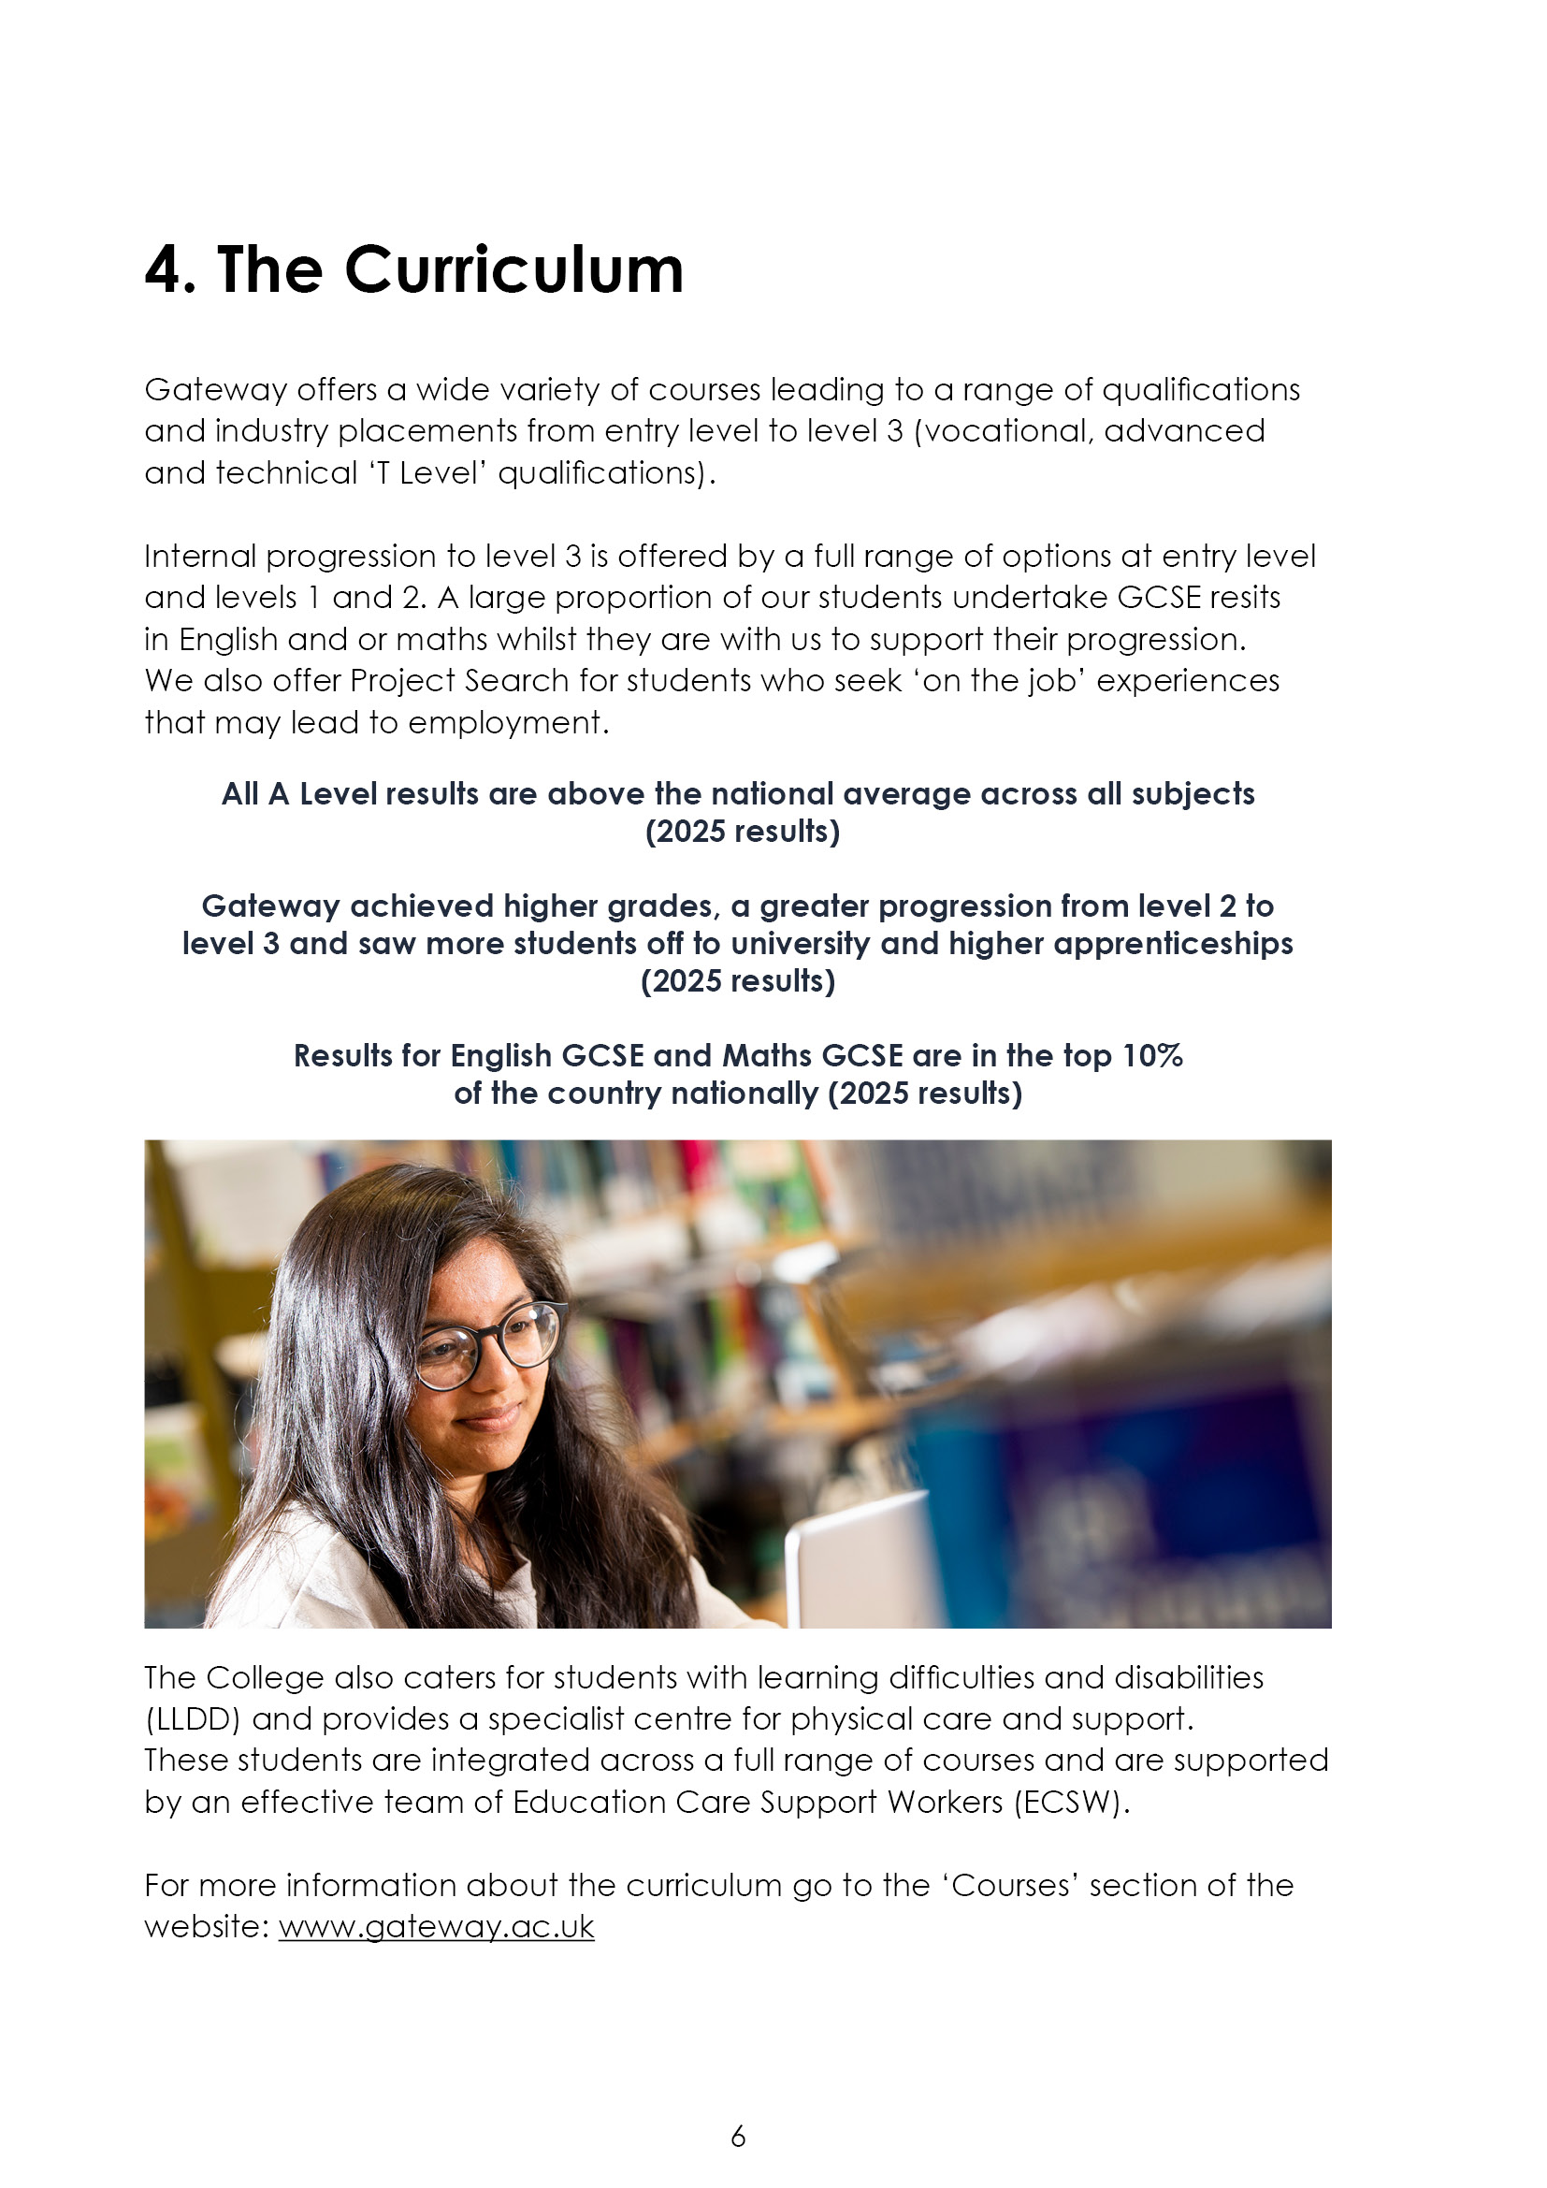

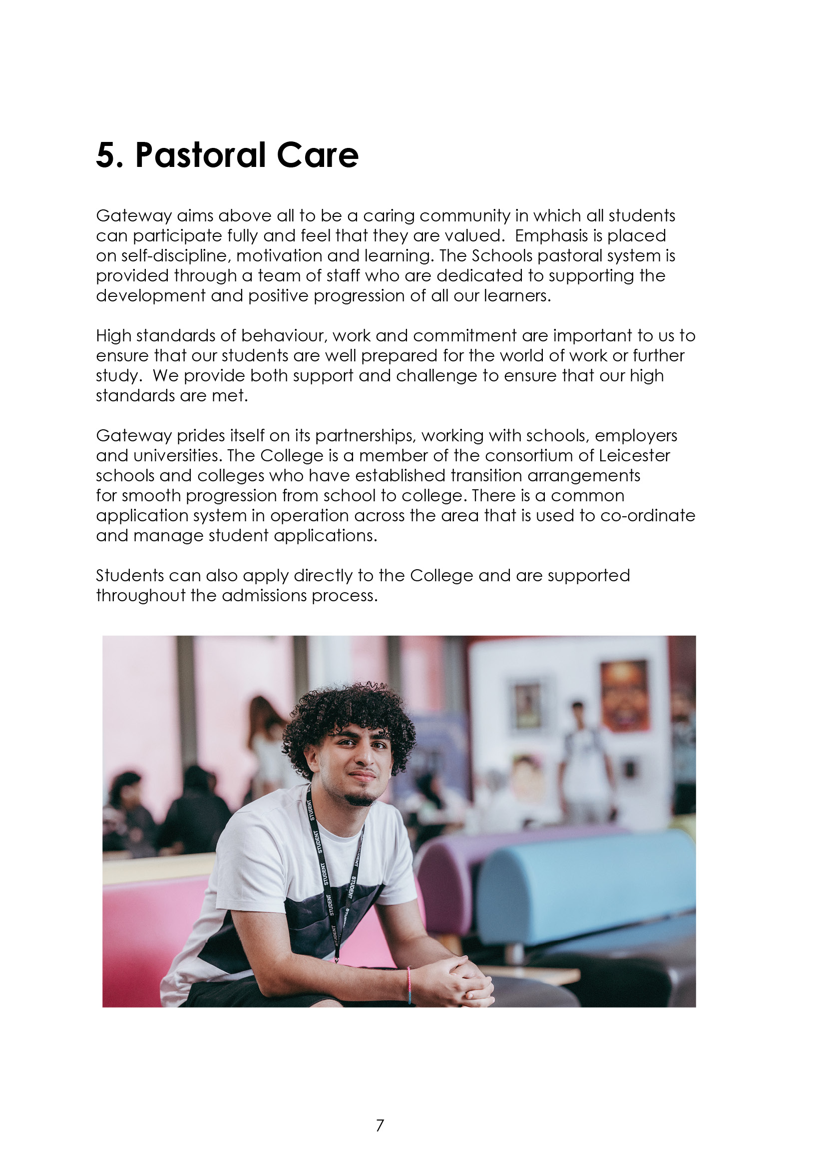

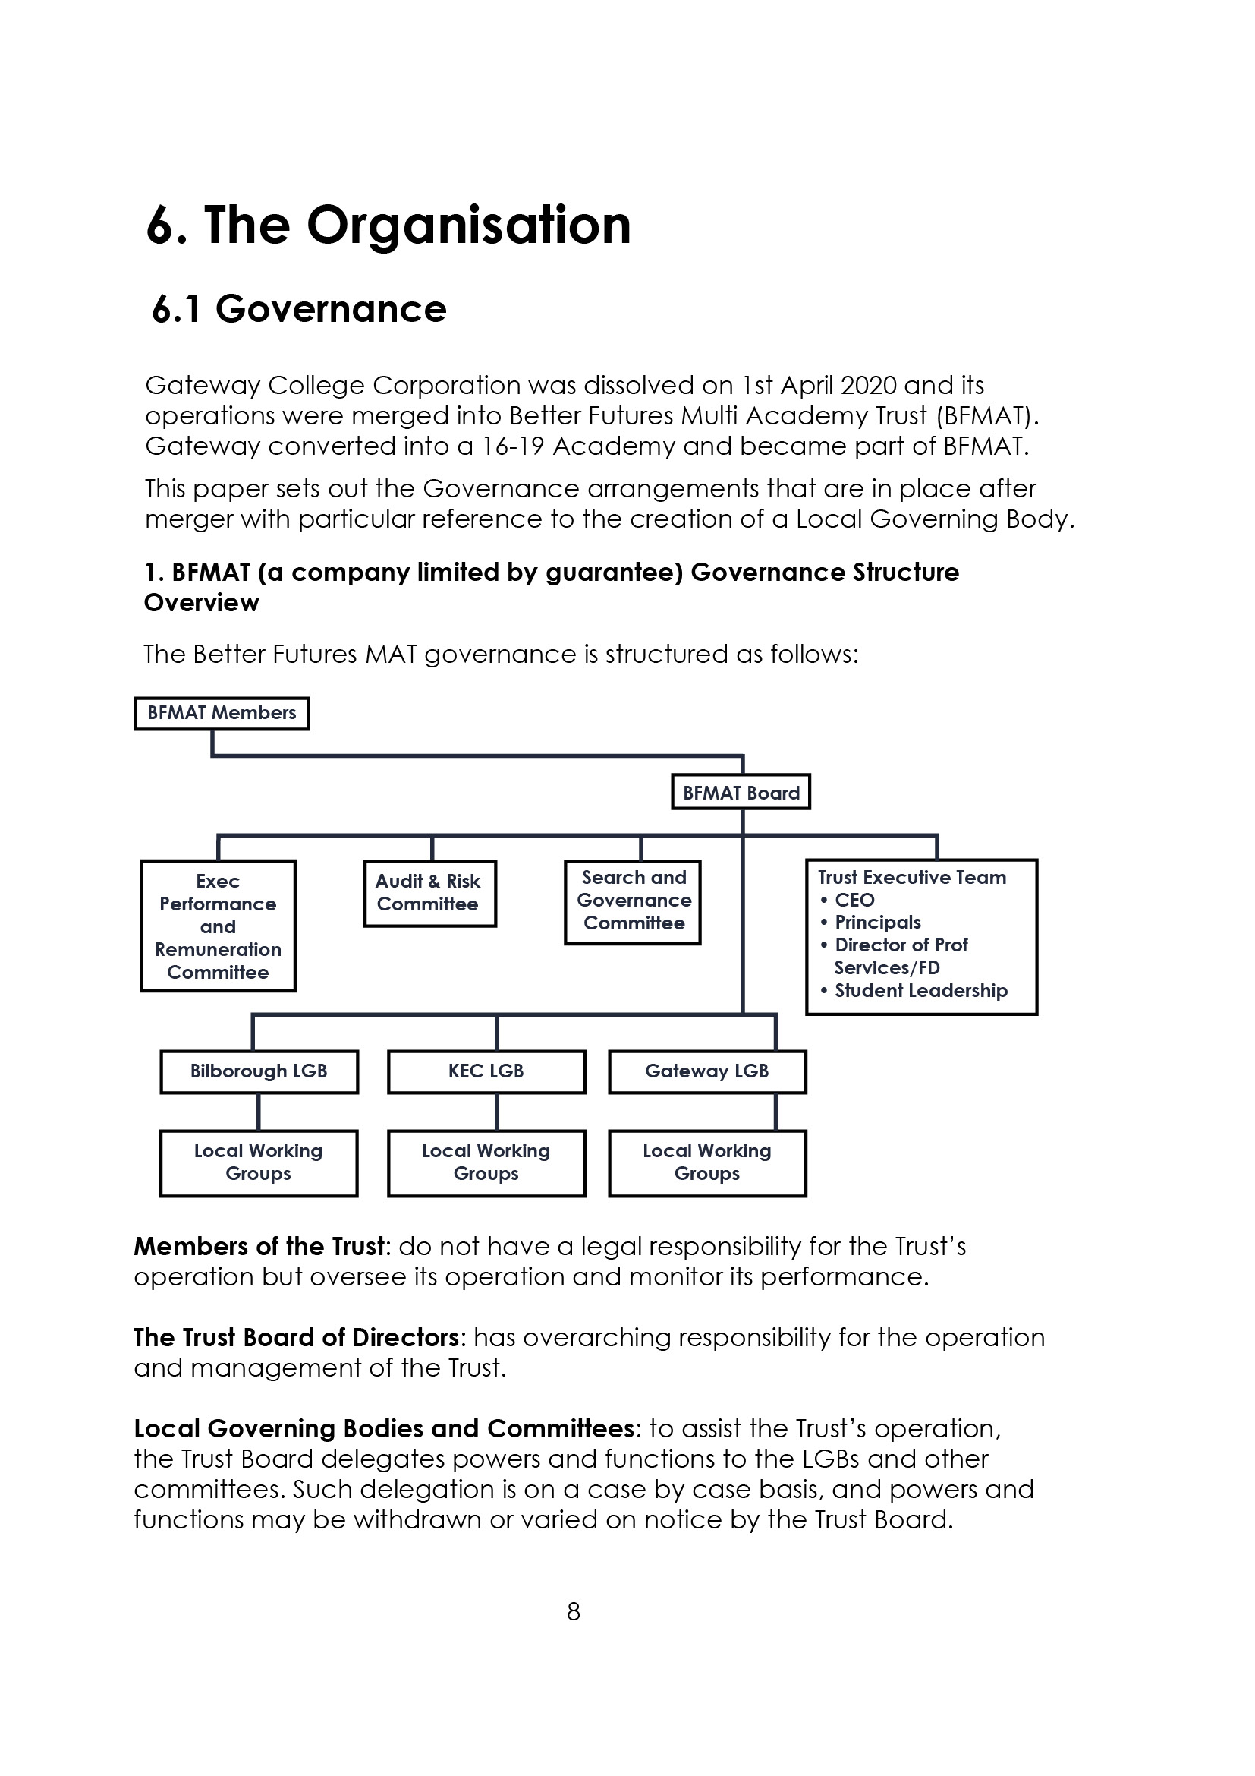



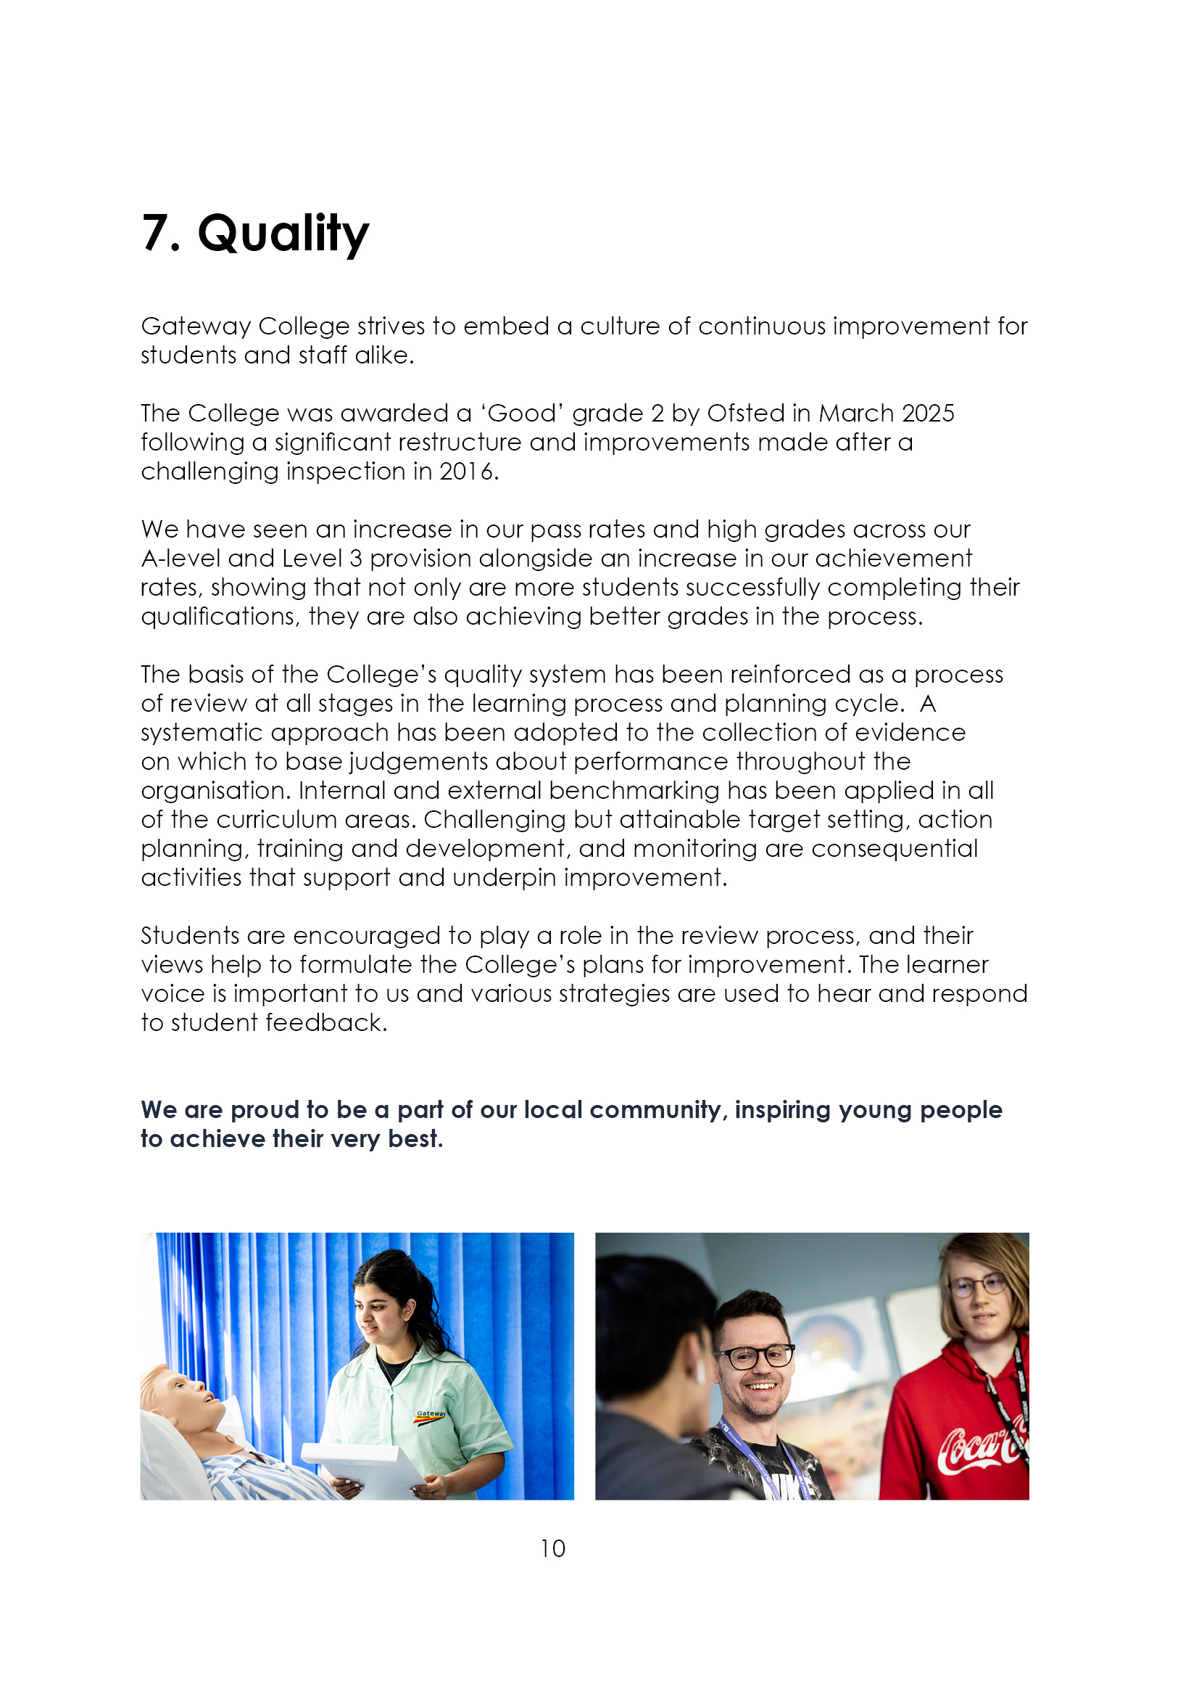

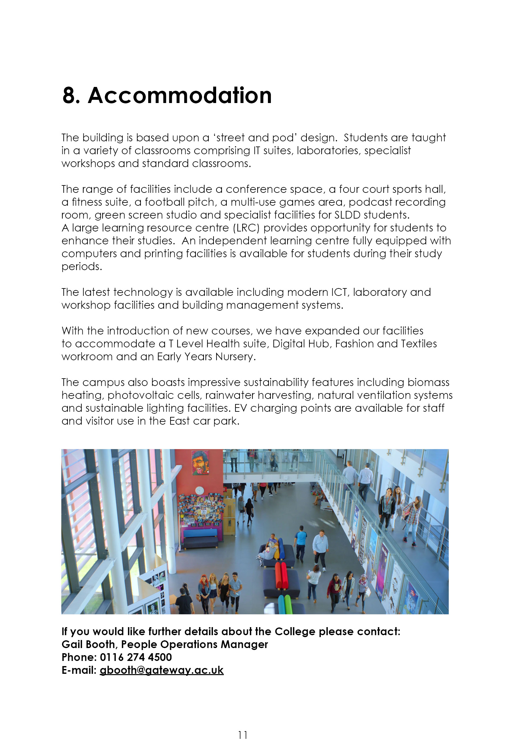

9. Job Advert

TEACHER OF T LEVEL EDUCATION AND EARLY YEARS WITH SOME REQUIREMENTS TO TEACH HEALTH AND SOCIAL CARE

PERMANENT

We are seeking to appoint an enthusiastic and innovative person to join our successful, growing and supportive Life Sciences and Health team. Ideally you will have a teaching qualification with expertise in Education and Early Years and / Or a health background to be able to deliver on T Level Education and Early years and Health and Social care courses. For this post you will need to be an excellent team player and be confident in the delivery of high-quality teaching, assessment and learning.

The preferred start date is 13th April 2026 but is negotiable for the right candidate.

Employment is under the Sixth Form Colleges contract, 195 days (1265 hours) with the SFCA pay spine (£33,465 - £51,714 FTE) dependent on qualifications and experience.

Closing date: 21st January 2026 (12 noon)
Interviews held: w/b 26th January 2026

For further details and application guidance can be found at Teaching and education jobs in LE5 1GA | Tes.

10. Job Description
Duties and Responsibilities:
The generalised duties and responsibilities laid down in the Teachers Statement of Conditions of Employment apply to all staff. These should be read in conjunction with this outline job description. Most staff will be both subject teachers and Personal Tutors.

- To undertake the teaching of students working on T level Education and Early years up to levels 3, or any other programmes, using a variety of teaching methods and learning styles.

- To participate under the direction of the Head of Department and/or Assistant Principal in the development of appropriate specifications, schemes of work, supported self study material and the use of information technology.

- To participate as a member of a team in the organisation of course material, resources and stock maintenance and the general management of subject areas.

- To ensure that in the teaching room assigned to the teacher, displays are regularly updated and that the room is generally kept in good order, with any problems reported using the normal College procedure.

- To take part, where appropriate, in the College personal guidance programme and recreational activities.

- To participate in appropriate meetings with colleagues and parents.

- To set appropriate work/homework for students.

- To assess and moderate in a timely manner in accordance with exam board regulations.

- To maintain detailed records of each student's attendance and progress and contribute to the preparation of records of achievement.

- To discuss with students regularly their progress and to refer, as appropriate, students to the Assistant Principal or Head of Department.

- To provide students with tutorial opportunities for individual/small group discussion as required within the College's published time budget.

- To participate in appropriate CPD.

- To negotiate an appropriate range of courses for each student during the induction period and monitor and adapt this provision whenever necessary in consultation with other staff and the student.

- To liaise with subject teachers and other colleagues as necessary.

- To liaise closely with the Head of Department and/or Head of School and refer students as appropriate.

- To liaise with parents/guardians/external agencies as appropriate.

- To monitor and develop each student's profile and to prepare initial drafts of references and reports as required.

- To provide information and data as and when required.

- To attend parents' evenings and discuss students' progress.

- To participate in appropriate meetings with colleagues in addition to those specified in the College calendar.

- To undertake other reasonable duties as required by the Principal.

Notes:

The above responsibilities are subject to the general duties and responsibilities contained in the statement of conditions of employment and our equal opportunities policy.

This job description allocates duties and responsibilities but does not direct the particular amount of time to be spent on carrying them out and no part of it may be so construed.

This job description is not necessarily a comprehensive definition of the post and is subject to review following consultation.

This post is subject to enhanced disclosure from the Disclosure and Barring Service (DBS).

ESSENTIAL | Method of Assessment | Shortlisting Column
- A graduate in an Early Years or Health and Social Care or substantial vocational experience in the Education / health and social care sector. | A
- Experience of delivering T level Education and Early years courses to post 16 students, with some experience of delivering H&SC courses up to level 3 | A
- Organisational skills and the ability to develop new resources as part of a team. | I
- Ability to work as a member of a team. | I
- A desire to teach within a post-16 environment. | A
- Awareness of the needs of students in the post-16 education sector. | I
- Professional competence and ability to teach post-16 using a broad range of teaching and learning styles. | I
- Ability to integrate ICT into classroom and working practices. | I
- Willingness to contribute to the extra-curricular life of the College. | I
- Awareness of recent educational developments in the post-16 sector. | I
- Recognition and support for the Better future Academy educational philosophy of individual support, personal choice and positive achievement. | I
- A sense of humour, patience, resilience and energy at all times. | I
- A commitment to all students and a clear understanding of all equal opportunities. | I
- Recognised teaching qualification or the willingness to work towards it. | A

DESIRABLE | Method of Assessment | Shortlisting Column
- Ability to offer a further subject. | A
- Experience of teaching the College’s present (NCFE / Btec ) course specifications. With some familiarity with the T level curriculum requirements and industry placement standards. | I
- Experience of delivering lessons that develop learners’ literacy and numeracy | A, I
- Experience of working in an Education and Early years or health and social care sector. | A
- Experience and/or willingness to offer courses for adults, including ‘full cost’ courses for local businesses.

- Evidence of curriculum resource development | I
- Evidence of team player activities. | I
- Successfully taught a wide range of student abilities and experience of curriculum development. | A
- Experience of 16-19 role of pastoral tutor. Experience of individual action planning and target setting. | A
- Recognition of quality standards and procedures in teaching and learning. | I
- Knowledge of inclusive learning, widening participation and lifelong learning philosophies. | I
- Assessor or internal Quality Assurance qualification or be willing to work towards | A/ I

A = Application form I = Interview



