**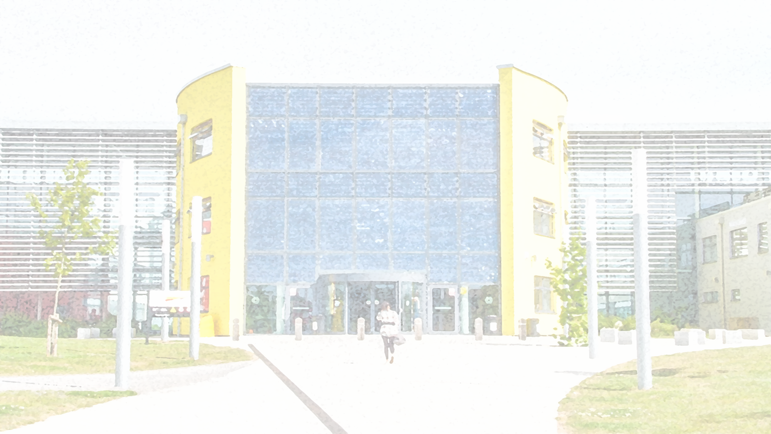****Careers Programme 2025-2026**

**Gateway Sixth Form College is committed to providing impartial Careers Education, Information, Advice and Guidance (CEIAG) to all students, both through the curriculum and a comprehensive range of organised activities. Students are provided with differentiated, current, accurate and relevant information to help them raise their aspirations, make good choices and understand what they need to do to reach and succeed in their chosen career and progression plans. Students are encouraged to develop their knowledge, skills and behaviours to increase their self-awareness, resilience and confidence and prepare them for next steps. Working with the local and regional business community to understand and address the needs of the local area Gateway Sixth Form College provides high-quality careers, employability and enrichment provision which raises aspirations, improves motivation and develops the skills needed for students to achieve their full potential in an inclusive and supportive environment.**

**This Careers Programme is mapped against the eight Gatsby benchmarks for IAG, which are:**

**1. A stable careers programme**

**2. Learning from career and labour market information**

**3. Addressing the needs of each pupil**

**4. Linking curriculum learning to careers**

**5. Encounters with employers and employees**

**6. Experiences of workplaces**

**7. Encounters with further and higher education**

**8. Personal guidance**

Think Creatively

Remain Positive

Adapt My Approach

Act With Integrity

Communicate Effectively

Get Things Done

|  |  |  |  |  |  |  |  |  |  |  |  |  |  |  |
| --- | --- | --- | --- | --- | --- | --- | --- | --- | --- | --- | --- | --- | --- | --- |
| **Event** | **Skills Developed** | **Gatsby Benchmarks** | **Aug** | **Sept** | **Oct** | **Nov** | **Dec** | **Jan** | **Feb** | **Mar** | **Apr** | **May** | **Jun** | **Jul** |
| **Results Day/Clearing** | **Independence**  **Adaptability**  **Resilience** | **3,4,7,8** | **\*** |  |  |  |  |  |  |  |  |  |  |  |
| **Information, advice and guidance at enrolment** | **Awareness**  **Decision-making**  **Planning** | **3, 4, 7, 8** | **\*** | **\*** |  |  |  |  |  |  |  |  |  |  |
| **Career readiness screening** | **Employability Skills**  **Communication**  **Planning**  **Research**  **Goal setting** | **3, 4, 5, 7, 8** | **\*** | **\*** |  |  |  |  |  |  |  |  |  |  |
| **GroFar Careers Programme (available to students all year round)** | **Independence**  **Planning**  **Organisation**  **Professionalism**  **IT skills** | **3, 4, 8** |  |  |  | **\*** | **\*** | **\*** | **\*** | **\*** | **\*** | **\*** | **\*** | **\*** |
| **HE provider UCAS talks and workshops** | **Organisation Planning Communication**  **Research**  **Investigation** | **3,4,7,8** | **\*** | **\*** | **\*** | **\*** | **\*** | **\*** | **\*** | **\*** | **\*** | **\*** | **\*** | **\*** |
| **Employer talks in curriculum** | **Communication**  **Awareness**  **Initiative** | **2, 3, 4,5** |  | **\*** | **\*** | **\*** | **\*** | **\*** | **\*** | **\*** | **\*** | **\*** | **\*** | **\*** |
| **One to one guidance with careers advisors** | **Action planning**  **Awareness**  **Communication**  **Decision-making**  **Organisation** | **1, 2, 3, 4, 7, 8** | **\*** | **\*** | **\*** | **\*** | **\*** | **\*** | **\*** | **\*** | **\*** | **\*** | **\*** | **\*** |
| **College Induction** | **Organisation**  **Awareness**  **Communication**  **Planning** | **1, 2, 3, 4** |  | **\*** |  |  |  |  |  |  |  |  |  |  |
| **Unbox your future** | **Employability Skills** | **2, 3, 4, 5, 6** |  |  |  |  | **\*** |  | **\*** | **\*** |  |  |  |  |
| **We discover digital** | **Employability Skills** | **2, 3, 4, 5, 6** |  |  |  |  |  |  |  | **\*** | **\*** |  |  |  |
| **Event** | **Skills Developed** | **Gatsby Benchmarks** | **Aug** | **Sept** | **Oct** | **Nov** | **Dec** | **Jan** | **Feb** | **Mar** | **Apr** | **May** | **June** | **Aug** |
| **Medic Society** | **Awareness**  **Planning**  **Organisation**  **Networking** | **2, 3, 4, 5, 7, 8** |  | **\*** | **\*** | **\*** | **\*** | **\*** | **\*** | **\*** | **\*** | **\*** | **\*** |  |
| **Project Search** | **Employability Skills** | **2, 3, 4, 5, 6** |  | **\*** | **\*** | **\*** | **\*** | **\*** | **\*** | **\*** | **\*** | **\*** | **\*** | **\*** |
| **Employer Networking and Breakfasts** | **Networking**  **Communication**  **Professionalism** | **2, 3, 4, 5** |  |  |  |  | **\*** |  |  |  |  |  | **\*** |  |
| **UCAS application and personal statement support** | **Time management**  **Organisation**  **Initiative**  **Literacy skills**  **Research** | **3, 4, 7, 8** | **\*** | **\*** | **\*** | **\*** | **\*** | **\*** |  |  |  | **\*** | **\*** | **\*** |
| **Part time jobs club** | **Professionalism**  **Organisation**  **Research**  **Awareness** | **2, 3, 4, 8** |  |  |  | **\*** | **\*** | **\*** |  |  |  |  |  |  |
| **Careers Termly**  **Newsletter** | **Awareness**  **Research**  **Communication**  **Planning** | **2, 3, 4, 8** |  |  |  |  | **\*** |  |  | **\*** |  |  | **\*** |  |
| **Careers Padlet** | **Awareness**  **Research**  **Communication**  **Planning** | **2, 3, 4, 8** | **\*** | **\*** | **\*** | **\*** | **\*** | **\*** | **\*** | **\*** | **\*** | **\*** | **\*** |  |
| **Mock Interviews (offered all year round)** | **Communication**  **Presentation**  **Professionalism**  **Initiative**  **Constructive feedback** | **3, 4. 8** | **\*** | **\*** | **\*** | **\*** | **\*** | **\*** | **\*** | **\*** | **\*** | **\*** | **\*** | **\*** |
| **Work Experience** | **Wide variety of soft employability skills** | **3, 4, 5, 6** | **\*** |  | **\*** | **\*** | **\*** | **\*** | **\*** | **\*** |  |  | **\*** |  |
| **Work Experience Preparation** | **Planning**  **Organisation**  **Professionalism]**  **Research** | **2, 3, 4, 5, 8** |  |  |  |  |  |  |  |  |  |  |  |  |
| **Event** | **Skills Developed** | **Gatsby Benchmarks** | **Aug** | **Sept** | **Oct** | **Nov** | **Dec** | **Jan** | **Feb** | **Mar** | **Apr** | **May** | **Jun** | **Jul** |
| **Speed Networking Event** | **Communication**  **Presentation**  **Professionalism**  **Initiative** | **2, 3, 4, 5** |  |  | **\*** |  |  |  |  |  |  |  |  |  |
| **Employability Week** | **Communication**  **Networking**  **Problem solving**  **Independence** | **2, 3, 4, 5** |  |  |  |  |  |  |  | **\*** |  |  |  |  |
| **SEND Supported Internship Workshop** | **A variety of soft employability skills** | **3, 4, 5, 6** |  | **\*** | **\*** | **\*** | **\*** | **\*** | **\*** | **\*** | **\*** | **\*** | **\*** |  |
| **Apprenticeship**  **Week** | **Planning**  **Initiative**  **Communication**  **Organisation**  **Research** | **2, 3, 4, 5, 7, 8** |  |  |  |  |  | **\*** |  |  |  |  |  |  |
| **National T Level Week** | **Communication**  **Awareness**  **Planning**  **Employability Skills** | **2, 3, 4, 5, 6, 8** |  |  | **\*** |  |  |  |  |  |  |  |  |  |
| **Annual Progression Fair** | **Communication**  **Interpersonal**  **Networking**  **Awareness**  **Research** | **3, 4, 5, 7, 8** |  |  |  |  |  |  |  |  | **\*** |  |  |  |
| **Annual Career Fair** | **Communication**  **Awareness**  **Networking**  **Planning**  **Research** | **2, 3, 4, 5, 6, 8** |  |  |  |  |  |  |  |  | **\*** |  |  |  |
| **Level 1 and 2 Progression Fair** | **Communication**  **Awareness**  **Research**  **Planning** | **2, 3, 4, 7, 8** |  |  |  |  |  |  |  |  |  | **\*** |  |  |
| **University and Employer Trips** | **Communication**  **Networking**  **Professionalism**  **Independence** | **3, 4, 5, 6, 7, 8** |  |  | **\*** | **\*** | **\*** | **\*** | **\*** | **\*** | **\*** |  | **\*** |  |
| **Oxbridge Trips** | **Independence**  **Resilience**  **Awareness**  **Research** | **7, 8** |  |  |  |  |  |  | **\*** |  |  |  | **\*** |  |
| **Bespoke Medicine, Dentistry and Veterinary Workshop** | **Time management**  **Organisation**  **Awareness**  **Research**  **Goal setting**  **Communication** | **2, 3, 4, 5, 7, 8** | **\*** | **\*** | **\*** |  |  |  |  |  |  | **\*** | **\*** | **\*** |
| **Phoenix Plus** | **Awareness**  **Employability Skills**  **Communication**  **Professionalism** | **2, 3, 4, 5, 7, 8** |  | **\*** | **\*** | **\*** | **\*** | **\*** | **\*** | **\*** | **\*** | **\*** | **\*** |  |



**Community Assistant Principal:**

**Kerry Reeve** [**kreeve@gateway.ac.uk**](mailto:kreeve@gateway.ac.uk)

**Head of Careers, Employability and Progressions:**

**Daisy Atwal** [**datwal@gateway.ac.uk**](mailto:datwal@gateway.ac.uk)