

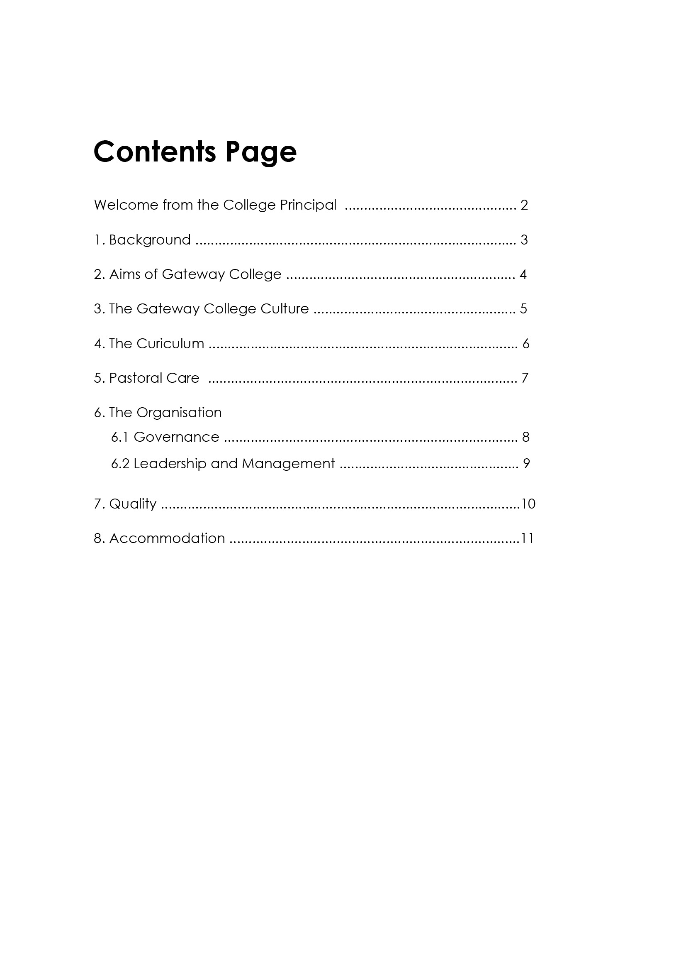

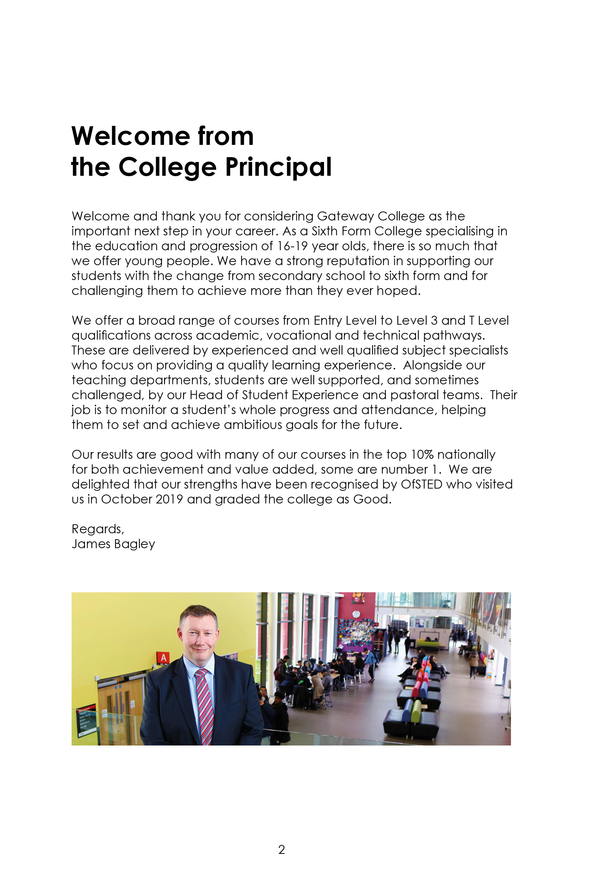

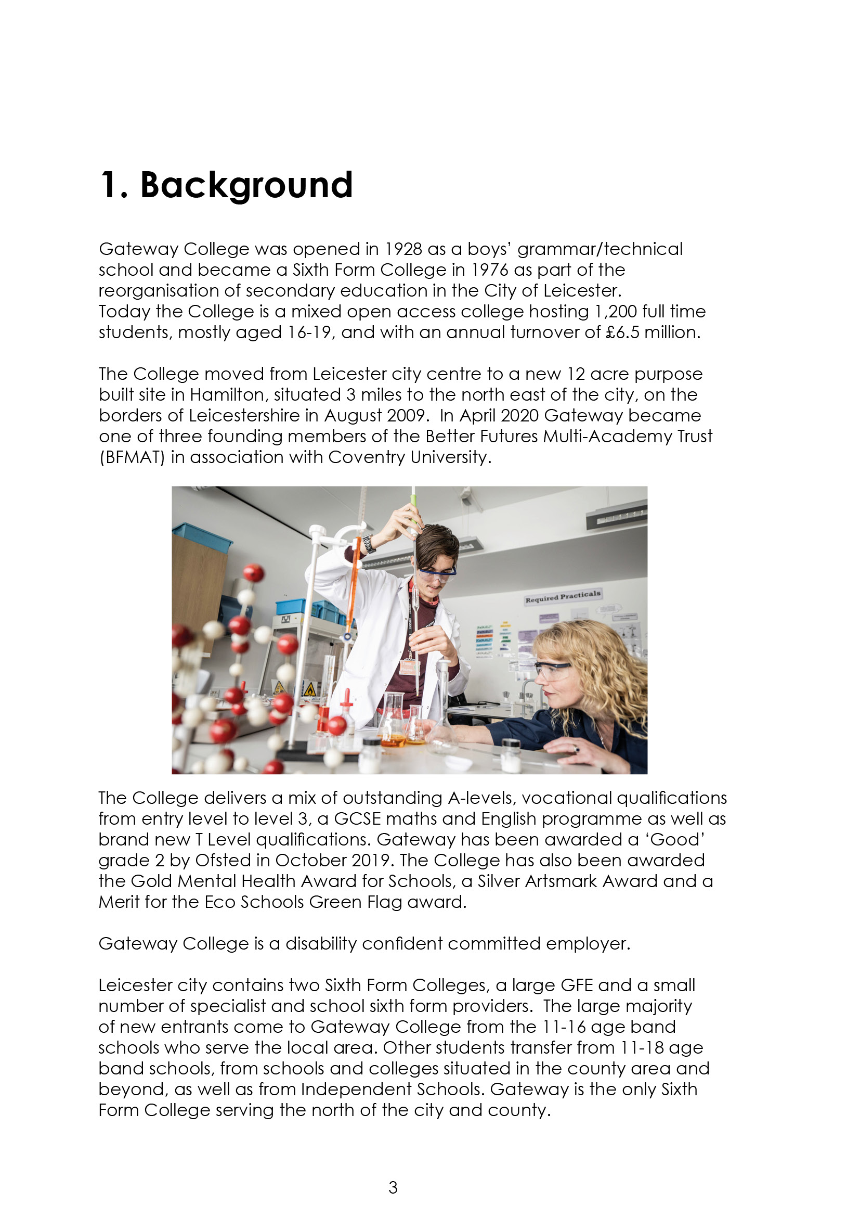

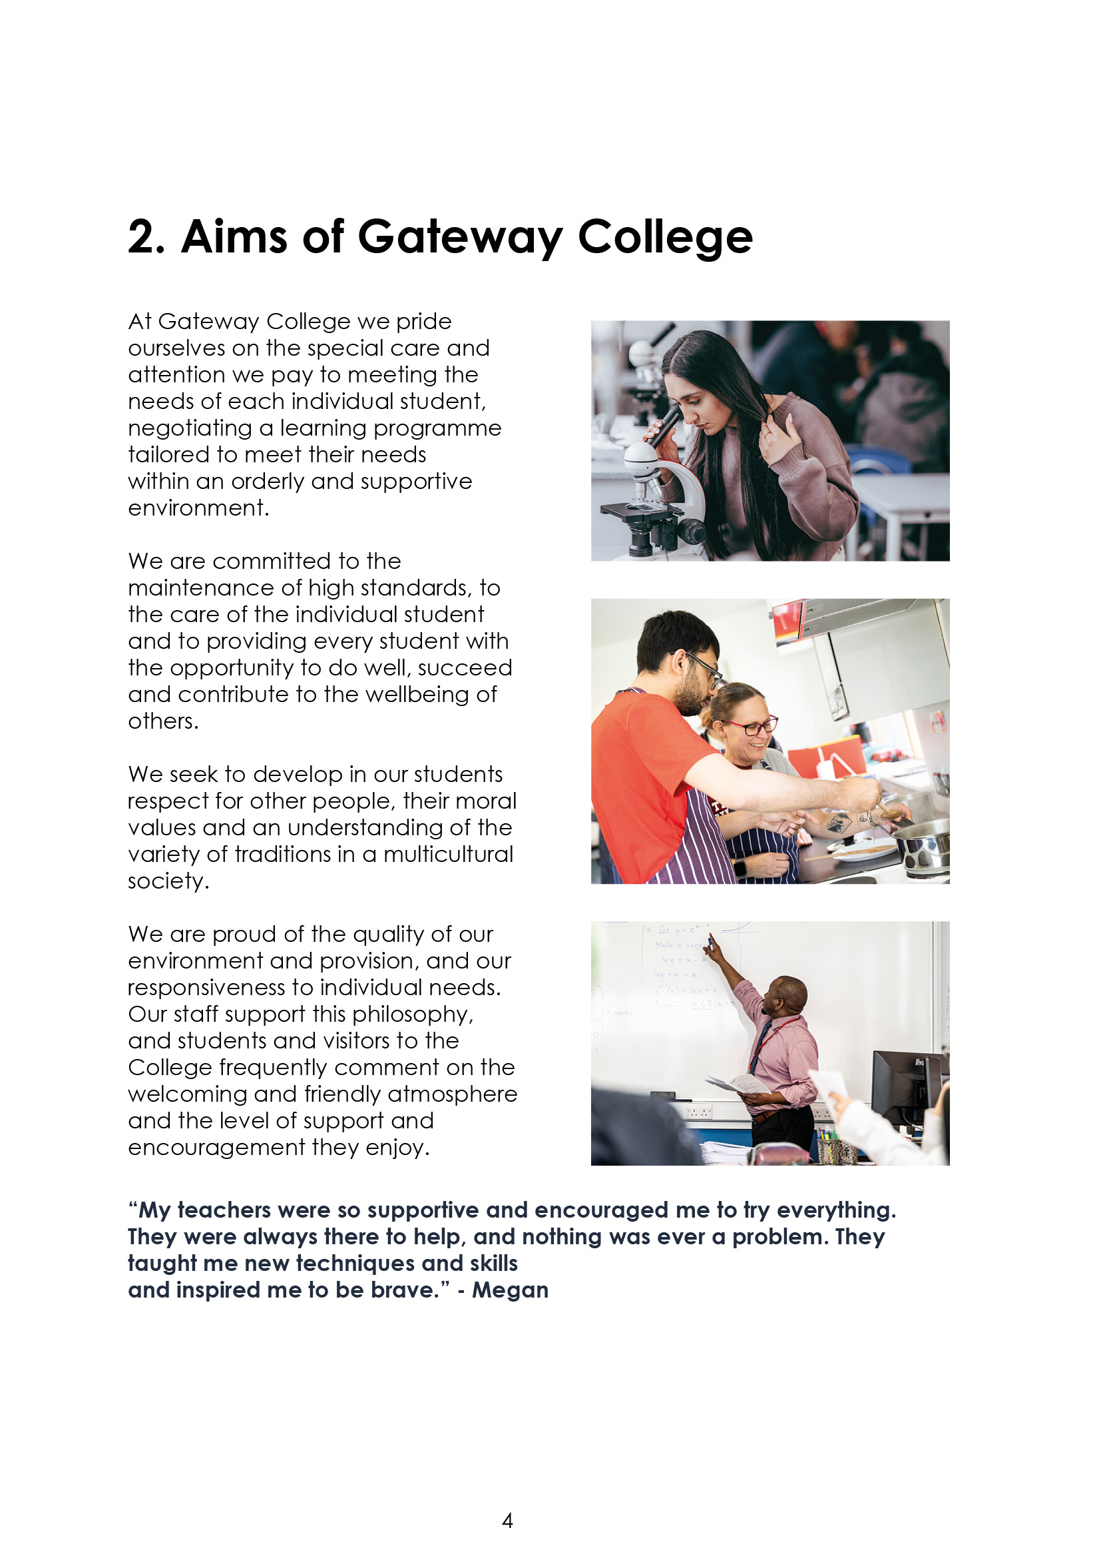

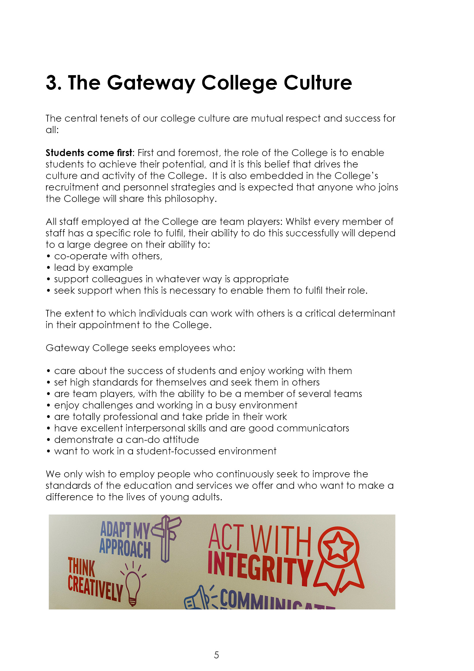





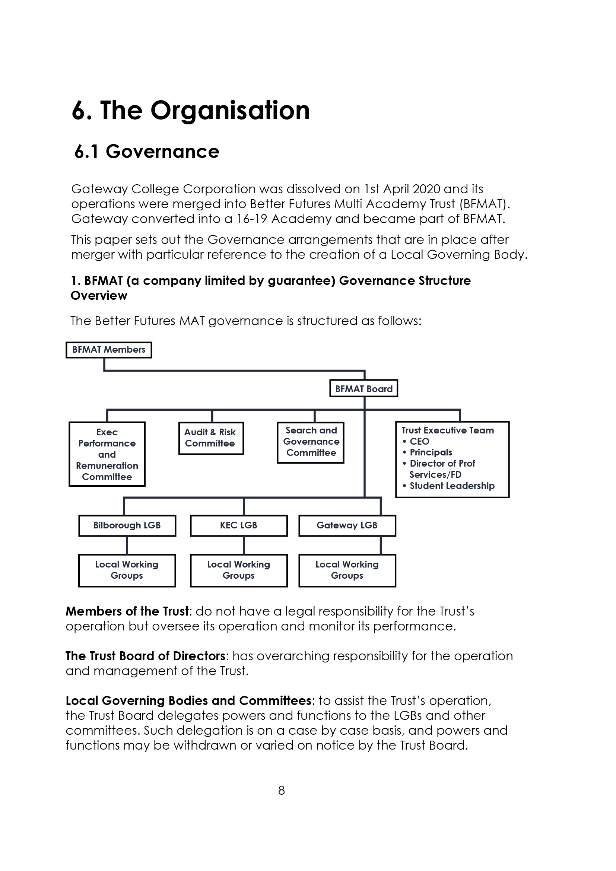



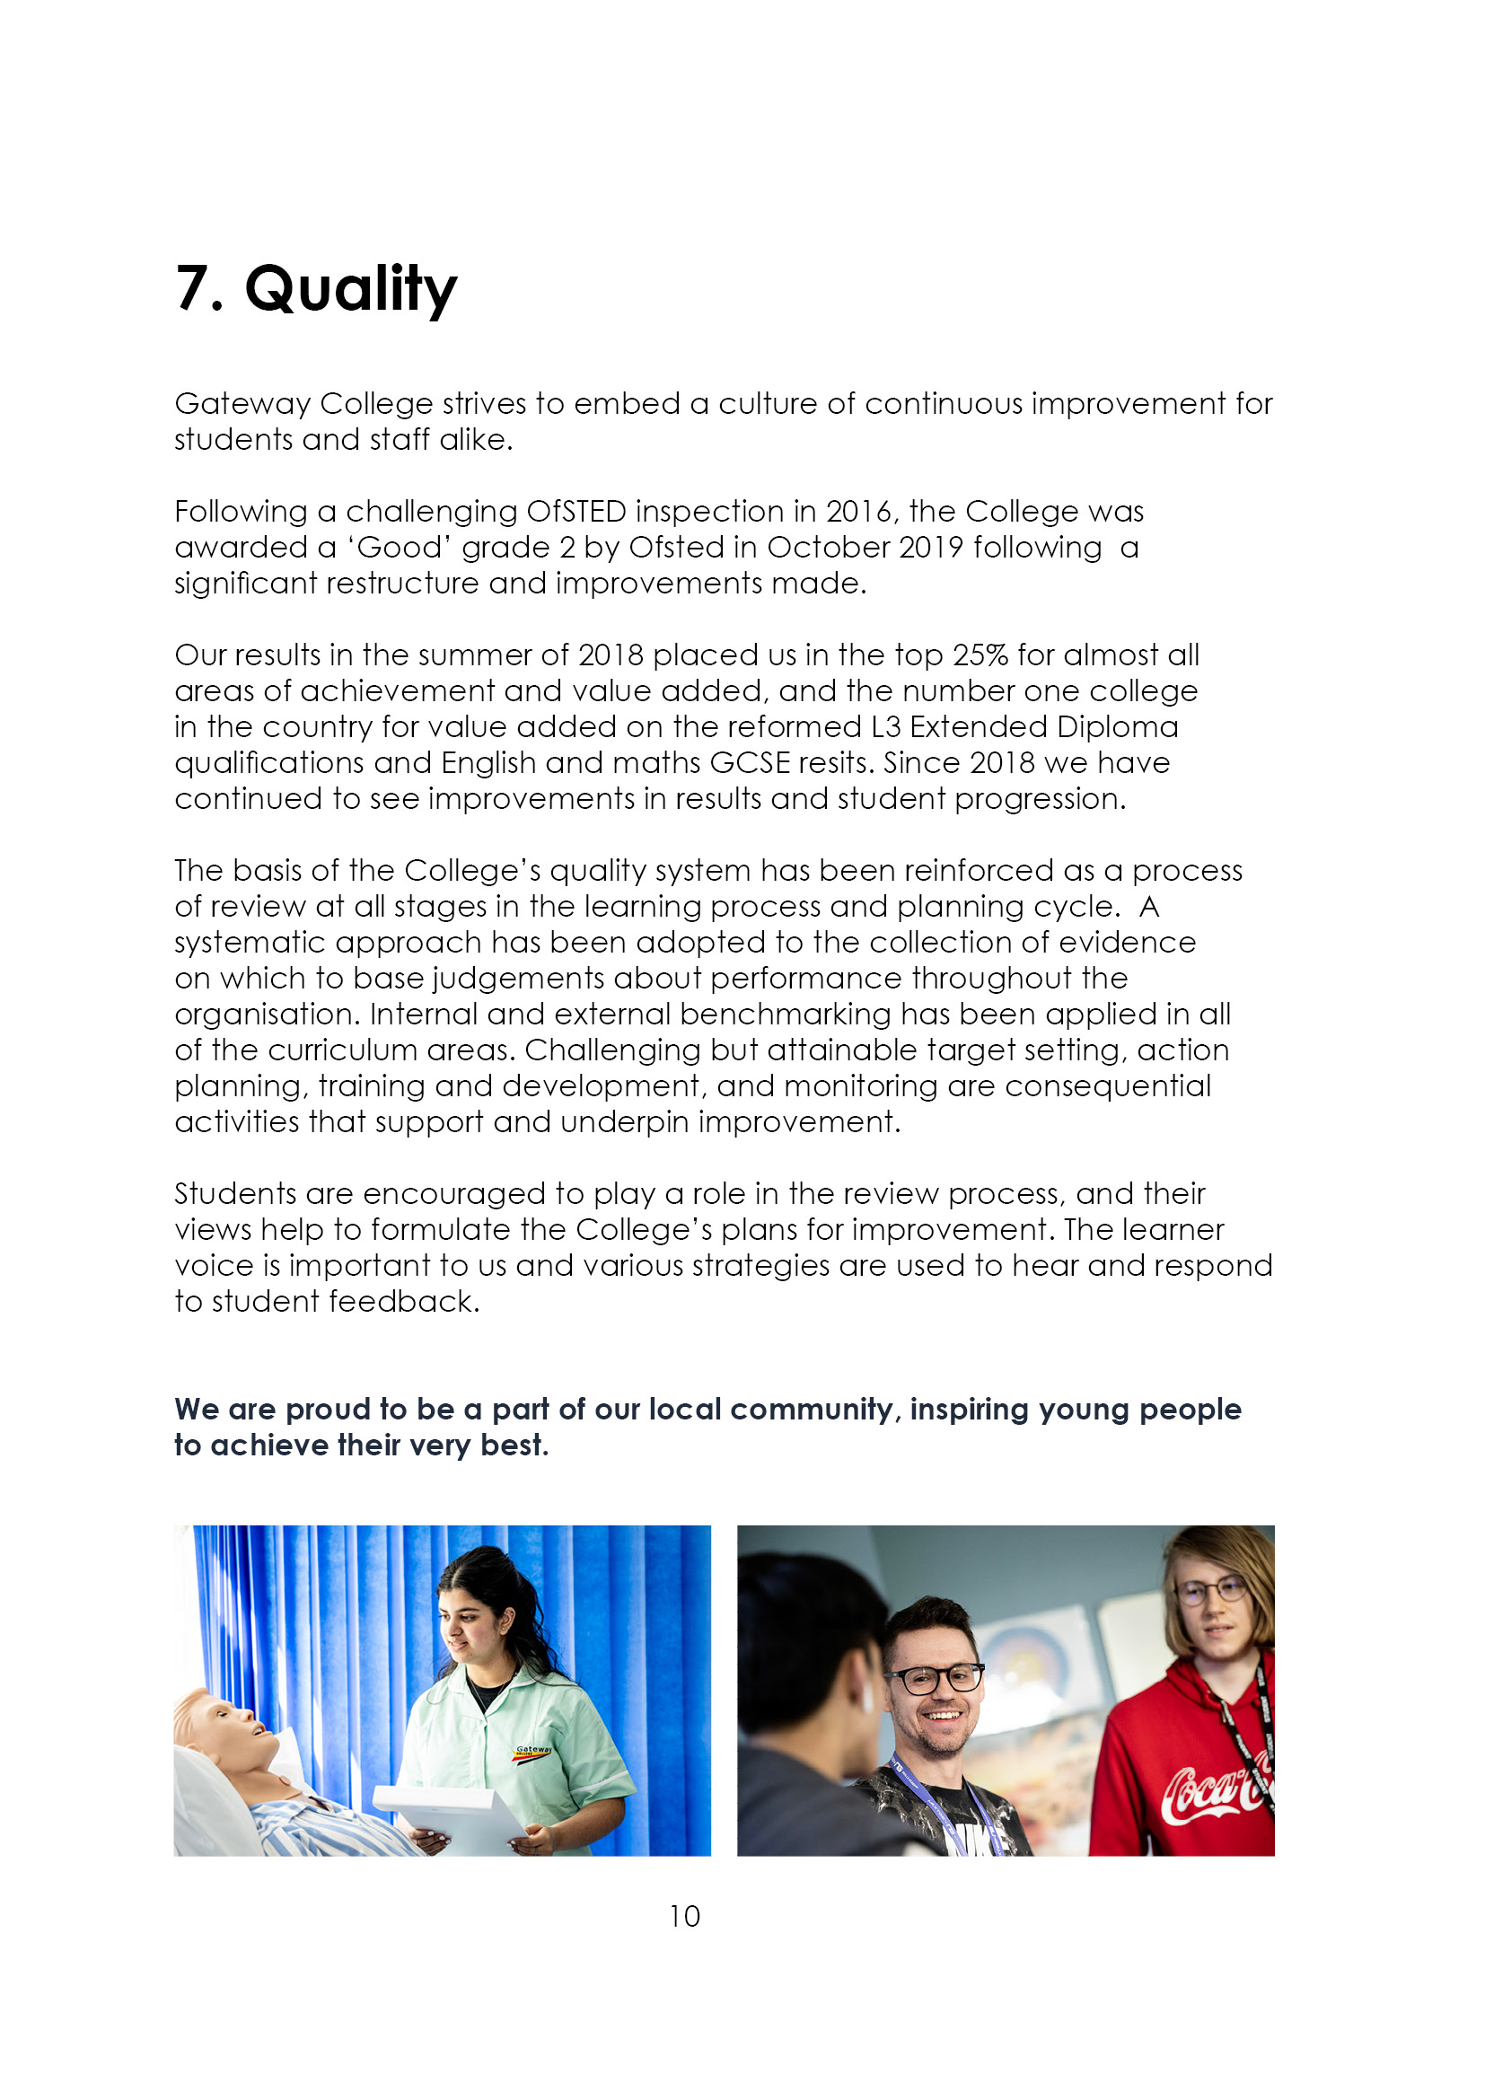



9. Job Advert

Welfare officer (Ref: 25/12)
37 hours per week, term time plus 5 days (40 weeks per year)
Actual salary: ££24,289 - £26,571 (SFCA salary points 11-14)

The opportunity to play a leading role in shaping this newly created position at the college. A dynamic approach and problem-solving mentality. It will be your opportunity to shape the role and develop it to best suit the needs of the diverse student population we serve. This role will ideally suit somebody who has experience and an interest in the development of young people. Recent knowledge and experience of post-16 education and dealing successfully with parents, students and staff. An understanding of the developmental, emotional, social and educational issues of young people is also a key requirement, together with an awareness of the range of needs of people from diverse ethnic, cultural and social backgrounds. To promote positive attitudes towards regular college attendance on the part of students and their parents/carers. To improve levels of student attendance and engagement. To form part of the safeguarding team, if you are a safeguarding trained already is desirable, but training and support will be provided to gain this qualification.
Closing date: Monday 23rd June 2025 (12 noon)
Interview Date: Monday 30th June 2025

If you feel you have the qualities we are asking for and are looking for an exciting challenge, please see Teaching and education jobs in LE5 1GA | Tes or visit www.gateway.ac.uk.

10. Job Description
Key Purpose

The Welfare Support Officer plays a vital role in supporting students facing welfare-related barriers to learning. Reporting to the Head of Student Experience, the officer provides targeted interventions, monitors student progress and attendance, and contributes to a safe, inclusive college environment. As a Deputy Designated Safeguarding Lead, the role involves managing welfare concerns, promoting equality and diversity, and collaborating with staff, families, and external services to enhance student wellbeing and engagement.

Responsibilities
1. | Provide target support for students with welfare barriers.
2. | Deliver and support several tutorial groups, monitoring attendance and behaviour for learning.
3. | Monitor and track the progress of students receiving welfare support, adjusting Intervention Action Plans as necessary.
4. | Act as a Deputy Designated Safeguarding Lead, as part of the college safeguarding team. Responding to and managing safeguarding concerns in line with college policies.
5. | Monitor wider student attendance and punctuality, identifying patterns that may indicate underlying welfare issues.
6. | Develop and deliver workshops and initiatives to college groups promoting EDI, LGBTQ+, and young carers to provide targeted support.

Further duties and Responsibilities:

a | Work closely with teaching staff, tutors, Head of Student Experience and the wider student support team to identify students in need of welfare  support.
b | As a member of the safeguarding team, lead on low level safeguarding and welfare concerns.
c | Encourage positive behaviour and a safe, inclusive environment across the college. Ensure you have visibility and presence in and around the college.
d | Support students who are struggling with their bursary applications or payments, communicating with Assistant Principal for Community.
e | Be First Aid trained and be part of the Duty Manager rota when required.
f | Sign post young people and families to additional external services. E.g Early Help.
g | Collaborate with the attendance team to address concerns and implement strategies to improve student engagement.
h | Ensure effective communication/consultation as appropriate with the parents/carers of students via phone, letter and home visits as relevant, ensuring student contracts are agreed and monitored.
i | Work with Student Support with cross college wellbeing activities which can enhance student welfare.
j | Carry out other routine and ad hoc administrative tasks as directed by the Head of Student Experience.
k | To deliver weekly tutorial sessions, and carefully monitor performance and attendance.

This person specification is intended to assist both candidates and interviewers in the appointment process. In the 'method of assessment' column 1= application form 2 = interview/tests and 3= documentary evidence

ESSENTIAL | Method of assessment | Short listing  column
Education to level 3 (Degree desirable) or equivalent experience, with maths and English L2 qualifications | 1/3
Evidence of personal characteristics, professional skills and experience suitable for working with young people who have welfare or safeguarding needs. | 1/2/3
Ability to communication with students, parents and peers – face to face and via telephone | 1/2
Ability to motivate and stretch young people to achieve their full potential | 1/2
Able to deliver tutorials and workshops | 1/2
Be flexible in approach and able to adapt to the differing needs of the students | 1/2
Good organisational and planning skills and ability to prioritise work | 2
A professional understanding of confidentiality, trust and discretion in all areas | 2
Good IT skills | 1/2
Good record of attendance and punctuality | 3
Be willing to undertake training and development as required within the role. To champion knowledge sharing and collaboration | 2
The ability to not be afraid to admit to making mistakes and learn from them to improve own performance | 2

 | DESIRABLE
 | Knowledge of Post 16 education and progression routes | 2
 | Ability to organise events and deliver presentations | 1/2
 | Have been part of a DSL or safeguarding team or equivalent experience in your organisation. | 1/2
 | Be trained in First Aid | 1/2
Notes:
The above responsibilities are subject to the general duties and responsibilities contained in the statement of conditions of employment and our equal opportunities policy.
This job description allocates duties and responsibilities but does not direct the amount of time to be spent on carrying them out and no part of it may be so construed.
This job description is not necessarily a comprehensive definition of the post and is subject to review following consultation.
This post is subject to enhanced disclosure from the Disclosure and Barring Service (DBS).

Gateway College is subject to the Safeguarding Vulnerable Groups Act 2006 which requires that any candidate appointed must produce:
- A DBS clearance certificate
- Proof of identity
- Proof of qualifications
- Proof of the right to work in the UK.

All of these documents must be produced BEFORE commencement of employment.



