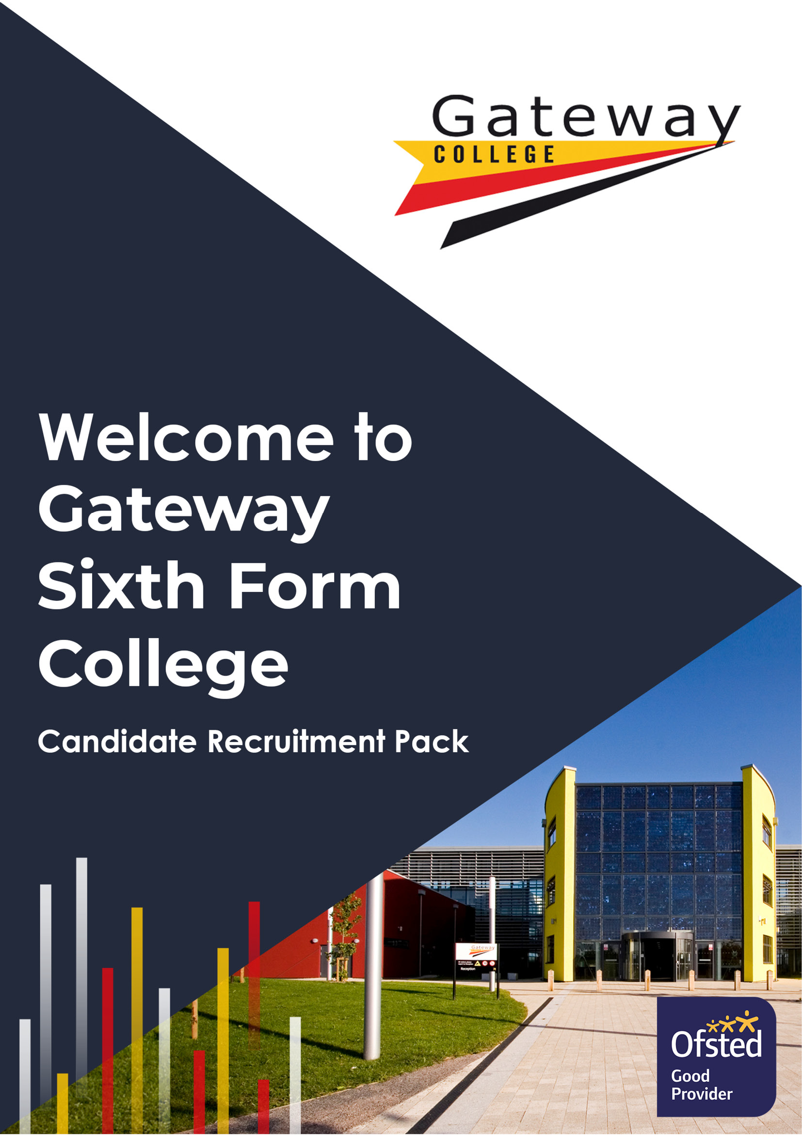

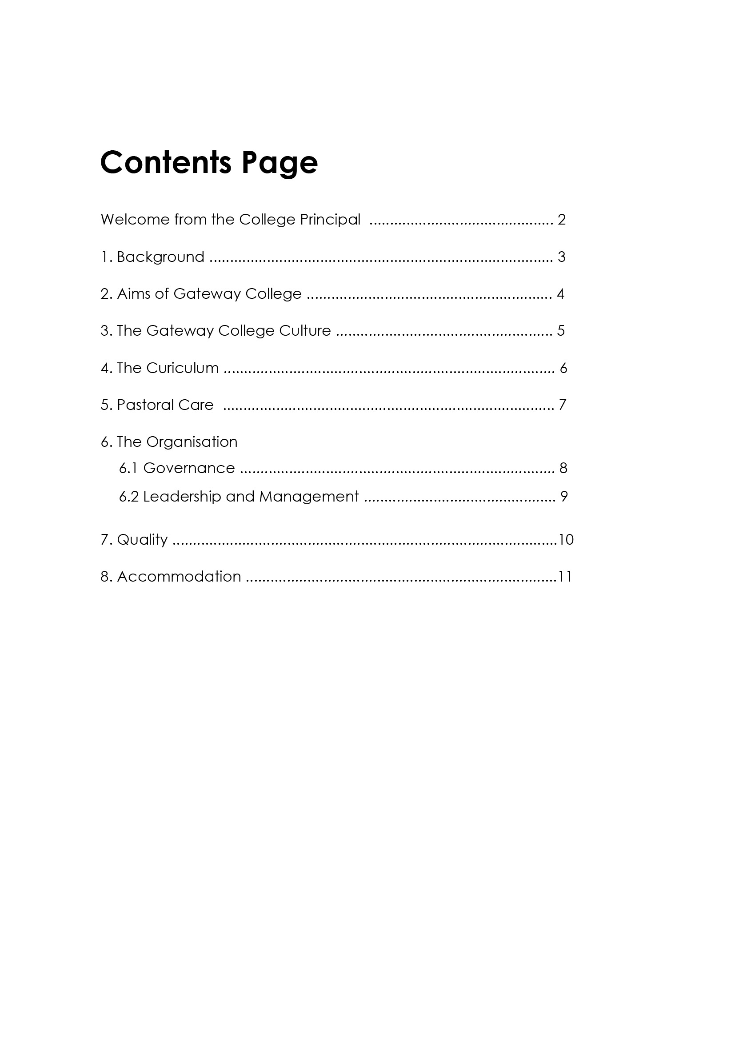

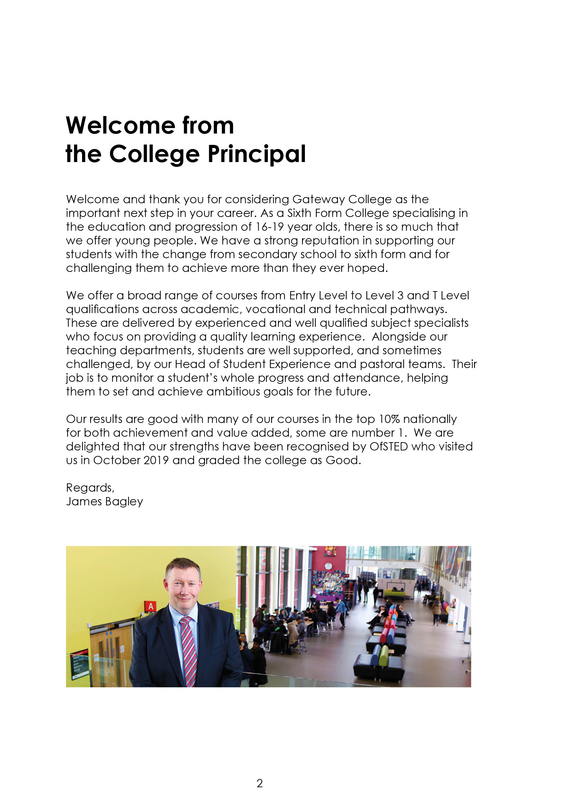

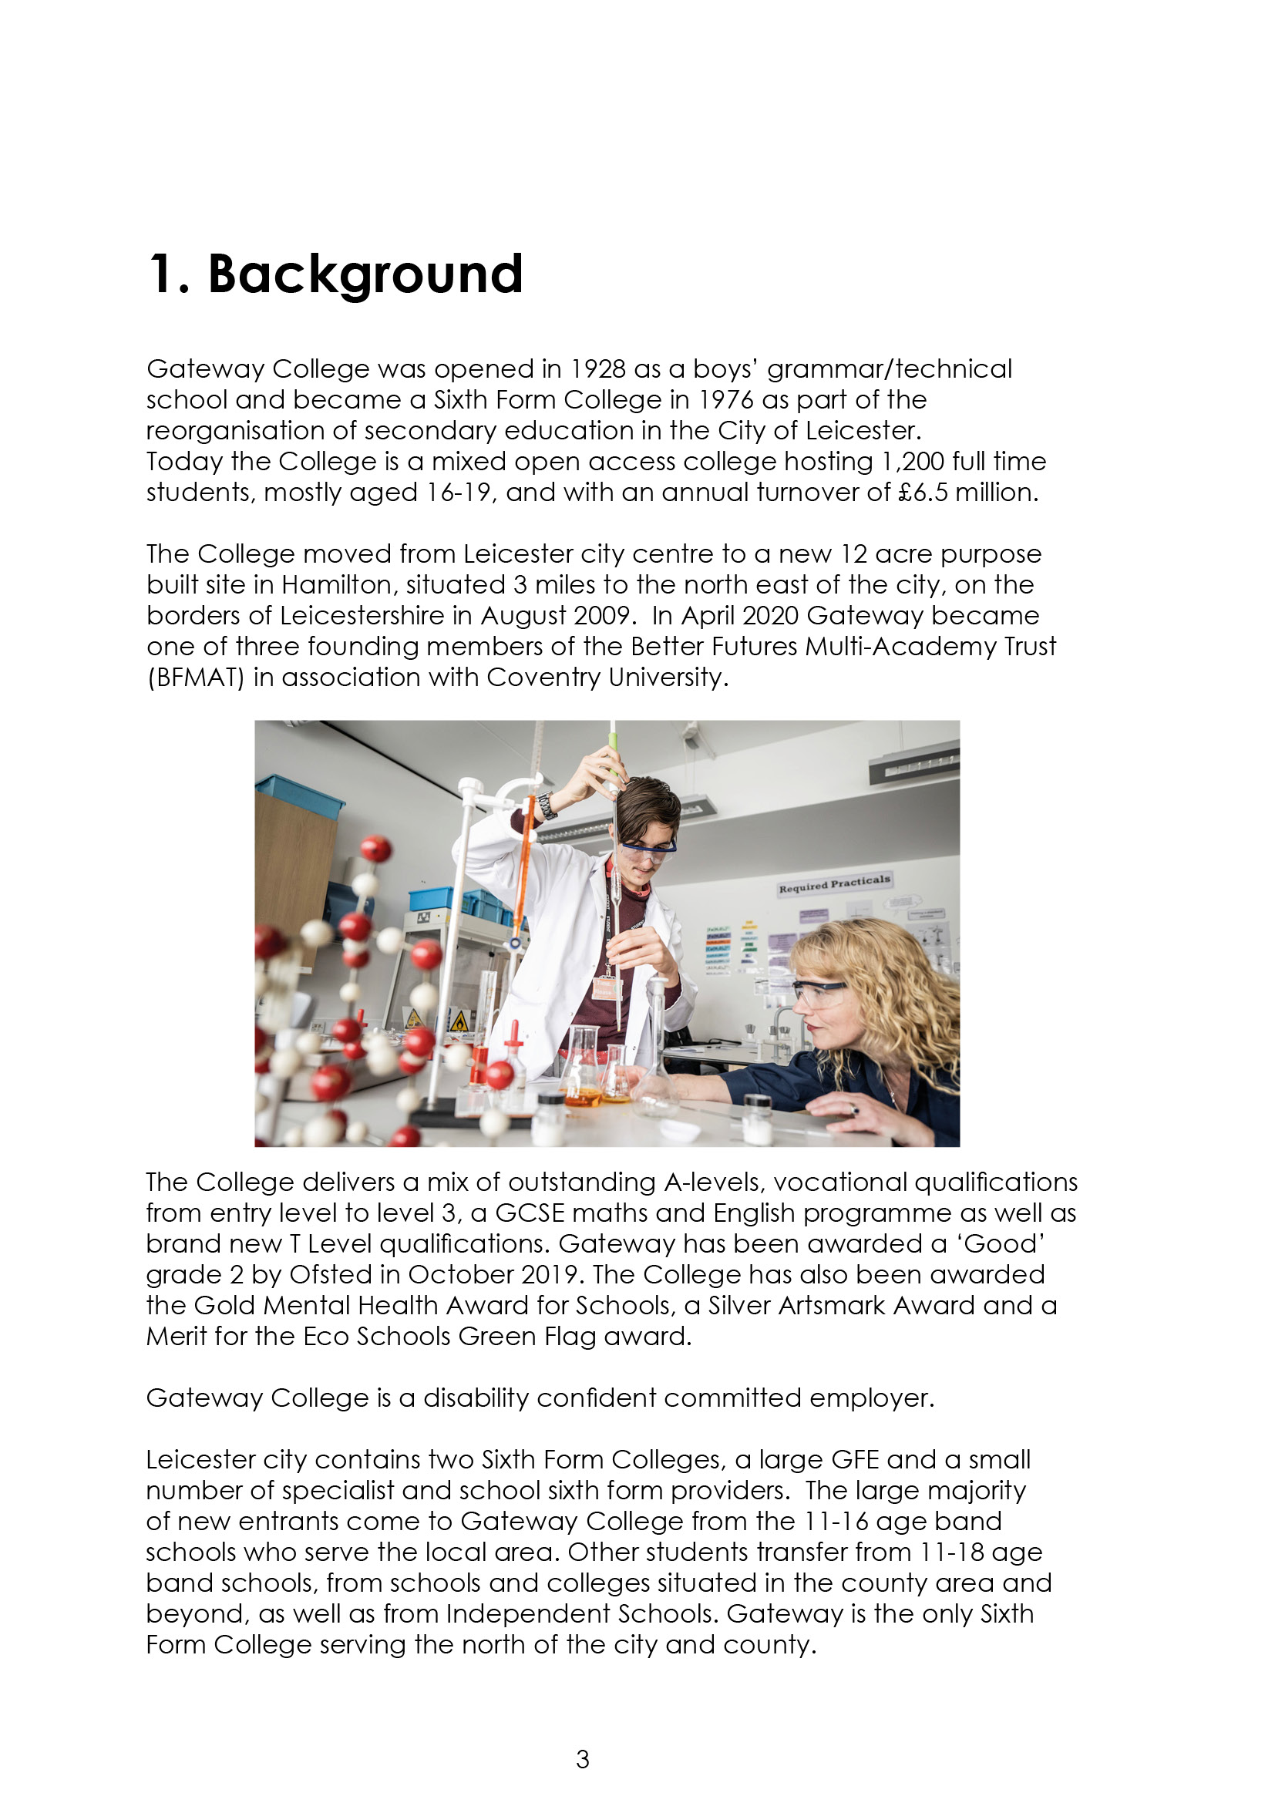

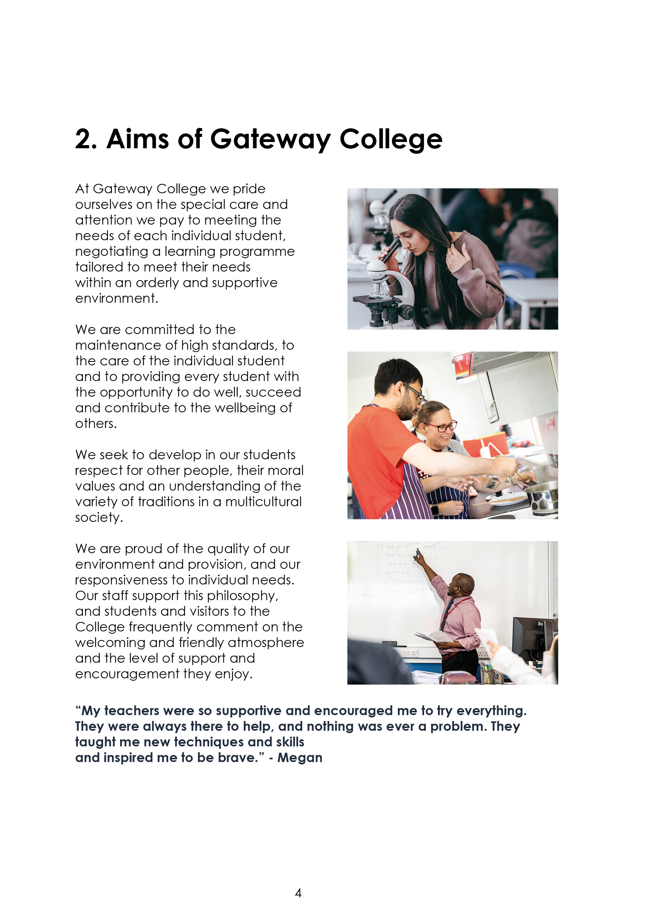

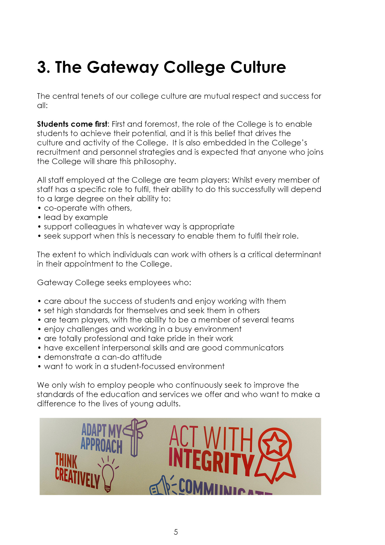

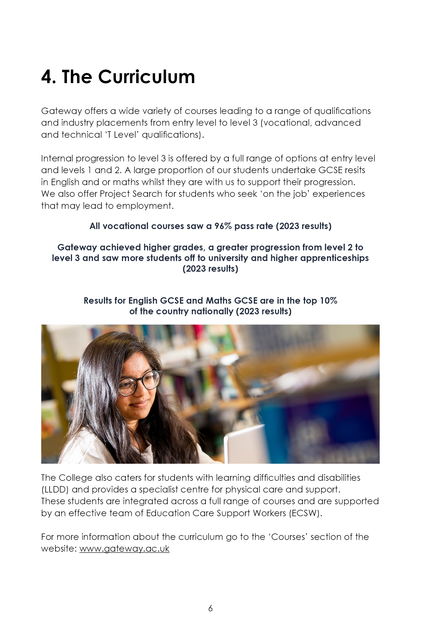



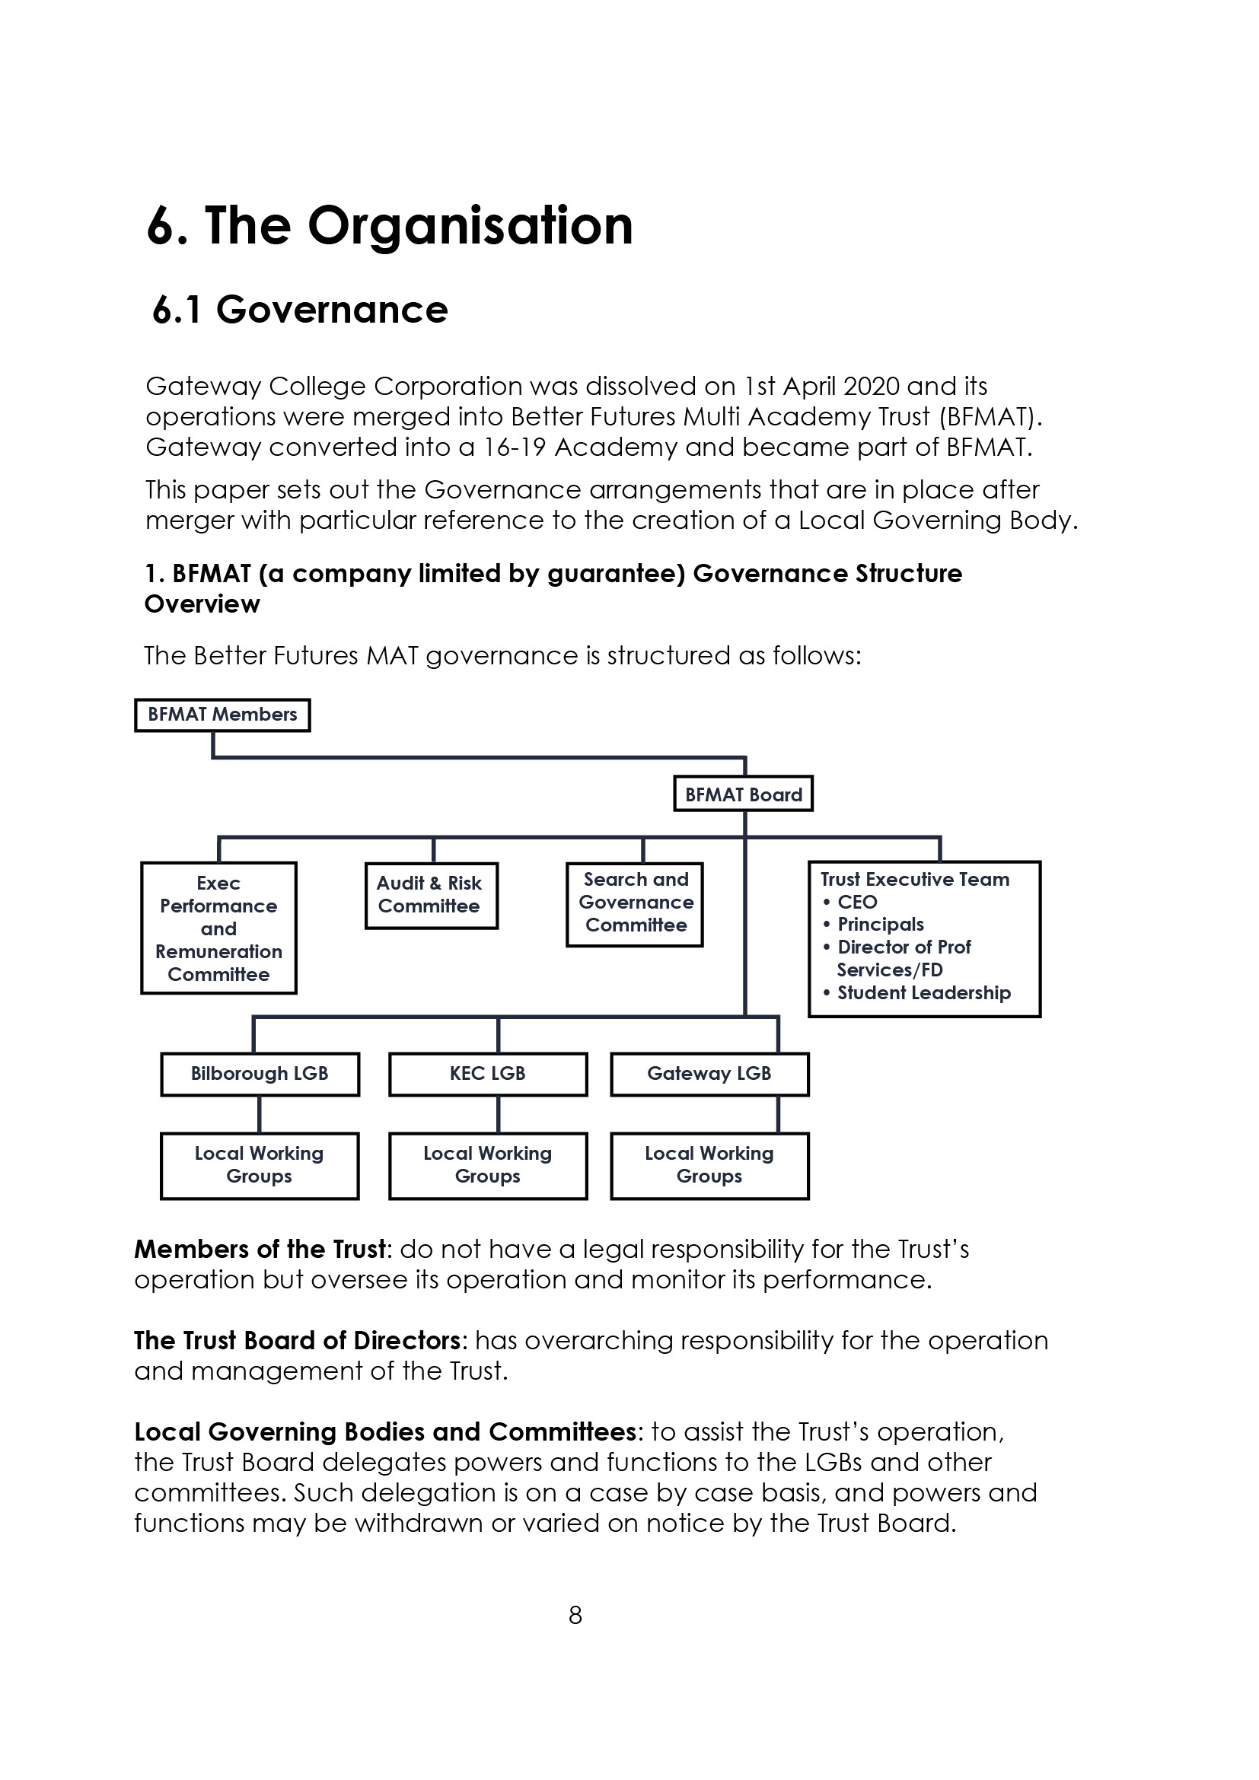

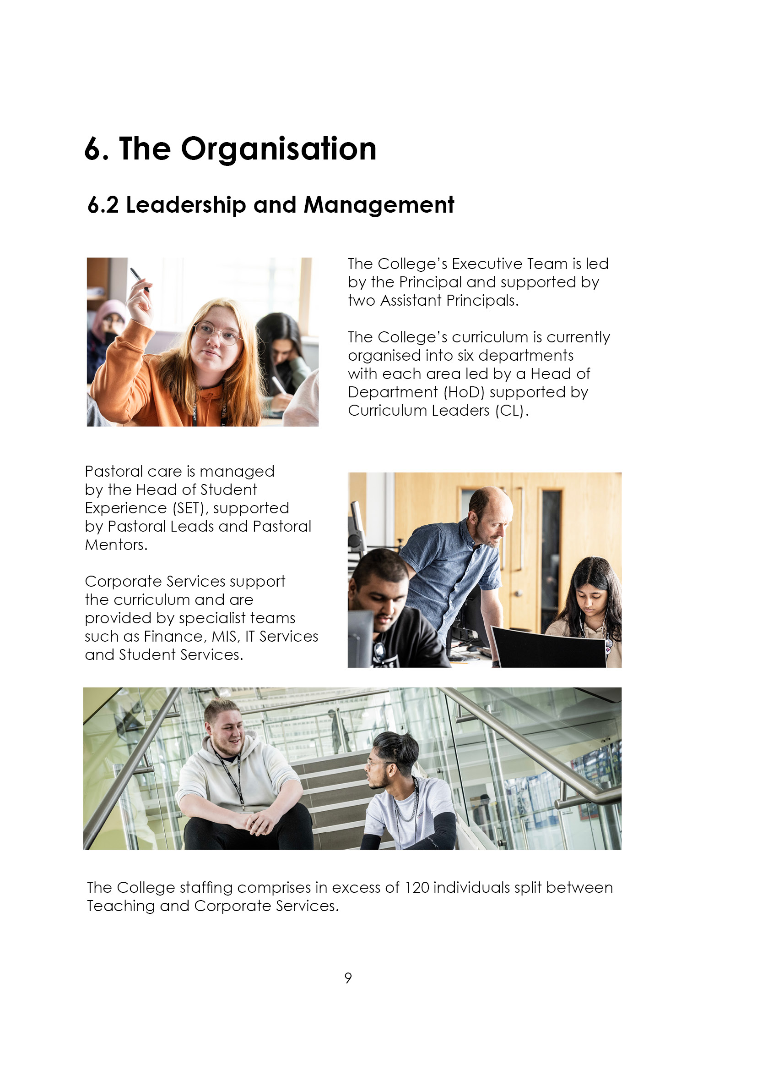

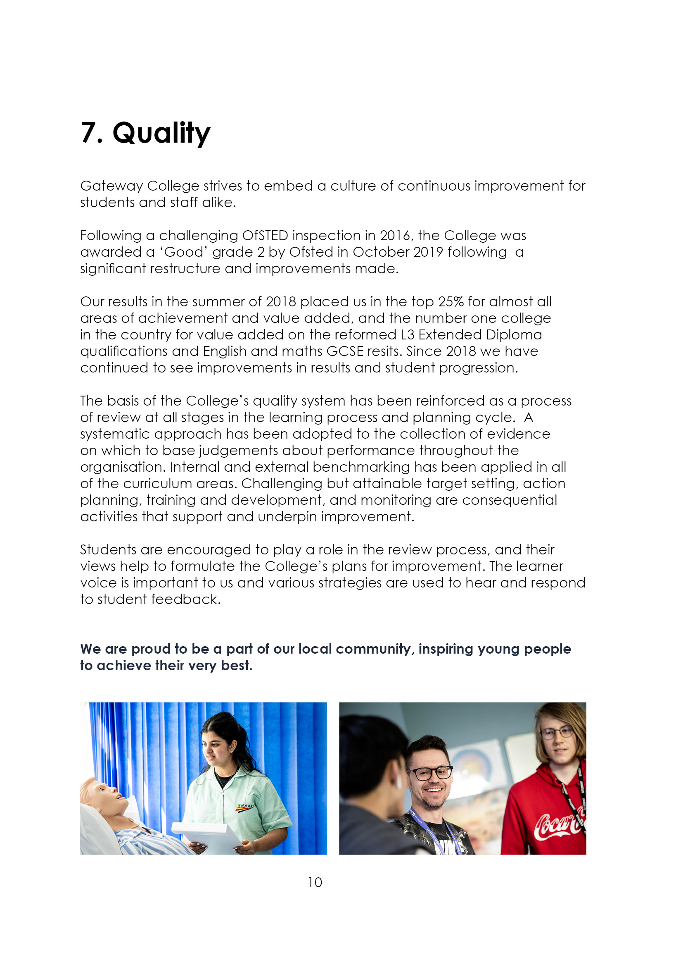

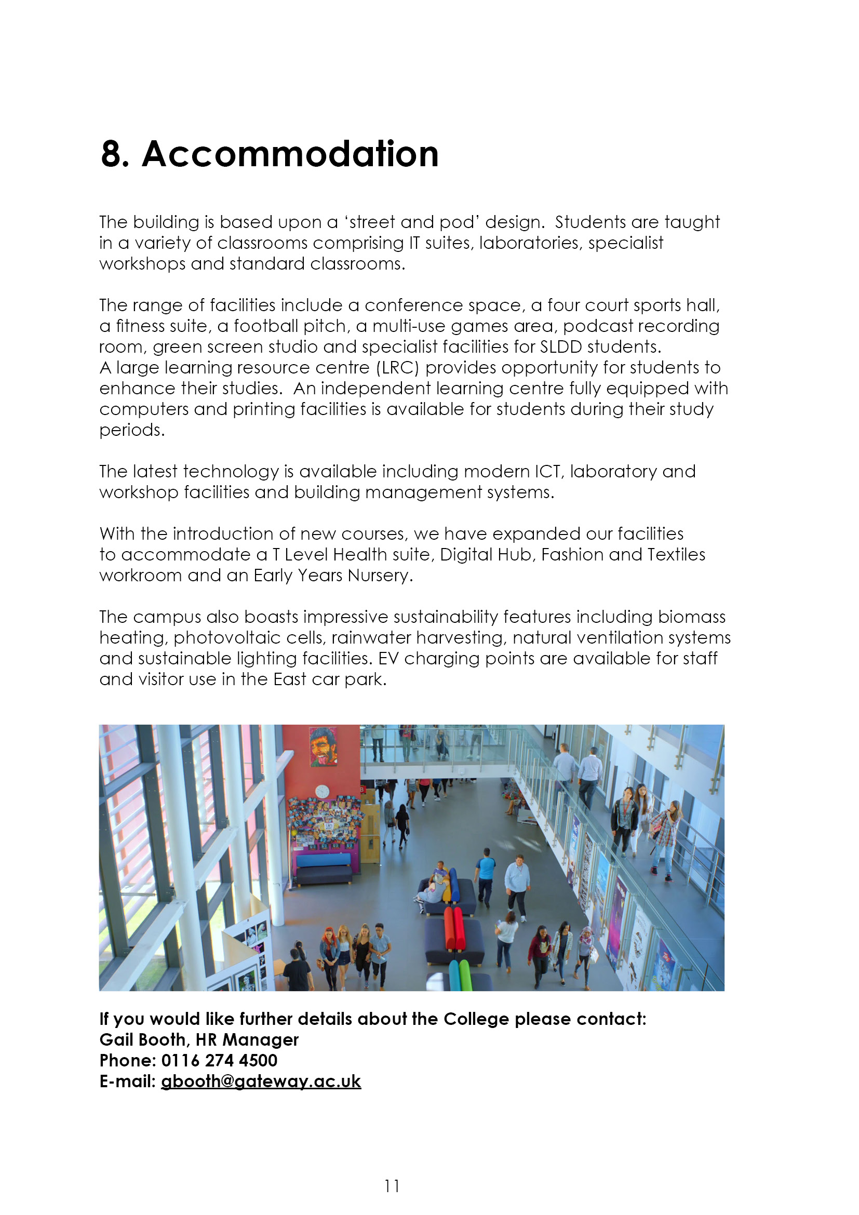

9. Job Advert
TEACHER OF A LEVEL ECONOMICS & BUSINESS STUDIES (1.0 FTE)

Gateway Sixth Form College is a vibrant, forward thinking and aspiring outstanding sixth form provider, catering for 1300 students in the East Leicestershire area. In September 2021, Gateway joined the Better Futures Multi Academy Trust (BFMAT). In September 2022, Gateway launched an exciting range of T Level courses, to further supplement their diverse and inclusive range of A Level and General Applied courses. Gateway College has just recently resecured it’s ‘Good’ grading following a very successful Ofsted Inspection in March 2025.

Gateway has high ambitions and strives towards continued excellence across all areas of the organisation. Business remains one of the most popular subjects for learners at Gateway where in addition to our academic and achievement focus, we are also keen to offer students enrichment opportunities to enhance the learner journey. Gateway College benefits from brand new classroom workspaces and ICT facilities, as well as fantastic professional development opportunities for both newly qualified, and experienced teachers.

We are looking for an enthusiastic, highly skilled and passionate teacher of economics and business studies to join our successful and experienced team. The business department has a wide and varied selection of post sixteen courses, including A Level Business, Economics and Accounts. In addition, we also offer vocational courses at Level 1 to Level 3. In September 2022 we launched the first of our T Level courses; City & Guilds Management and Administration, in conjunction with our expanding industry partners network.

For this exciting and professionally challenging role, applicants should have a teaching qualification and relevant industry experience would be an advantage. The position is suitable for both experienced teachers or NQT’s.

The post is to commence on 18th August 2025

Employment is under the Sixth Form Colleges contract, 195 days (1265 hours) with the SFCA pay spine (£32,178 - £49,725) dependent on qualifications and experience.

Closing date: Monday 16th June (12 noon)
Interview date: TBC.

Further details and an application pack can be found at Teaching and education jobs in LE5 1GA | Tes or by contacting hr@gateway.ac.uk. We welcome potential candidates who wish to come and tour the college, and to meet with members of the business team.

10. Job Description
The generalised duties and responsibilities laid down in the Teachers Statement of Conditions of Employment apply to all staff. These should be read in conjunction with this outline job description.

Duties and Responsibilities:
- To undertake the teaching of students working on all courses up to level 3, or any other programmes, using a variety of teaching methods and learning styles.

- To participate under the direction of the Head of Department (HoD) in the development of appropriate specifications, schemes of work, supported self study material and the use of information technology.

- To participate as a member of a team in the organisation of course material, resources and stock maintenance and the general management of subject areas.

- To ensure that in the teaching room assigned to the teacher, displays are regularly updated and that the room is generally kept in good order, with any problems reported using the normal College procedure.

- To participate in appropriate meetings with colleagues, progress coaches and parents.

- To set appropriate work/homework for students.

- To maintain detailed records of each student's attendance and progress.

- To discuss with students regularly their progress and to refer, as appropriate, students to the Schools Team.

- To provide students with tutorial opportunities for individual/small group discussion as required within the College's published time budget.

- To participate in appropriate CPD.

- To undertake such other duties relevant to and connected with the teaching and running of the College as the Principal may reasonably require, which may include the teaching, or a contribution to the teaching of, other subjects or teaching elsewhere.

13. To negotiate an appropriate range of courses for each student during the induction period and monitor and adapt this provision whenever necessary in consultation with other staff and the student.
14. To liaise with subject teachers and other colleagues as necessary.
15. To liaise closely with the HoD and/or Aissistant Principal and refer students as appropriate.
16. To liaise with parents/guardians/external agencies as appropriate.
17. To monitor and develop each student's profile and to prepare initial drafts of references and
reports as required.
18. To provide information and data as and when required.
19. To attend parents' evenings and discuss students' progress.
20. To participate in appropriate meetings with colleagues in addition to those specified in the College calendar.
21. To undertake other reasonable duties as required by the Principal.

ESSENTIAL | Method of Assessment | Short listing Column
- Graduate in Business Studies or a business related subject, with a PGCE or recognised teaching qualification. | A
- Experience of teaching at least one Business Studies related subject to level 2 or level 3. | A
- Experience of post-16 teaching. | A
- Ability to work as a member of a team. | I
- Organisational skills and the ability to develop new resources as a member of a team. | I
- Awareness of the needs of students in the post-16 education sector. | I
- Professional competency and ability to teach 14-19 using a broad range of teaching and learning styles. | I
- Good IT skills, or a positive ability and willingness to develop such skills. | A
- Willingness to contribute to the extra-curricular life of the College. | I
- Awareness of recent educational developments in the post-16 sector. | I
- Recognition and support for the Gateway College educational philosophy of individual support, personal choice and positive achievement. | I
- A sense of humour, patience, resilience and energy at all times. | I
- Willingness to extend the range of business orientated activities e.g. Work Experience, Games. | I

DESIRABLE

- Extra academic qualification, including the ability to offer a second teaching discipline, within the Business and I.T department. | A
- Experience of College’s present specifications. | I
- Successfully taught a wide range of student abilities and experience of curriculum development. | A
- Evidence of team player activities. | I
- Evidence of curriculum resource development. | I
- Recognition of quality standards and procedures in teaching and learning. | I
- Outstanding practical skills in using IT within Faculty subject areas, including IT applications. | A
- Ability to offer an ‘additional study’ or recreational activity. | I
- A commitment to all students and a clear understanding of all equal opportunities. | I

A = Application form
I = Interview
Gateway College is subject to the Safeguarding Vulnerable Groups Act 2006 which requires that any candidate appointed must produce:

- A DBS clearance certificate
- Proof of identity
- Proof of qualifications
- Proof of the right to work in the UK.

All of these documents must be produced BEFORE commencement of employment.

