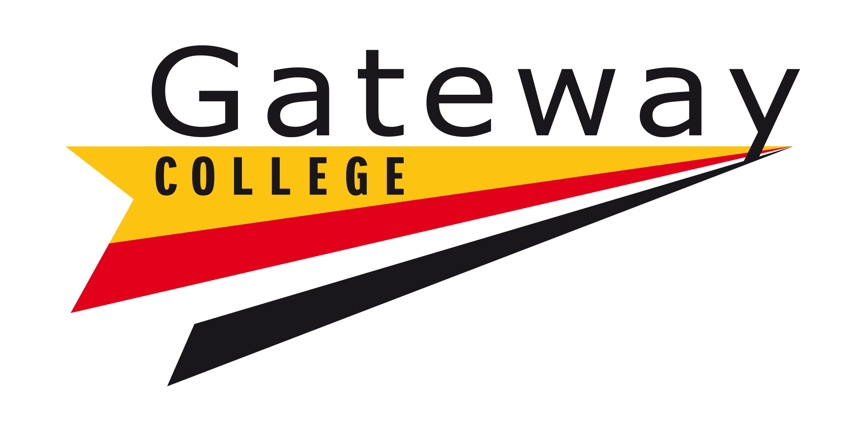

**Term Dates: 2025-26**

**Autumn Term 2025**

Start: Monday 18th August 2025 (44)

(Bank Holiday: Monday 25th August 2025)

Half Term: (Monday 20th October to Friday 24th October 2025)

End: Friday 19th December 2025 (40)

Term = 84 days

**Spring Term 2026**

Start: Monday 5th January 2026 (30)

Half Term: (Monday 16th February to Friday 20th February 2026)

End: Friday 27th March 2026 (25)

Term = 55 days

**Summer Term 2026**

Start: Monday 13th April 2026

(May Day: Monday 4th May 2026) (28)

Half Term: (Monday 25th to Friday 29th May 2026)

End: Friday 3rd July 2026* (25)

Monday 6th July 2026**

Term = 53 days