

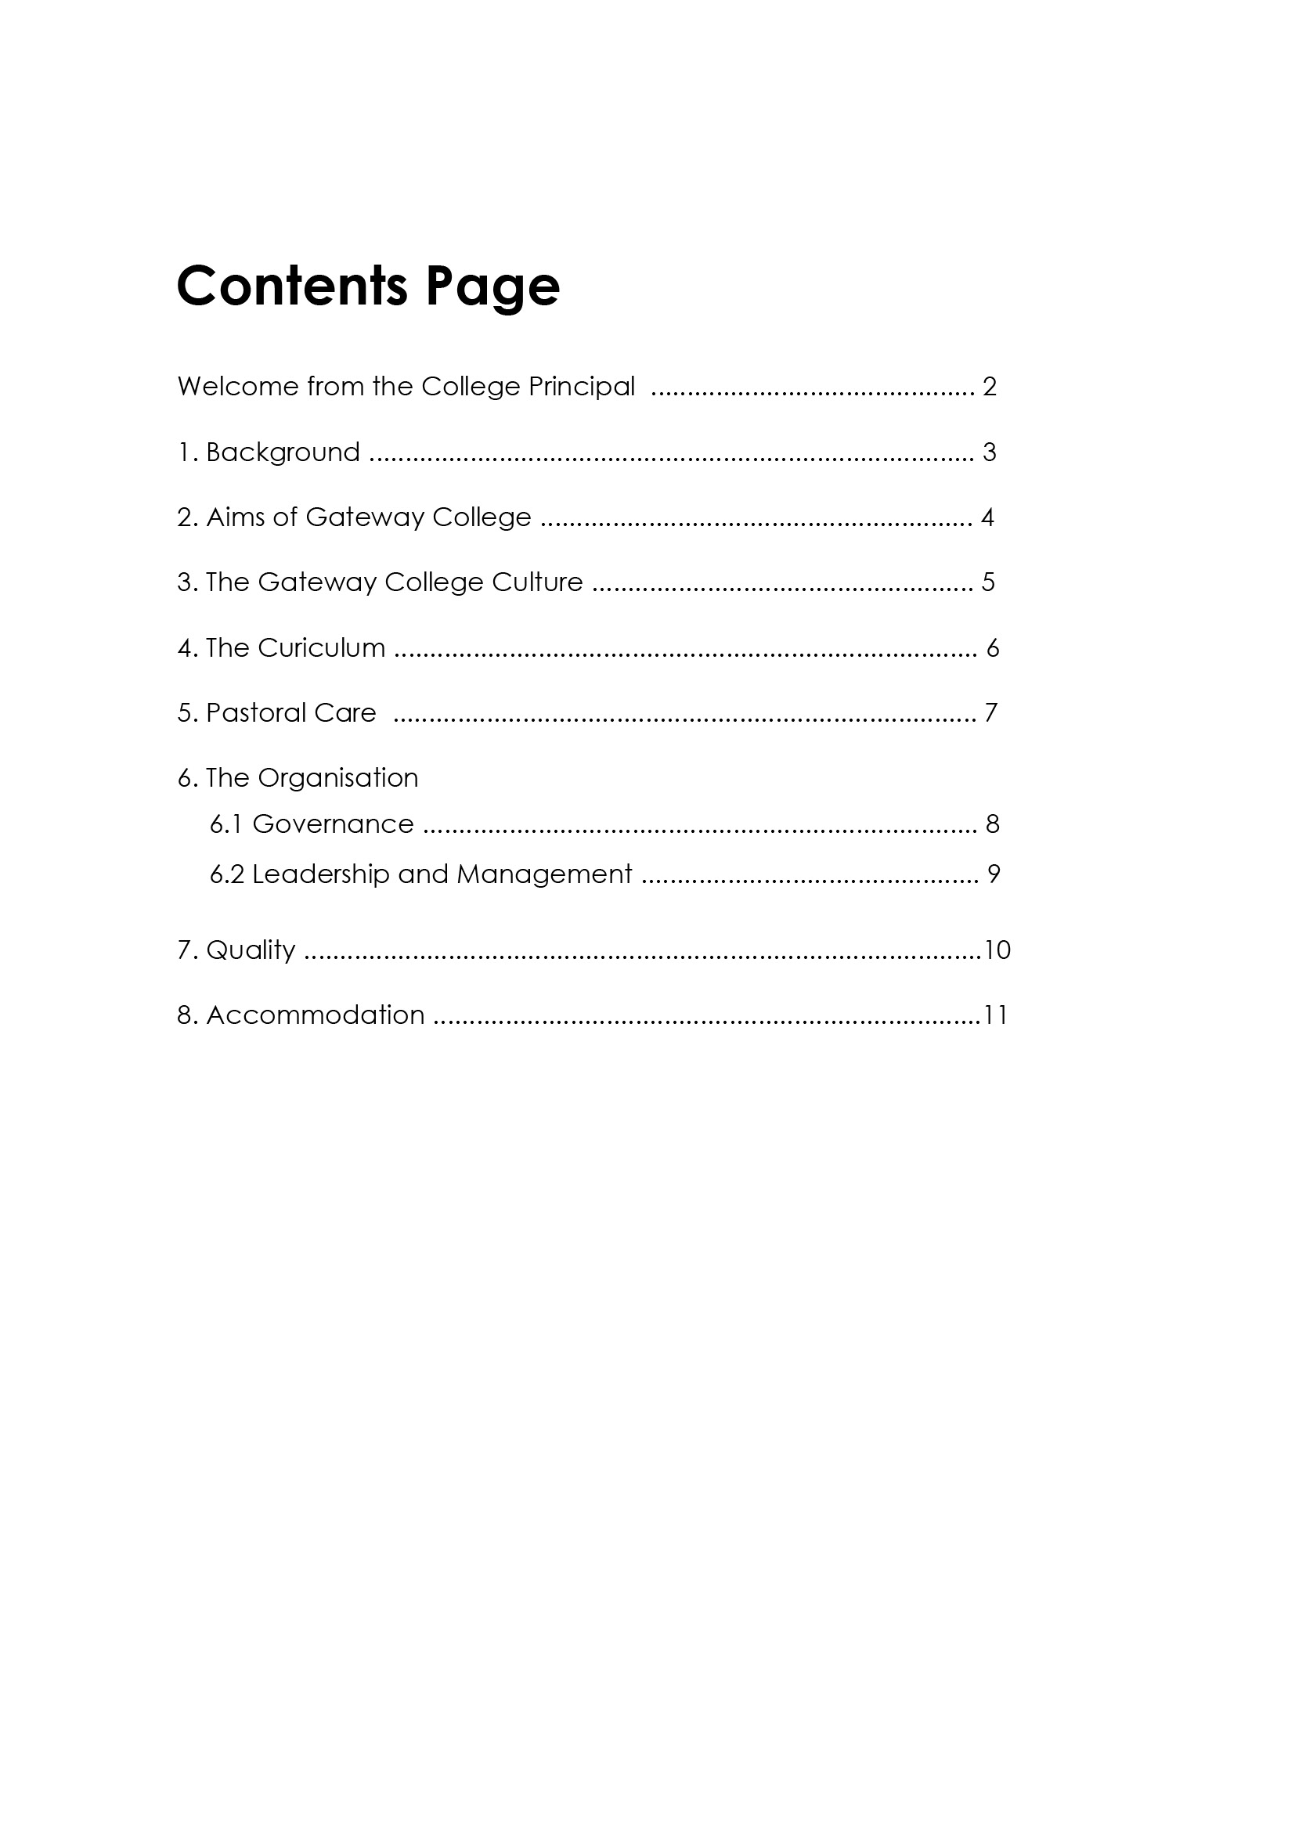

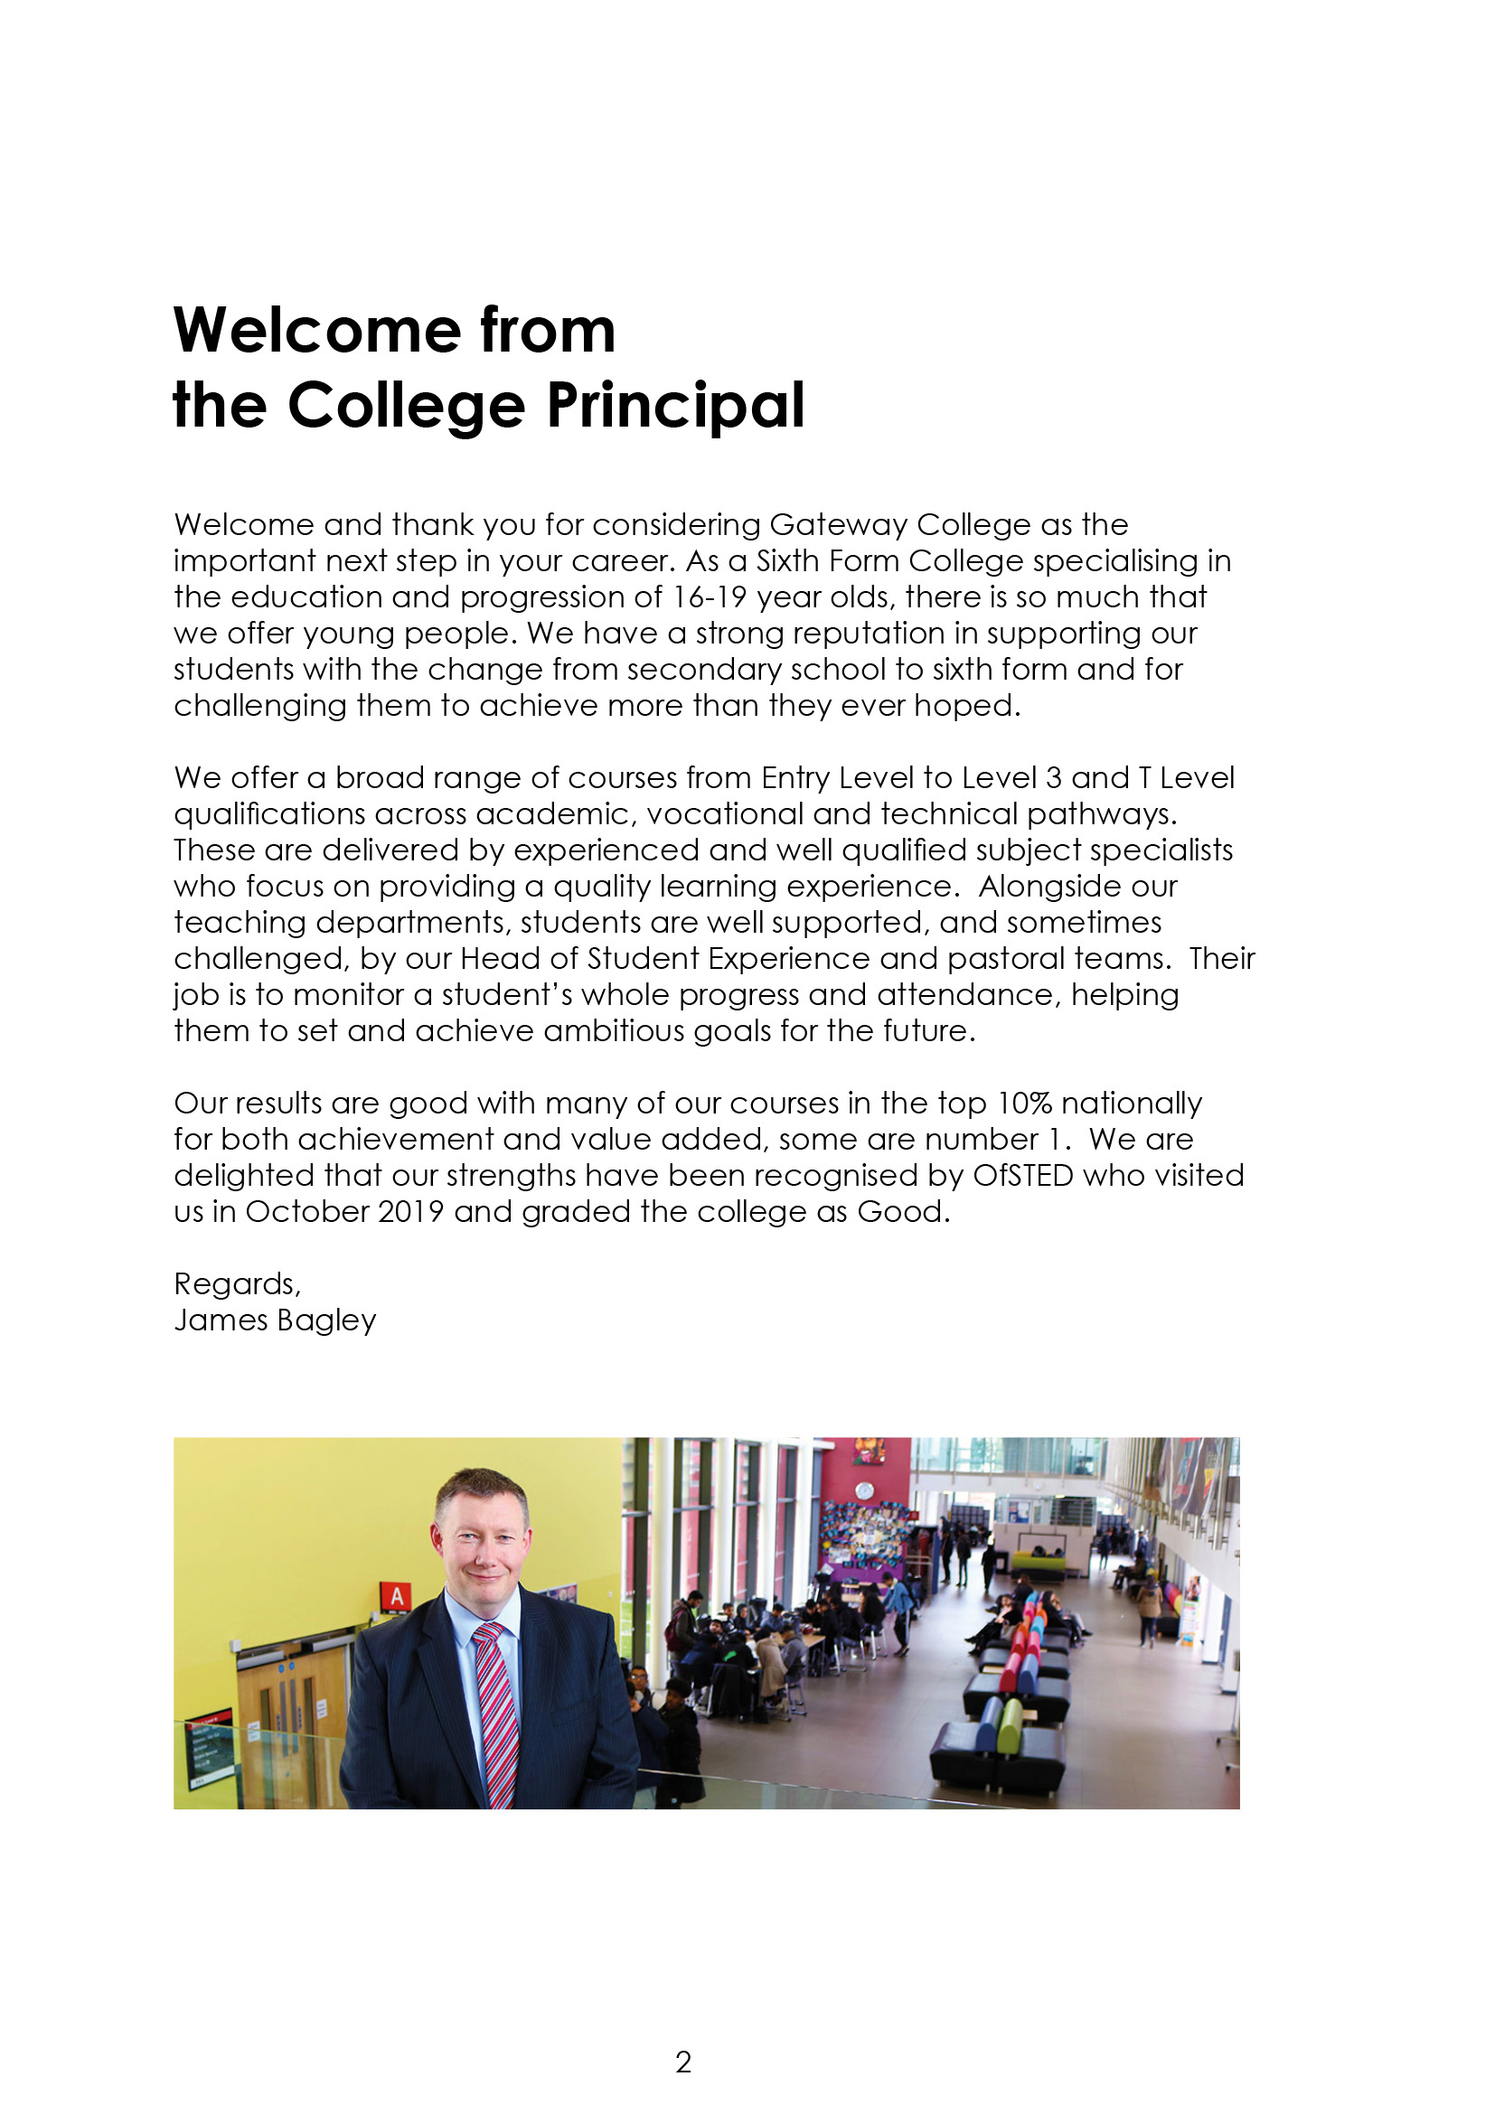

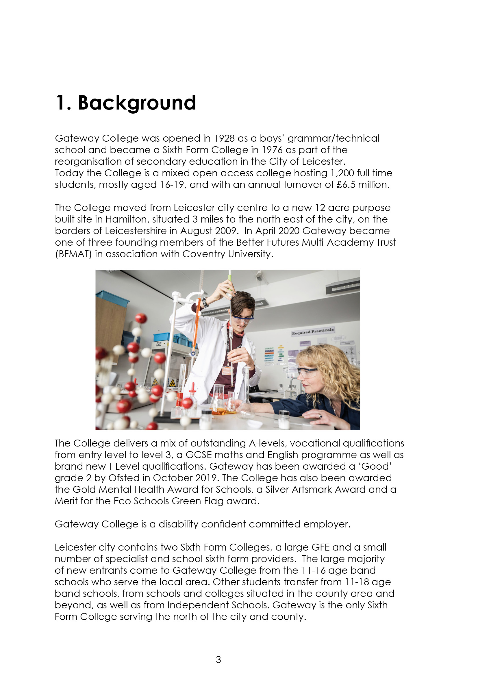

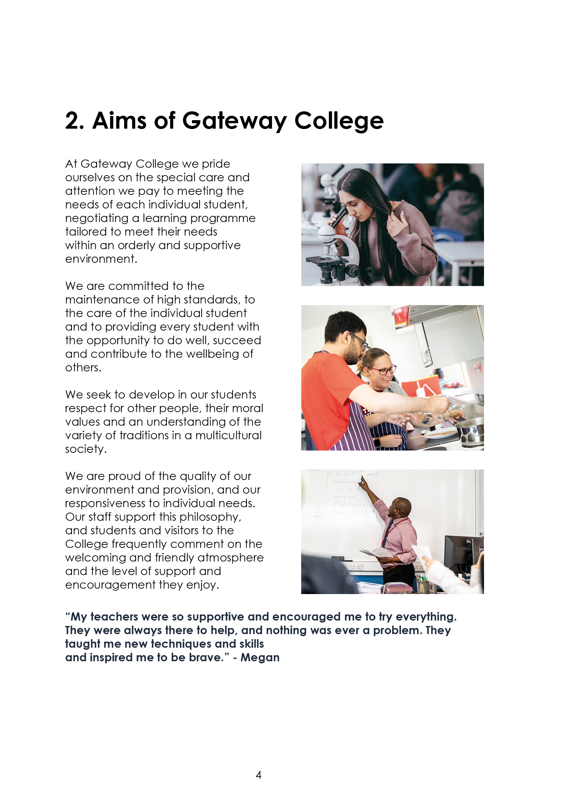

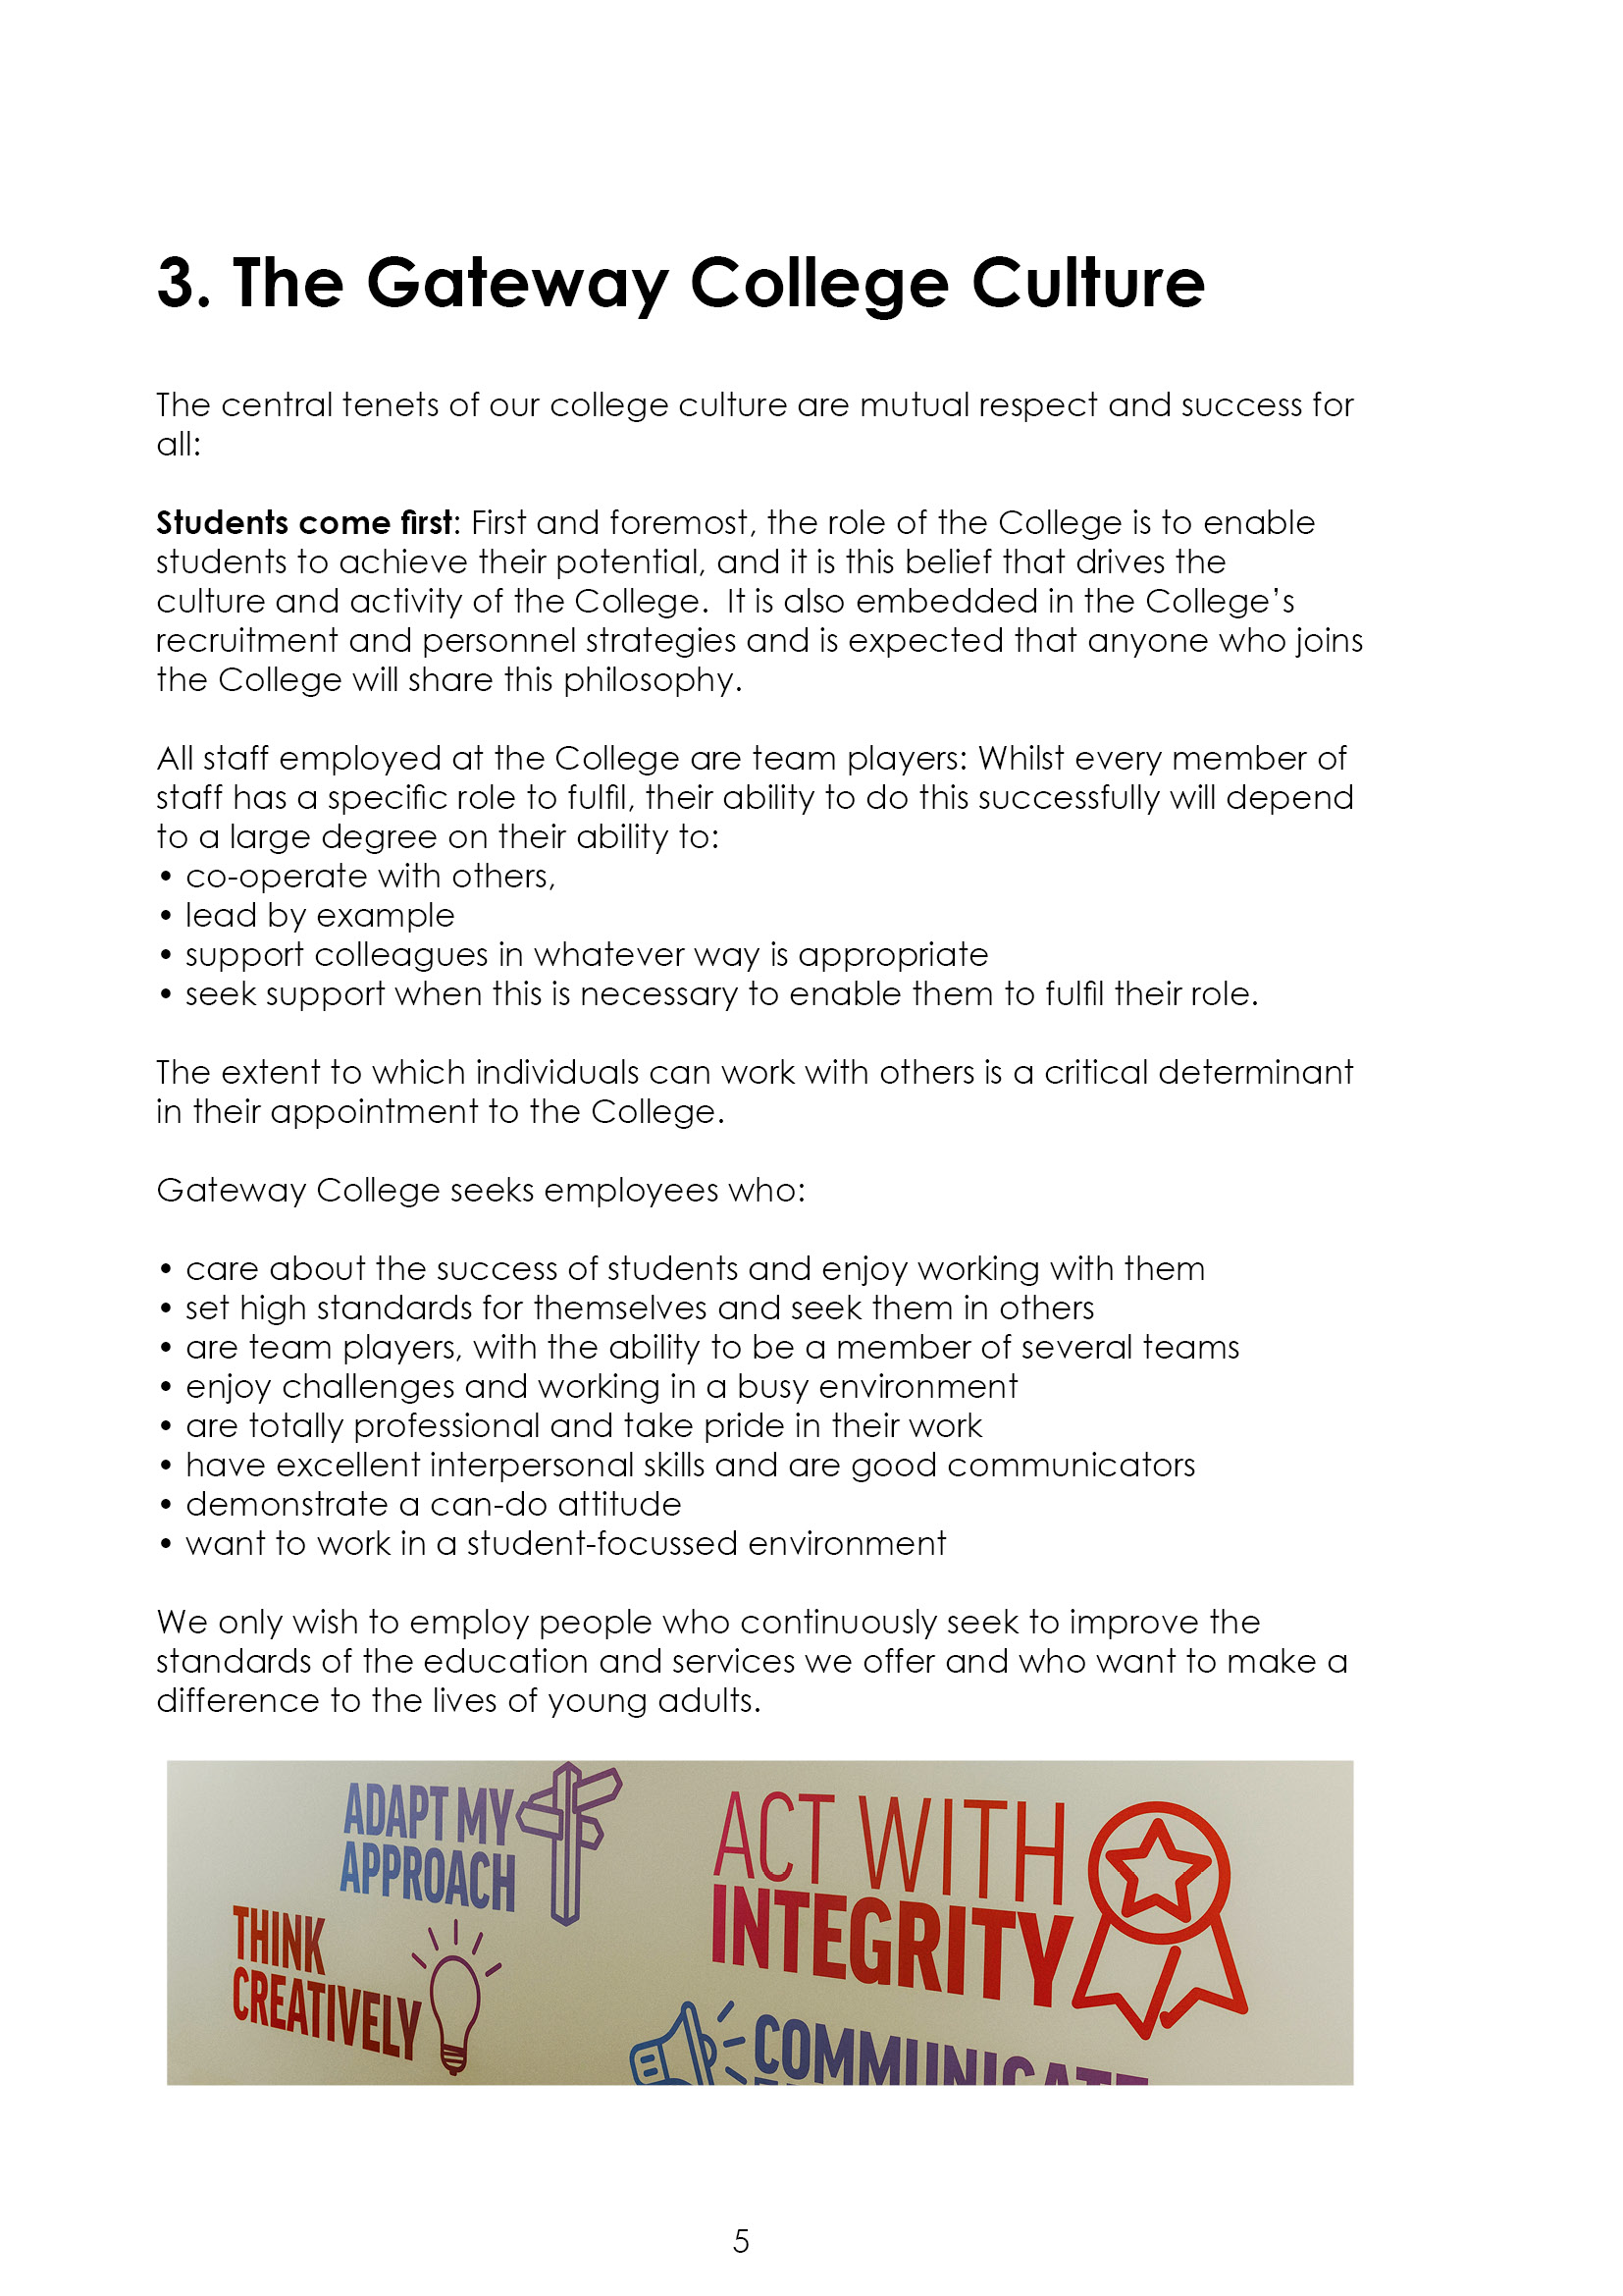

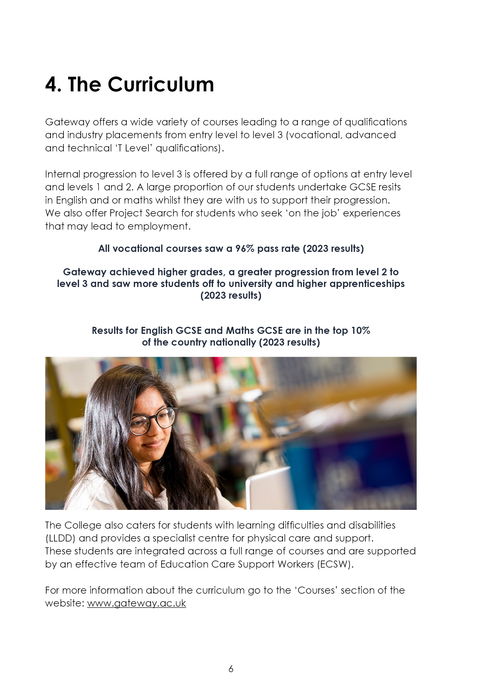



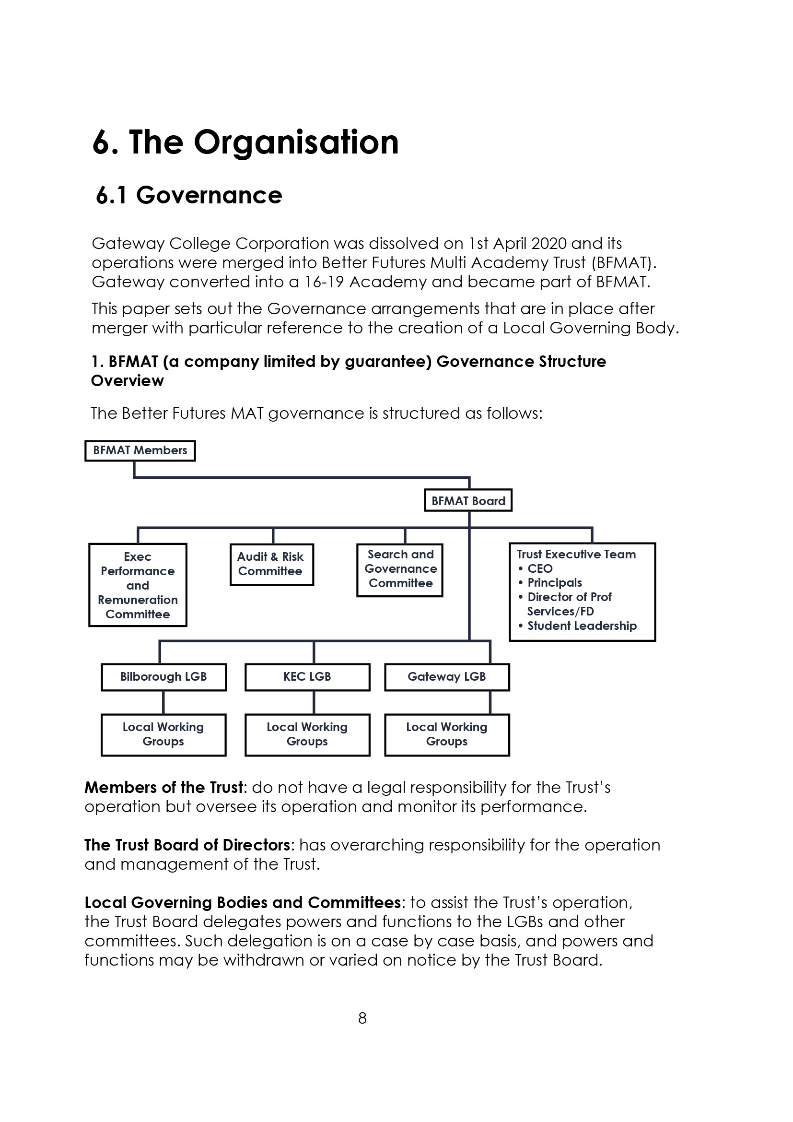



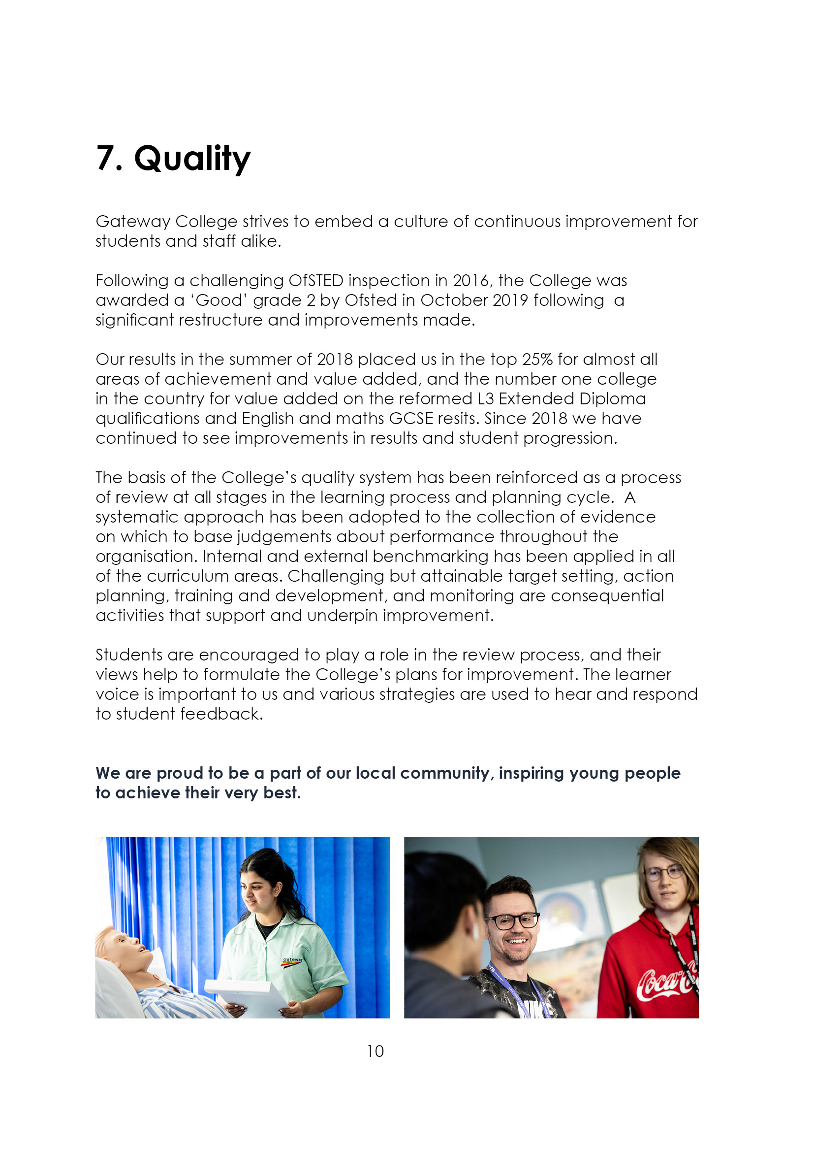

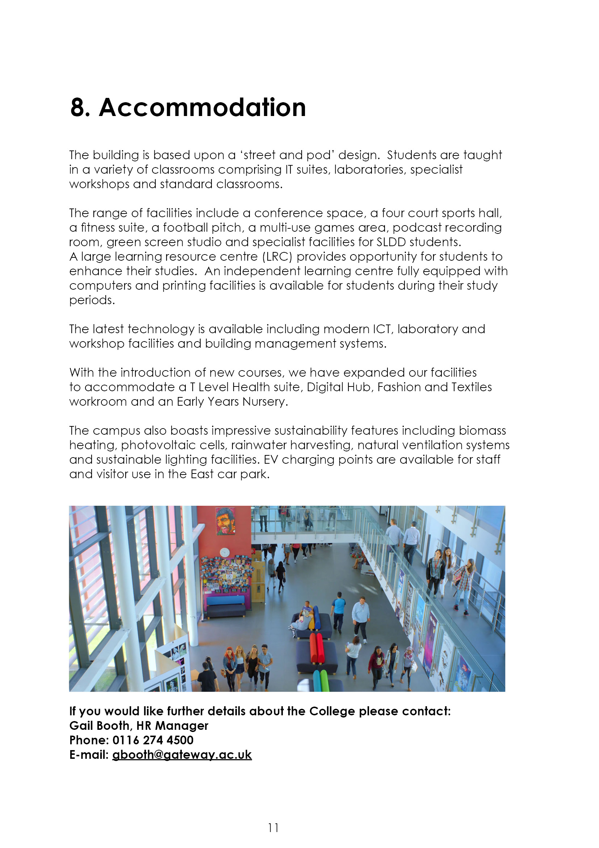

9. Job Advert
TEACHER OF MATHEMATICS (Ref: 25-06)
0.4 FTE (possibility of additional hours), permanent

Mathematics is crucial to the success and progression of young people in all aspects of their lives. At Gateway College, we offer maths courses at all levels, ensuring accessibility for everyone.
As a team, we believe in working collaboratively, sharing ideas, and supporting one another to achieve our potential together. We prioritise students’ needs and wellbeing, striving to remove barriers to learning and create a supportive, nurturing environment.
We are seeking a dynamic, passionate, and creative teacher to join our successful and supportive team to teach GCSE Maths. The successful candidate will have in-depth subject knowledge and, ideally, experience teaching resit students. This position is suitable for both experienced teachers and ECTs/NQTs.
Closing date: 30th April 2025 (12 noon)
Interview date: 8th May 2025
The post is to commence on 18th August 2025.
Employment is under the Sixth Form Colleges contract, 195 days (1265 hours) with the SFCA pay spine £32,178 - £49,725 FTE dependent on qualifications and experience.
Further details and an application pack can be found at Teaching and education jobs in LE5 1GA | Tes or www.gateway.ac.uk.

10. Job Description
Reporting to: Head of Department, Assistant Principal
Accountable to: The Principal
Tenure: 0.4 FTE, permanent.
Salary: Sixth Form College’s Pay Spine Points 1 – 9, £32,178 - £49,725 FTE

Duties and Responsibilities:

The generalised duties and responsibilities laid down in the Teachers Statement of Conditions of Employment apply to all staff. These should be read in conjunction with this outline job description.

- To undertake the teaching and support of students working on Mathematics courses up to GCSE, or any other programmes, using a variety of teaching methods and learning styles.
- To participate under the direction of the Head of Department (HoD) in the development of appropriate specifications, schemes of work, supported self study material and the use of information technology.
- To participate as a member of a team in the organisation of course material, resources and stock maintenance and the general management of subject areas.
- To ensure that in the teaching room assigned to the teacher, displays are regularly updated and that the room is generally kept in good order, with any problems reported using the normal College procedure.
- To take part, where appropriate, in the College personal guidance programme and recreational activities.
- To participate in appropriate meetings with colleagues, progress coaches and parents.
- To set appropriate work/homework for students and independent study tasks.
- To maintain detailed records of each student's attendance and progress.
- To discuss progress regularly with students and to refer, as appropriate, to the HoD, Assistant Principal (AP) or Tutors.
- To provide students with tutorial opportunities for individual/small group discussion as required within the College's published time budget.
- To participate in appropriate CPD.
- To undertake such other duties relevant to and connected with the teaching and running of the College as the Principal may reasonably require, which may include the teaching, or a contribution to the teaching of, other subjects or teaching elsewhere.

- To negotiate an appropriate range of courses for each student during the induction period and monitor and adapt this provision whenever necessary in consultation with other staff and the student.
- To liaise with subject teachers and other colleagues as necessary.
- To liaise closely with the HoD and/or AP and refer students as appropriate.
- To liaise with parents/guardians/external agencies as appropriate.
- To monitor and develop each student's profile and to prepare initial drafts of references and reports as required.
- To provide information and data as and when required.
- To attend parents' evenings and discuss students' progress.
- To participate in appropriate meetings with colleagues in addition to those specified in the College calendar.
- To undertake other reasonable duties as required by the Principal.

Notes:

The above responsibilities are subject to the general duties and responsibilities contained in the statement of conditions of employment and our equal opportunities policy.

This job description allocates duties and responsibilities but does not direct the particular amount of time to be spent on carrying them out and no part of it may be so construed.

This job description is not necessarily a comprehensive definition of the post and is subject to review following consultation.

This post is subject to enhanced disclosure from the Disclosure and Barring Service (DBS).



