

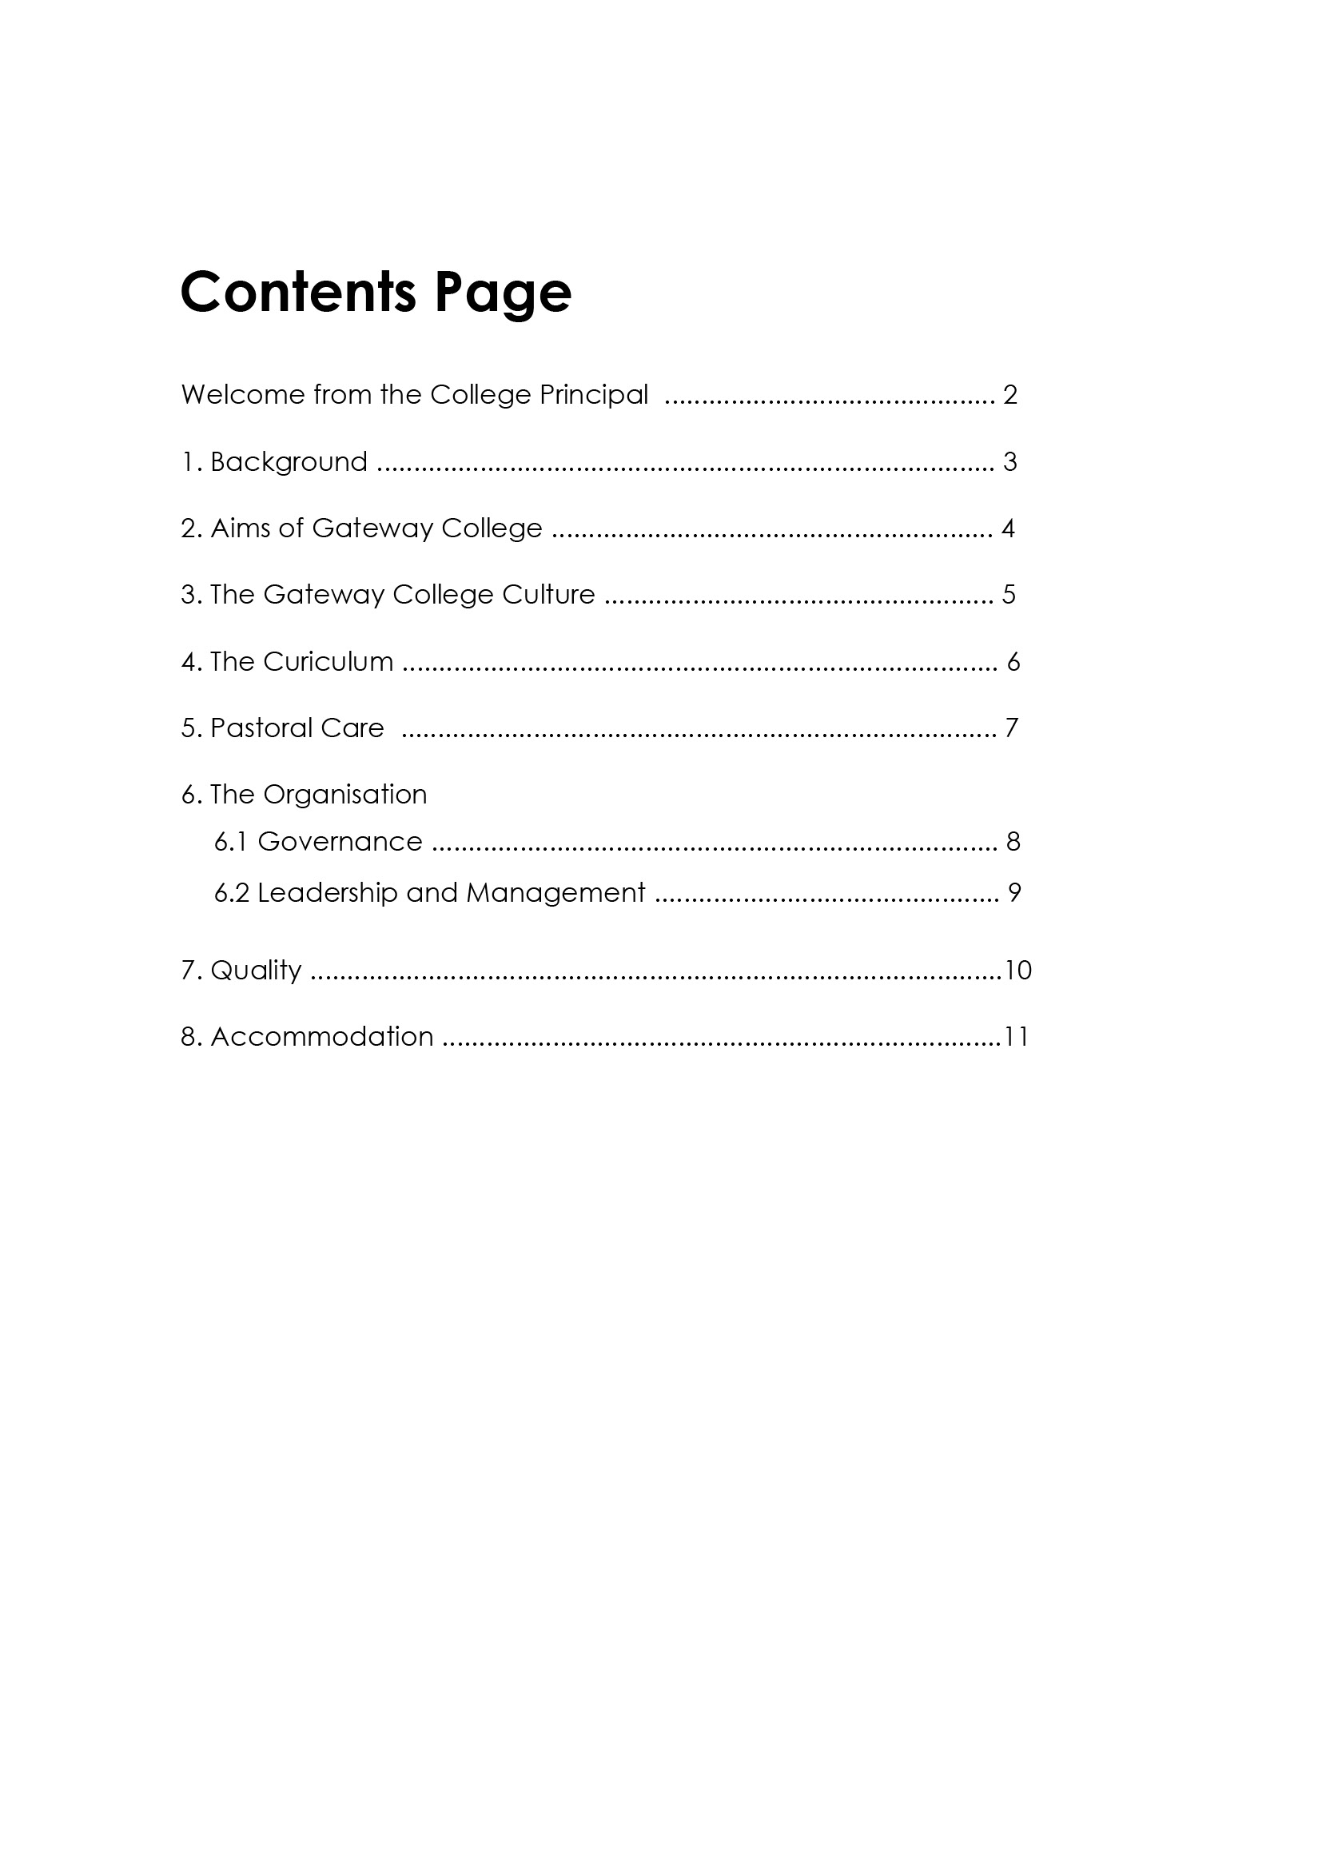

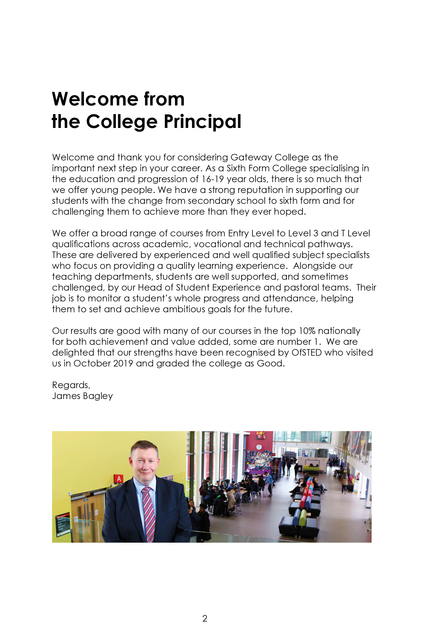

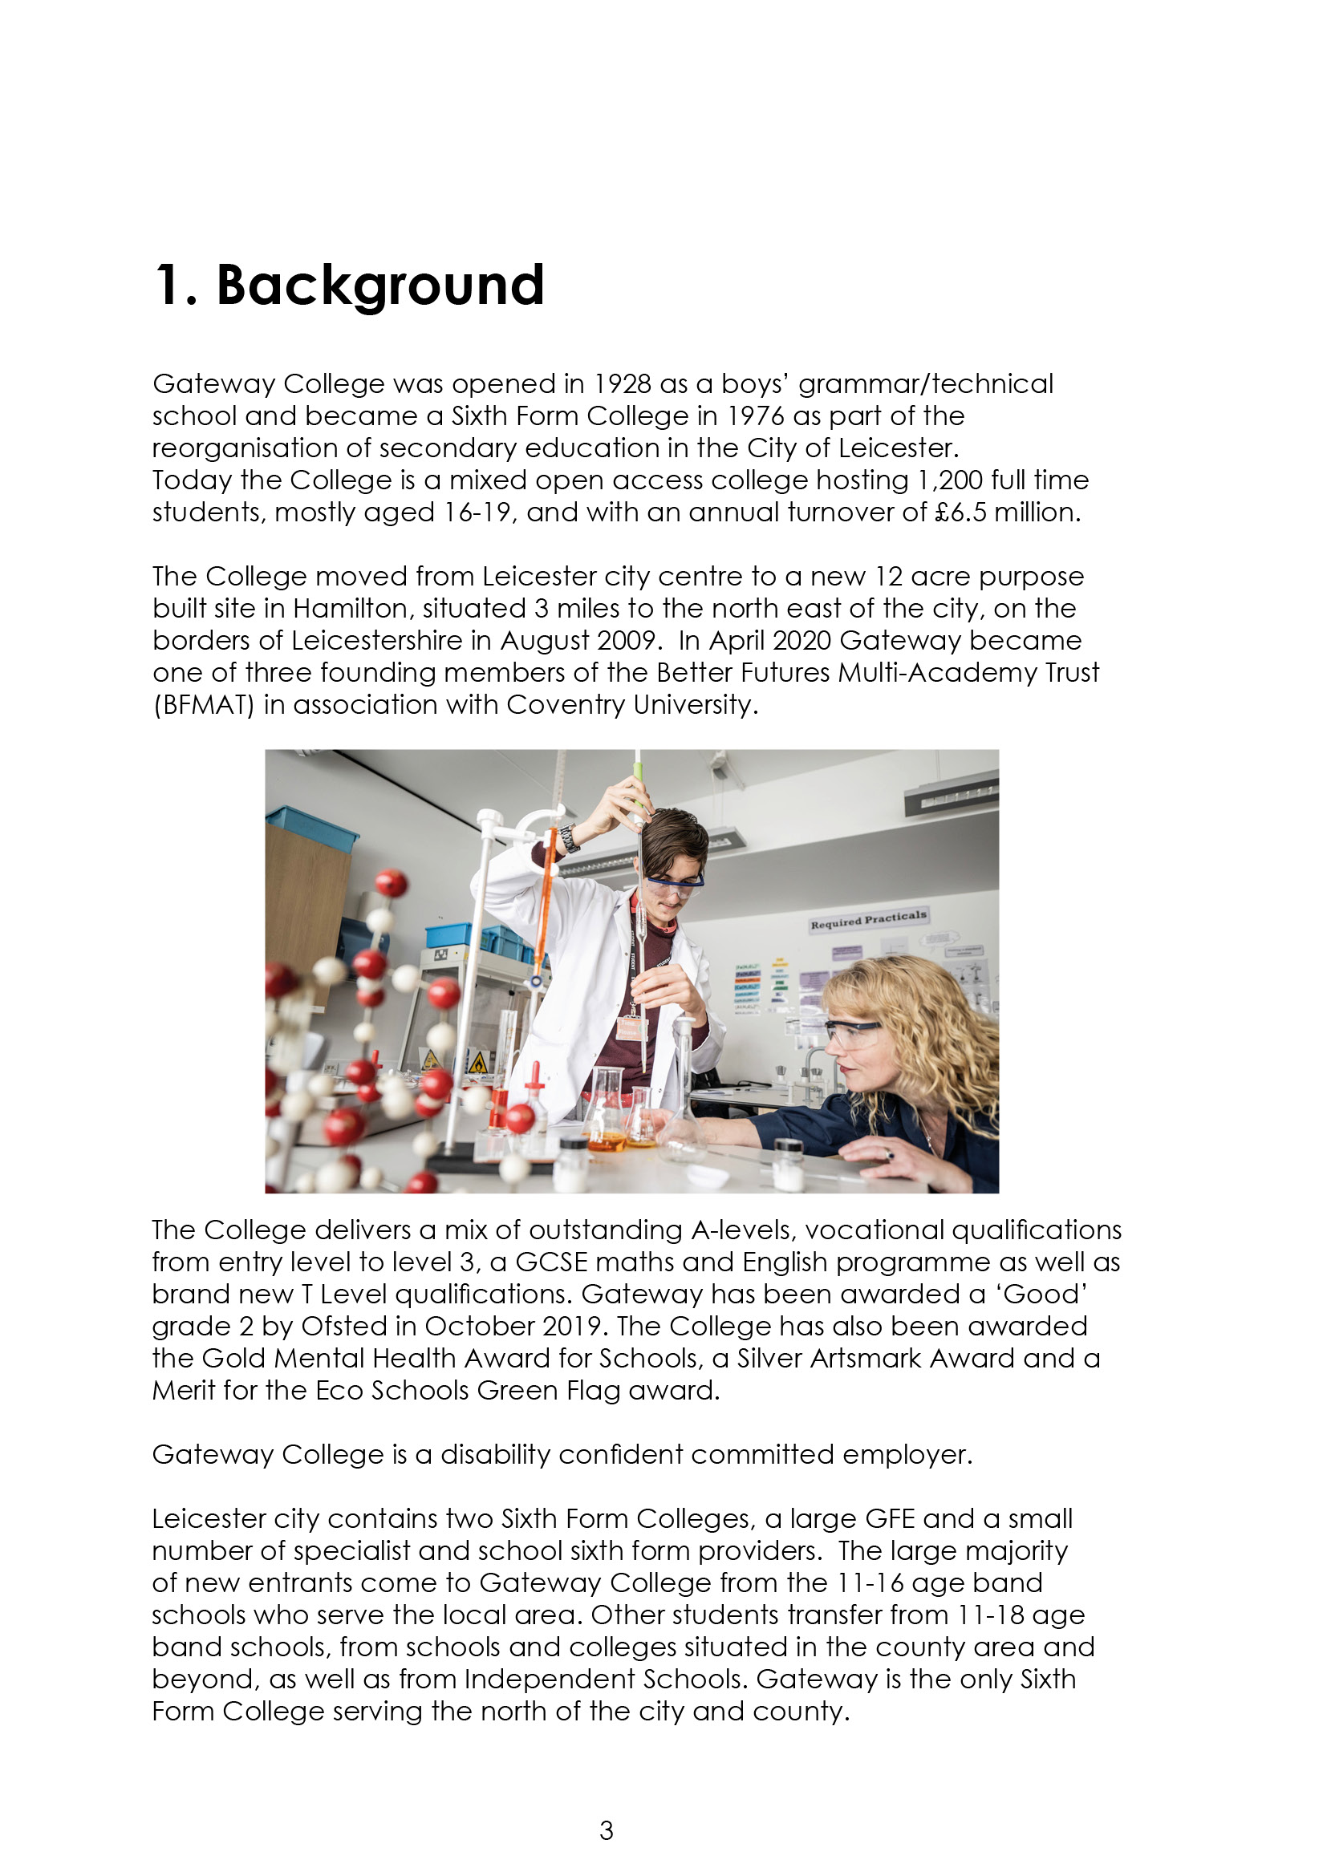

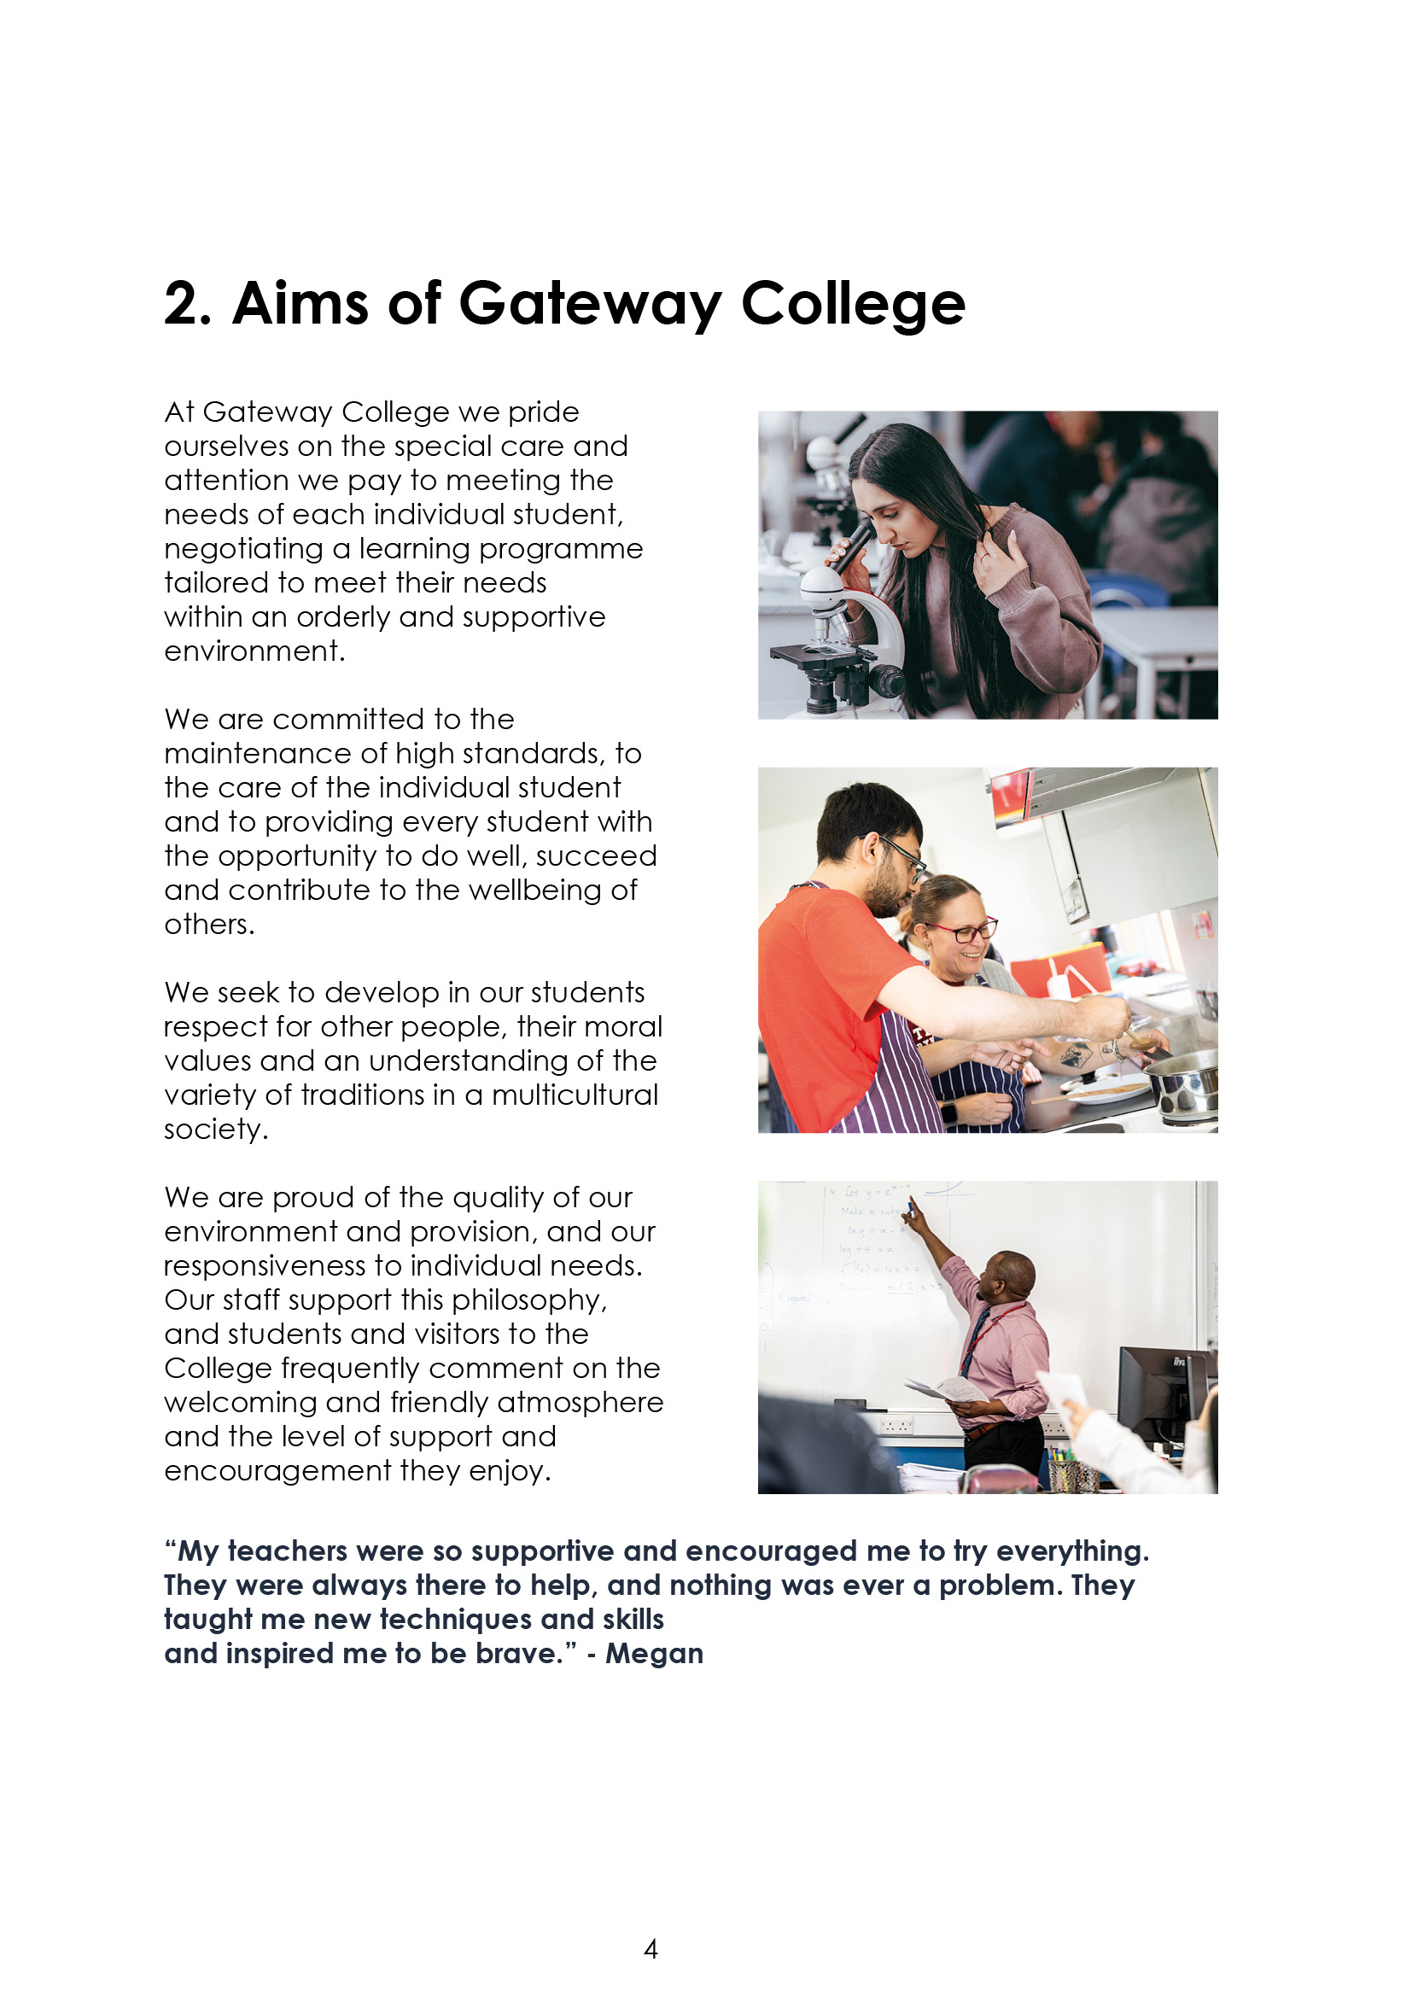

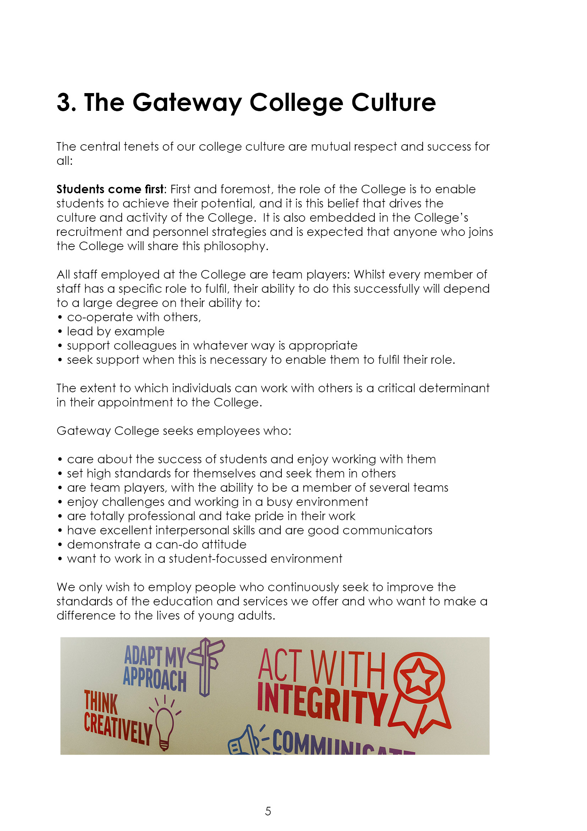





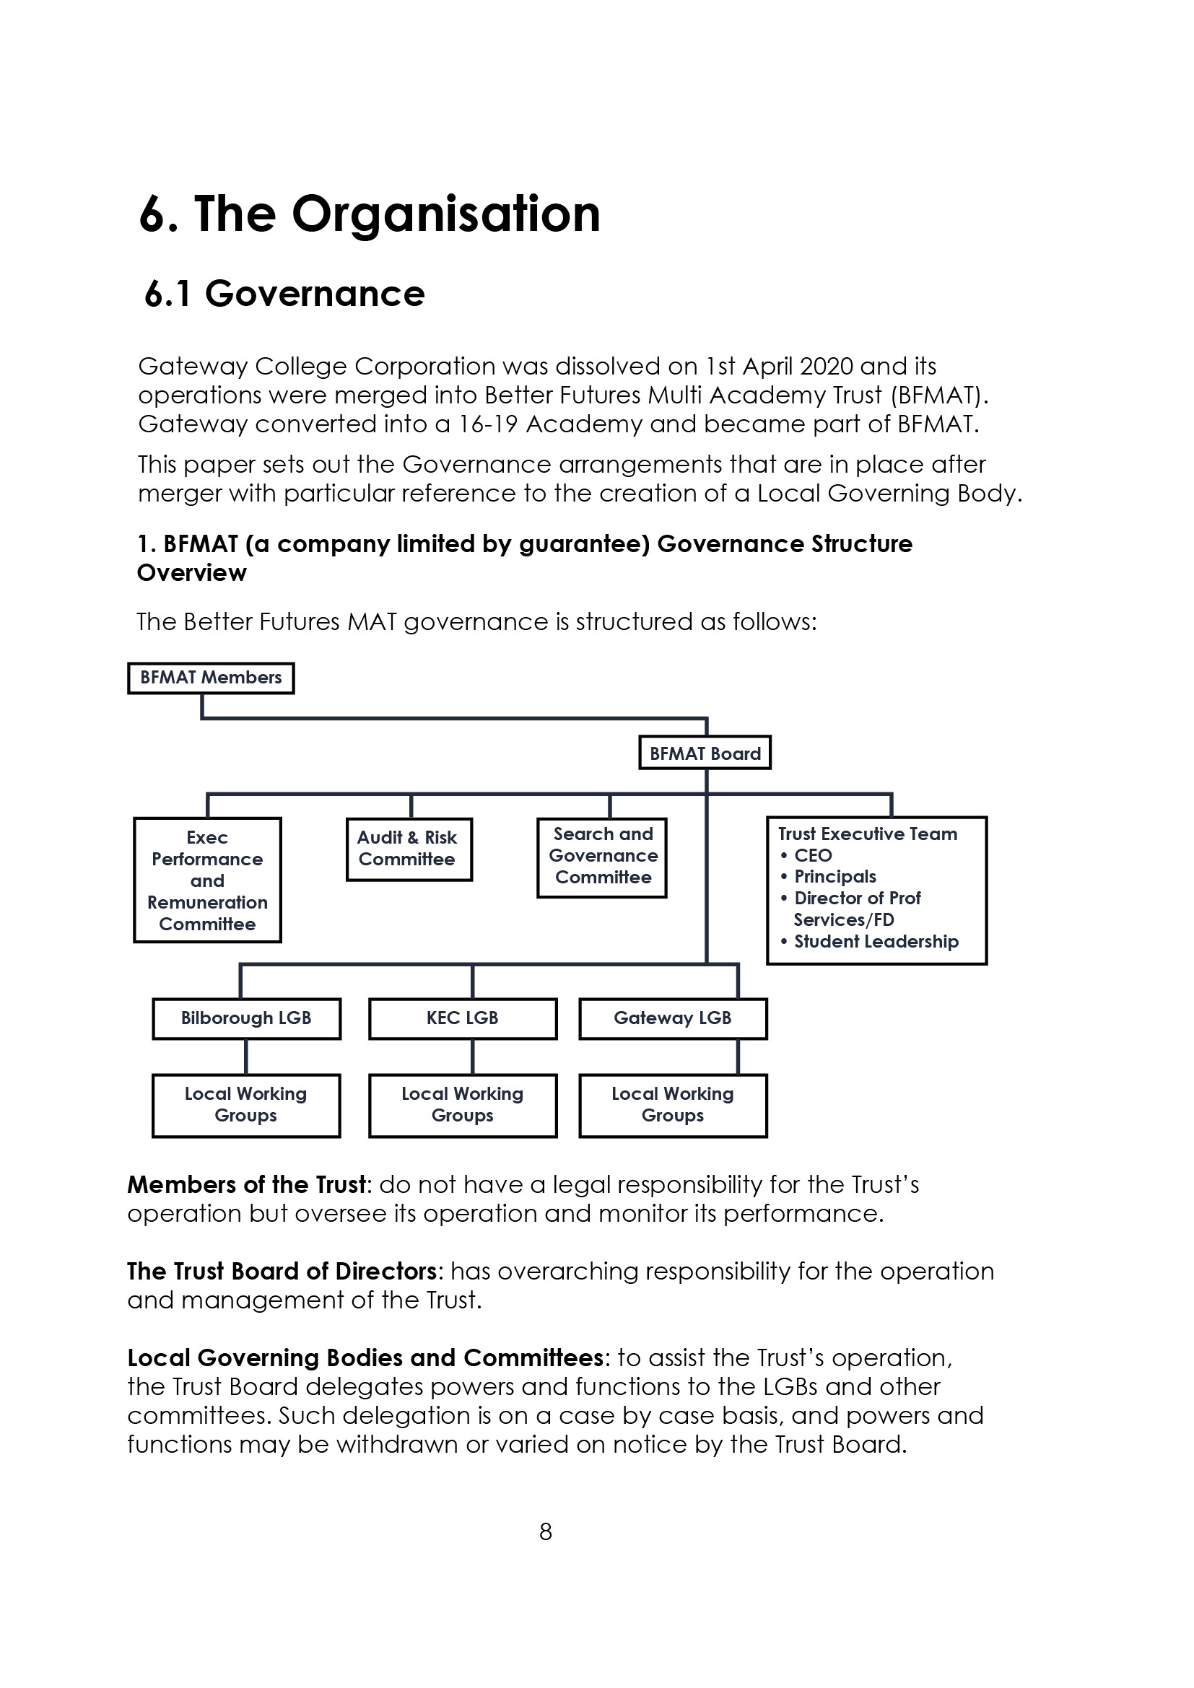



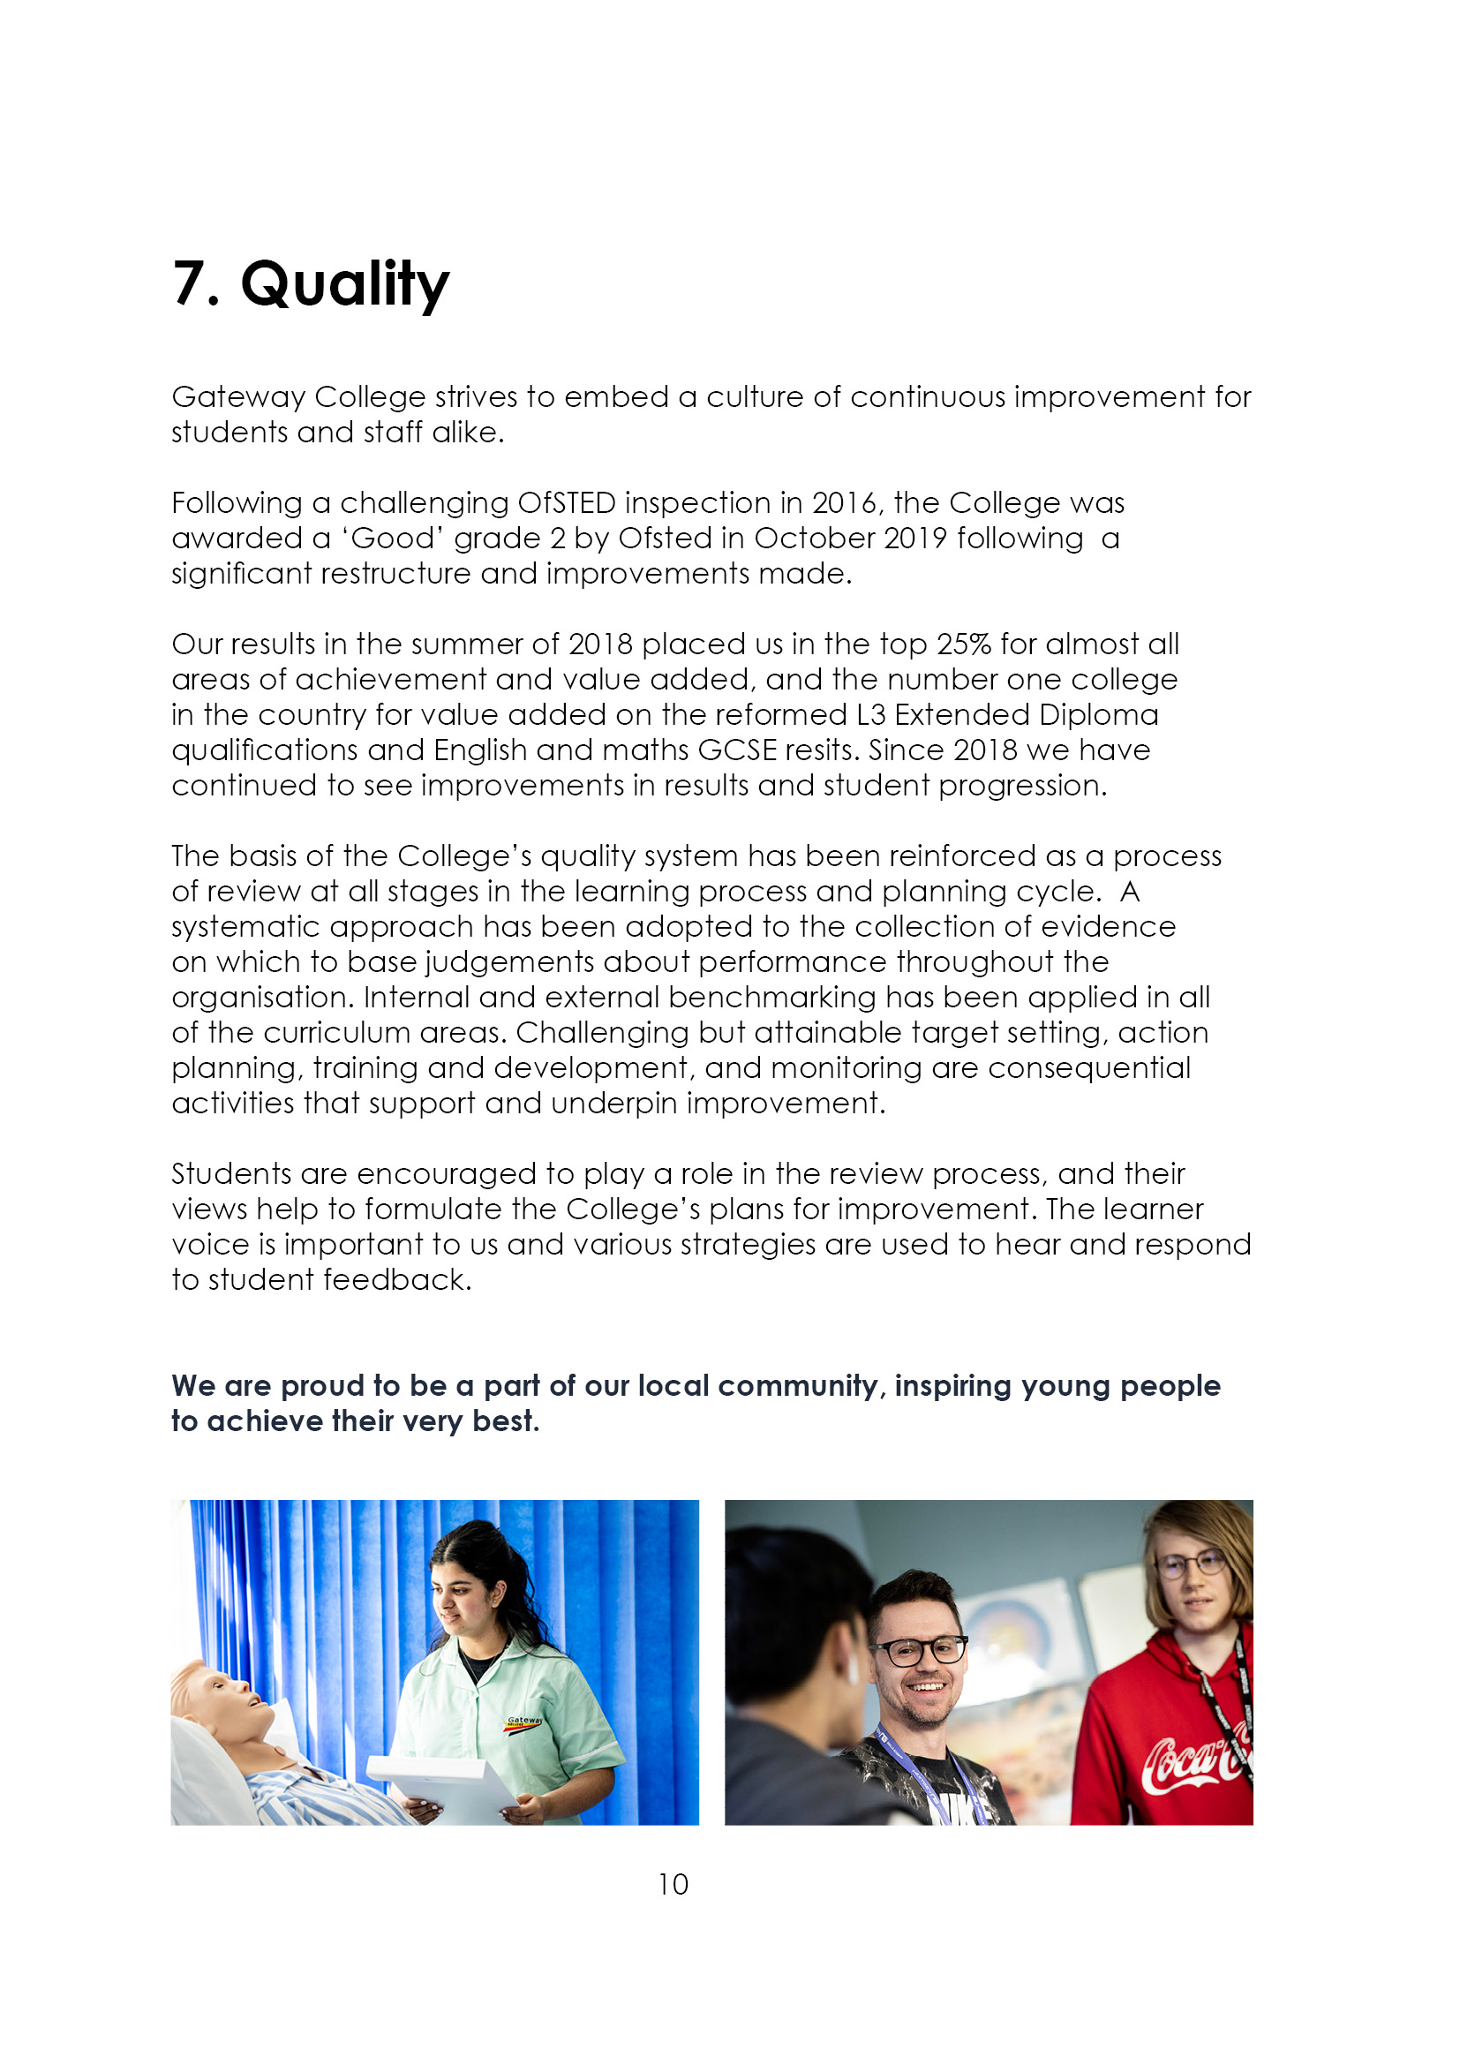



9. Job Advert

TEACHER OF HEALTH & SOCIAL CARE (REF: 25-05)
0.6 FTE, PERMANENT

We are seeking to appoint an enthusiastic and innovative person to join our successful, growing and supportive Health & Social Care team. Ideally you will have a teaching qualification with expertise in a health or science background to be able to deliver on BTEC and T Level Health and Social care courses. For this post you will need to be an excellent team player and be confident in the delivery of high-quality teaching, assessment and learning.

The post is to commence on 18th August 2025.

Employment is under the Sixth Form Colleges contract, 195 days (1265 hours) with the SFCA pay spine (£32,178 - £49,725 FTE) dependent on qualifications and experience.

Closing date: 2nd May (12 noon)
Interviews held: w/b 12th May 2025

Further details and an application pack can be obtained from www.gateway.ac.uk or Teaching and education jobs in LE5 1GA | Tes.

10. Job Description
Reporting to: Head of Department
Accountable to: The Principal
Tenure: Permanent, 0.6 FTE
Salary: Sixth Form College’s Pay Spine Point 1 - 9 (£32,178 - £49,725 FTE)

Duties and Responsibilities:
The generalised duties and responsibilities laid down in the Teachers Statement of Conditions of Employment apply to all staff. These should be read in conjunction with this outline job description. Most staff will be both subject teachers and Personal Tutors.

- To undertake the teaching of students working on Health and Social Care courses up to levels 3, or any other programmes, using a variety of teaching methods and learning styles.

- To participate under the direction of the Head of Department and/or Assistant Principal in the development of appropriate specifications, schemes of work, supported self study material and the use of information technology.

- To participate as a member of a team in the organisation of course material, resources and stock maintenance and the general management of subject areas.

- To ensure that in the teaching room assigned to the teacher, displays are regularly updated and that the room is generally kept in good order, with any problems reported using the normal College procedure.

- To take part, where appropriate, in the College personal guidance programme and recreational activities.

- To participate in appropriate meetings with colleagues and parents.

- To set appropriate work/homework for students.

- To assess and moderate in a timely manner in accordance with exam board regulations.

- To maintain detailed records of each student's attendance and progress, and contribute to the preparation of records of achievement.

- To discuss with students regularly their progress and to refer, as appropriate, students to the Assistant Principal or Head of Department.

- To provide students with tutorial opportunities for individual/small group discussion as required within the College's published time budget.

- To participate in appropriate CPD.

- To negotiate an appropriate range of courses for each student during the induction period and monitor and adapt this provision whenever necessary in consultation with other staff and the student.

- To liaise with subject teachers and other colleagues as necessary.

- To liaise closely with the Head of Department and/or Head of Student Experience and refer students as appropriate.

- To liaise with parents/guardians/external agencies as appropriate.

- To monitor and develop each student's profile and to prepare initial drafts of references and reports as required.

- To provide information and data as and when required.

- To attend parents' evenings and discuss students' progress.

- To participate in appropriate meetings with colleagues in addition to those specified in the College calendar.

- To undertake other reasonable duties as required by the Principal.

Notes:

The above responsibilities are subject to the general duties and responsibilities contained in the statement of conditions of employment and our equal opportunities policy.

This job description allocates duties and responsibilities but does not direct the particular amount of time to be spent on carrying them out and no part of it may be so construed.

This job description is not necessarily a comprehensive definition of the post and is subject to review following consultation.

This post is subject to enhanced disclosure from the Disclosure and Barring Service (DBS).



