

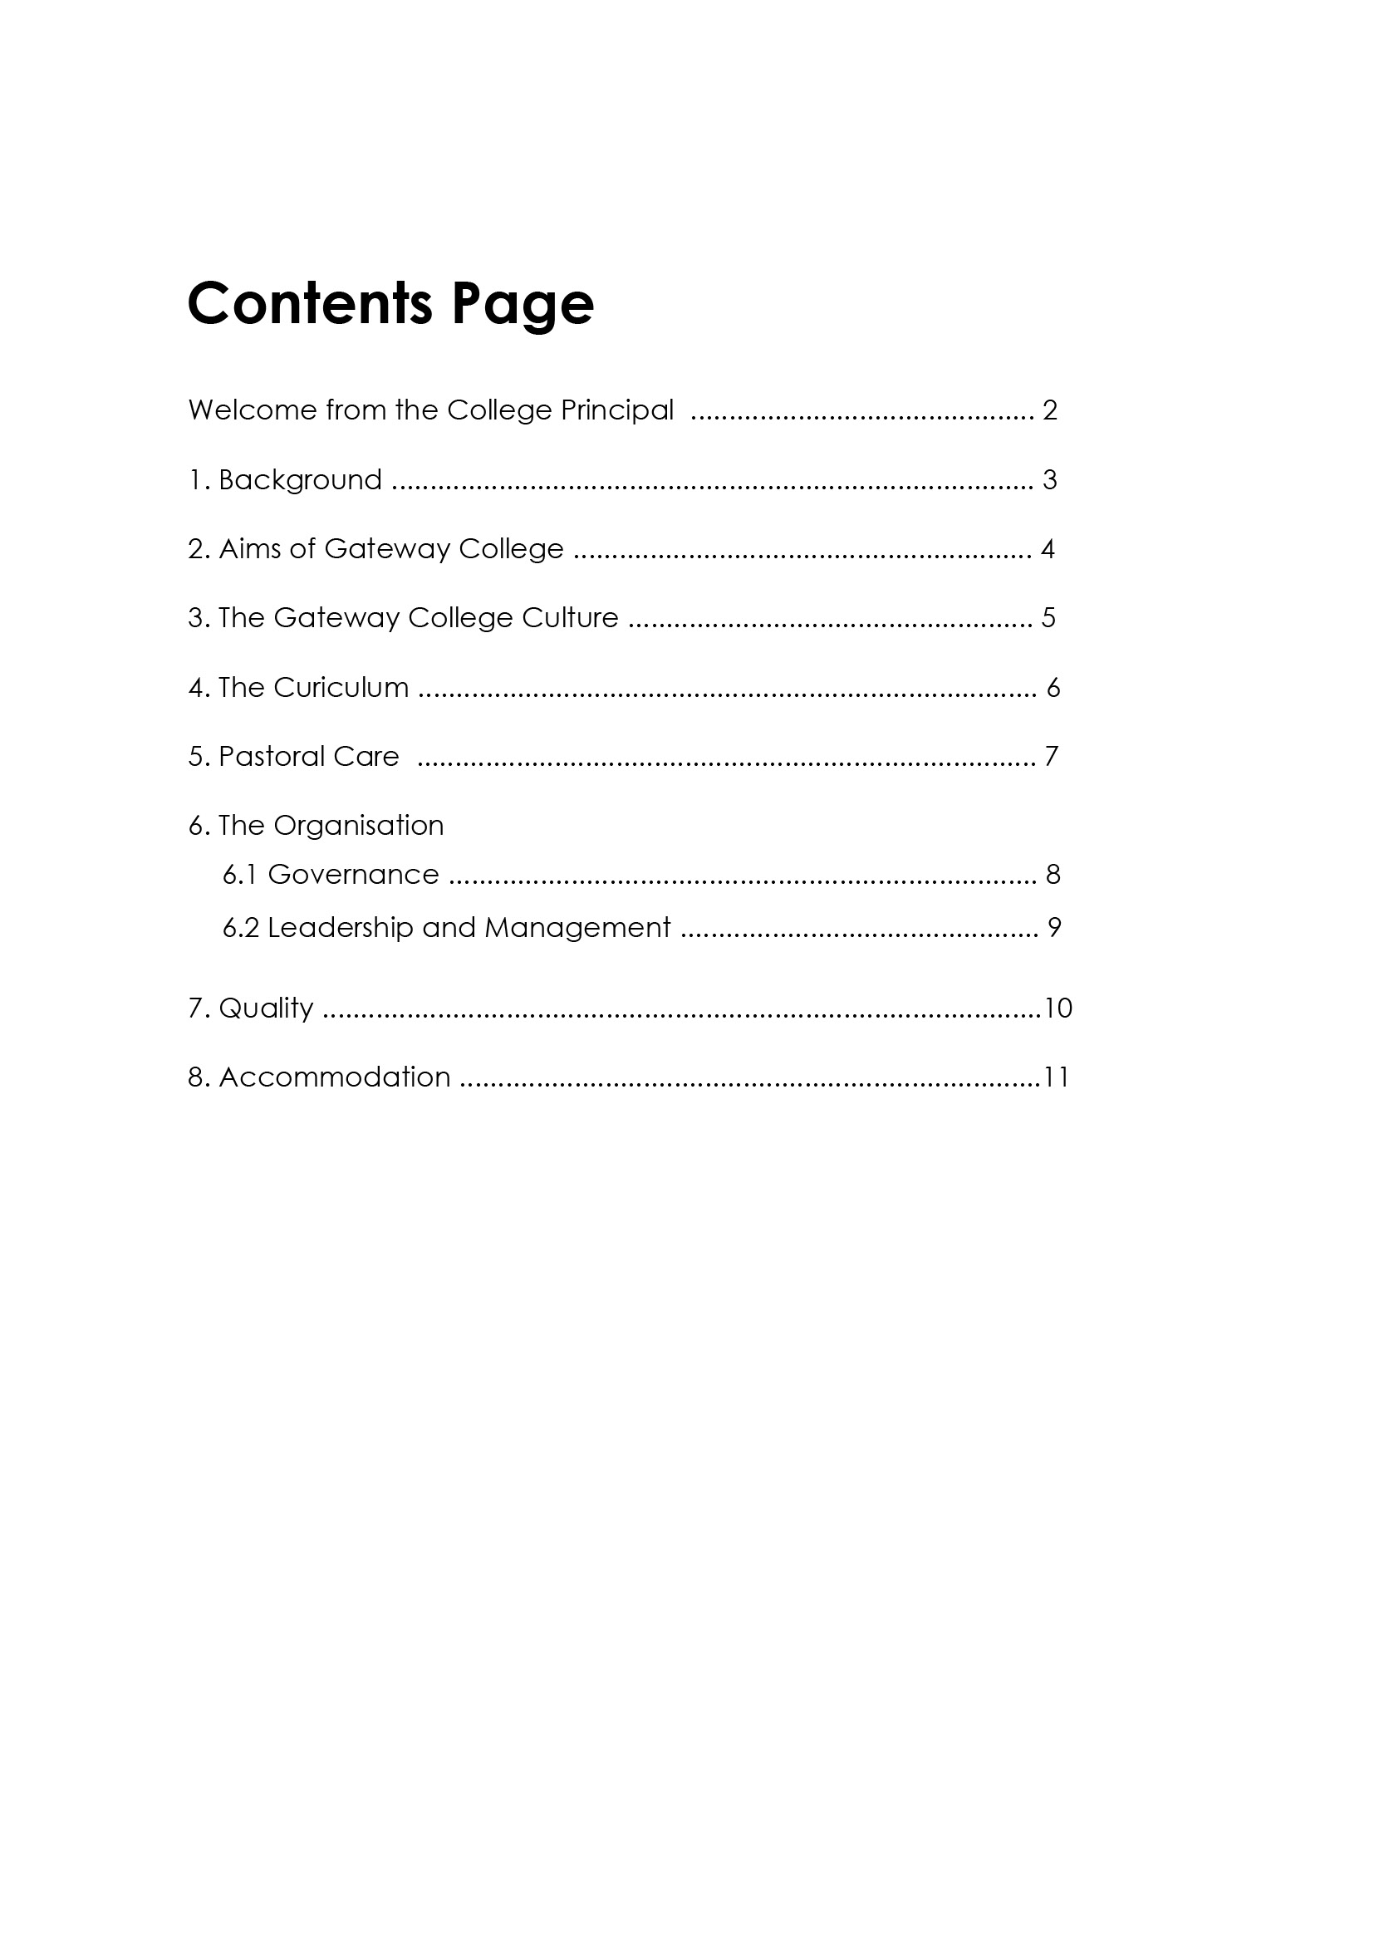

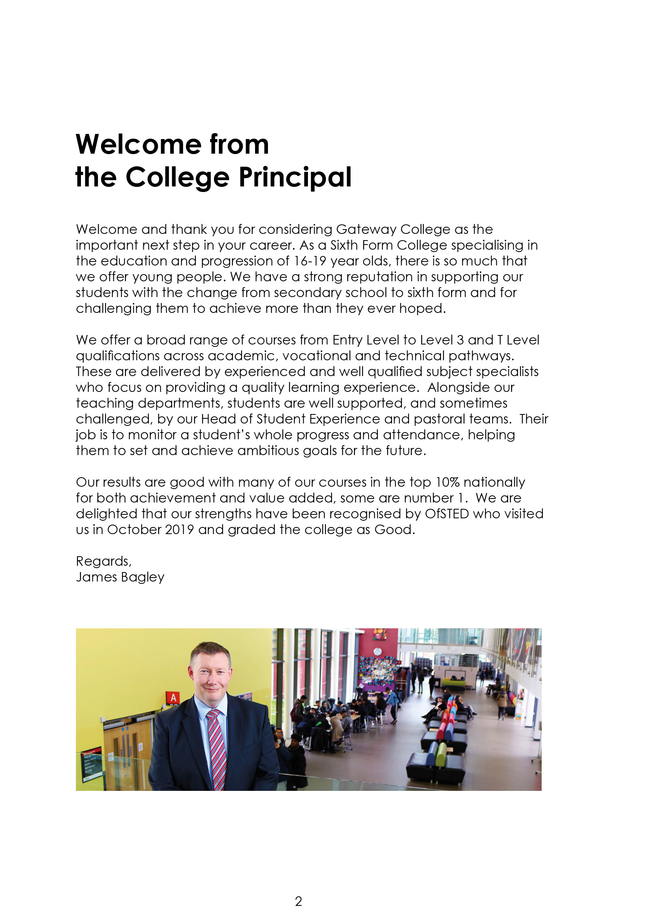

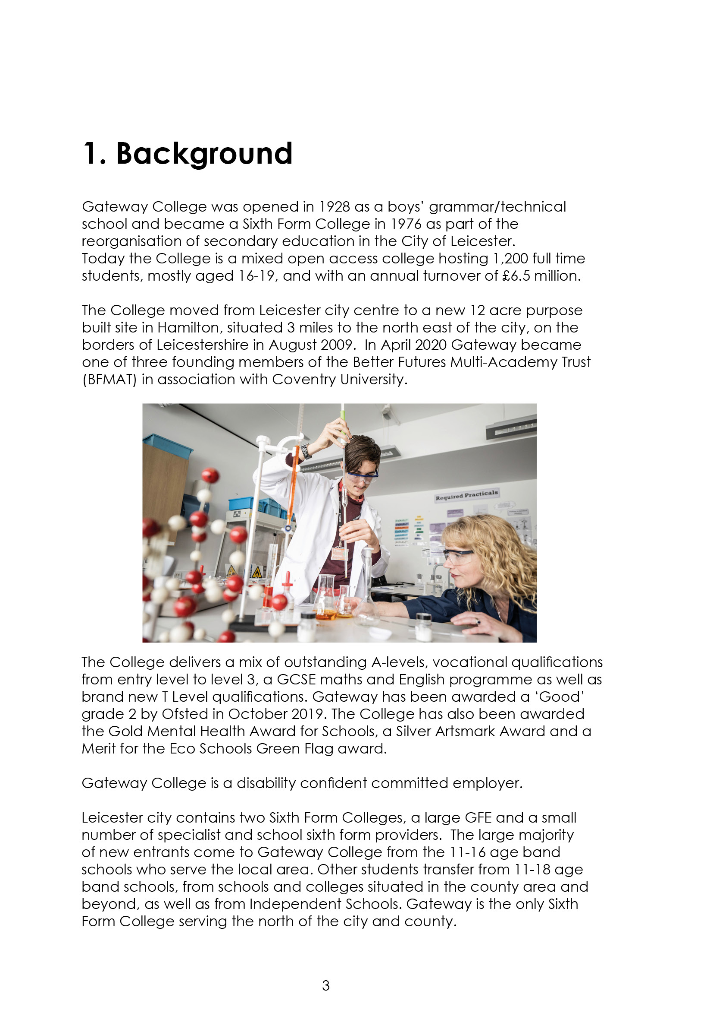

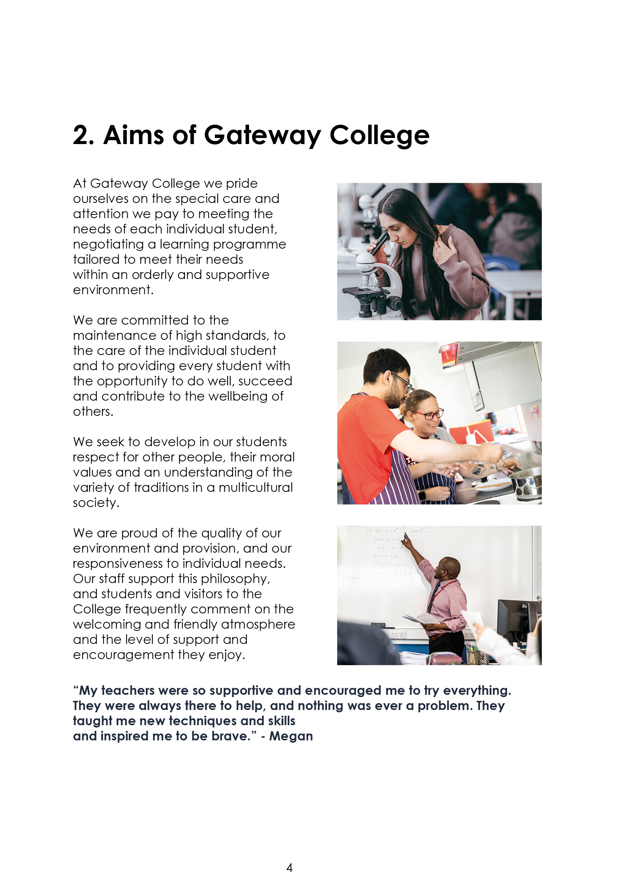

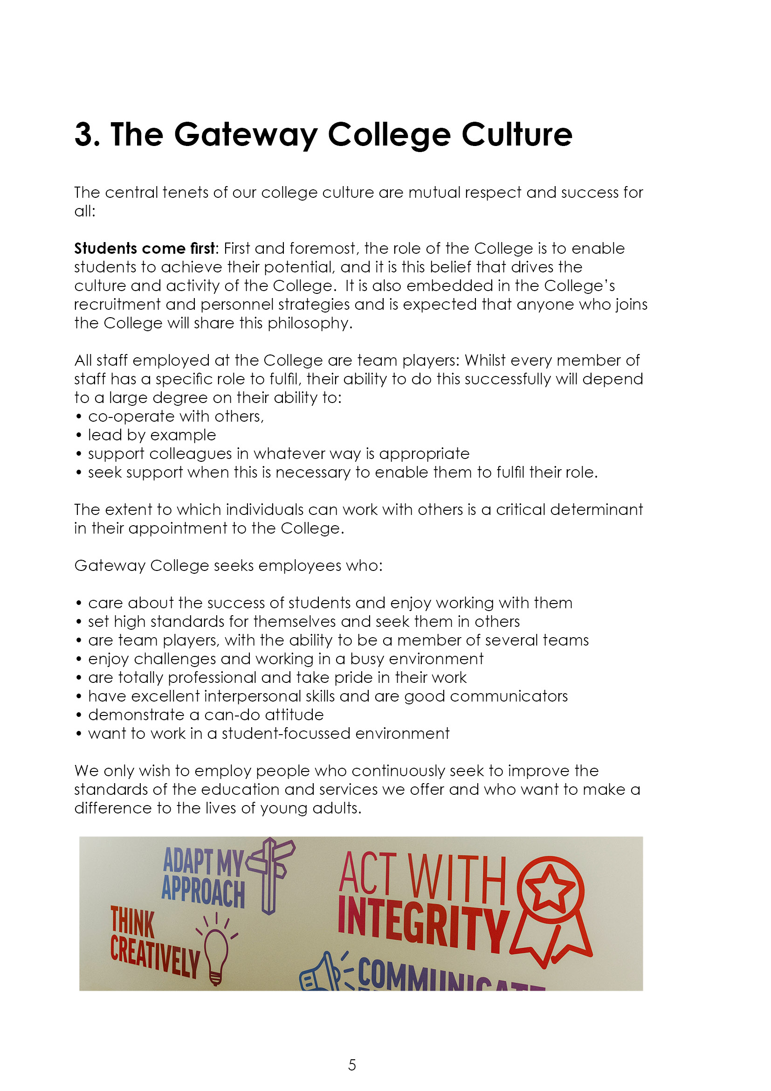

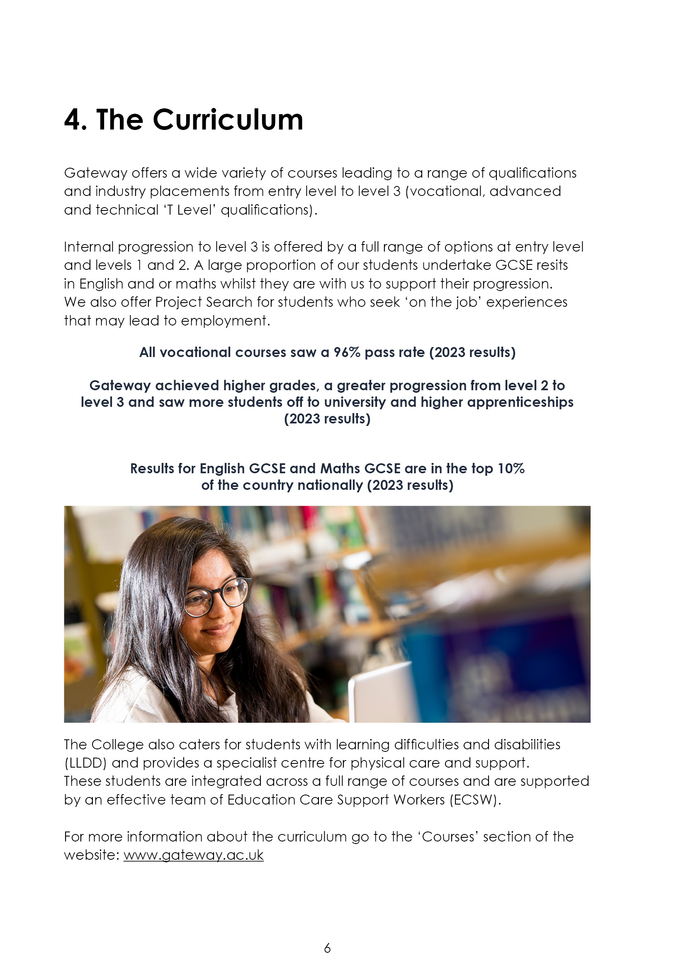

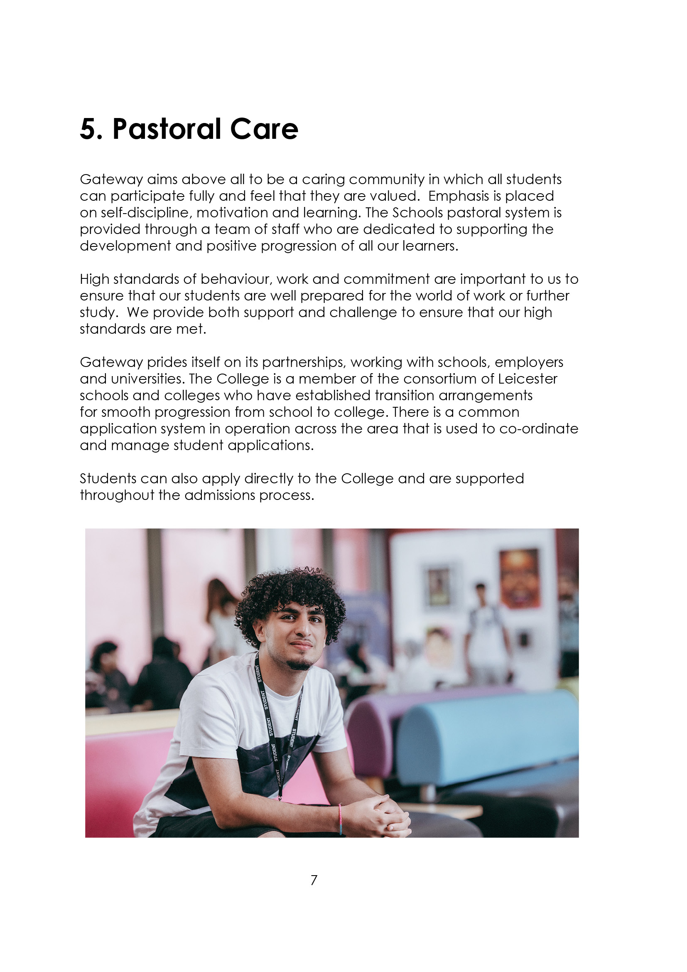

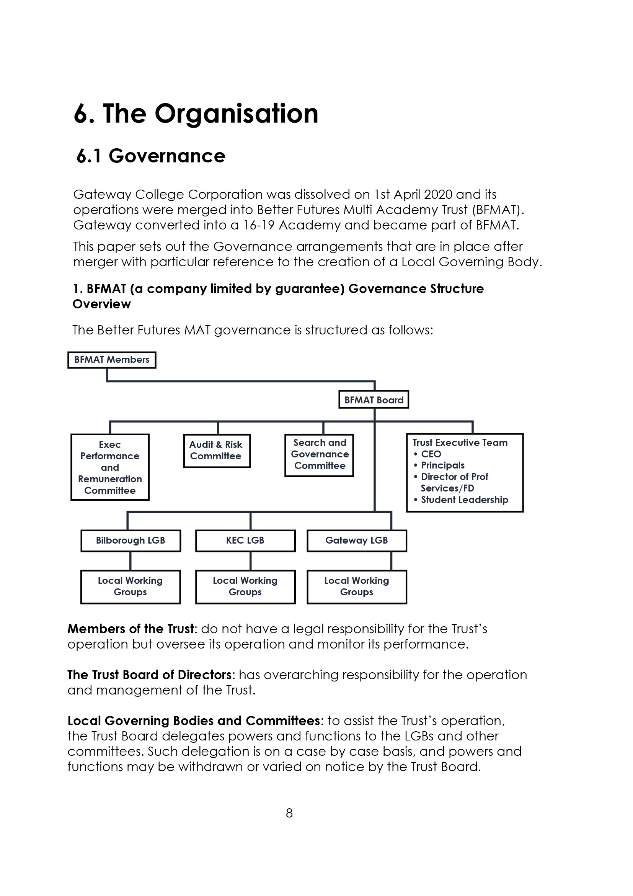

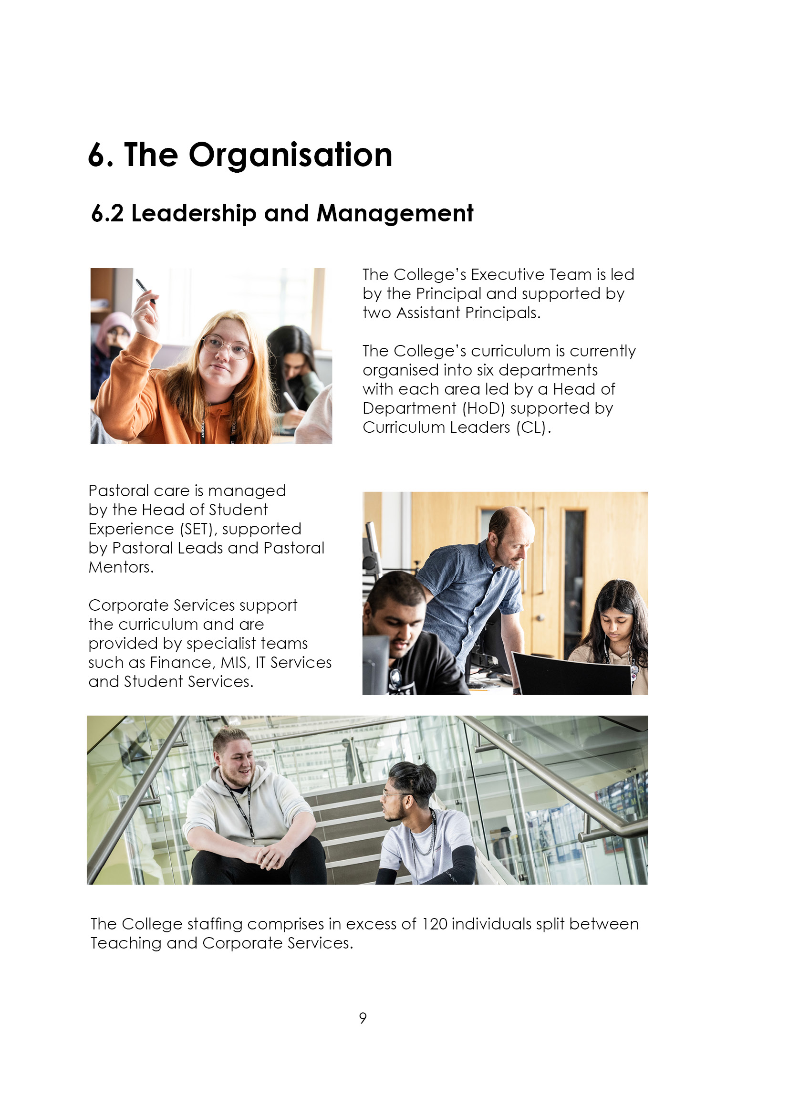

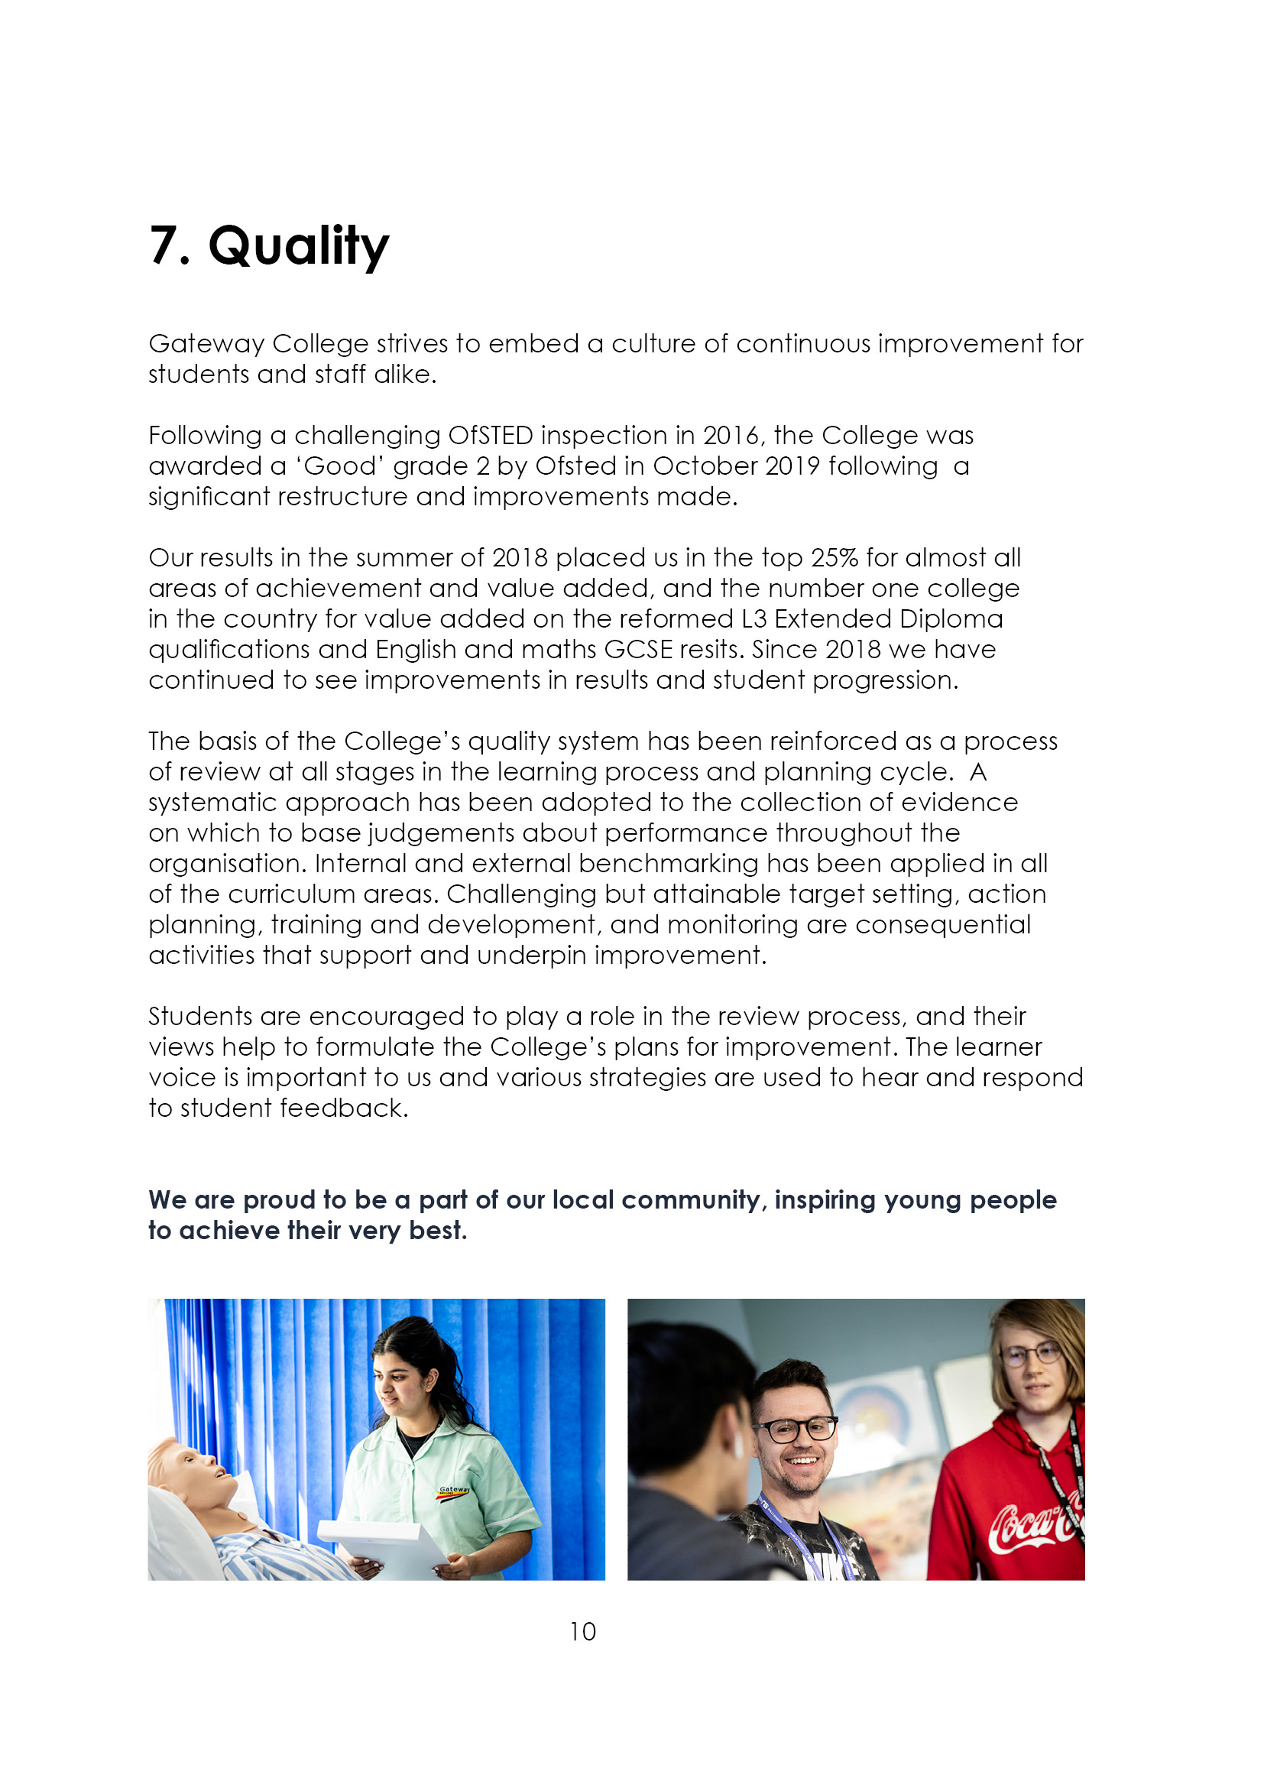

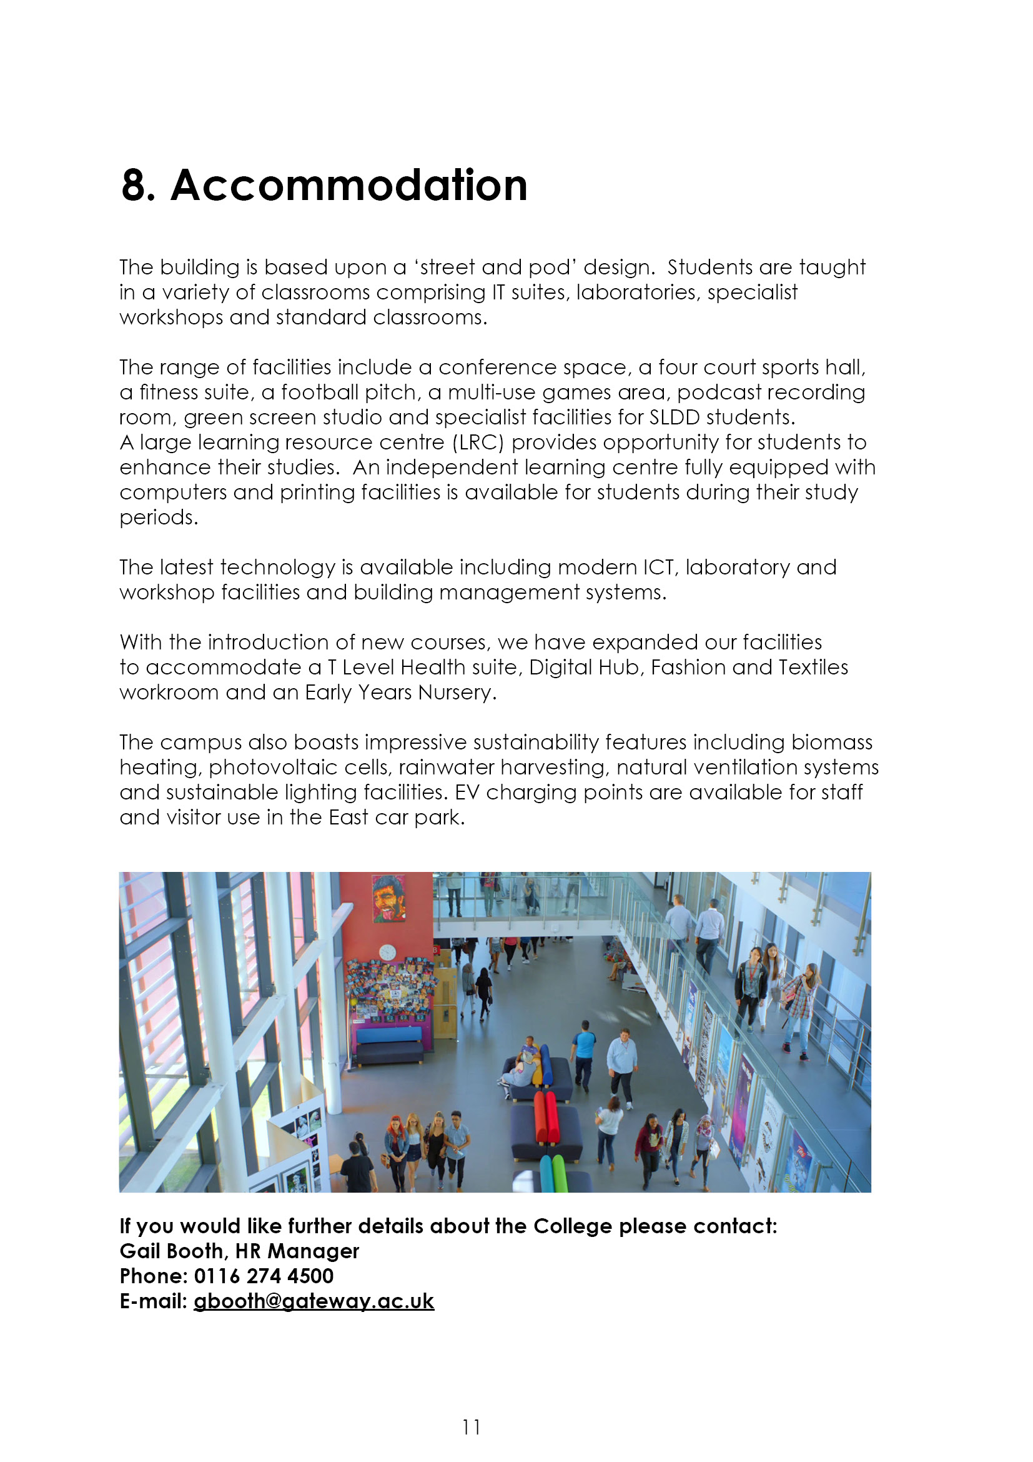

9. Job Advert

Teacher to join the Entry to Work team
0.4 FTE, permanent

The ideal candidate for this post will have some experience of teaching courses offered within the Department, offer excellent pastoral support and create opportunities for students to grow in independence, confidence and collaboration with each other. A ‘can do’ approach is essential. An understanding of RARPA practice is essential in this role.

The role is for two days a week and will also include a tutor role. You will be required to deliver on any of the programmes offered in the department such as Multi-skills, Entry 3 Life skills pathway and Pre Project Search courses. You will be delivering on Preparing for Adulthood Themes of Employability, Independent living skills, Friends and Relationship and Community inclusion.

This post will commence on 18th August 2025.

Employment is under the Sixth Form Colleges contract, 195 days (1265 hours) with the SFCA pay spine (£32,178 - £49,725 FTE) dependent on qualifications and experience.

Closing date: 5th May 2025
Interviews held: w/b 12th May 2025

Further details and an application pack can be obtained from www.gateway.ac.uk or Teaching and education jobs in LE5 1GA | Tes

10. Job Description
Reporting to: Head of Department/ASLT Skills Nominee, Assistant Principal
Accountable to: The Principal
Tenure: 0.4 FTE, permanent.
Salary: Sixth Form College’s Pay Spine Points 1 – 9, £32,178 - £49,725 FTE

Duties and Responsibilities:

The generalised duties and responsibilities laid down in the Teachers Statement of Conditions of Employment apply to all staff. These should be read in conjunction with this outline job description.

- To undertake the teaching and support of students working on Entry to Work courses up to Level 1 or any other programmes, using a variety of teaching methods and assessment methods to capture individual students’ progress.
- To establish a safe, nurturing and stimulating environment for SEND students based on mutual respect. To have a clear understanding of the needs of the students and to plan appropriately.
- To participate under the direction of the Head of Department (HoD) in the development of appropriate preparing for adulthood themes, schemes of work, supported self-study material and set appropriate goals and learning steps for each programme.
- To participate as a member of a team in the organisation of course material, resources and stock maintenance and the general management of subject areas.
- To ensure that in the teaching room assigned to the teacher, displays are regularly updated and that the room is generally kept in good order, with any problems reported using the normal College procedure.
- To take part, where appropriate, in the College personal guidance programme and recreational activities.
- To participate in appropriate meetings with external agencies, colleagues, students and parents.
- To maintain detailed records of each student's attendance and progress.
- To discuss progress regularly with students and to refer, as appropriate, to the HoD, Assistant Principal (AP).
- To provide students with tutorial opportunities for individual/small group discussion as required within the College's published time budget.
- To participate in appropriate CPD.
- To undertake such other duties relevant to and connected with the teaching and running of the College as the Principal may reasonably require, which may include the teaching, or a contribution to the teaching of, other subjects or teaching elsewhere.

- To negotiate an appropriate range of courses for each student during the induction period and monitor and adapt this provision whenever necessary in consultation with other staff and the student.
- To monitor and develop each student's profile and to prepare initial drafts of references and reports as required. To update students annual review paperwork and provide updates.
- To provide information and data as and when required.
- To attend parents' evenings and discuss students' progress.
- To participate in appropriate meetings with colleagues in addition to those specified in the College calendar.
- To undertake other reasonable duties as required by the Principal.

ESSENTIAL | Method of Assessment | Short listing Column
- Graduate in the subject, with a PGCE/recognised teaching qualification. | A
Professional competency and ability to teach post-16 using a broad range of teaching and learning styles. | I
Awareness of the needs of students in the post-16 education sector. | I
Good understanding of disability and fully inclusive practice | I
Ability to work as a member of a team. | I
Organisational skills and the ability to develop new resources as part of a team. | I
Willingness to contribute to the extra-curricular life of the College. | I
Basic IT skills, or a positive willingness to develop such skills. | I
A sense of humour, patience, resilience and energy at all times. | I

DESIRABLE | Method of Assessment | Short listing Column
- Successfully taught a wide range of student abilities and experience of curriculum development. | A
- Evidence of working effectively as part of a team. | I
- Evidence of curriculum resource development. | I
- Recognition of quality standards and procedures in teaching and learning. | I
- Ability to offer an ‘additional study’ or recreational activity. | I
- Familiarity with new curriculum developments in SEND | I
- Knowledge of inclusive learning and widening participation. | I

A = Application form I = Interview

Notes:

The above responsibilities are subject to the general duties and responsibilities contained in the statement of conditions of employment and our equal opportunities policy.

This job description allocates duties and responsibilities but does not direct the particular amount of time to be spent on carrying them out and no part of it may be so construed.

This job description is not necessarily a comprehensive definition of the post and is subject to review following consultation.

This post is subject to enhanced disclosure from the Disclosure and Barring Service (DBS)



