

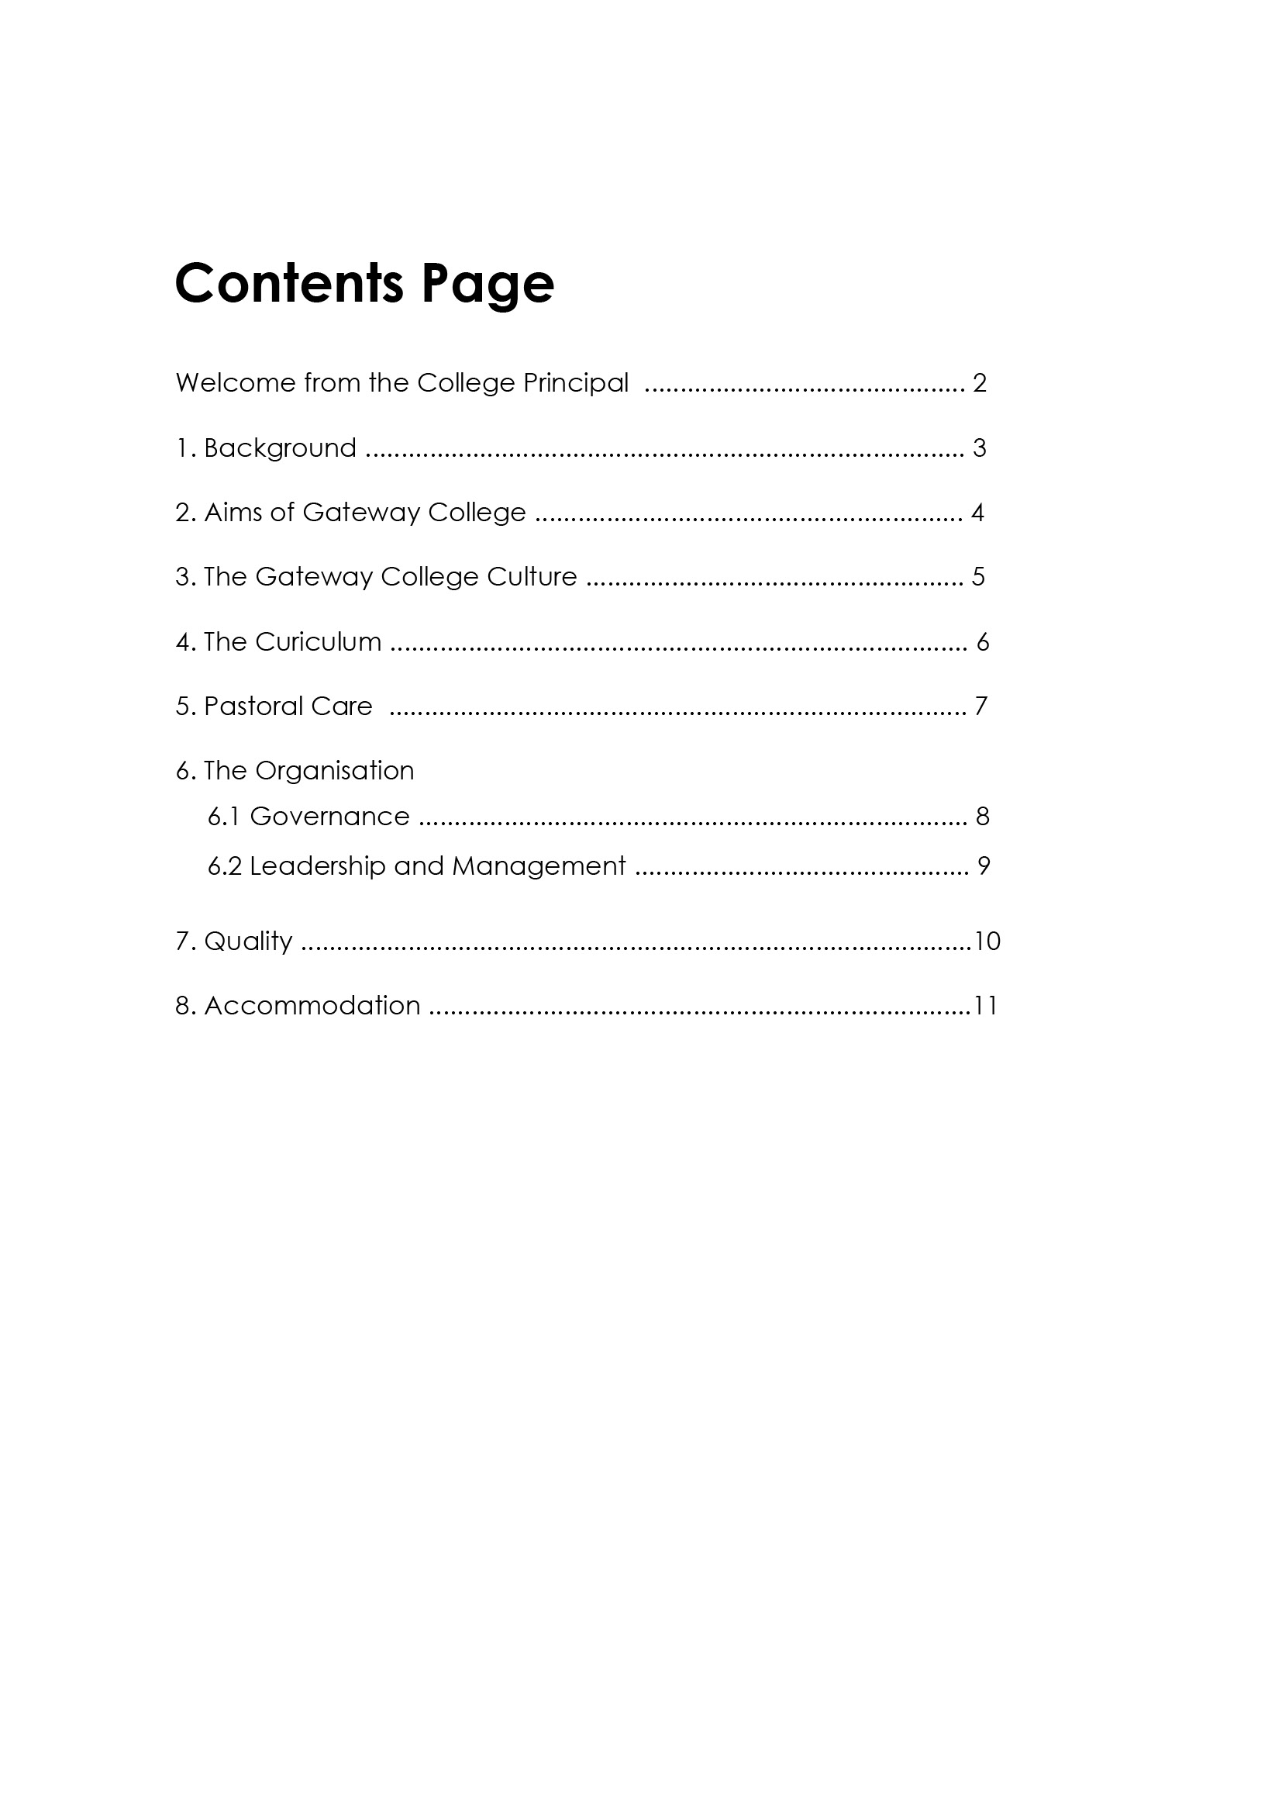

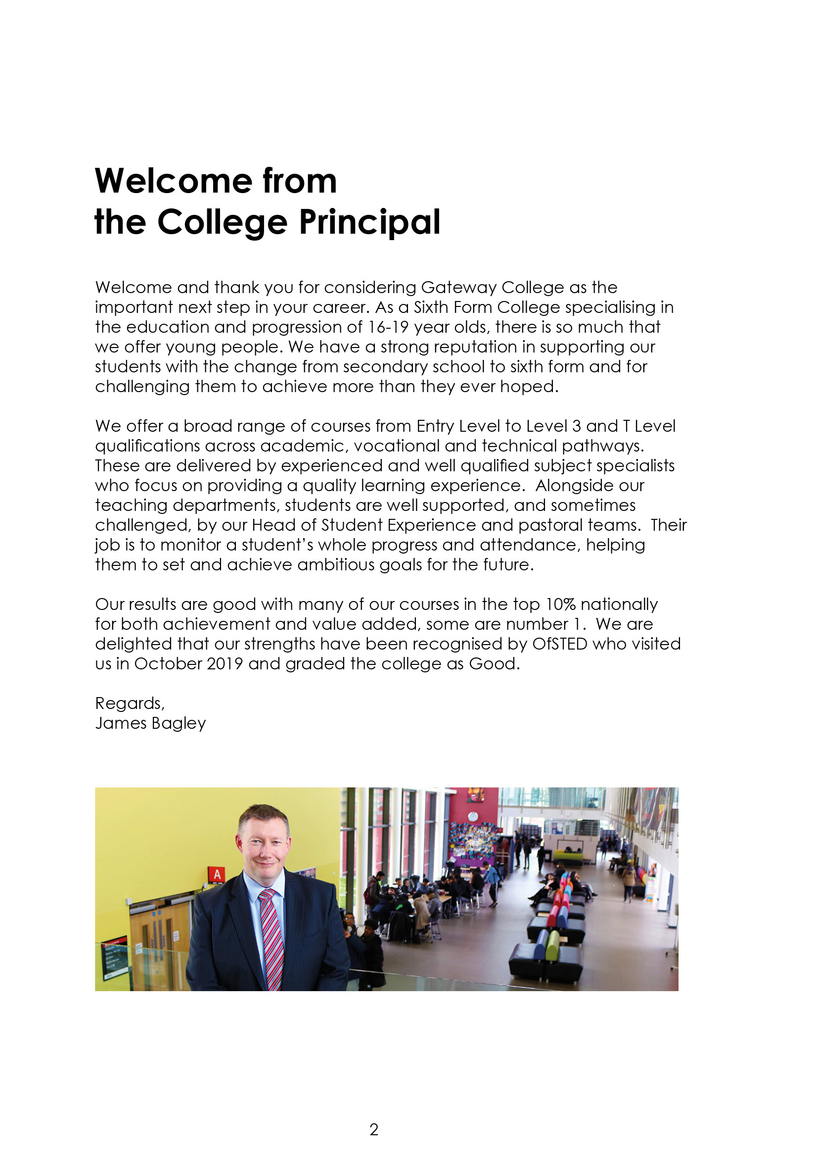

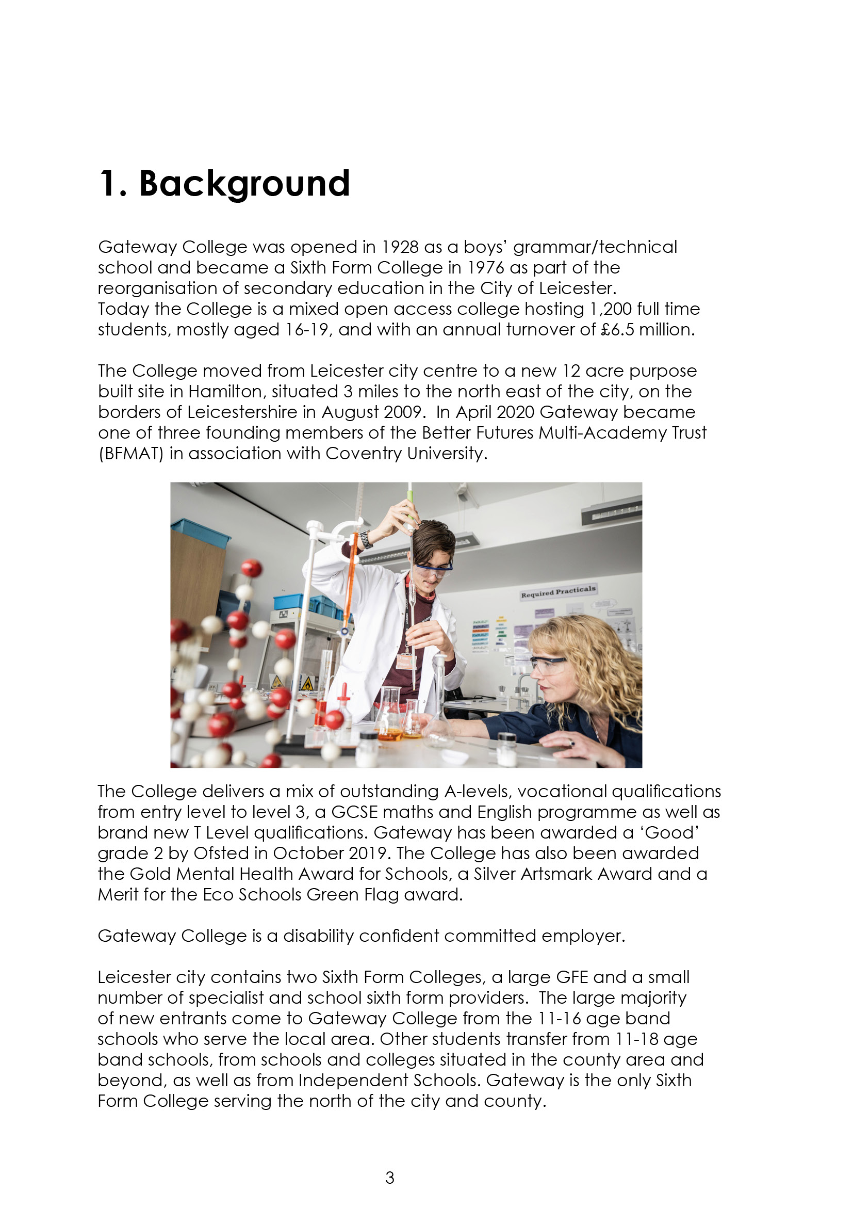

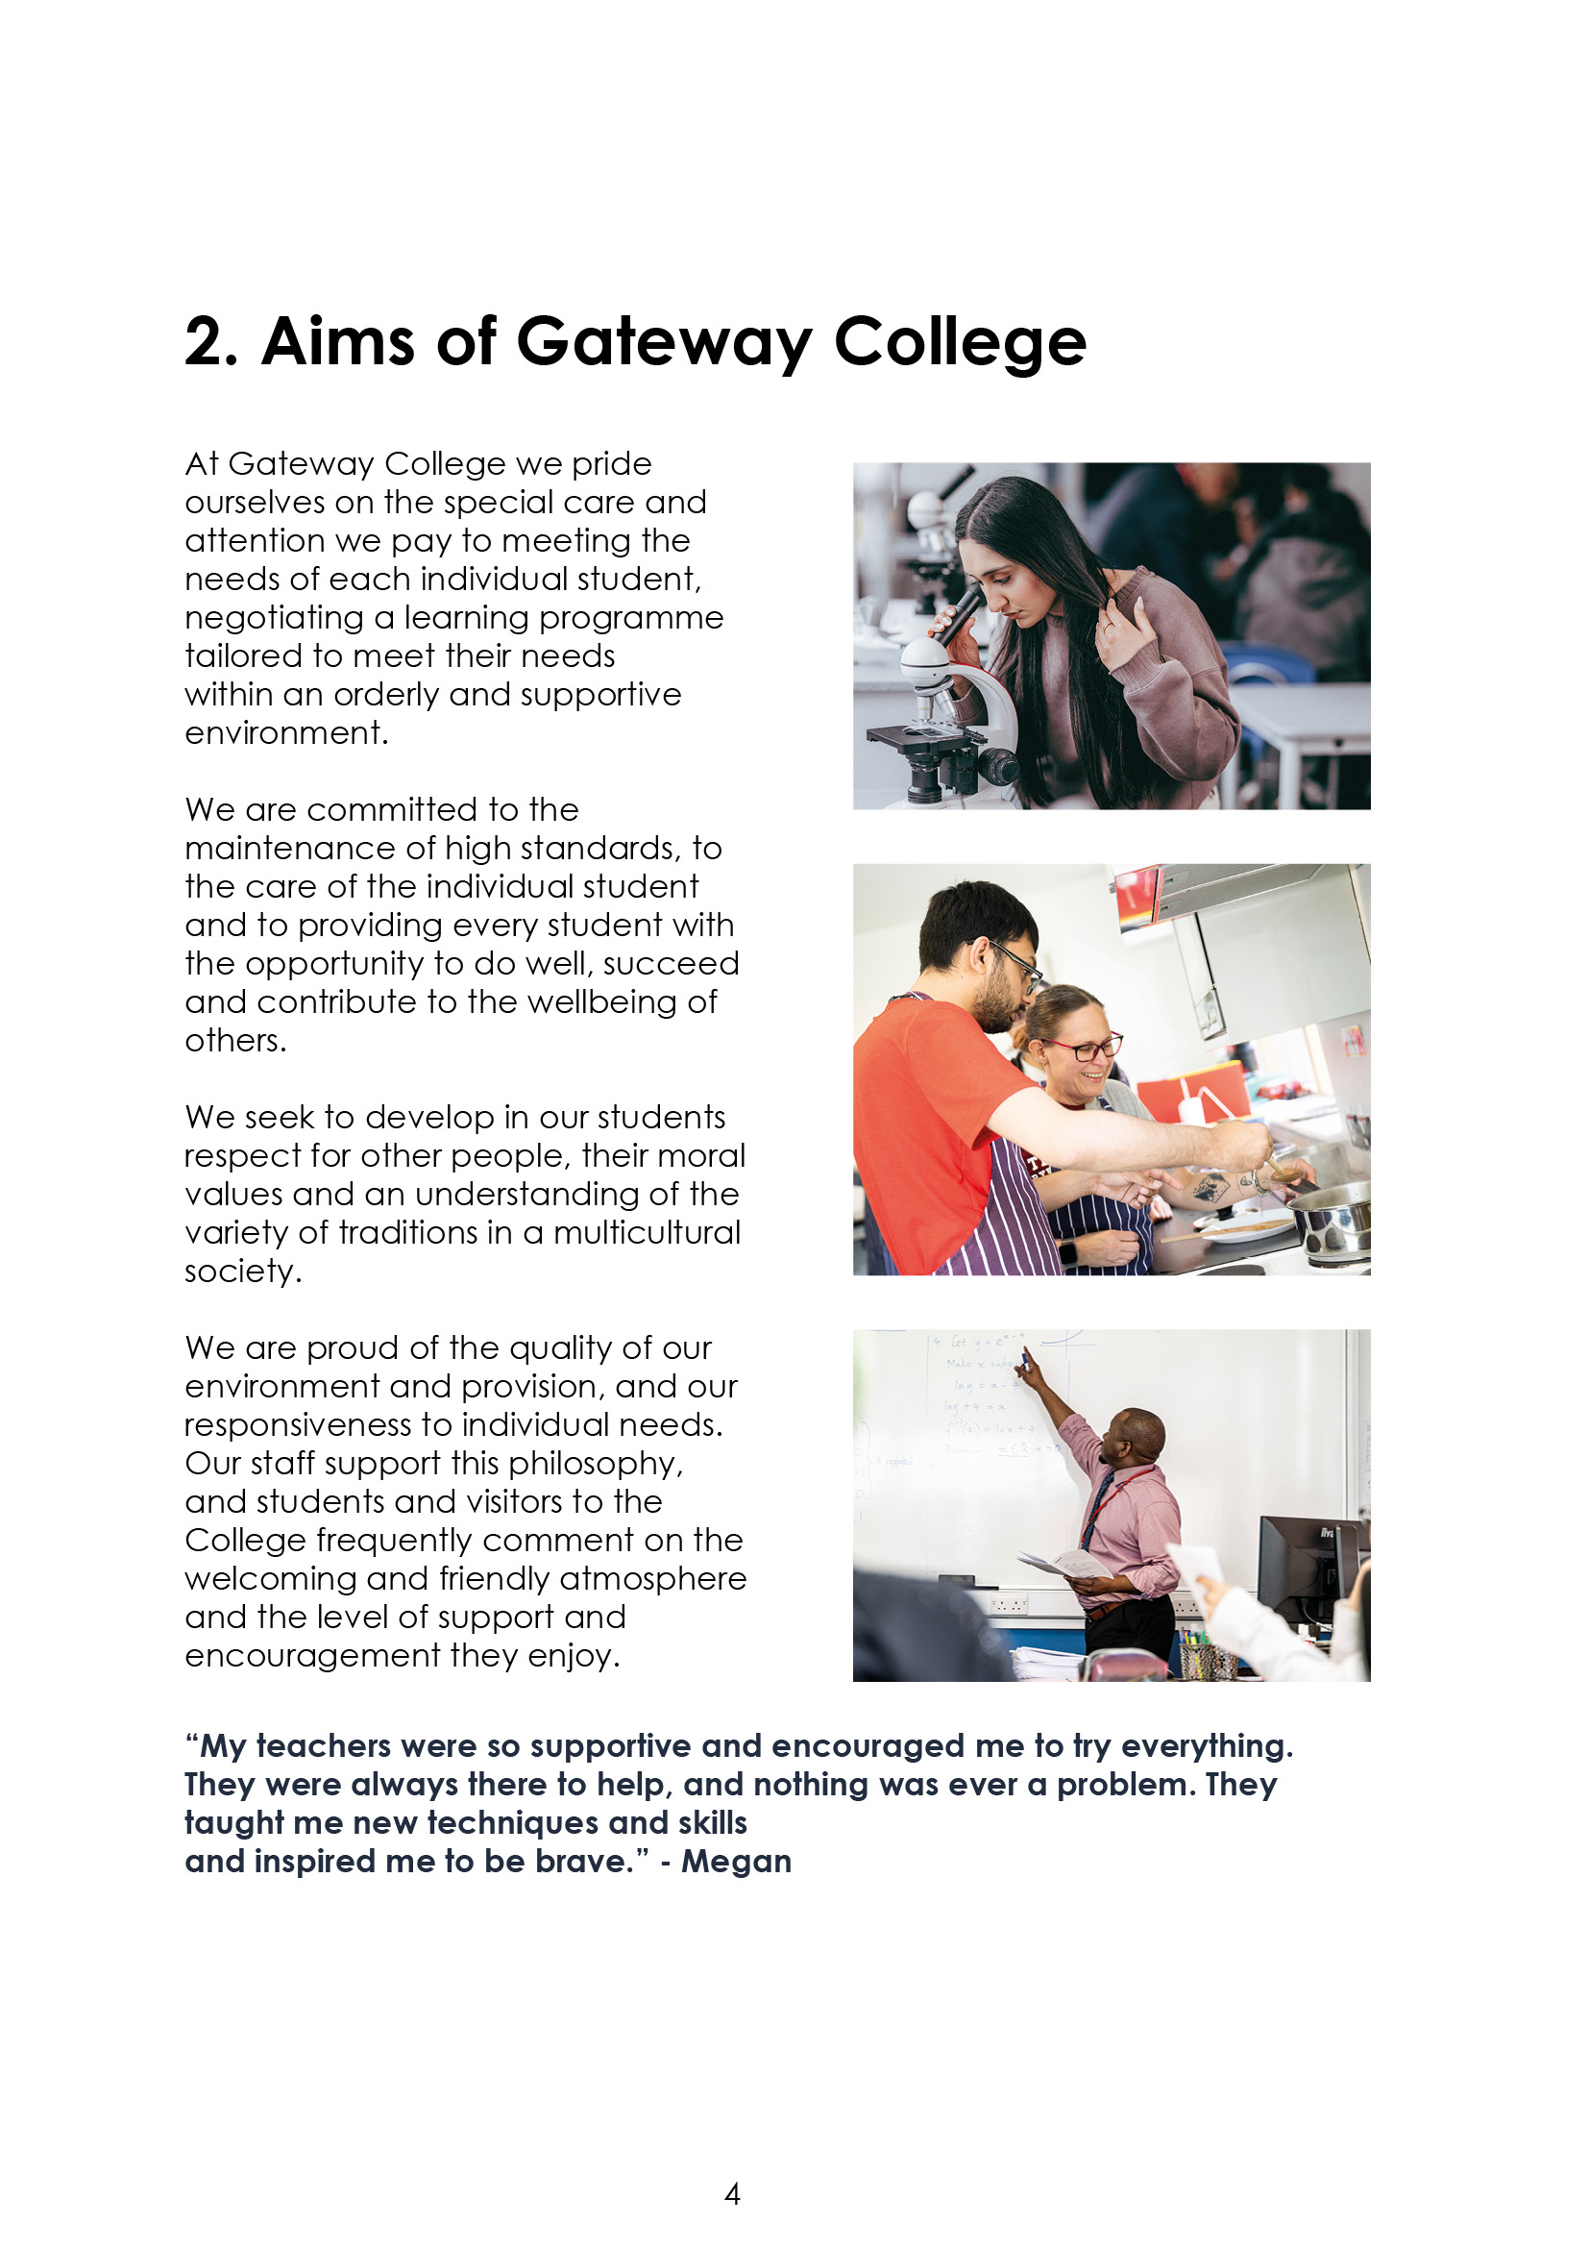

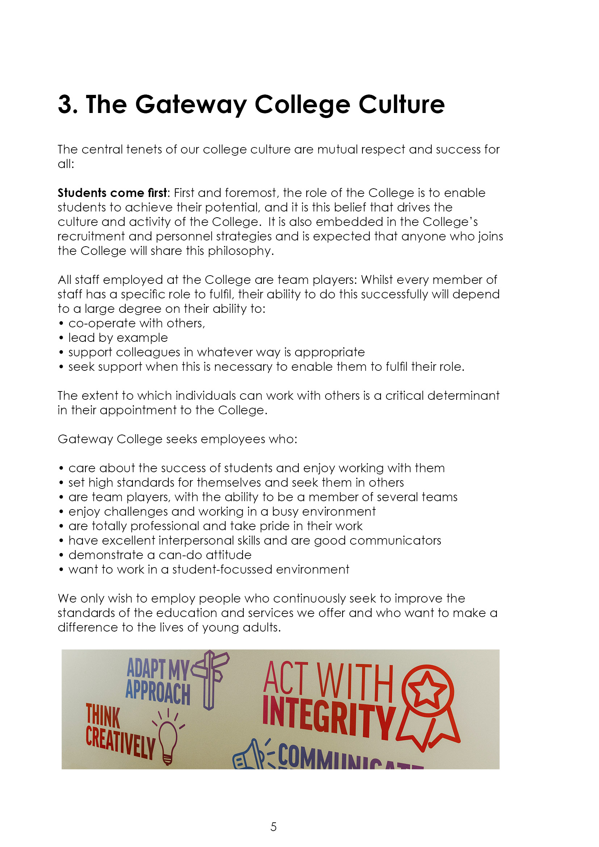

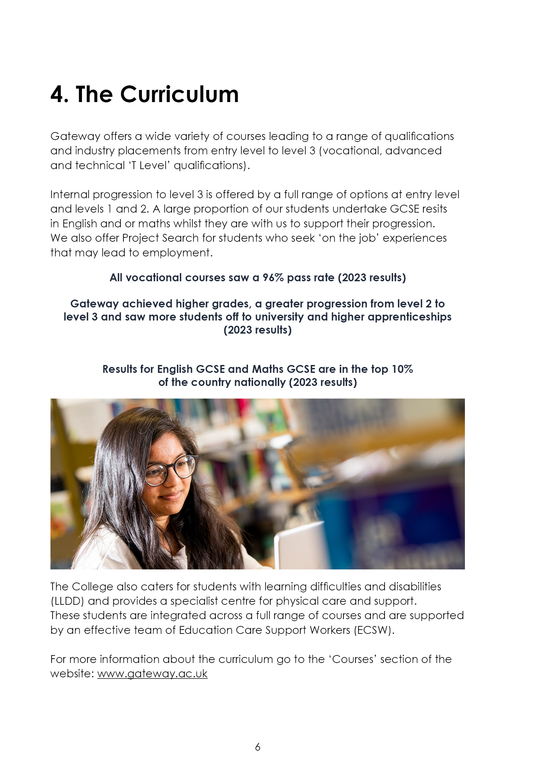

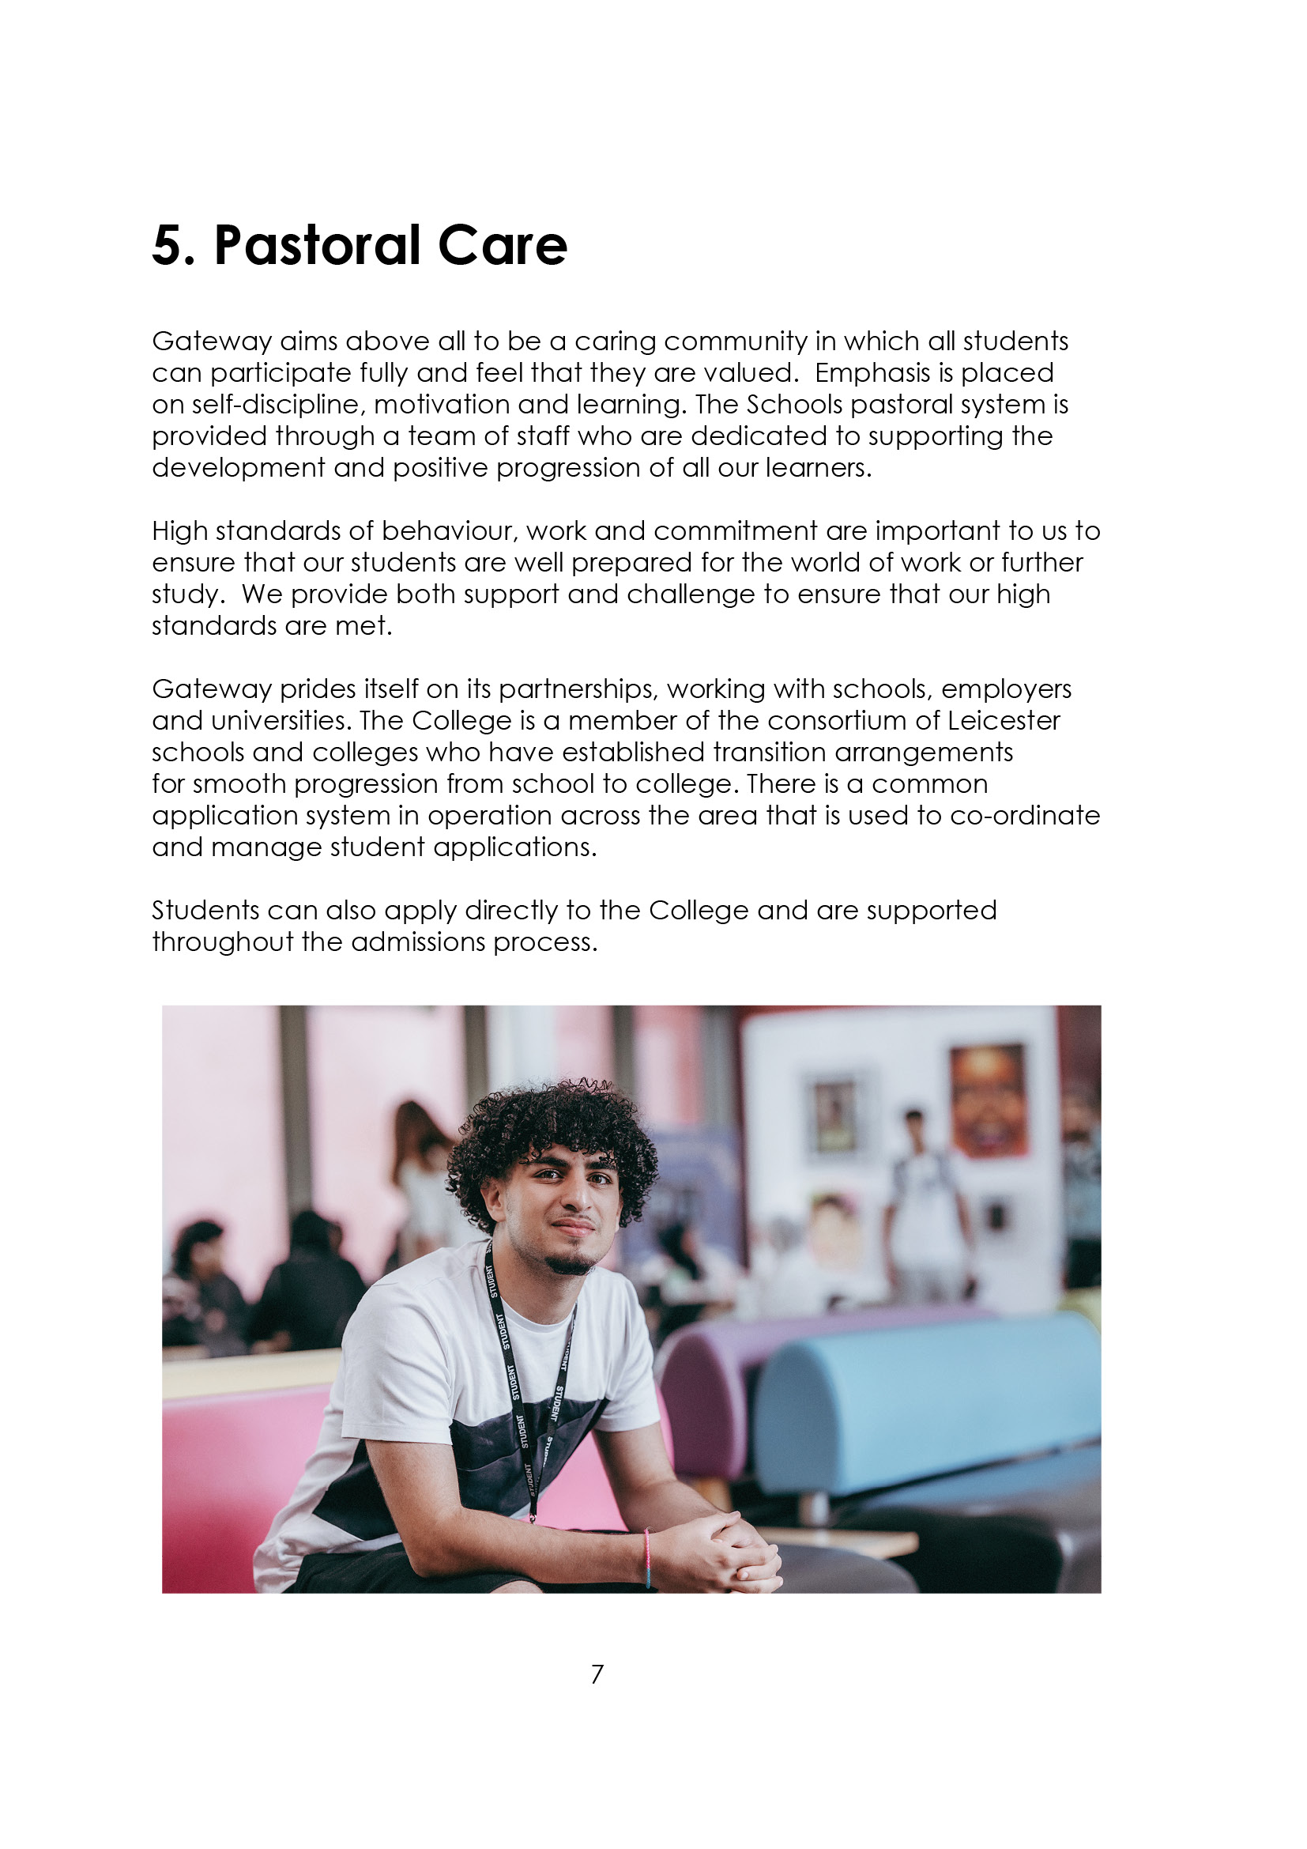

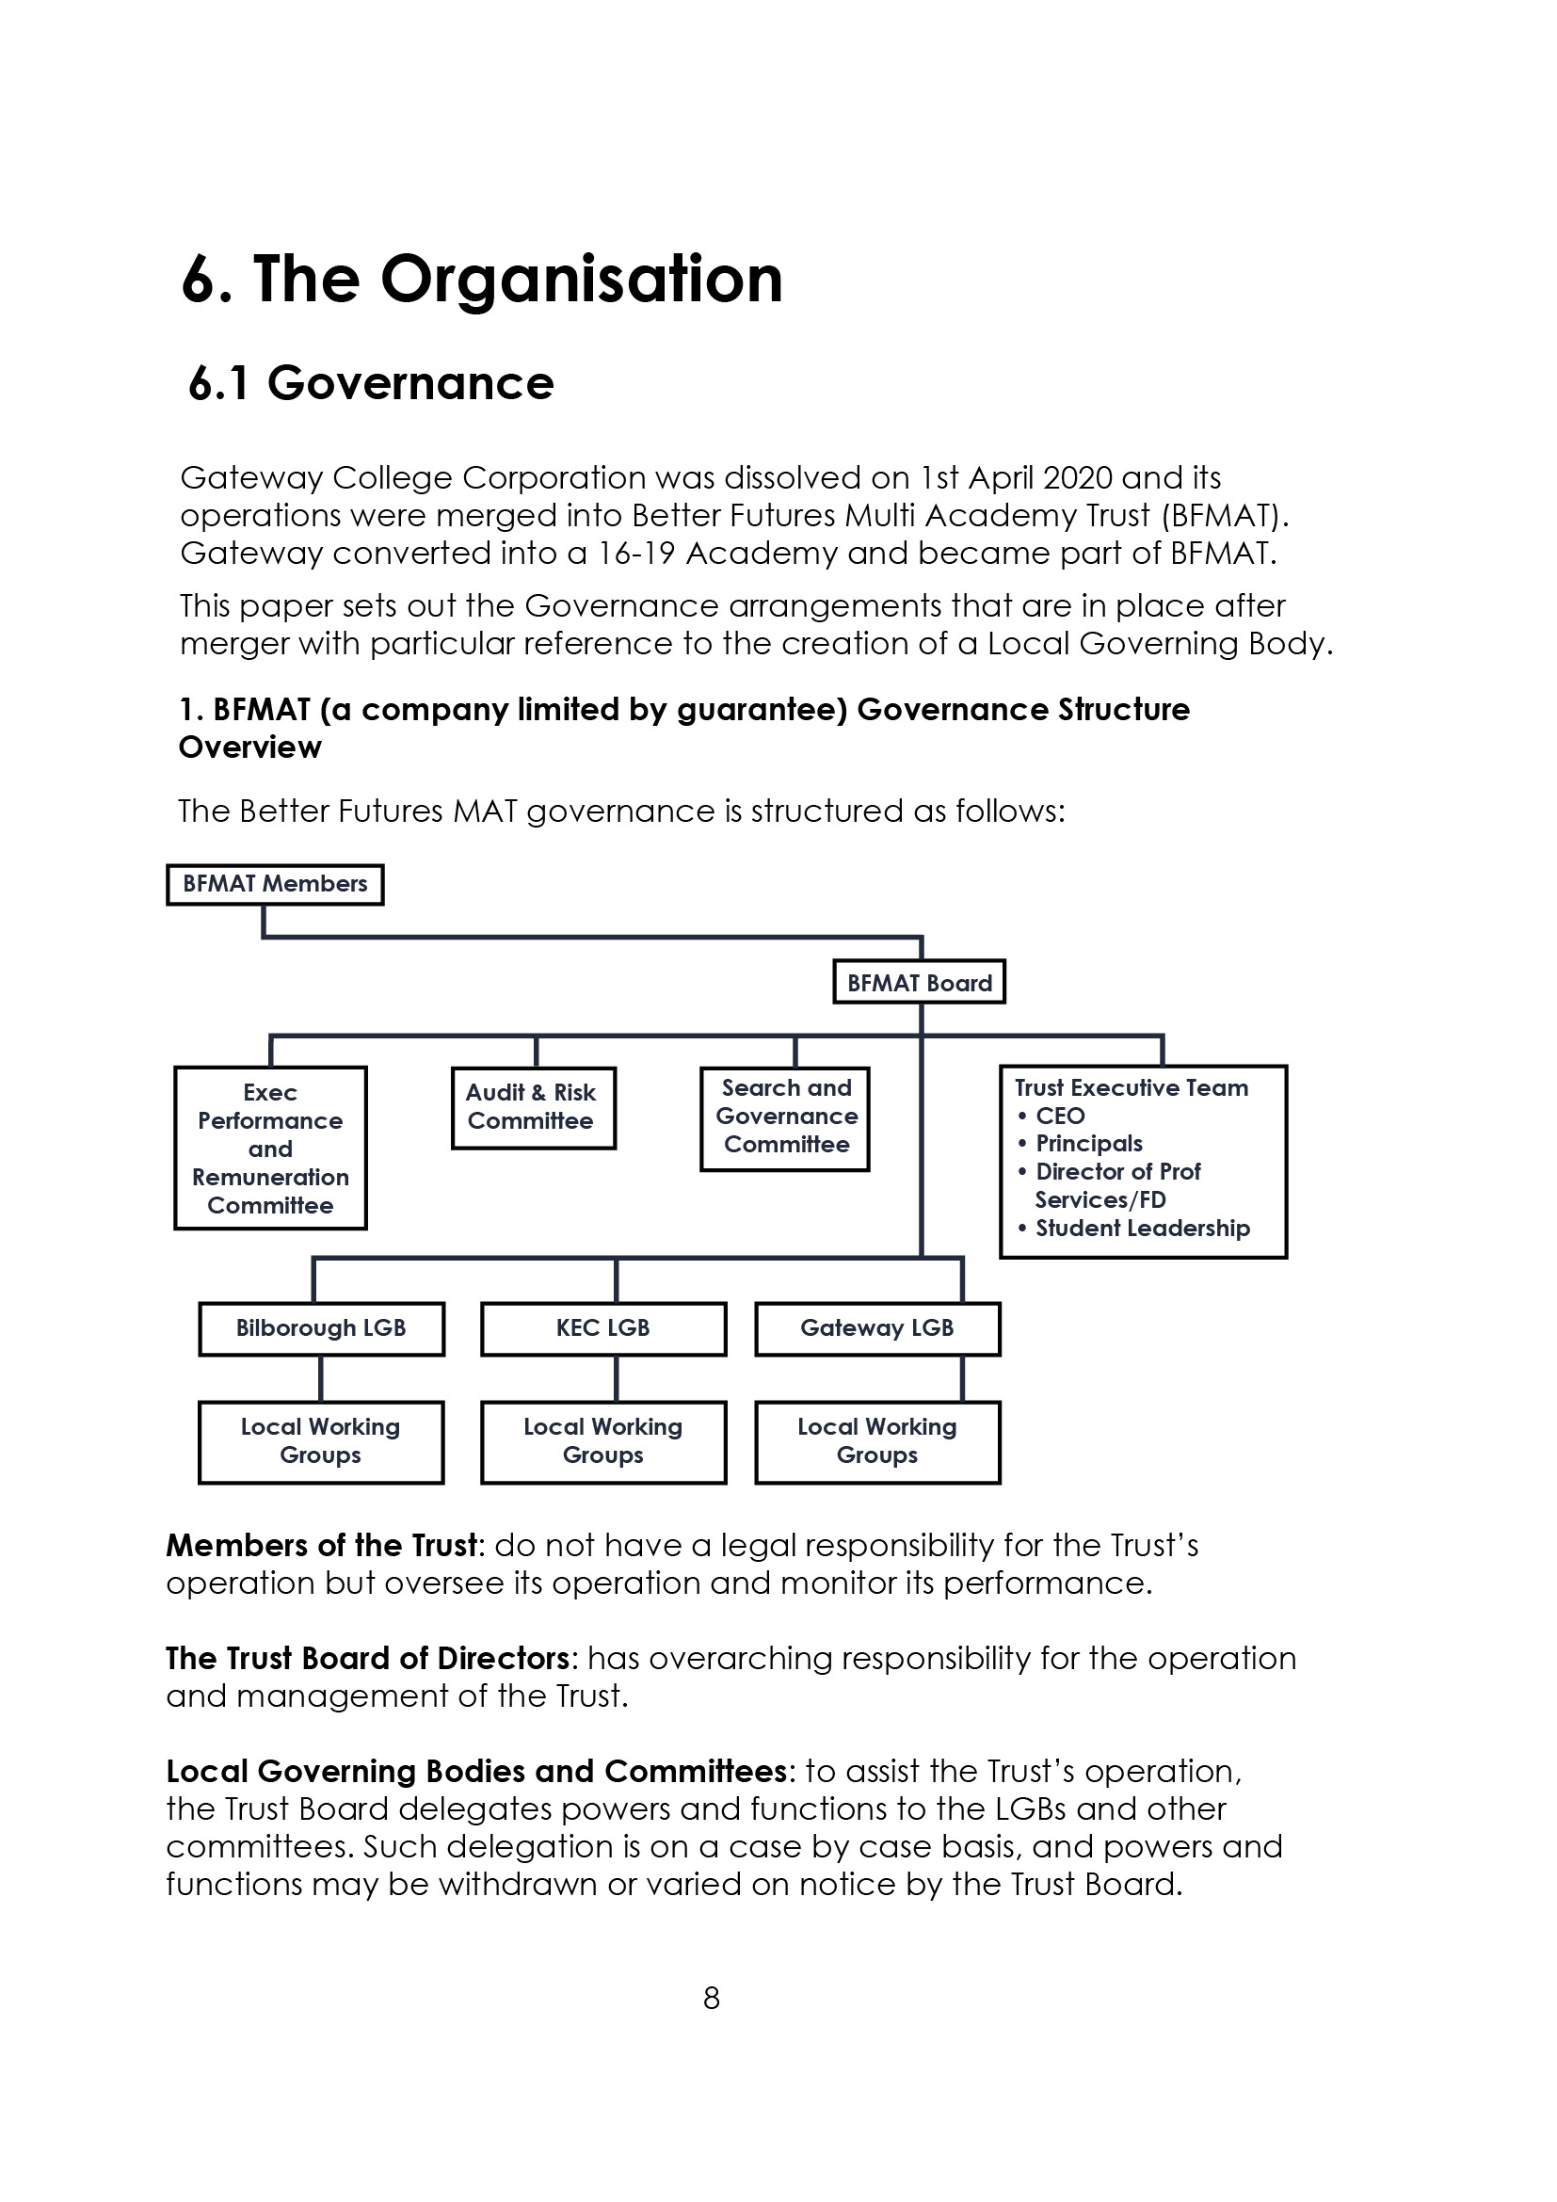

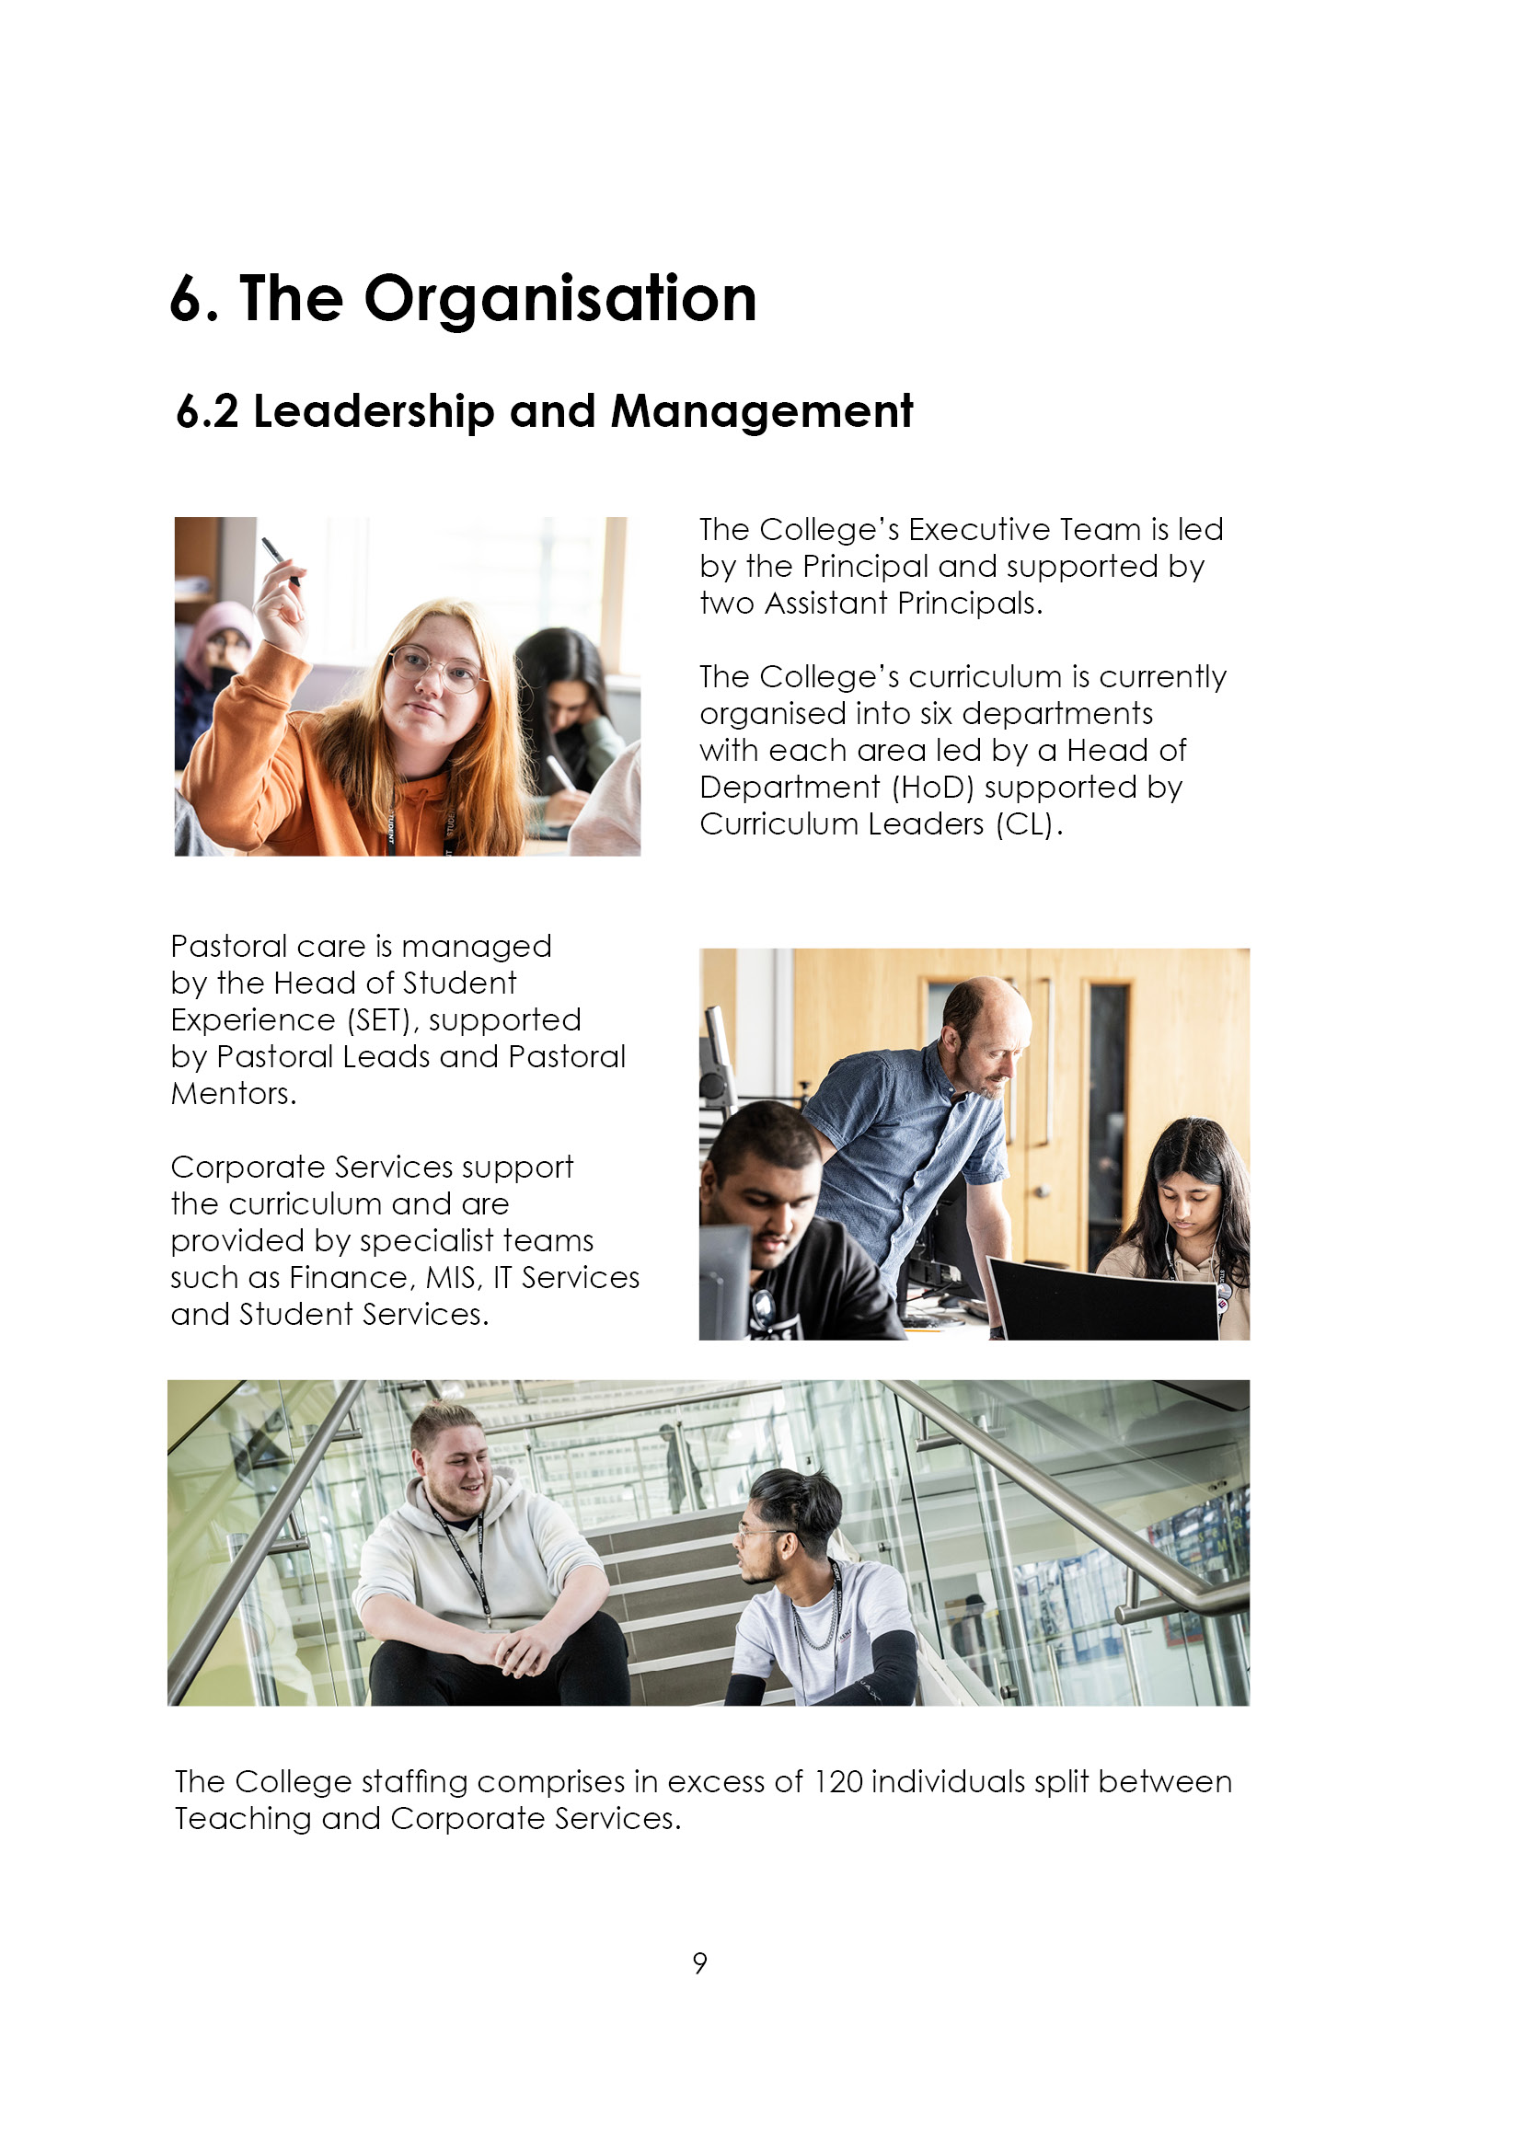

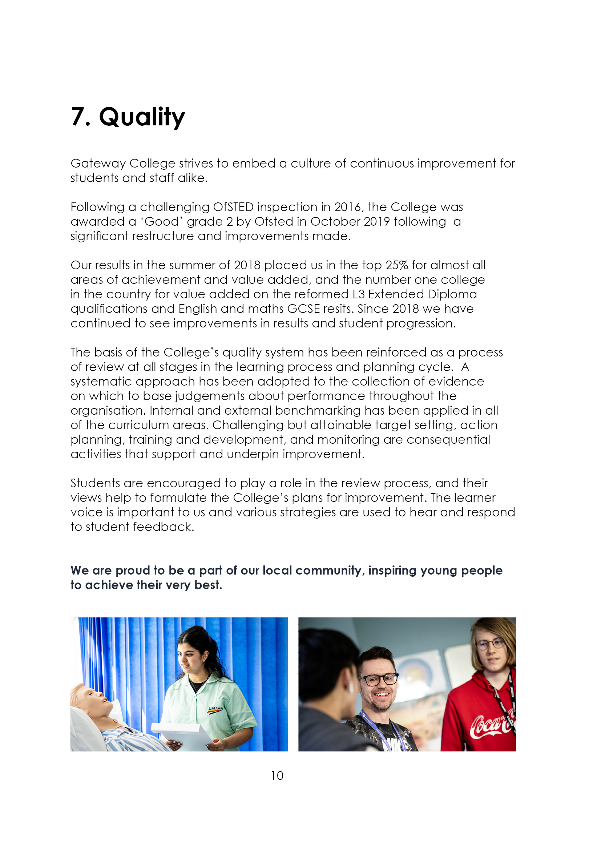

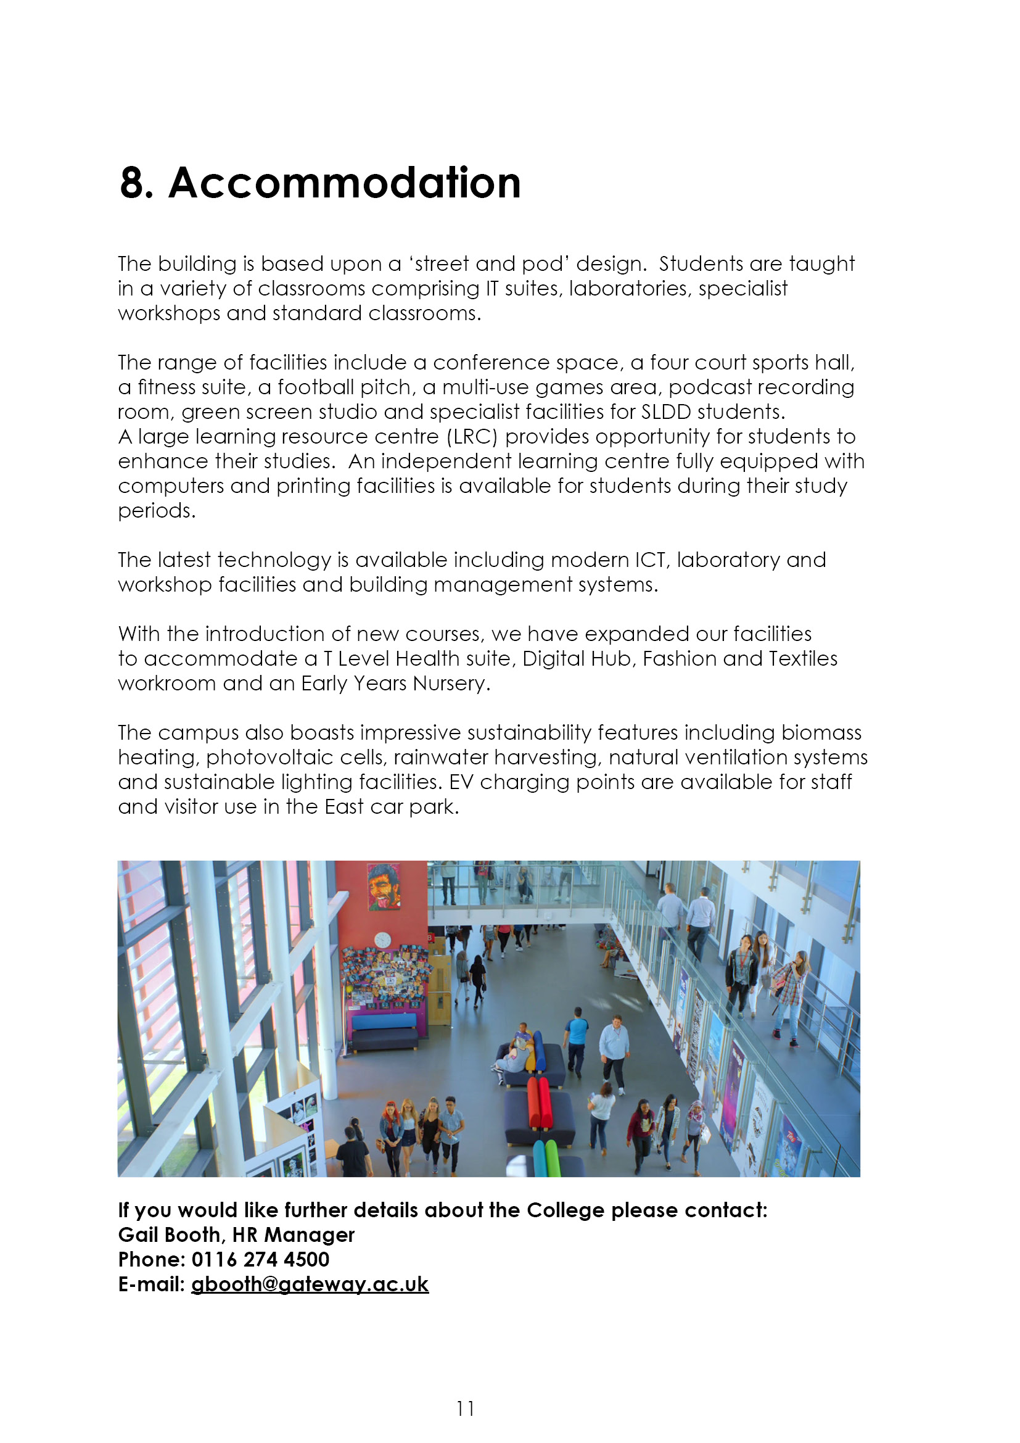

9. Job Advert
An exciting opportunity exists to join a strong staff team based at our campus in Hamilton, Leicester.

EDUCATION/CARE SUPPORT WORKER – LEVEL 2 (Ref: 25/04)
34½ hours per week, 35 weeks per year
Actual annual salary: £17,134

If you are ambitious, curious, involved, supportive, genuine and optimistic we want to hear from you.

The successful candidate will develop the independence of students within the College, through encouragement and respect. You will be required to support students with physical disabilities and/or learning difficulties. Experience of classroom support is essential and supporting students with personal care is desirable, but training will be given.

Closing date: 31st March 2025 (12 noon)
Interview date: 7th April 2025

If you feel you have the qualities we are asking for and are looking for an exciting challenge, please apply via:

Teaching and education jobs in LE5 1GA | Tes or visit www.gateway.ac.uk

10. Job Description
Responsible to: Head of Support to Learners

Salary: Sixth Form College’s Pay Spine point 3 £17,134 (actual salary)

Job Purpose:
To provide educational support and physical care for young people with physical and learning disabilities.

Duties and Responsibilities:

- To develop the independence of students within College, through encouragement and respect.

- To provide personal care as needed, in a sensitive manner; including assistance with meals; toileting and mobility.

- To assist small groups and individuals in their learning within the classroom and during private study where appropriate.

- Ensure student ownership of all work produced, by encouraging students to maintain their control over all their work.

- To accompany students on trips and activities associated with their college courses.

- To assist the Head of Support to Learners in the provision of quality learning environment.

- To assist in the general care of equipment in the department and ensure health and safety procedures are followed.

- To help develop a positive attitude to disability and implement the College’s Equal Opportunities Policy with respect to all students and staff.

- To keep up to date knowledge of disability issues and ensure staff development opportunities are optimised.

- To attend meetings as directed by the Line Manager.

- To carry out any other reasonable duties in the College as may be required by the Principal or designated alternative.

ESSENTIAL | Method of Assessment | Short listing Column
- Experience of working with students/ young people (16 and above), in an educational setting, community or youth group. | A
- An understanding of the social model of disability and a positive attitude towards all disabilities. | I
- Effective literacy and numeracy skills (for supporting students’ studies). | T
- Recent experience of working flexibly (variety of tasks, methods of working). | I
- Good listening skills. | I
- Professional understanding of confidentiality and trust. | I
- A sense of humour. | I
- Reliable with a good attendance record. | A/I
- Organised and punctual with an ability to work in a team. | I
- NVQ level 2 in supporting teaching and learning in schools or equivalent | A
- English A – C } GCSE or  Maths A – C } equivalent | A/I

DESIRABLE

- First Aid qualification | A
- Knowledge and understanding of the Disability Discrimination Act. | I
- I.T skills | T
- Willingness to work flexibly – evenings, social and leisure times, residential trips. | I
- Basic counselling skills. | I
- Experience of supporting people with behaviour and emotional difficulties. | I
- Experience in providing personal care | A
A = Application form I = Interview T = Test

Notes:

The above responsibilities are subject to the general duties and responsibilities contained in the statement of conditions of employment and our equal opportunities policy.

This job description allocates duties and responsibilities but does not direct the particular amount of time to be spent on carrying them out and no part of it may be so construed.

This job description is not necessarily a comprehensive definition of the post and is subject to review following consultation.

This post is subject to enhanced disclosure from the Disclosure and Barring Service.
Gateway College is subject to the Safeguarding Vulnerable Groups Act 2006 which requires that any candidate appointed must produce:

- A DBS clearance certificate
- Proof of identity
- Proof of qualifications
- Proof of the right to work in the UK.

All of these documents must be produced BEFORE commencement of employment.



