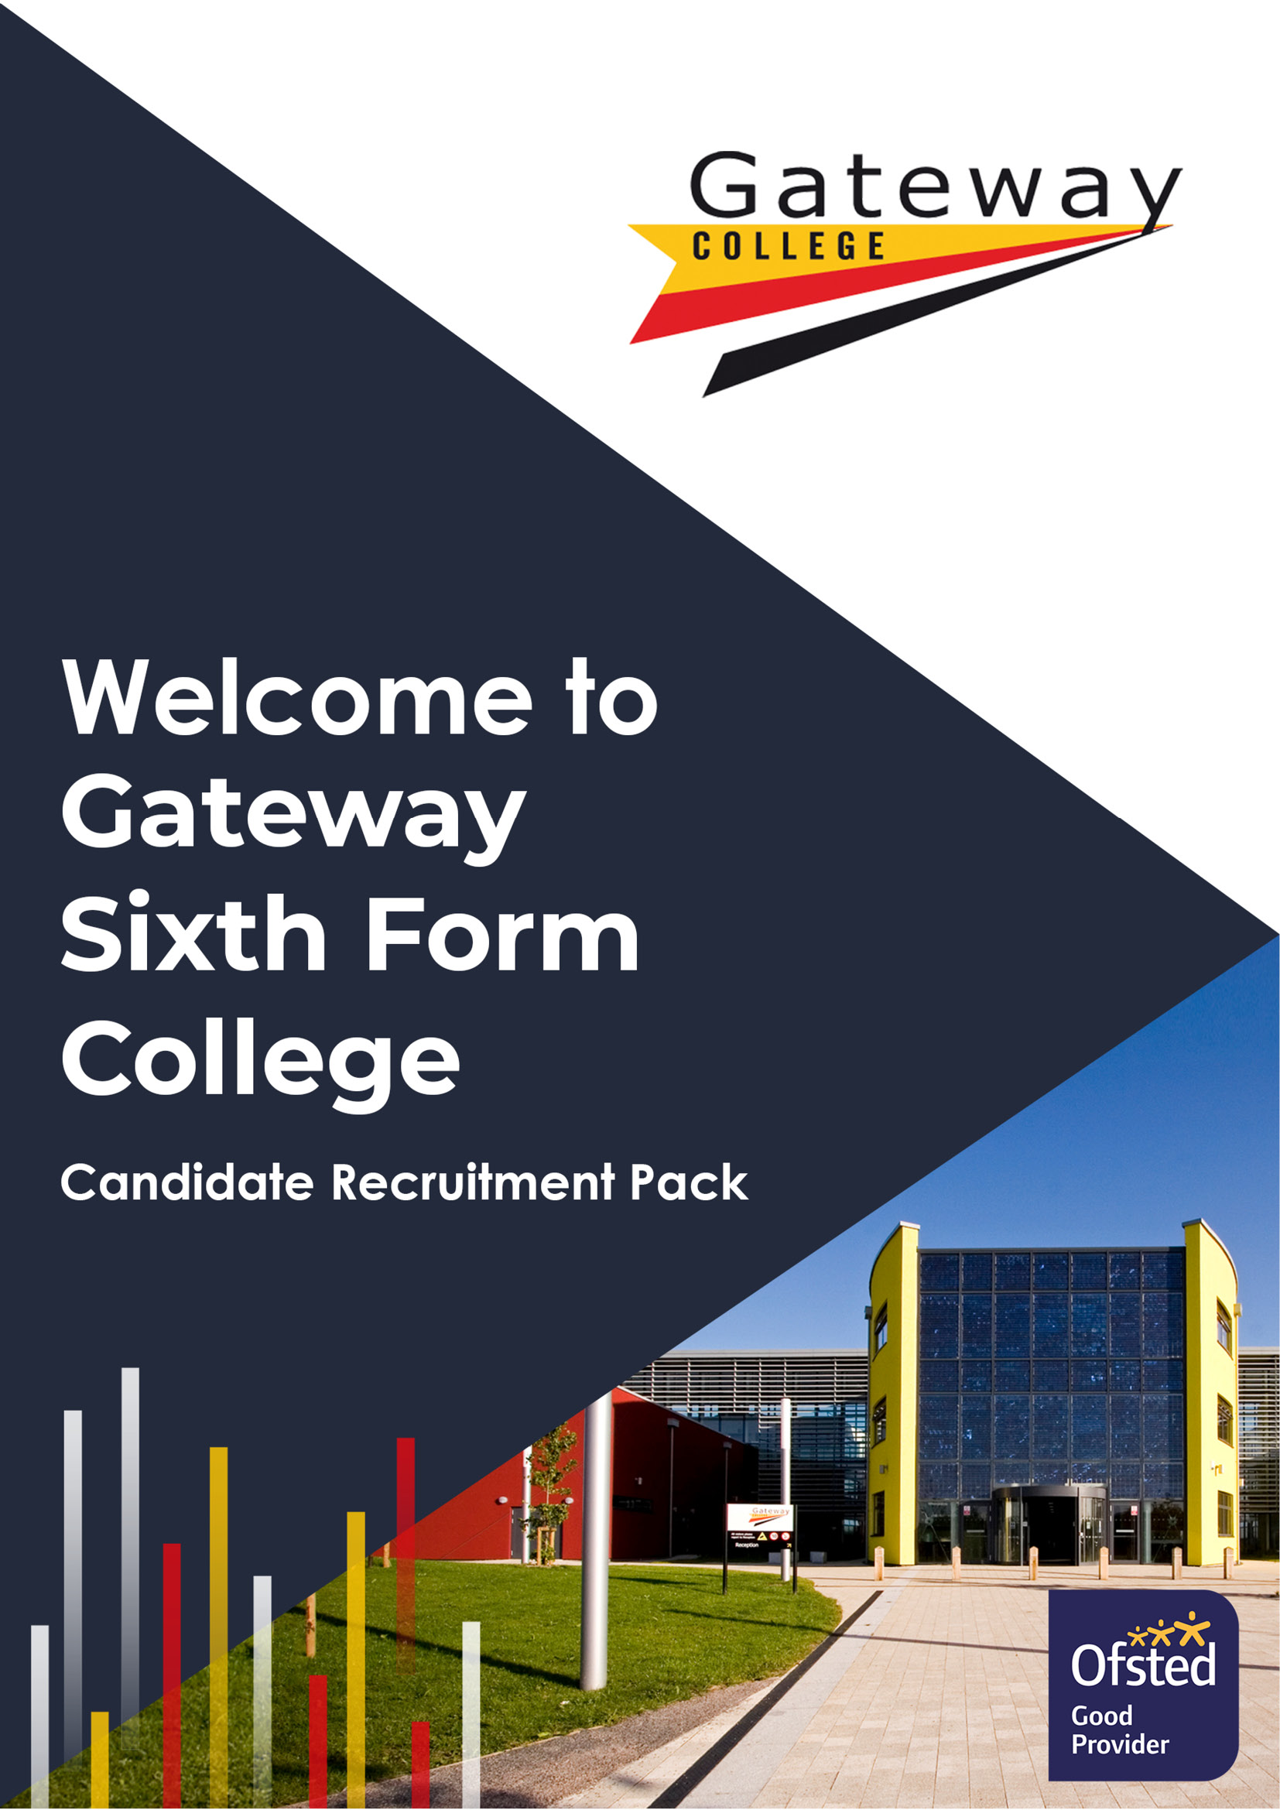

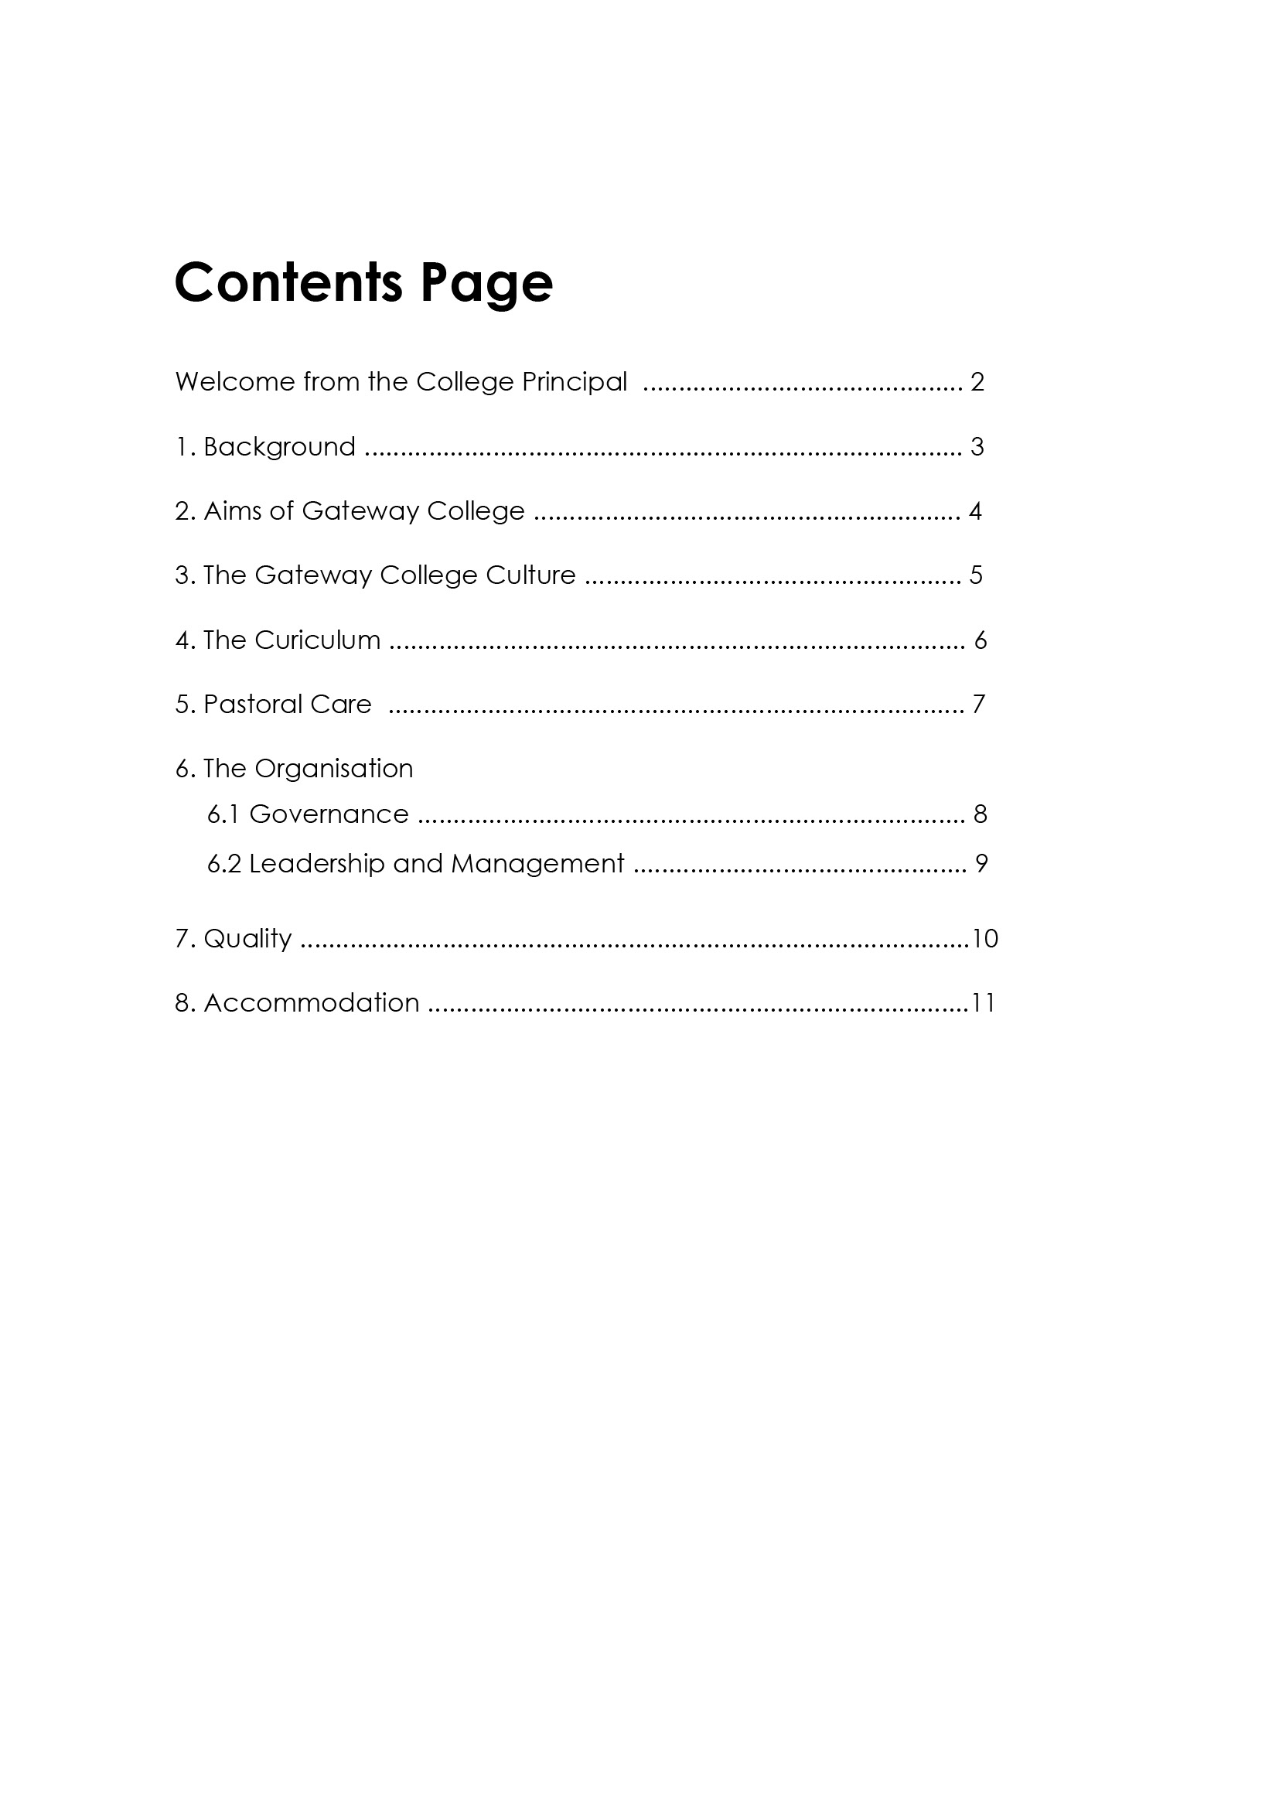

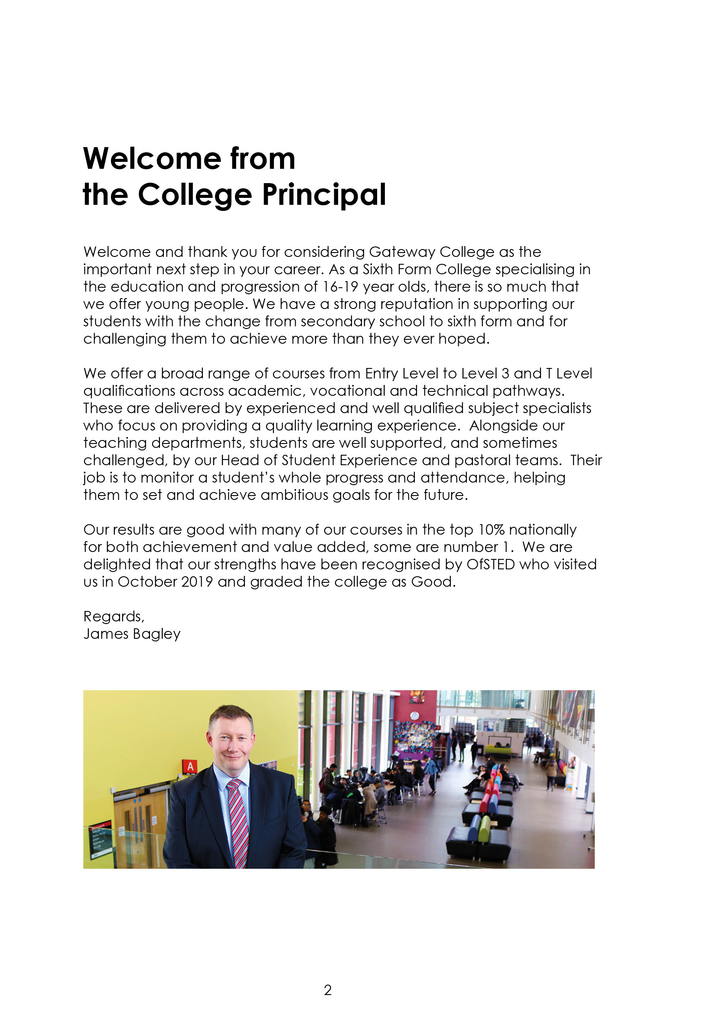

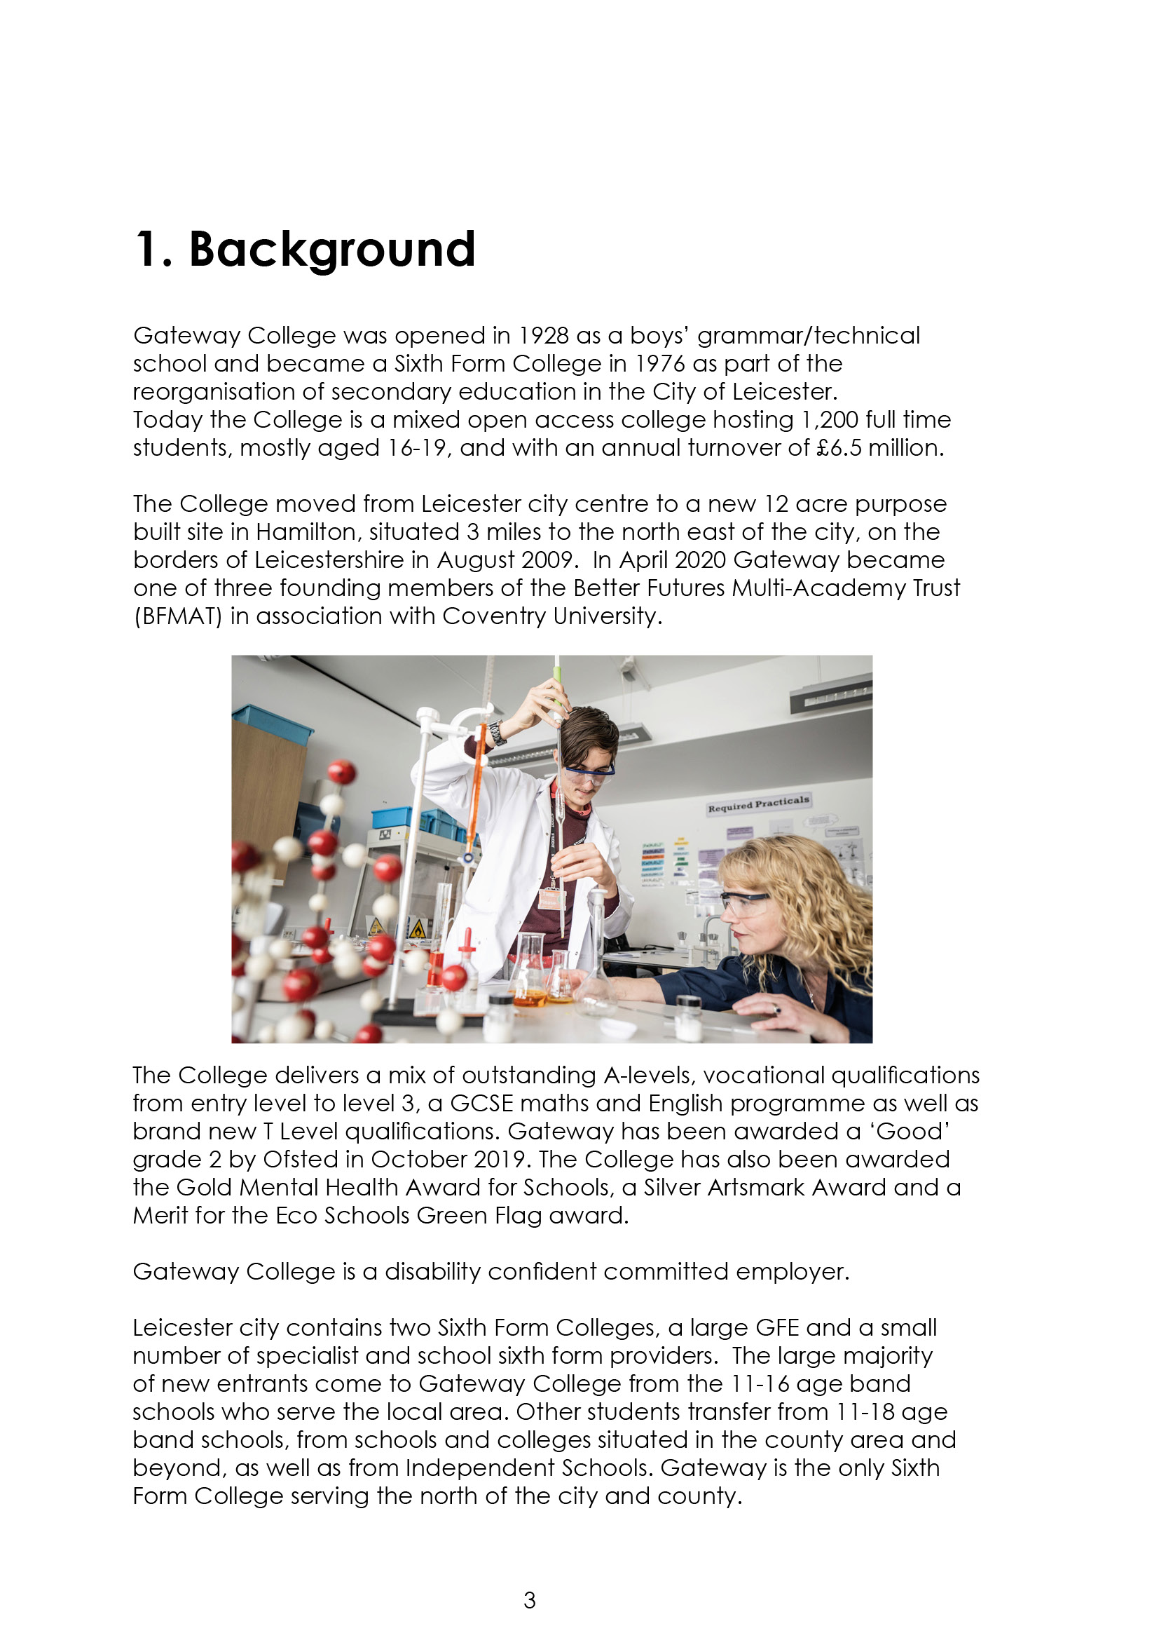

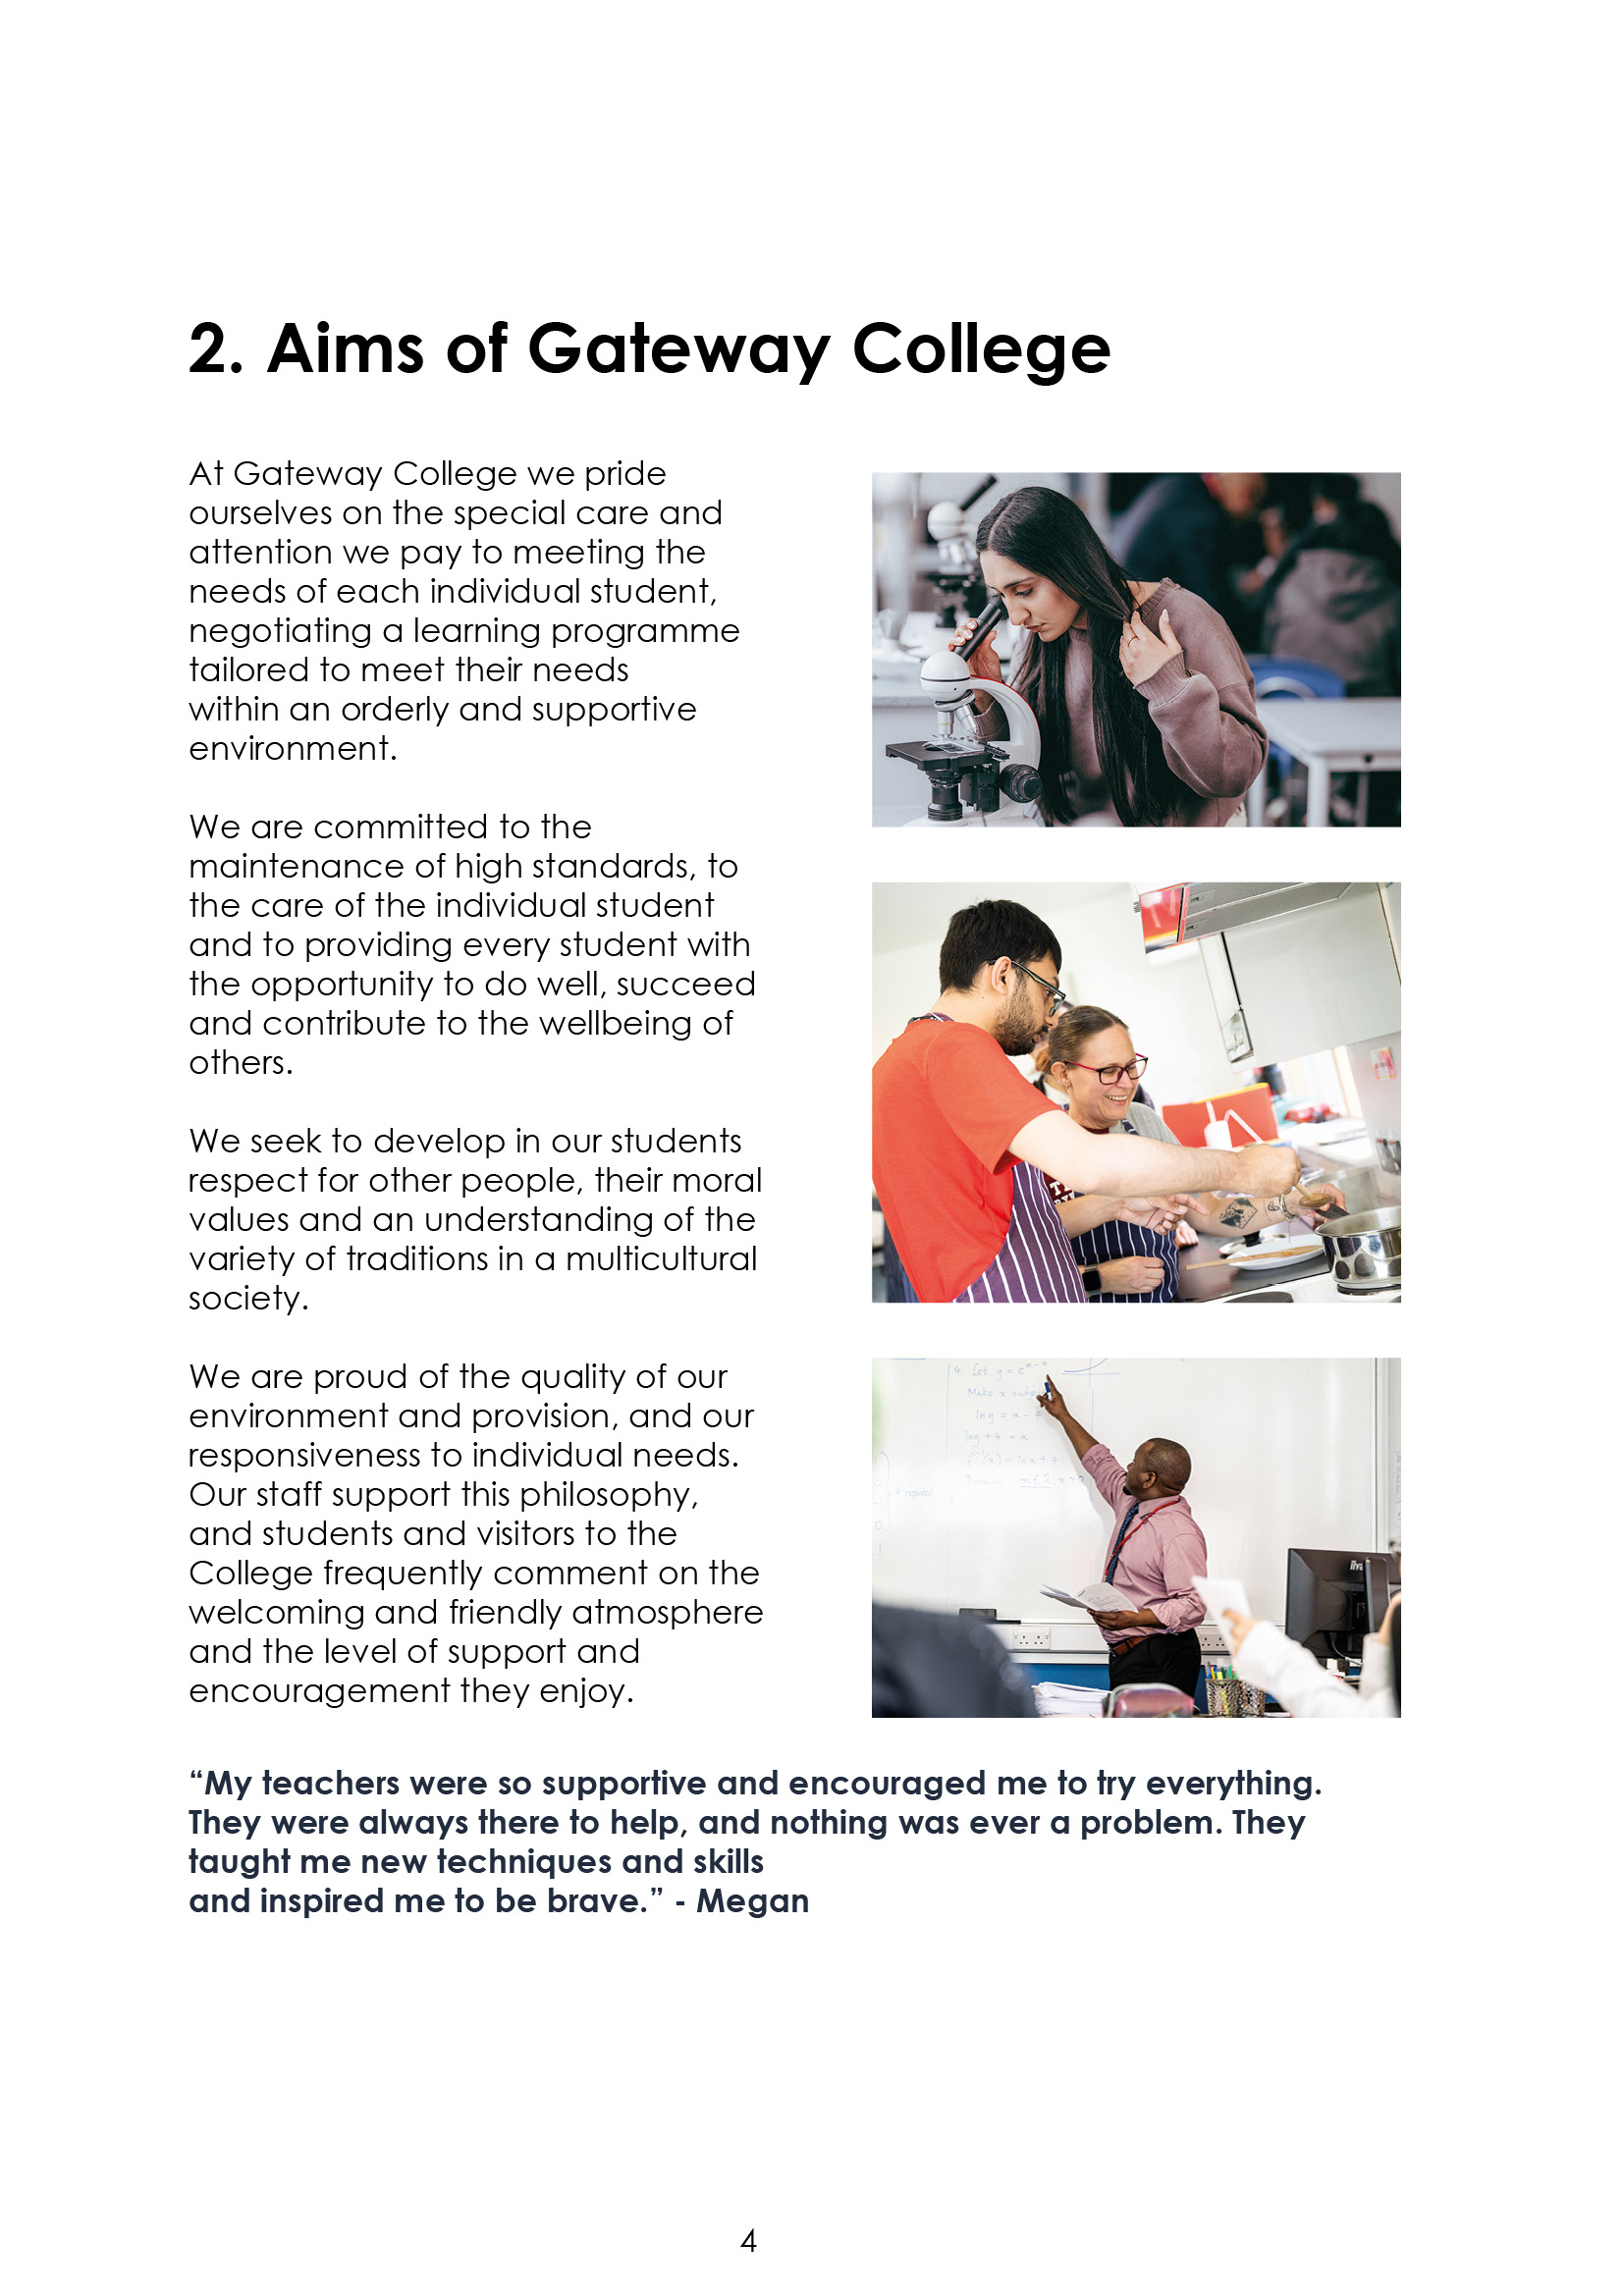

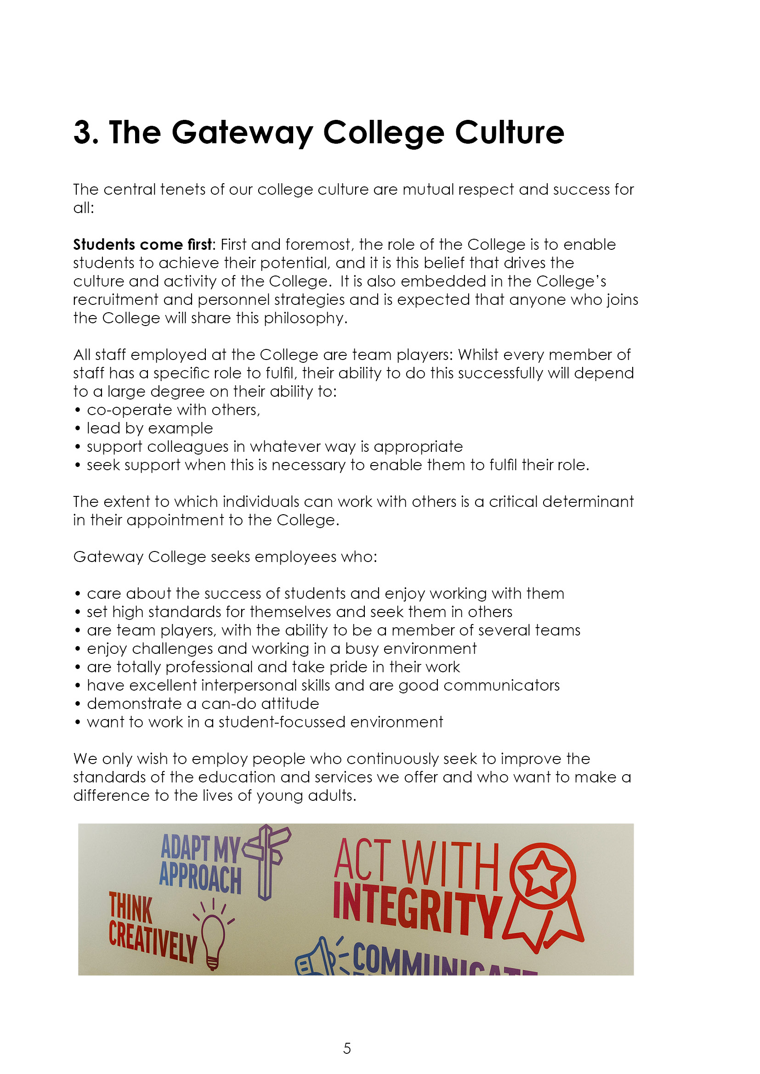

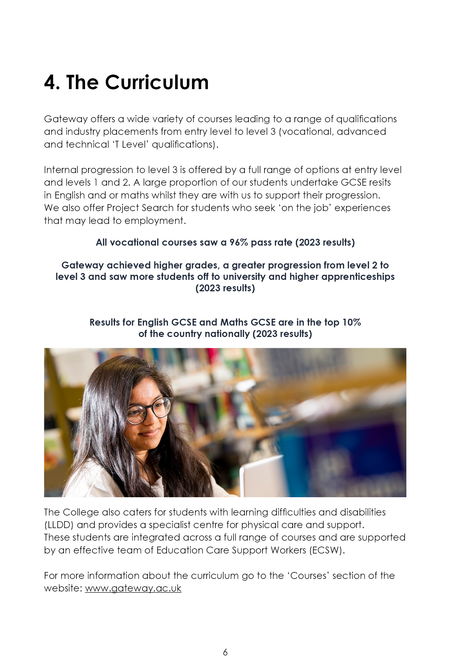

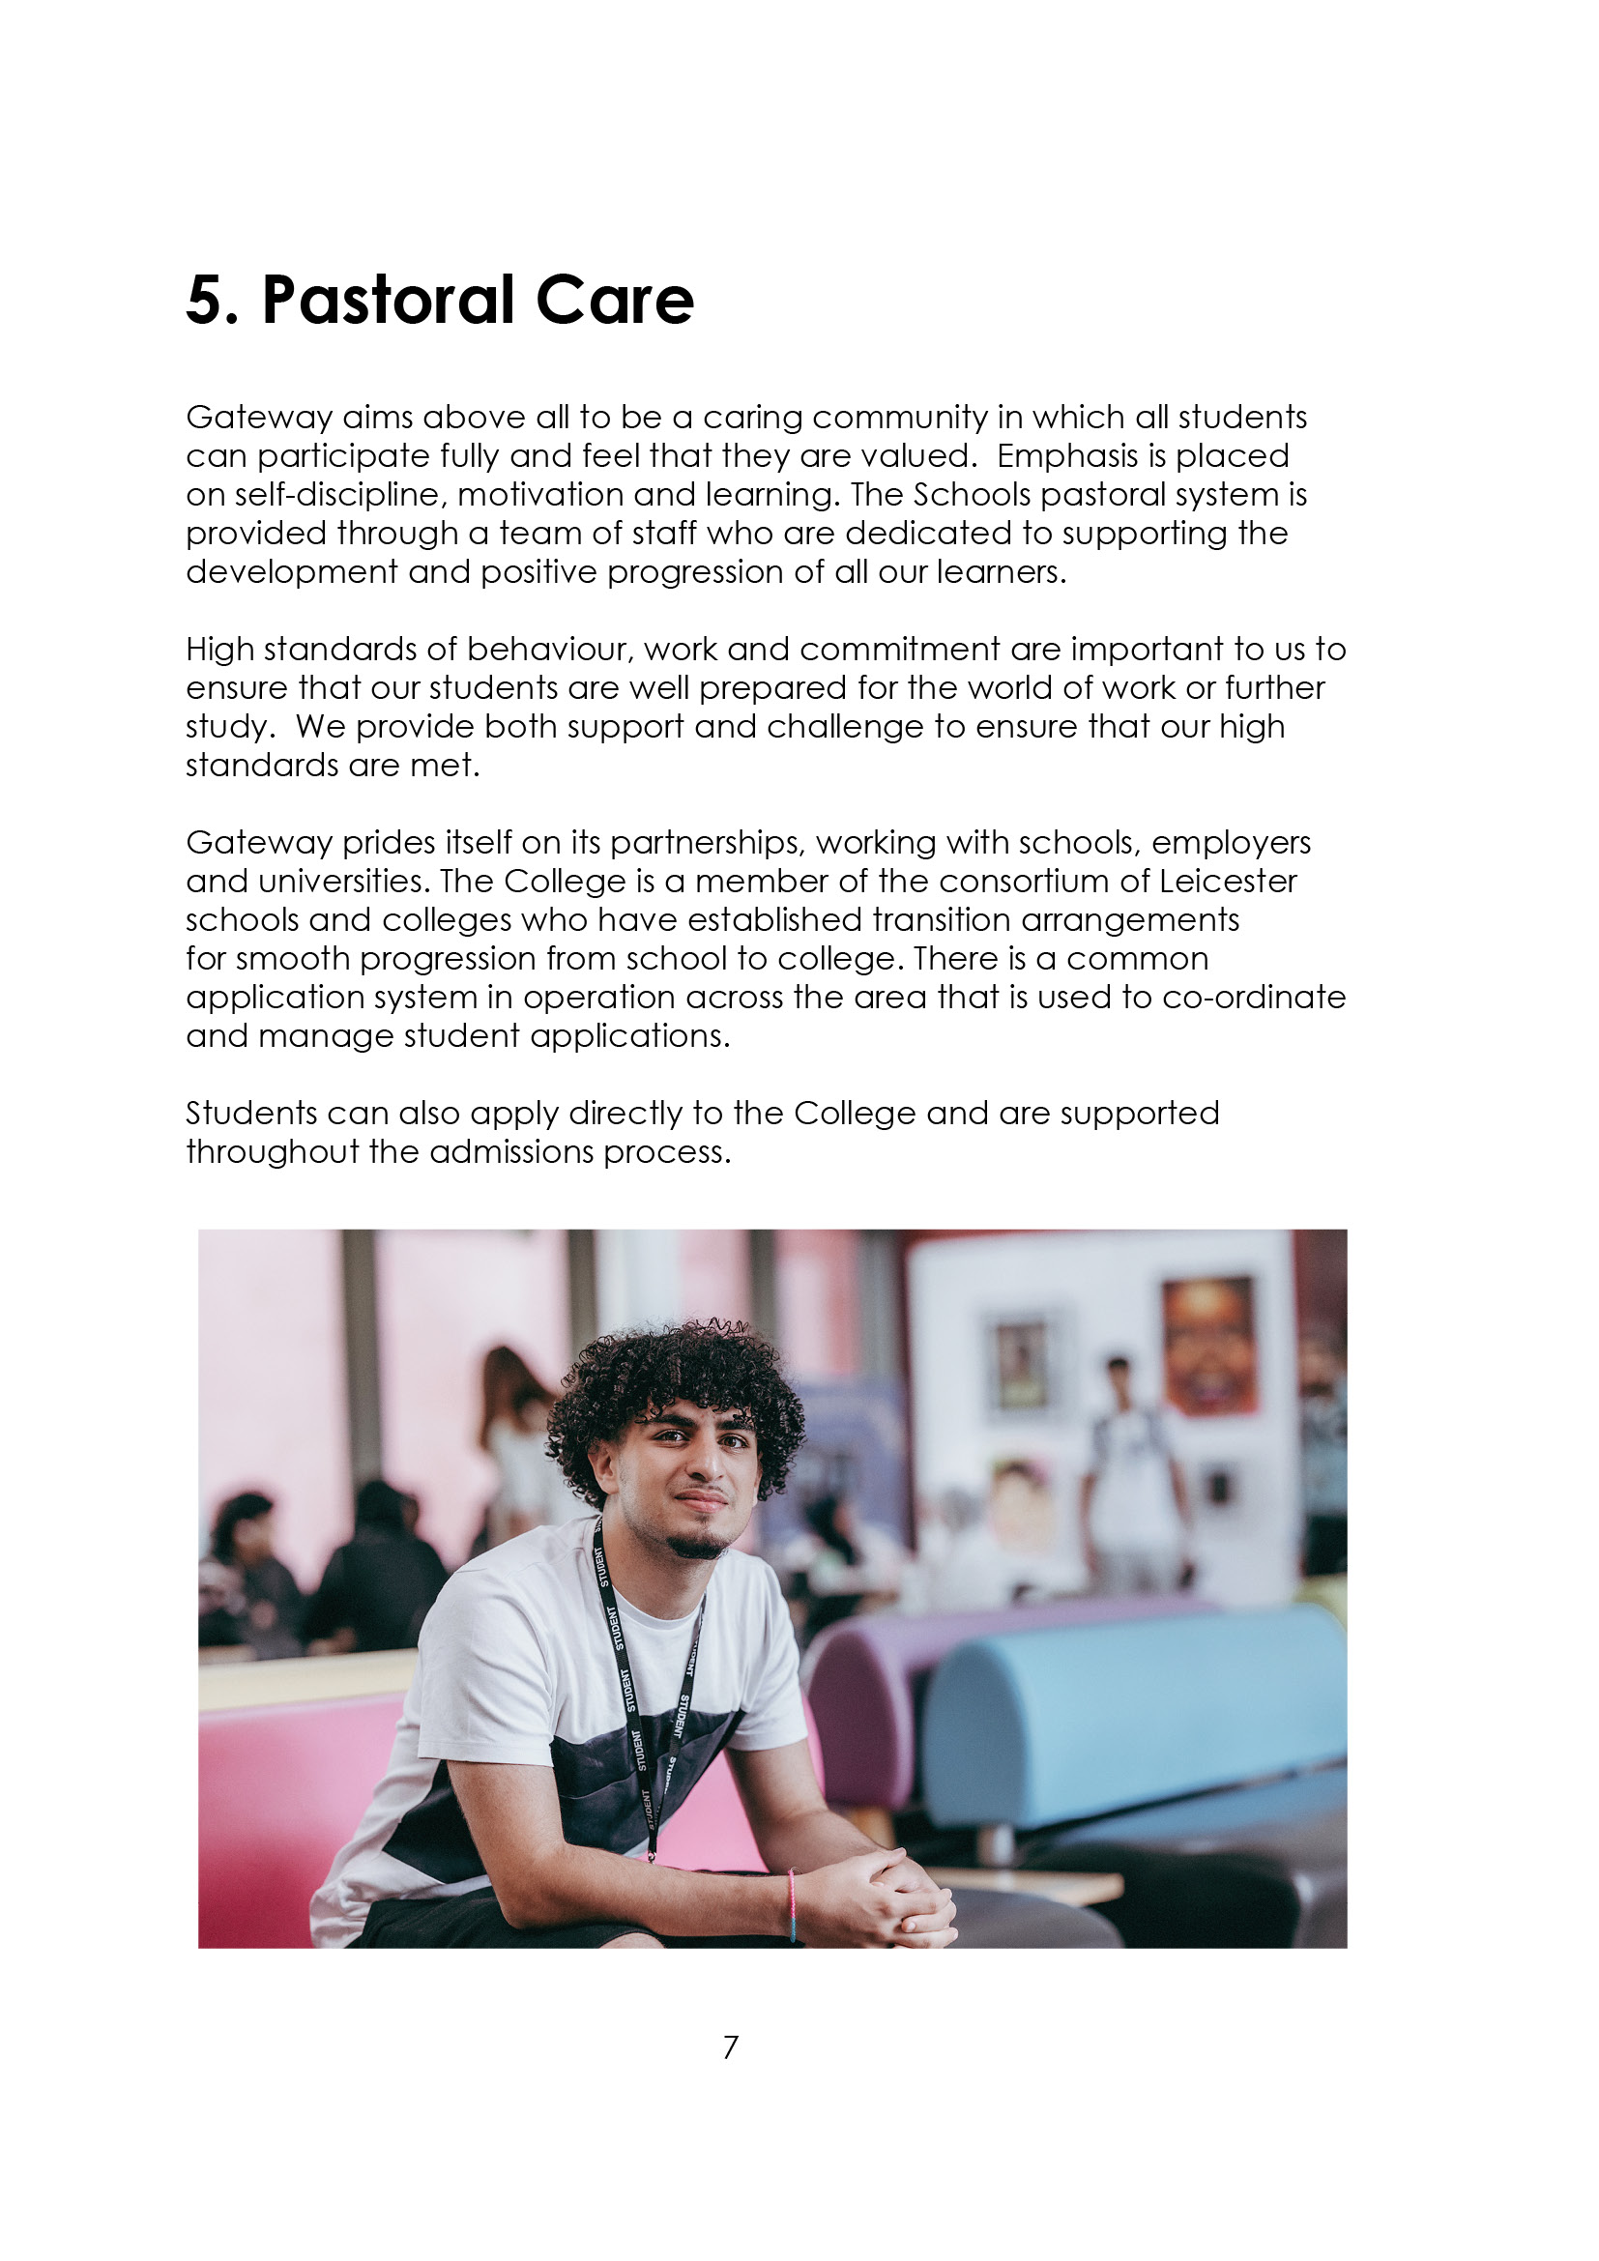

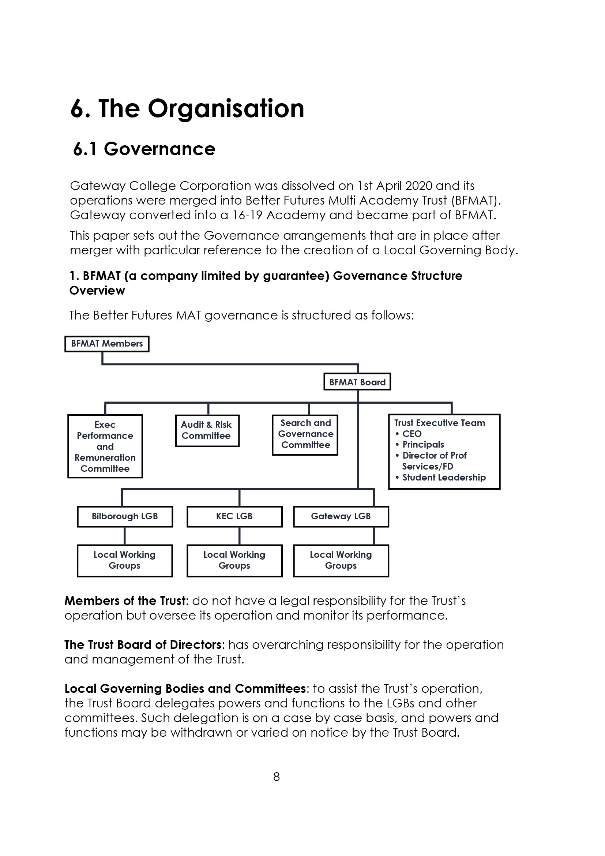

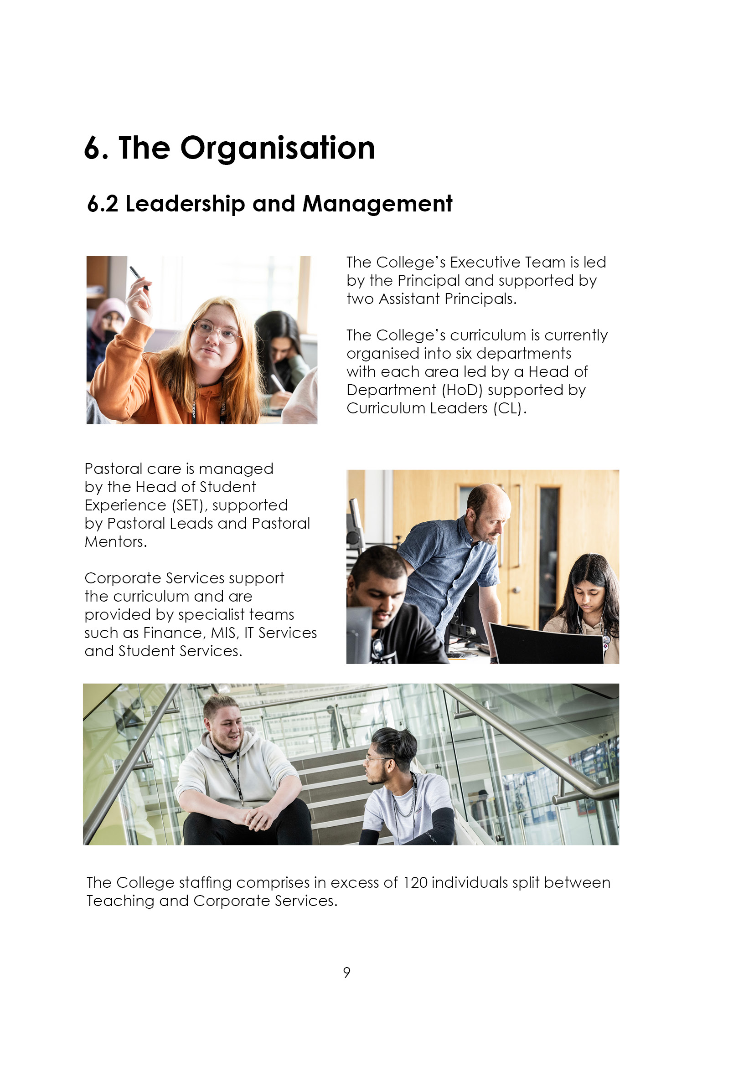

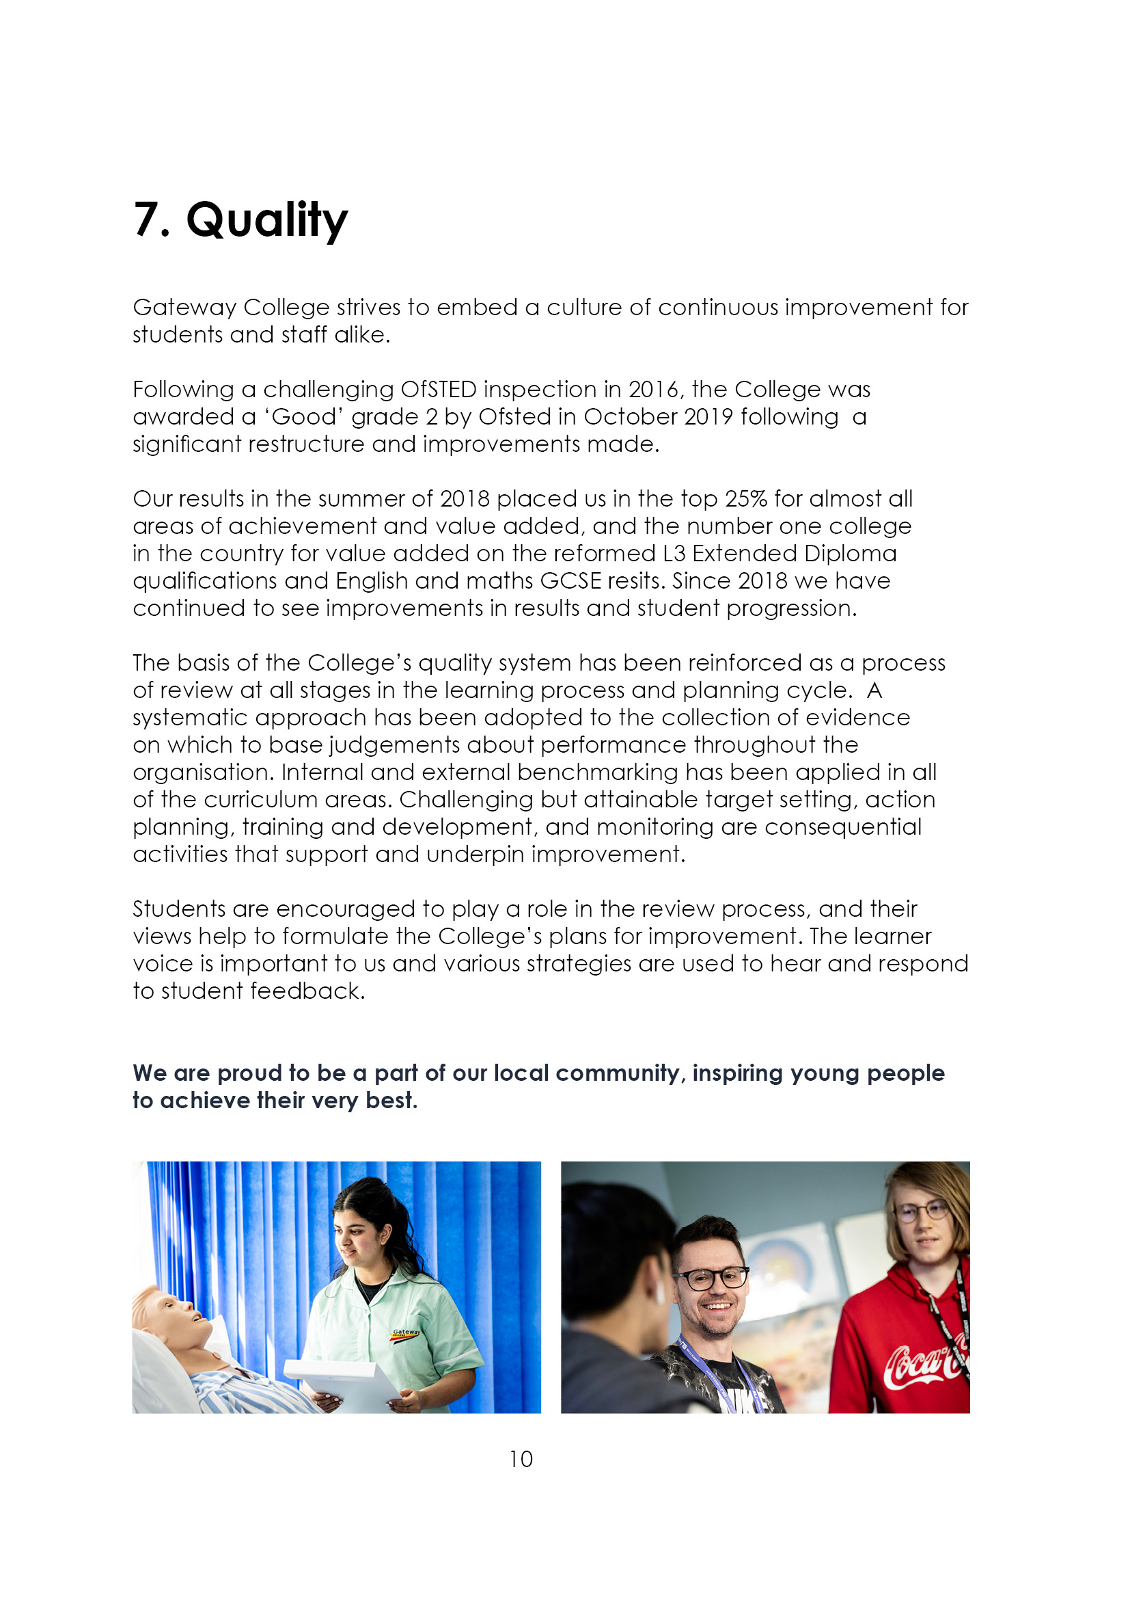

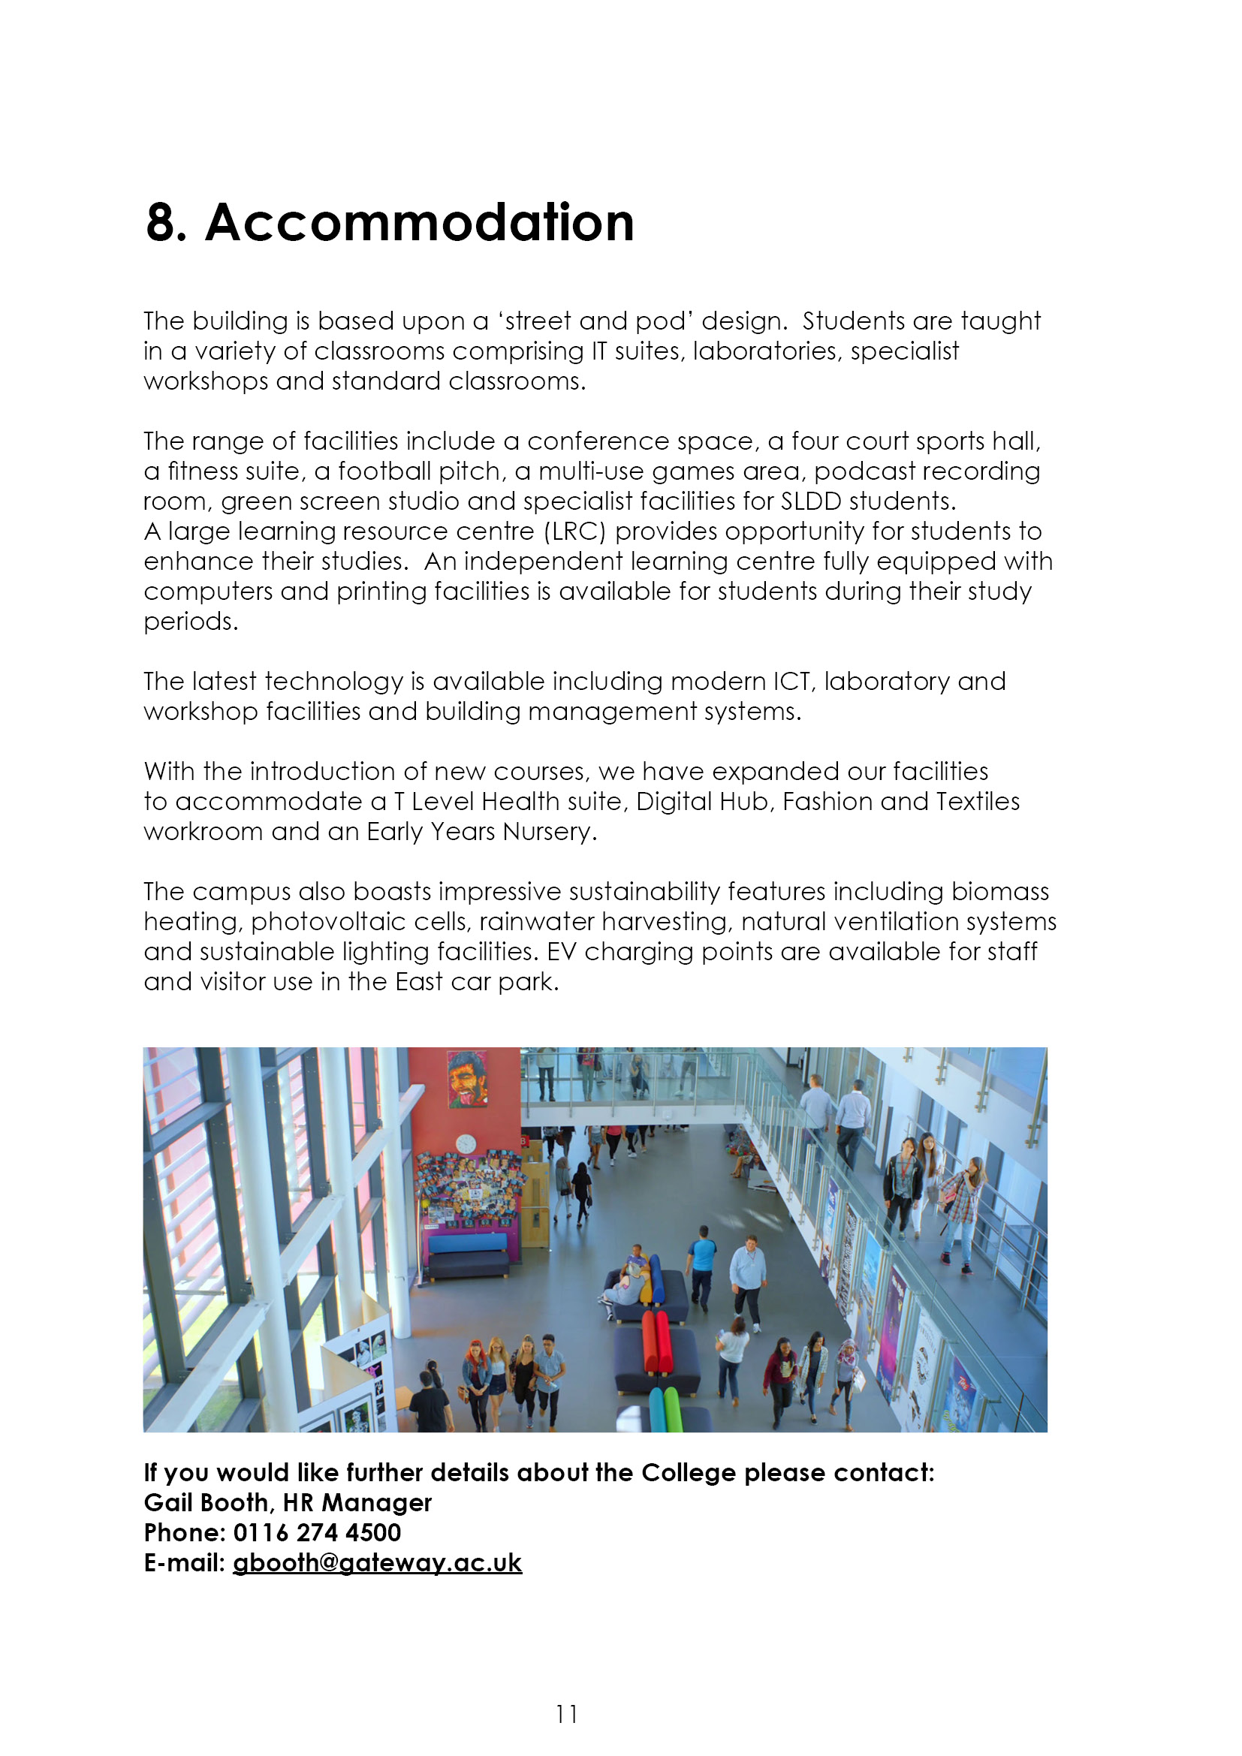

9. Job Advert

Senior Administrator (Ref: 25/03)
Salary range £12,756-£13,954 (support staff pay spine points 11-14)
Permanent post, 20 hours per week / Term-time only plus 2 weeks (41 weeks per year)

The Executive Team require an Administrator to support all aspects of their work including administration, communication, the management of specific projects and IT support.

This is an exciting and challenging role that requires a high level of IT competence, excellent interpersonal skills, tact and diplomacy, the ability to co-ordinate a number of activities at any one time. The ideal candidate will have the experience and ability to work independently, bring new ideas and be able to communicate effectively with young people.

The working pattern is flexible and negotiable for the right candidate.

Closing date for applications: Wednesday 12th March 2025 (12 noon)
Interview date: Thursday 20th March 2025.

If you feel you have the qualities we are asking for and are looking for an exciting challenge, please see Teaching and education jobs in LE5 1GA | Tes or visit www.gateway.ac.uk

10. Job Description
Responsible to: The Principal

Salary: £26,097-£28,549 FTE (actual £12,756-£13,954) (support staff pay spine points 11-14)
Tenure: Permanent, 20 hours per week / 41 weeks per year

Job Summary:
To support all aspects of the Executive Team’s work, including administrative support, communications including IT systems and management of specific projects on behalf of the Principal/Deputy Principal and Cross College Administration.

Duties and Responsibilities:

- Maintaining regular contact with the Executive Team and Cross College Managers to provide appropriate administrative support as directed.

- Assisting the Executive Team with appointments, travel, accommodation, visitors, internal and external enquiries, correspondence and presentations.

- Planning and scheduling meetings with the Executive Team, Staff, students, parents and external stakeholders, to include minute taking, distribution and follow up actions.

- Assisting cross college administration as and when required.

- Organising certain key events in the annual College calendar as directed by the Executive Team, to include preparation, distribution and keeping the college key date calendar (support and academic) up to date.

- Organisation of internal room bookings.

- Minute taking and distribution of meetings to include, Executive Team, College Management Team and other internal meetings as agreed.

- Developing systems and procedures to improve the efficiency of the support for the Executive Team.

- Assist with the arrangement of CPD events, in liaison with the Executive Team.

- Liaise with students and/or parents in person, by telephone and email regarding issues of a personal, confidential or disciplinary nature.

- Maintain, organise and order stationery and catering provision (stocks).

- To provide emergency cover in other areas of the college as required. This may include reception duties, examination invigilation and support, and covering for absent colleagues (non-teaching staff).
- To line manage a small team of Admin Assistants, prioritising work where necessary and providing guidance and training (or access to training).

- To undertake any other reasonable duties/activities as required by the Principal or designated alternative.

Qualifications | Essential | Desirable | Assessed by
- A good standard of education to include GCSE English and Mathematics |  |  | Application
- A minimum standard of education to A level or Level 3 equivalent |  |  | Application
- Recognised qualifications in some aspects of ICT |  |  | Application
Experience
- Experience of working within a multicultural education setting |  |  | Application
- Experience of administrative responsibility and working under own initiative |  |  | Interview
- Experience of minute taking at senior level |  |  | Application/  Interview
- Ability to work with young people aged 16-19, displaying both patience and strong will |  |  | Interview
- Experience of managing a small team |  |  | Interview
Skills and Abilities
- Good organisational, planning and communication skills, with the ability to meet strict deadlines and remain calm under pressure |  |  | Application/  Interview
- To engage effectively with internal and external stakeholders with tact, diplomacy and integrity |  |  | Interview
- Adaptable and flexible |  |  | Interview
- High level of IT skills and all-round knowledge of electronic platforms – PowerPoint, outlook, TEAMS, Cedar (or similar) |  |  | Application/  interview
- Possess a high level of interpersonal skills to relate and communicate effectively with colleagues verbally and in written form |  |  | Interview
- To always maintain confidentiality |  |  | Application/  Interview
Values
- Be committed to the BFMAT Mission and Values |  |  | Application/  interview
- Be committed to own self development and engage in regular continued professional development opportunities |  |  | Application/  Interview
- A clear commitment to the principles and practices of Equality & Diversity and the safeguarding of young people |  |  | Interview

This post is subject to enhanced disclosure from the Disclosure & Barring Service.

Gateway College is subject to the Safeguarding Vulnerable Groups Act 2006 which requires that any candidate appointed must produce:

- A DBS clearance certificate
- Proof of identity
- Proof of qualifications
- Proof of the right to work in the UK.

All these documents must be produced BEFORE commencement of employment.

Gateway College is an equal opportunities employer, committed to equality in employment and services.

