

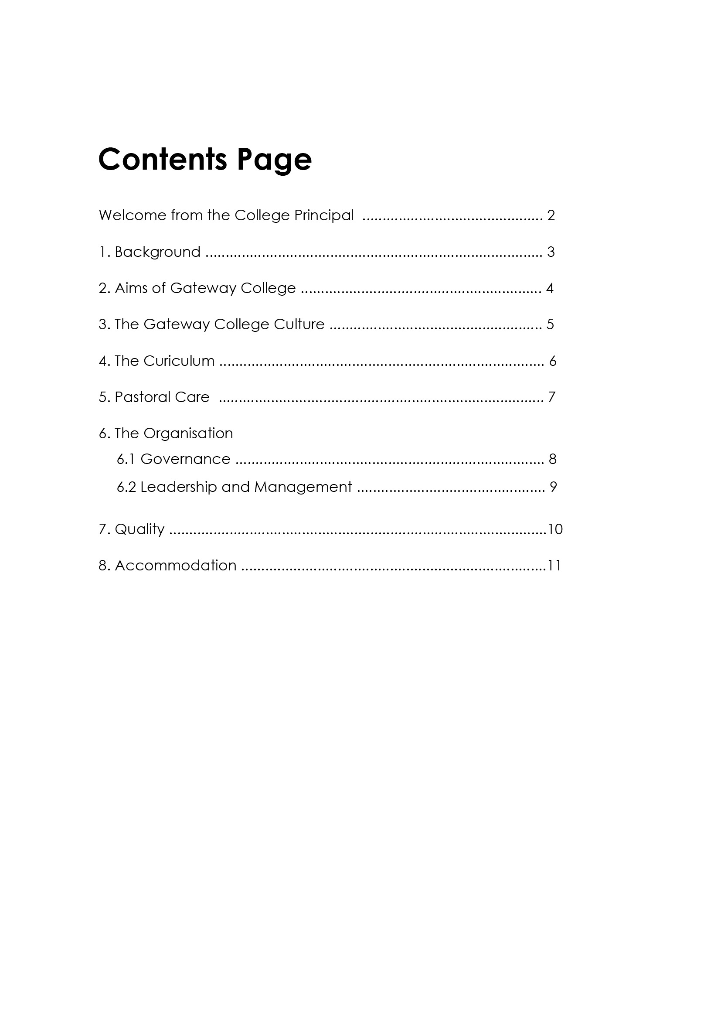

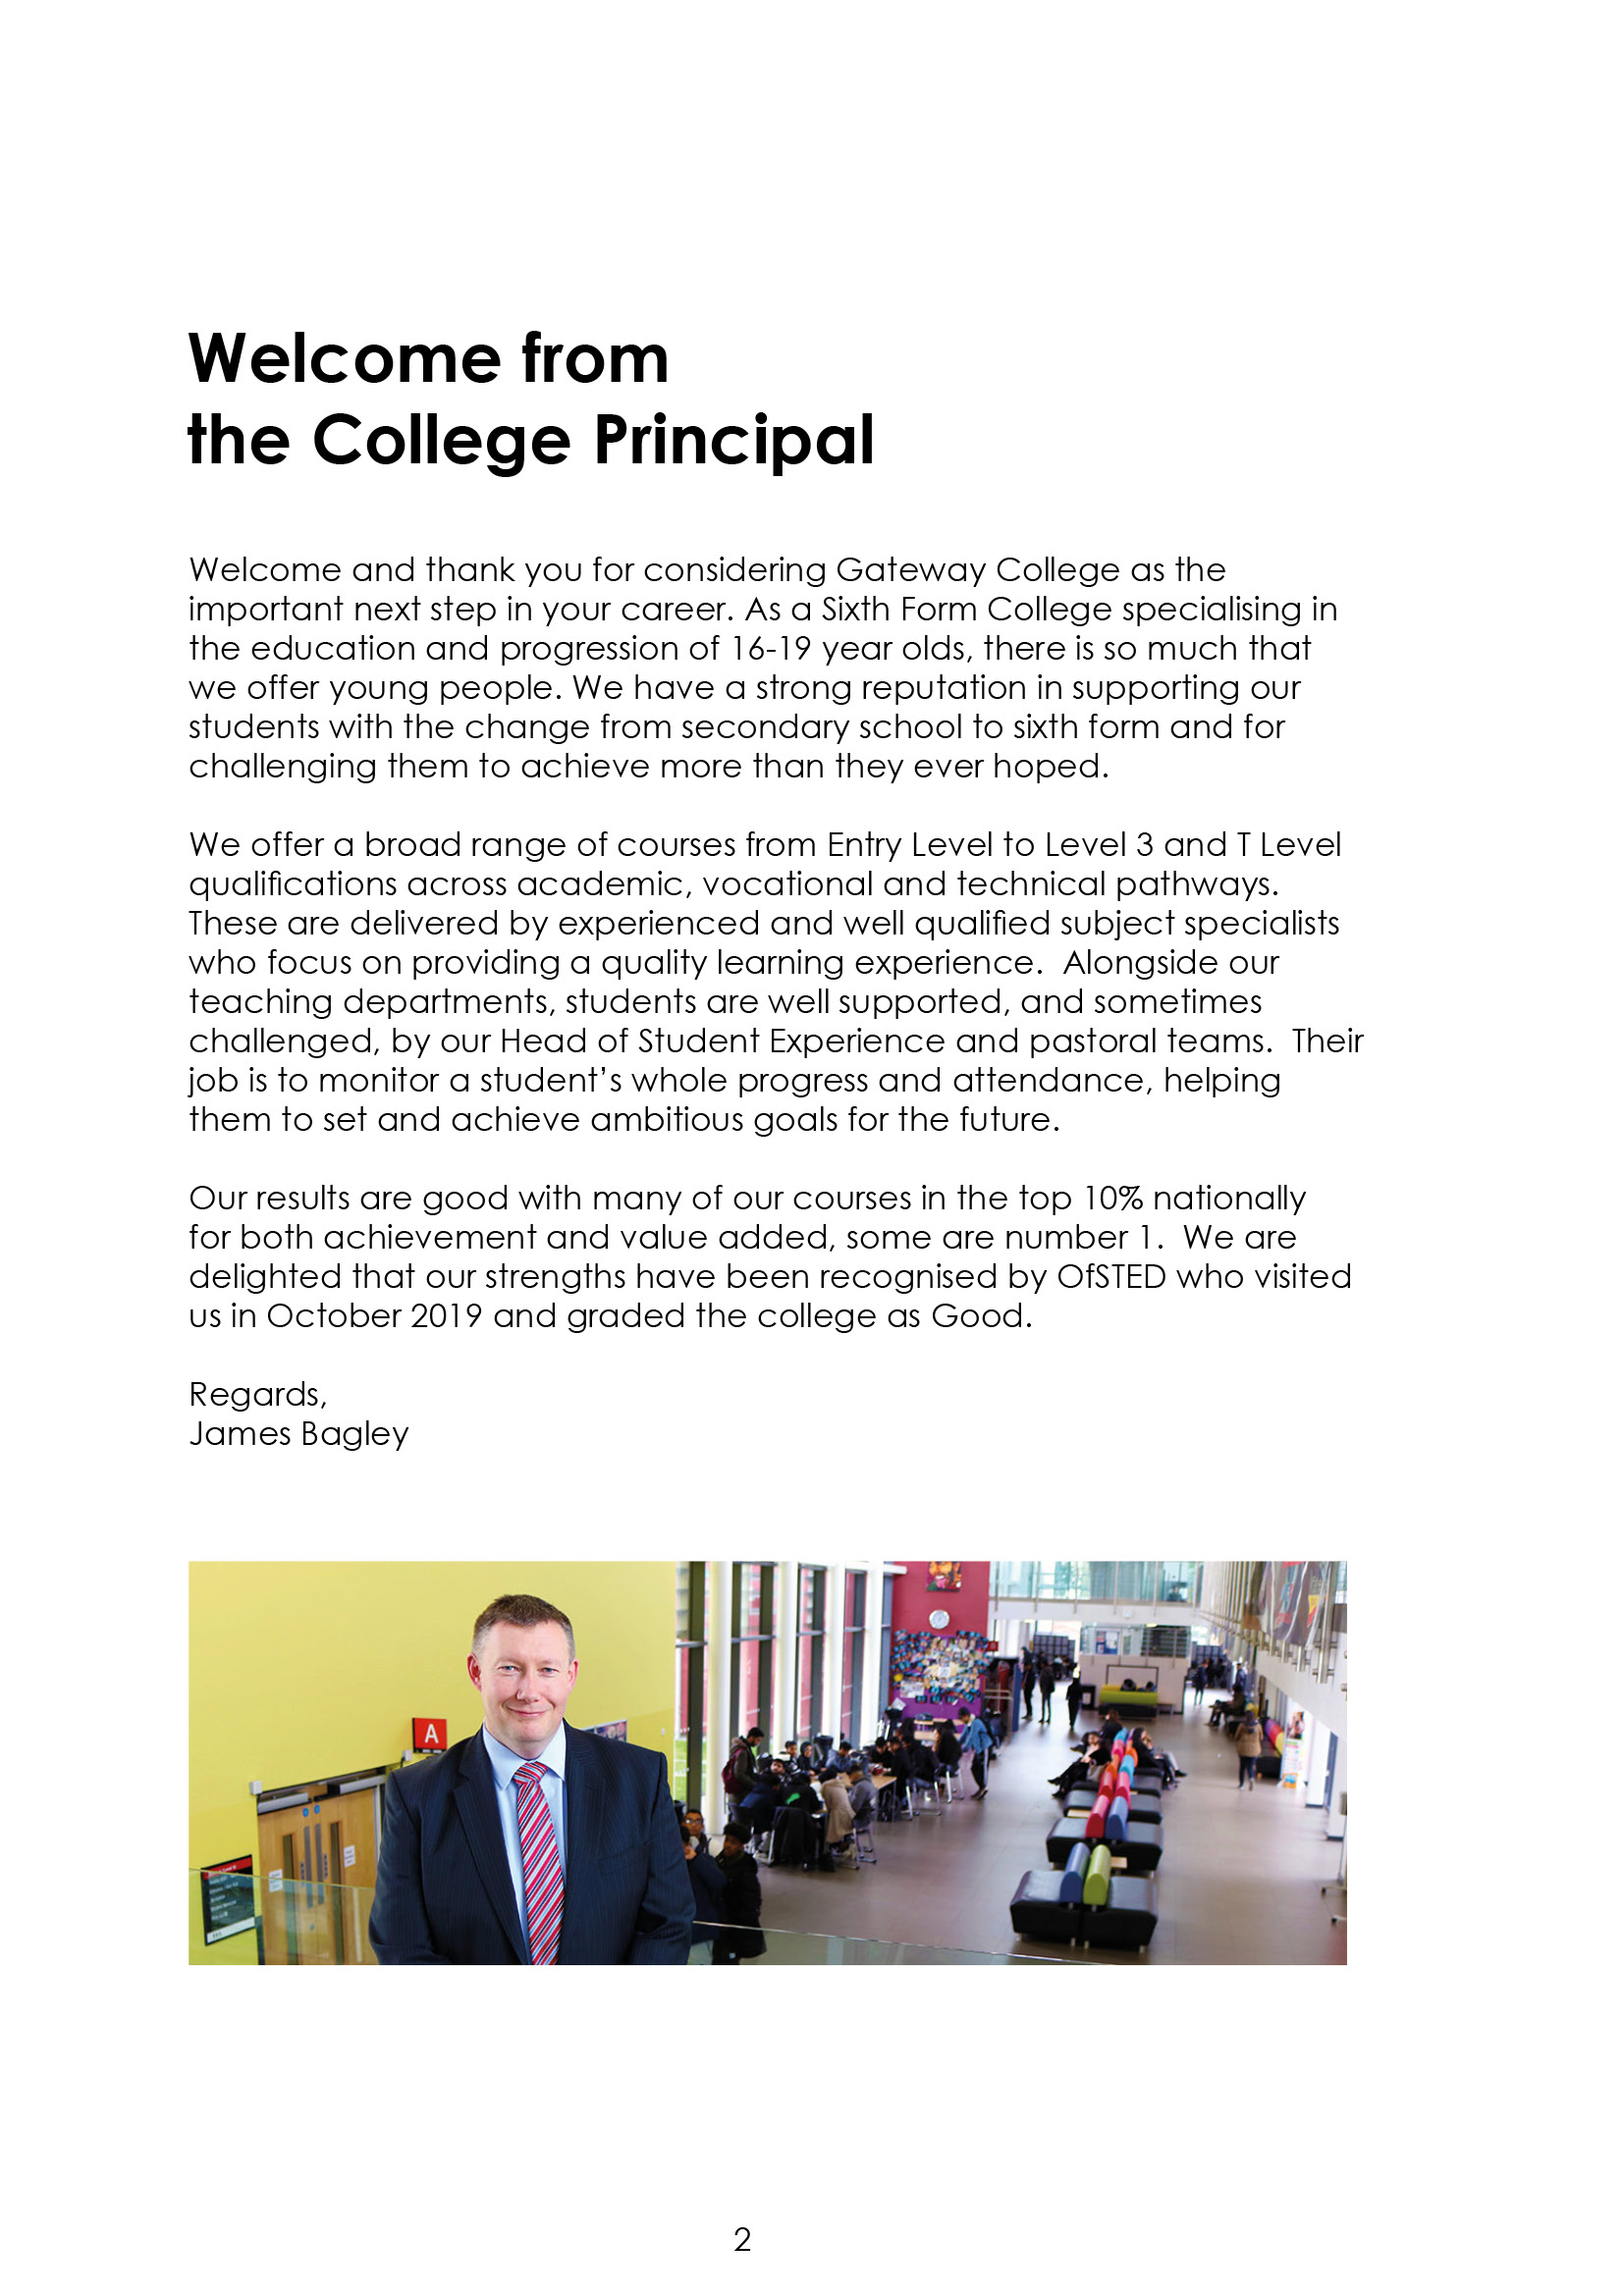

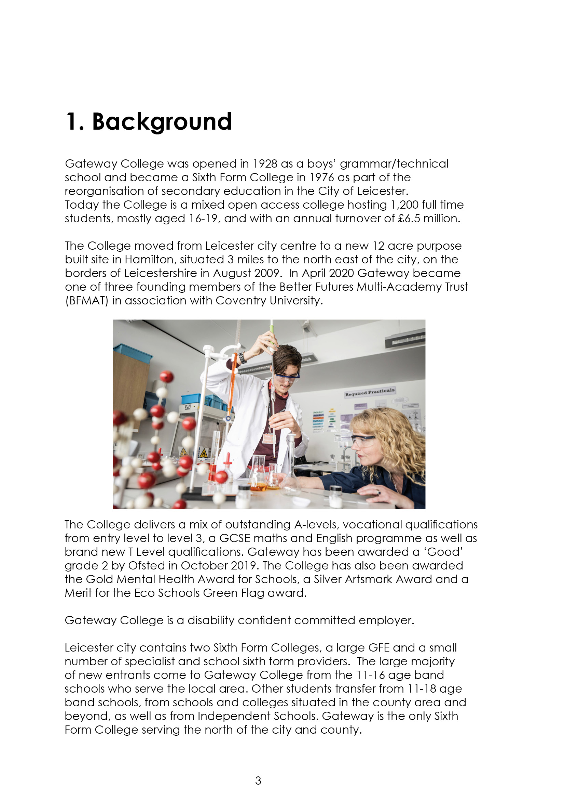

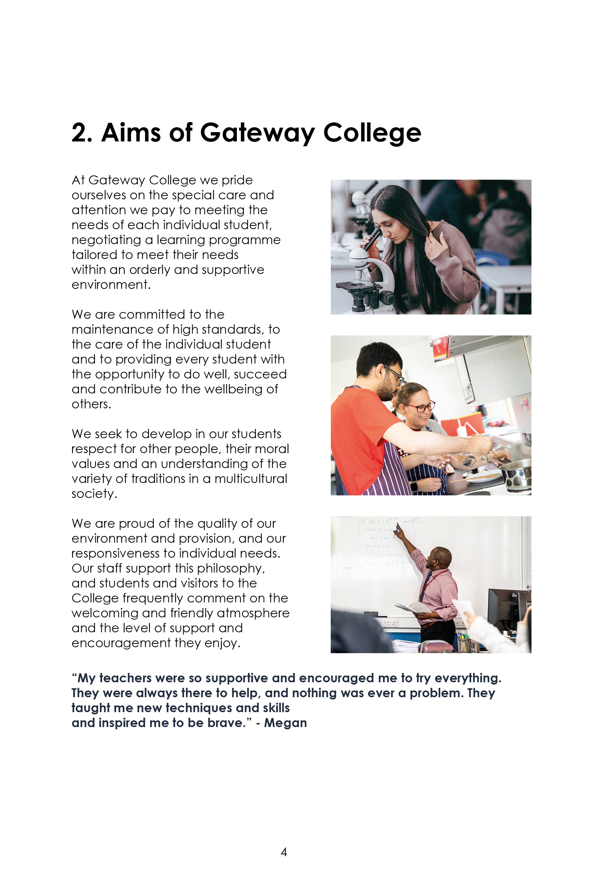

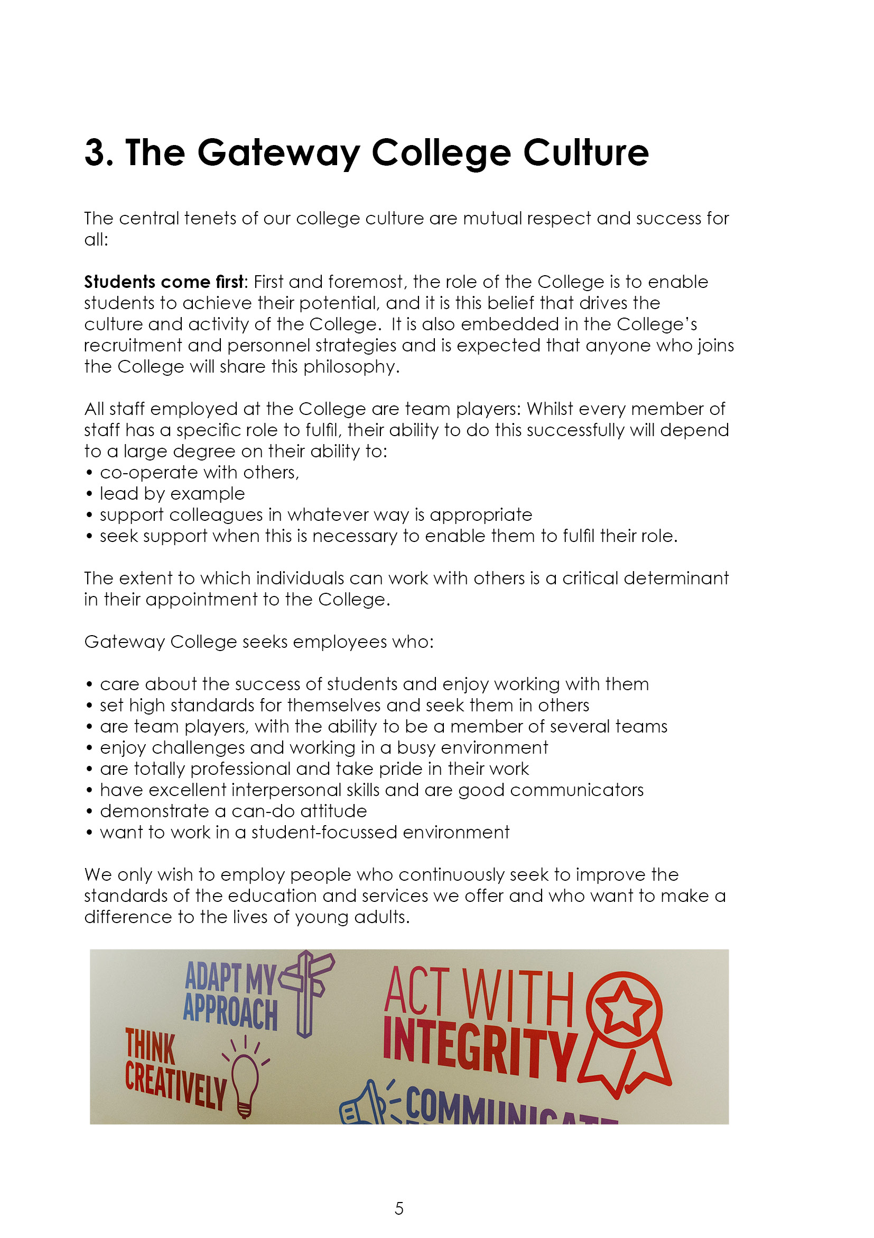





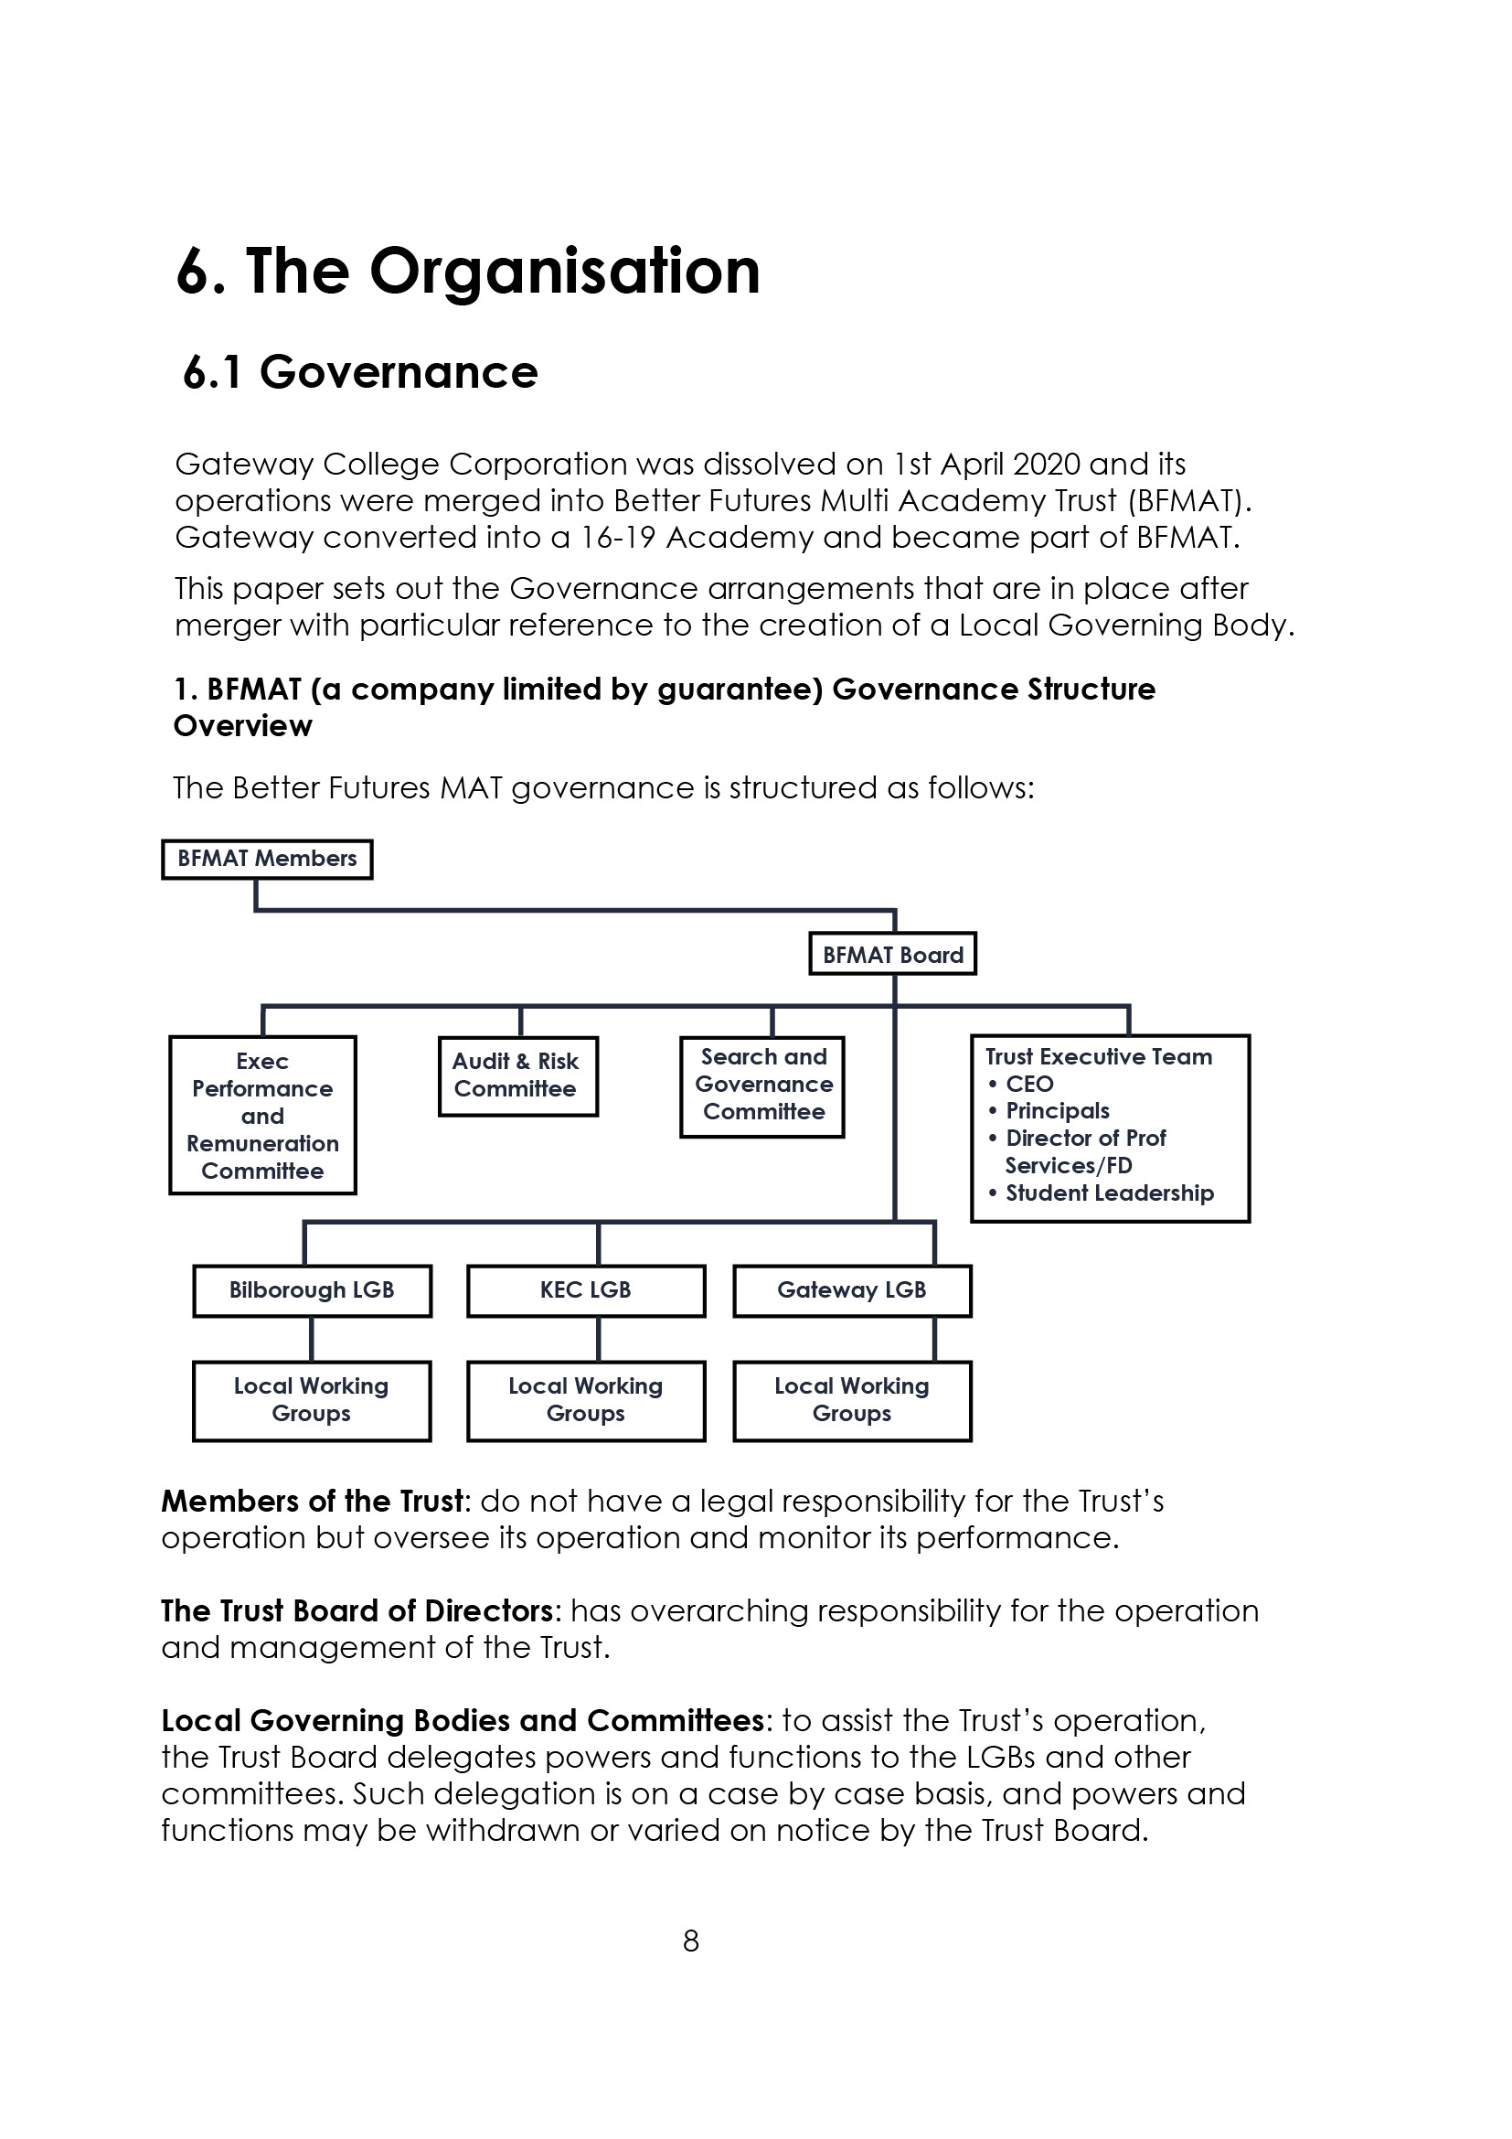



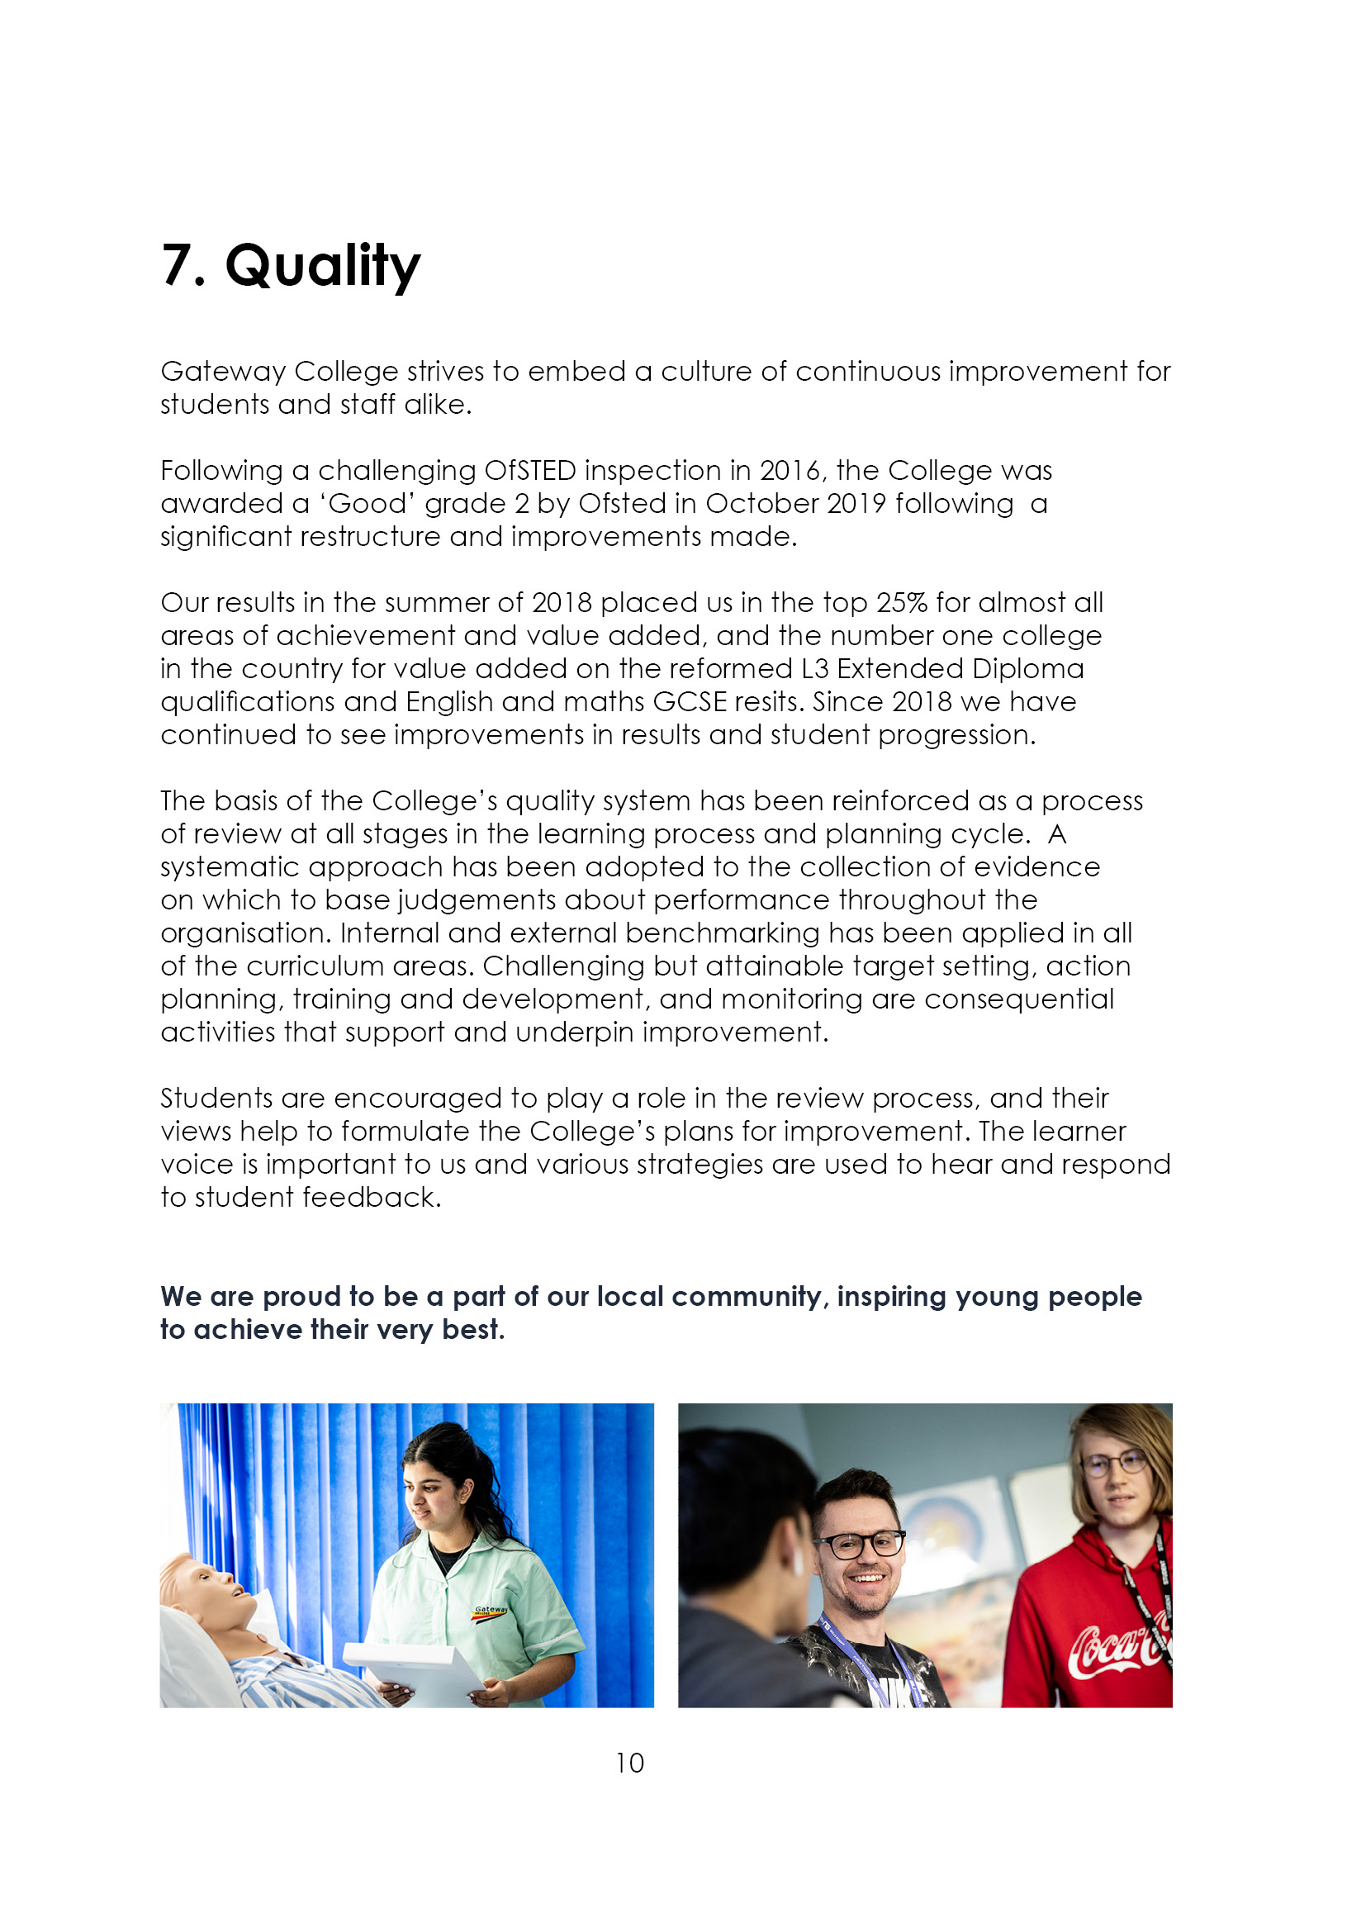

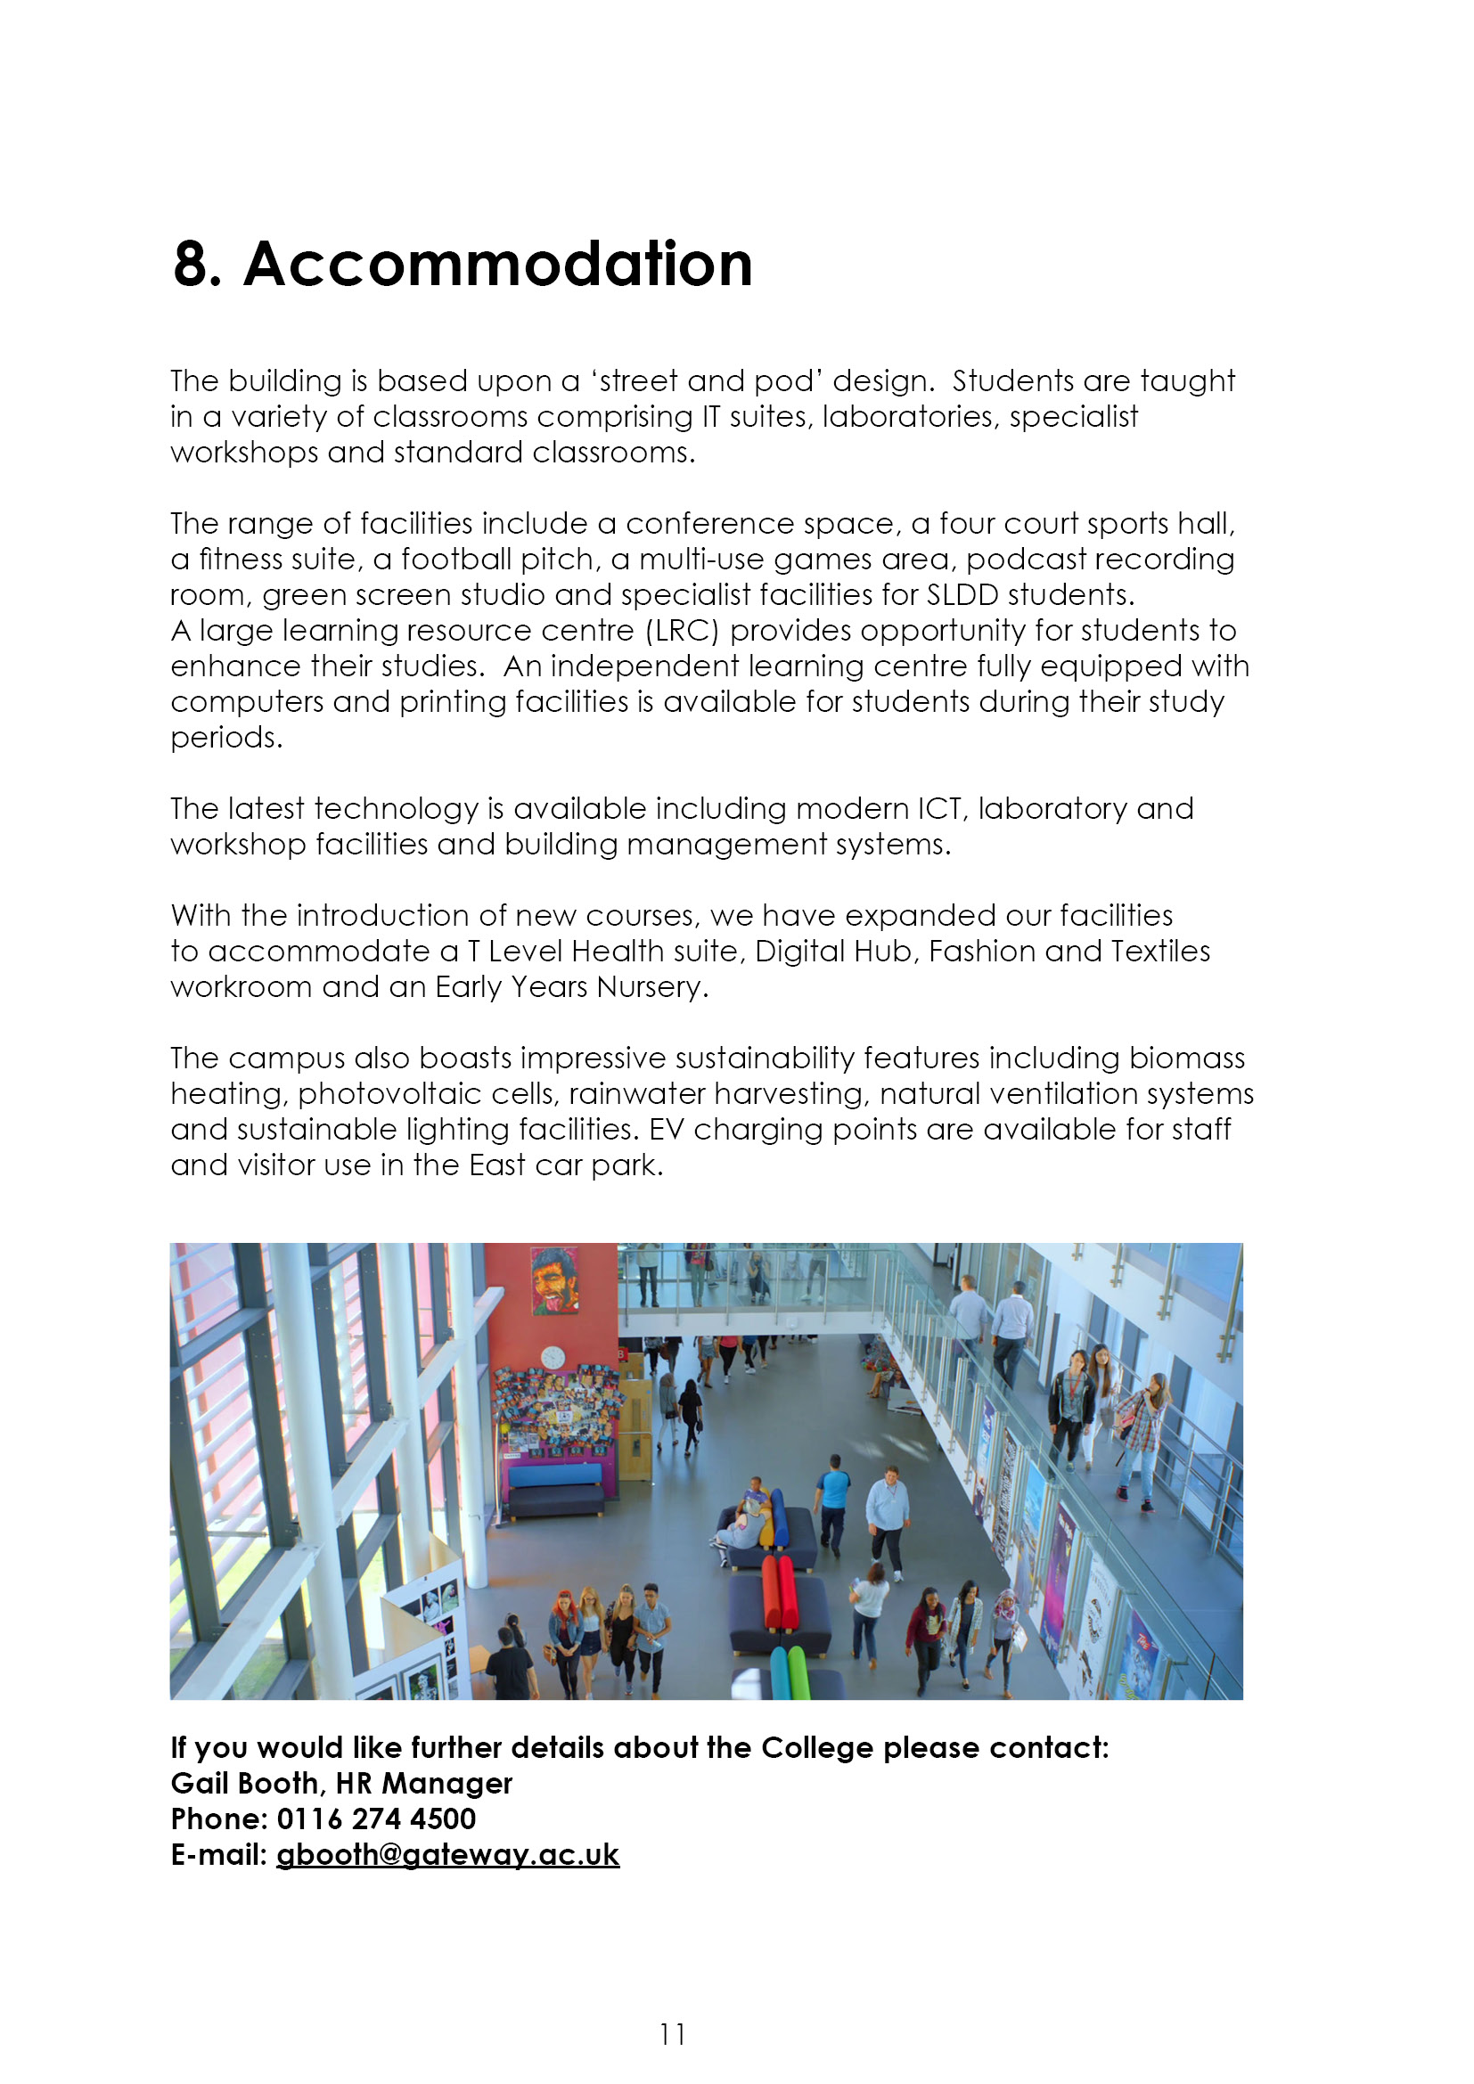

9. Job Advert

PHYSICS TECHNICIAN (Ref: 25/01)
Permanent,15 hours per week (days are negotiable at interview), term time only.
Actual Salary £7,780-£8,076 (points 3-6)

A Physics background is essential as is the ability to work flexibly with minimal supervision and to a high degree of accuracy.

The successful candidate will be required to work in a busy science environment dealing with the needs of Primarily Physics based subjects including the A level and the Science T level.

Qualification – degree in a Physics related area and / or relevant work experience in a Physics related area

Closing date: 28th February 2025 (12 noon)

Interview date: TBC

If you feel you have the qualities we are asking for and are looking for an exciting challenge, please see Search results for Gateway College jobs in LE5 1GA | Tes or visit www.gateway.ac.uk

10. Job Description
Responsible to: The Principal
Accountable to: Head of Department (Health & Life Science)
Actual salary: £7,780 - £8,076 (support staff pay spine points 3-6)

Job Summary:

To manage the day to day storage maintenance and replacement of all Science and Science related equipment in consultation with the appropriate Head of Department or Curriculum Leader. To manage the preparation of all equipment/apparatus required for practical sessions with consideration at all times for all Health & Safety and COSHH regulations.

Duties and Responsibilities:
- To set out, clear away and store safely, all apparatus, machinery and chemicals required for practical work, which may include the cleaning of apparatus before storage.

- To correctly dispose of all waste materials resulting from practical work with due regard for Health and Safety regulations.

- To repair faulty equipment where possible, otherwise to report such faults to the Head of Department or Curriculum Leader.

- To report defects in any of the science areas or circumstances likely to cause a breach of Health and Safety regulations.

- To check on a regular basis all physics and apparatus and advise when re-ordering is necessary.

- Check chemicals and apparatus when delivered by suppliers and advise on missing and damaged items. Work with finance to arrange returns.

- To be aware of the teaching programmes in the Science Department in order to anticipate the need for experiments and practical lessons, with a focus on Physics

- To be fully aware of safe working practice in the handling of chemicals and apparatus as laid down in the COSHH regulations.

- To check equipment on the inventory on an annual basis.

- To develop practices/techniques for experiments/practicals.

- To support/advise new and inexperienced teachers, primarily in the area of Physics.

- To undertake such other duties in the College as requested by the Principal or the Head of Department.

ESSENTIAL | Method of Assessment | Short listing Column
- Experience working in school, college or university laboratories or an appropriate qualification. | A
- Good team work skills. | I
- Ability to support work in the science faculty i.e. primarily Physics but Chemistry, Biology will be considered | I
- Able to work quickly and accurately. | P
- Good knowledge of Health and Safety requirements and procedures. | P
- Good I.T skills. | A
- Able to support students during practical work. | I
- Able to work flexibly and with initiative. | I
- Willing to learn new skills. | A
- A high level of practical skills. | P
DESIRABLE

- Experience in post-16. | A
- Experience of managing others. | A
- Able to suggest improvements in working practices. | I
- Up to date with current requirements. | A
- Able to manage equipment database. | I
- Able to demonstrate experiments. | P
- Prepared to be flexible with hours of work i.e. Open day/evenings | I
- Test new experiments. | P

A = Application Form
I = Interview
P = Practical Test



