16-18 Further Education Bursary

PayMyStudent (PMS)
Application Guide

Please note: you will only be able to apply for the college bursary once you have enrolled on your course at Gateway College

16-18 Further Education Bursary

PayMyStudent (PMS)
Application Guide

Please note: you will only be able to apply for the college bursary once you have enrolled on your course at Gateway College

Step 1 – Accessing PMS
Type in the following web address :
https://gateway.paymystudent.com/

Step 2 – Registering
You will need to register.
- You will need your Gateway student number D****** this can be found on your paperwork that was issued to you when you enrolled or on your student ID card.
- Your date of birth should be 8 digits. Example 20/03/2006
- You can choose your own password.
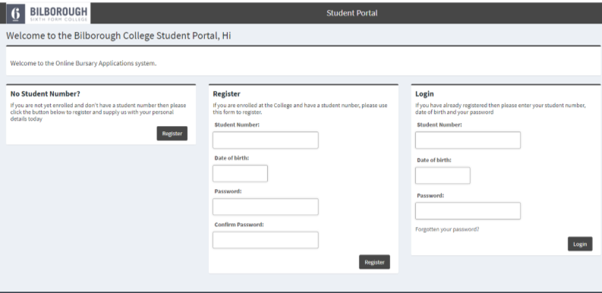

Step 2- Activation
You will receive an email with a link to activate your account.

Step 3 – login in
You will then login with your student number and password that you used to register.

Step 4 – Application
You should now see this screen. Click to proceed with your application

Start your application. Financial support evidence examples can be found in the Financial Evidence Guide.

Once you have uploaded your financial evidence and completed your application please ensure you sign the form and click submit.

College bus
If you have selected College Bus you will need to complete the college bus questionnaire. Please select which zone and route bus you require. Once you have completed the questionnaire it will ask for your signature.
Details of the dedicated college bus route and zones is on the college website https://bilborough.ac.uk/students/transport/
Once you have completed the questionnaire click ‘sign and finish’
Sign the form (using your mouse/finger) click submit.
Once you have completed everything you must ‘logout’ otherwise your application may not be processed

