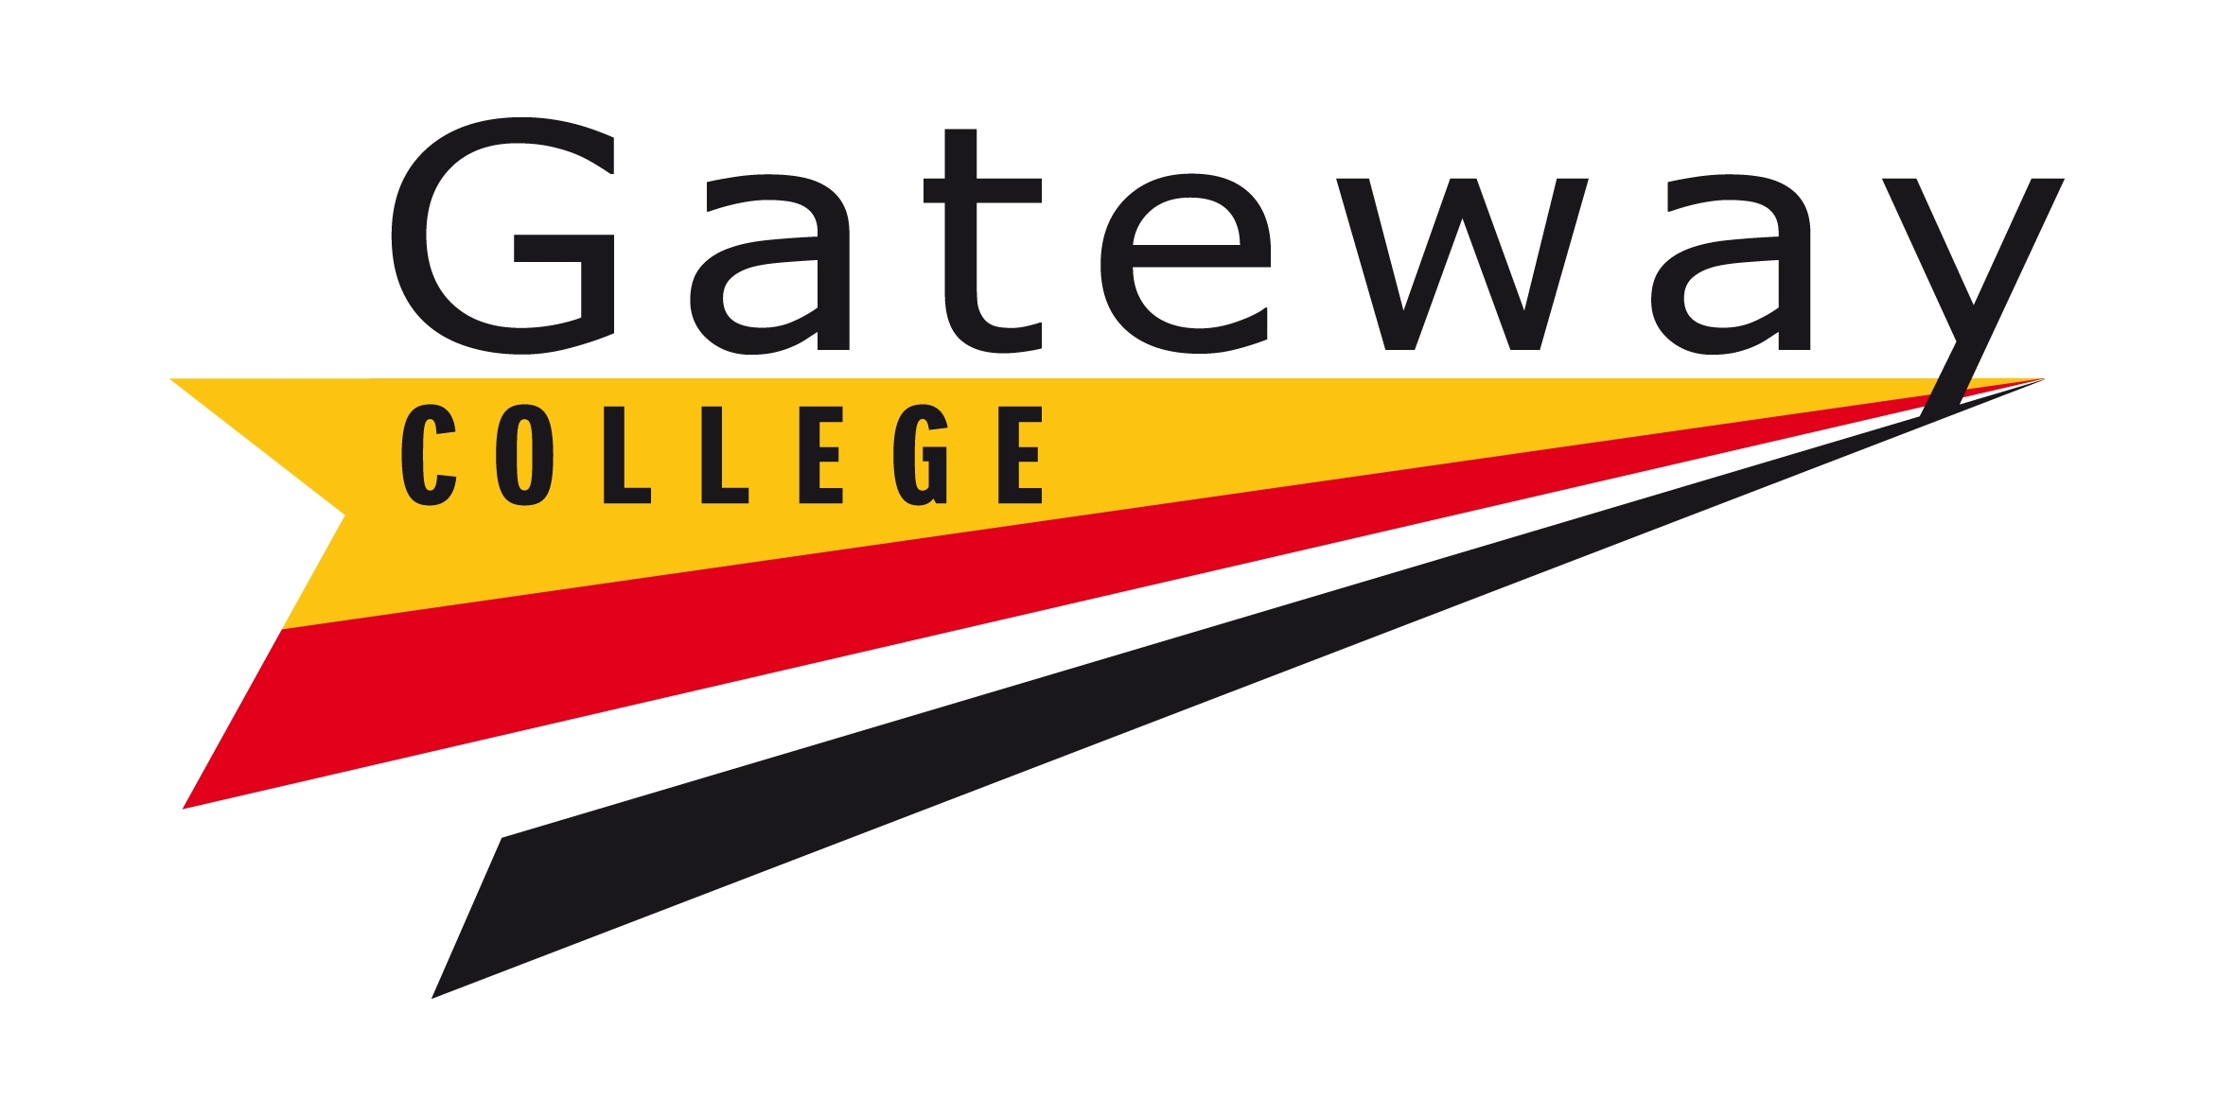

Term Dates: 2022-23

Autumn Term 2022

Start: Monday 22nd August 2022 (39)
(Bank Holiday: Monday 29th August 2022)

Half Term: (Monday 17th October to Friday 21st October 2022)

End: Friday 16th December 2022 (40)

Term = 79 days

Spring Term 2023

Start: Tuesday 3rd January 2023 (34)

Half Term: (Monday 20th February to Friday 24th February 2023)

End: Friday 31st March 2023 (25)

Term = 59 days

Summer Term 2023

Start: Monday 17th April 2023
(May Day: Monday 1st May 2023) (29)

Half Term: (Monday 29th to Friday 2nd June 2023)

End: Friday 7th July 2023* (25)
Monday 10th July 2023**

Term = 55 days

Full Year: 192 days
plus 1 day for open day in November 2022
plus 2 days for personal development/additional open events

* For teaching staff - open day is part of teaching staff 195 days, 1265 hours / For Corporate Staff who worked the Open Day.
** For Corporate Staff – last day of term for those who did not work the Open Day.

