

**Colin Grundy Drive, Leicester, LE5 1GA**

**Telephone: 0116 274 4500 Facsimile: 0116 274 2051**

**Email: admin@gateway.ac.uk www.gateway.ac.uk**

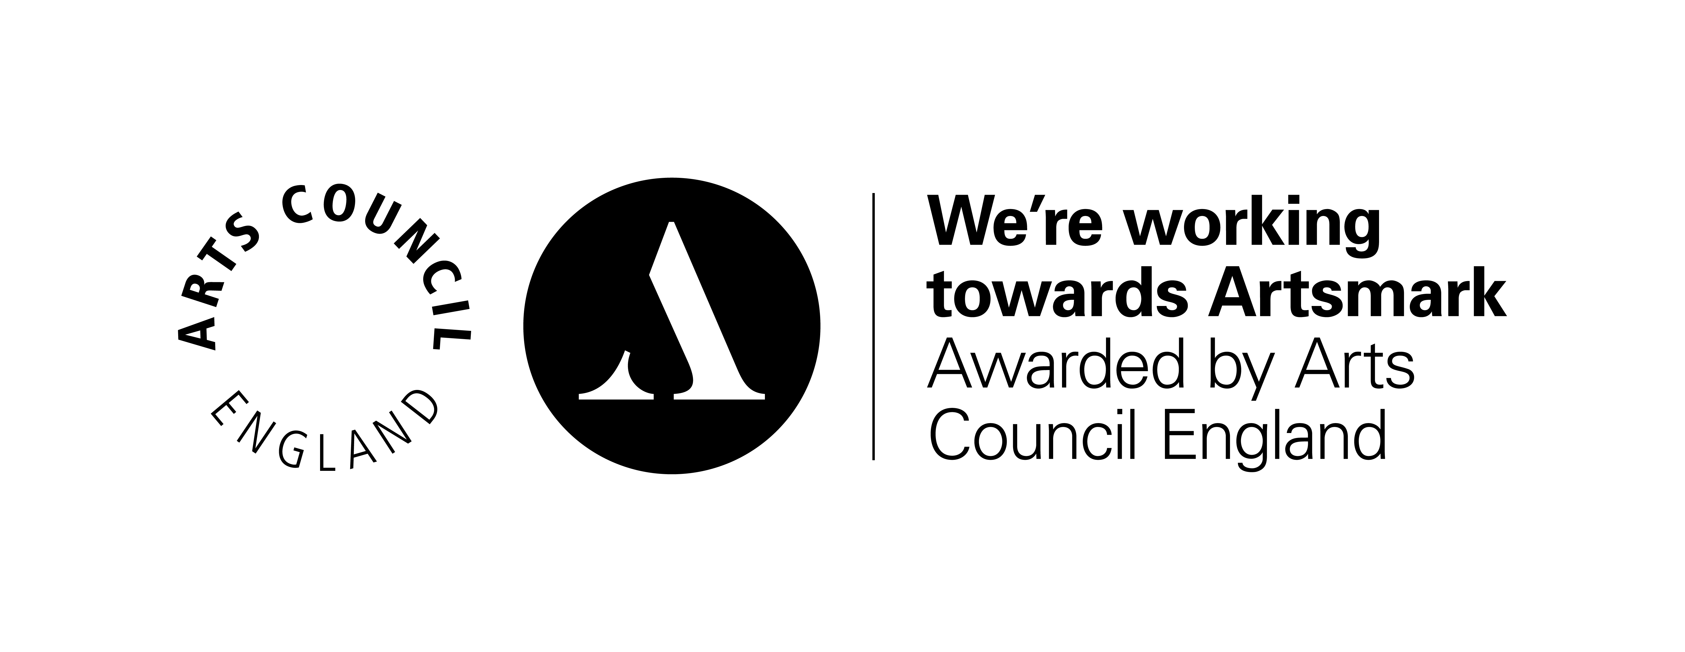

Hi,

Hope you are well.

As you have told us that you are interested in applying for a Medical, Dental or Veterinary degree, we have put together a schedule of events, help and support over summer. It’s important that the UCAS applications for these degrees are completed earlier than for other degree options, which is why we have developed this scheme for you: It is also important to be aware that these are some of the most competitive courses to gain entry onto.

|  |
| --- |
| **Friday 10th June, 2022, LRC 2pm**  **Daisy and Matthew: Introductory Presentation** |
|  |
| **Friday 17th June 2022, LRC 2pm**  **Daisy and Matthew: Start considering your university choices and how to select the right one for you** |
|  |
| **Friday 24th June, 2022, LRC 2pm**  **Aston University: University entrance exams – consider whether sitting UCAT/BMAT or both** |
|  |
| **Friday 1st July, 2022 TBC**  **UCAS & Personal Statement Workshop** |
|  |
| **Wednesday, 6th July, 2022**  **UCAS Discover Medicine, Dentistry and Veterinary Live interactive taster sessions** |
|  |
| **Monday 11th July, 2022, LRC, 11:30am**  **University of Leicester: A day in the life of a medic Q&A** |
|  |
| **Tuesday 19th July, 2022, 12pm**  **University of Dundee: UCAS & Personal Statement Workshop** |
|  |
| **WC 25th July, 2022, TBC**  **University of Nottingham: UCAS & Personal Statement Workshop** |
|  |
| **WC 1st August, 2022, TBC**  **Student Finance: Fees & Funding** |
|  |
| **9th August, 2022, Time TBC**  **University of Lincoln: Interview Process and Tips** |
|  |
| **WC 15th August- September 1st- Booking individual time slots with Matthew or Daisy. Students should be doing independent work on completing their application.** |

The venues are to be confirmed, but you will be updated with the information once we have finalised it.

All applications should be completed for return to college in September. This will allow for final checks by tutors and UCAS coordinators.

Kind regards,

***Matthew Smith & Daisy Atwal***

***Careers & Employability Leads, Gateway College***

***07944055735 / 07944055601***

[***careersandwex@gateway.ac.uk***](mailto:careersandwex@gateway.ac.uk)

The Further Education Corporation of Gateway Sixth Form College, Leicester